EXP NO: 04
USB FORENSICS - FINDING THE LAST CONNECTED USB DEVICE ON A SYSTEM
Aim:
To identify the last connected USB storage device on a Windows system by examining USB device history and related system registry entries.
Procedure:
- Start the Windows computer and log in with the required permissions.
- Press Windows + R, type regedit, and press Enter to open the Registry Editor.
- Navigate to the following registry location to examine USB storage device history:
HKEY_LOCAL_MACHINE\SYSTEM\CurrentControlSet\Enum\USBSTOR
- Expand the USBSTOR key to view the USB storage devices previously recognized by the system.
- Select a device entry and examine its subkeys to identify the device model and instance information.
- Navigate to the following registry location to examine USB device connection information:
HKEY_LOCAL_MACHINE\SYSTEM\CurrentControlSet\Enum\USB
- Record the available device details, such as the manufacturer, product name, device identifier, and serial number, if present.
- Examine the device properties and relevant timestamps using an appropriate forensic tool, such as USB Detective or a Windows registry analysis tool.
- If available, examine the Windows SetupAPI log at C:\Windows\INF\setupapi.dev.log for device installation and detection records.
- Compare the available timestamps and event records to determine which USB device was most recently connected or installed.
- Record the findings in the observation table.
Precaution: Registry entries may remain after a USB device is removed. Do not assume that the last registry entry automatically identifies the most recently connected device. Correlate timestamps and other available evidence.
Output:
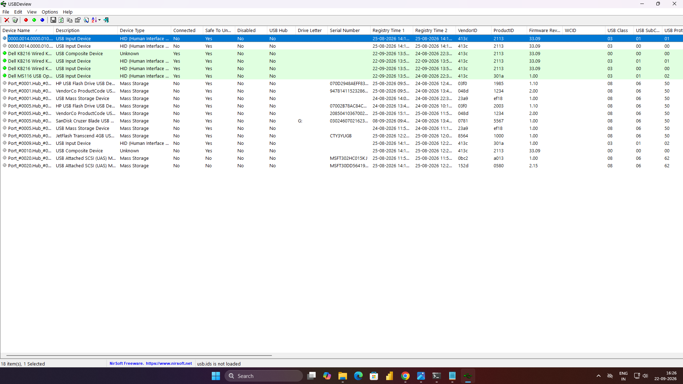

Observation:
The Windows Registry maintains information about USB devices that have been recognized by the computer. These entries may help investigators identify previously connected USB storage devices.
The following details can be observed during the investigation:
S.No | Parameter | Observation
1 | Operating System | Windows
2 | Forensic Technique | USB device history analysis
3 | Registry Location | USBSTOR
4 | Device Information | Manufacturer and model
5 | Device Identifier | Serial number or instance ID, if available
6 | Connection Evidence | Registry entries and system logs
7 | Last Connected Device | Record the device identified from the available evidence
8 | Timestamp | Record the relevant date and time, if available

The registry and system logs can provide evidence of previously recognized USB devices. The exact connection time may not be available from every registry entry, so additional logs or forensic artifacts may be required to establish the most recent connection.
Result:
Thus, USB forensics was studied by examining Windows Registry entries and system logs to identify previously connected USB storage devices. The available device information and timestamps were analyzed to determine the most recently connected USB device.

