EXP NO: 05
Viewing the Last Activity of a PC Using Windows Forensics
Aim:
To examine the recent activity of a Windows PC using system logs, recent files, and other Windows artifacts for digital forensic investigation.
Procedure:
1. Start the Windows computer and log in with the required permissions.
2. View recent files: Open File Explorer and select Home or Quick access to view recently accessed files, if this feature is enabled.
3. Check recent activity: Press Windows + R, type recent, and press Enter to open the Recent Items folder, if available.
4. Open Event Viewer: Press Windows + R, type eventvwr.msc, and press Enter.
5. Expand Windows Logs and select System to examine system events.
6. Select Windows Logs → Security to examine available security audit events. Administrative permissions may be required.
7. Select Windows Logs → Application to view application-related events.
8. Review the event date, time, event ID, and description to understand the recorded activity.
9. Check system startup information: In Event Viewer, examine relevant System log events to identify recorded startup and shutdown activity.
10. Check browser activity: Open the browser's history page to examine recently visited websites, if the history is available and you are authorized to inspect it. 11. Record the relevant activity, timestamps, and observations in the table below.

Output:
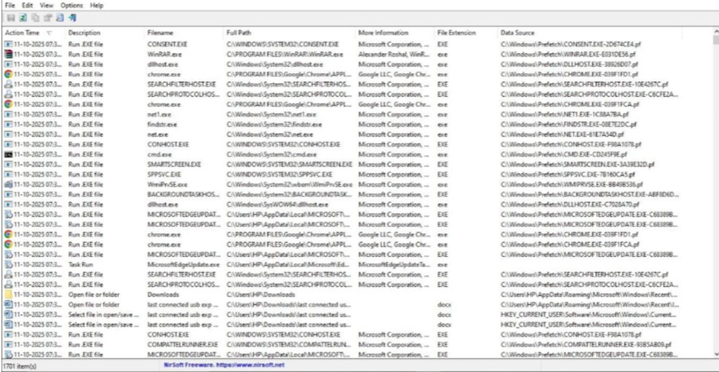
Observation:
Windows stores different types of activity information in system logs, recent-item records, and application artifacts. These sources can help an investigator understand some of the activities performed on a computer.
S.No | Activity Source | Observation
1 | Recent Items | Recently accessed files or shortcuts, if available
2 | Event Viewer - System | System startup, shutdown, and other system events
3 | Event Viewer - Security | Recorded login and security events, depending on audit settings
4 | Event Viewer - Application | Application-related events and errors
5 | Browser History | Recently visited websites, if retained
6 | Date and Time | Timestamp associated with the selected event or artifact

The available records depend on Windows settings, user activity, audit policies, and log retention. Recent-file entries and browser history may be incomplete or deleted. A recorded event should not automatically be treated as proof of a person's actions.

Result:
Thus, the recent activity of a Windows PC was examined using Windows Event Viewer, recent-file records, and browser history. The available artifacts and timestamps were studied to understand how computer activity can be investigated using digital forensic techniques.

