EXP NO: 07
COMPARISON OF TWO FILES FOR FORENSIC INVESTIGATION USING COMPARE IT SOFTWARE
Aim:
To compare two files using Compare It software and identify similarities, differences, and modifications in their contents for digital forensic investigation.
Procedure:
1. Start the computer and open the Compare It software.
2. Prepare two files that need to be compared. The files may contain text, code, or other supported content.
3. Keep both files in an accessible folder and note their names and locations.
4. Open Compare It software.
5. Select the first file as the original or reference file.
6. Select the second file as the file to be compared.
7. Start the comparison using the software's compare option.
8. Observe the differences highlighted by the software, including added, deleted, or modified lines of text.
9. Examine the matching sections to identify content that remains unchanged.
10. Record the differences and similarities between the two files. 11. Save or capture the comparison report or screenshots, if the software supports these features.
12. Document the findings for the forensic investigation.

Observation:
Compare It software helps identify differences between two files by displaying their contents side by side and highlighting changes. This is useful for examining whether a file has been modified.
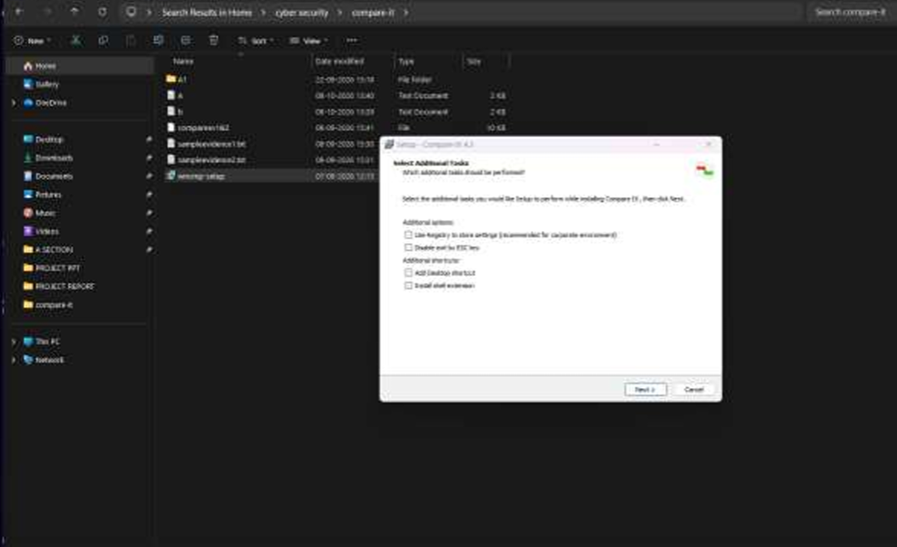
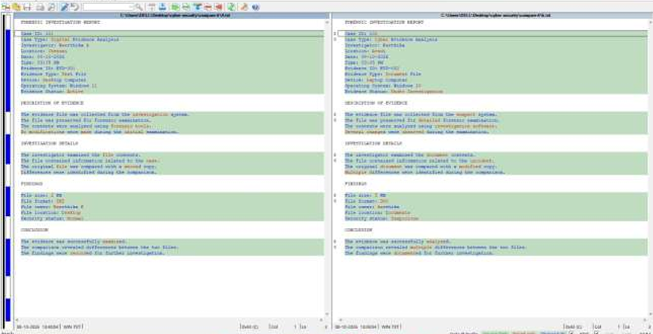

The comparison may reveal changes in text, lines, or other supported content. However, a visual comparison alone does not establish when a file was modified or who modified it. Hash comparison can help determine whether two files have identical contents.

Result:
Thus, two files were compared using Compare It software, and the similarities and differences in their contents were examined. The use of file comparison in identifying possible modifications during digital forensic investigations was understood.

