EXP NO: 08
COLLECTION OF EMAIL EVIDENCE FROM A VICTIM'S PC
Aim:
To study the methods used to identify, collect, preserve, and examine email evidence from a computer for digital forensic investigation.
Procedure:
1. Start the computer and obtain proper authorization to examine the email evidence.
2. Identify the email service or client used on the system, such as Gmail, Microsoft Outlook, or Mozilla Thunderbird.
3. Record the system details, date, time, user account information, and other relevant case details.
4. If the email account is accessed through a web browser, examine the available email messages and relevant browser artifacts, following the approved evidence-handling procedure.
5. If a desktop email client is used, identify its local mail storage files. For example, Outlook may use .pst or .ost files, while Thunderbird may store messages in MBOX files or other profile data.
6. Create a forensic image of the storage device or an authorized copy of the relevant email data, using a suitable forensic tool.
7. Preserve the original evidence and perform the examination on a verified copy whenever possible.
8. Export relevant email messages in a suitable format, such as .eml or .msg, where supported.
9. Examine the email sender, recipient, subject, date, time, message body, and available message headers.
10. Review attachments carefully and record their file names, types, and hash values where appropriate.
11. Calculate cryptographic hash values, such as SHA-256, for collected evidence files and maintain an evidence log.
12. Document the collection method, tools used, timestamps, and findings in the forensic report.
Output:
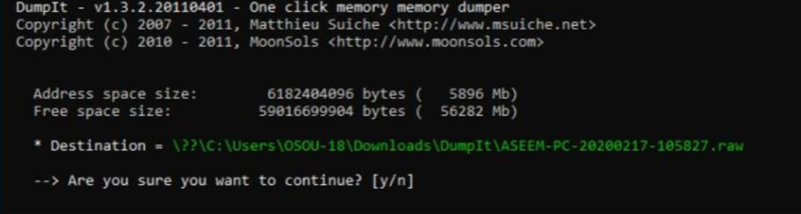
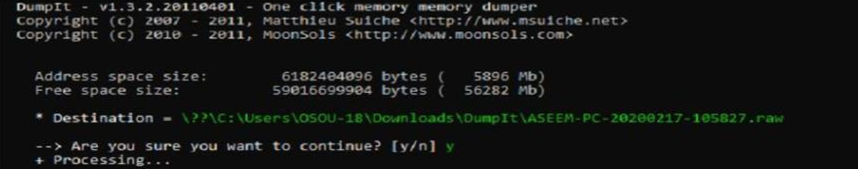
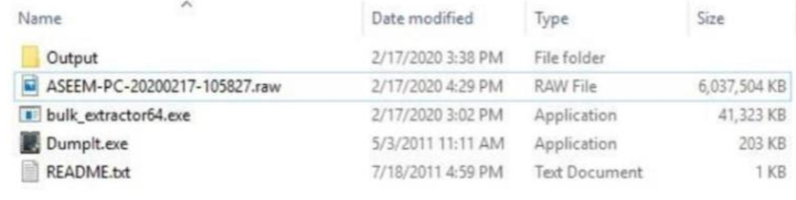
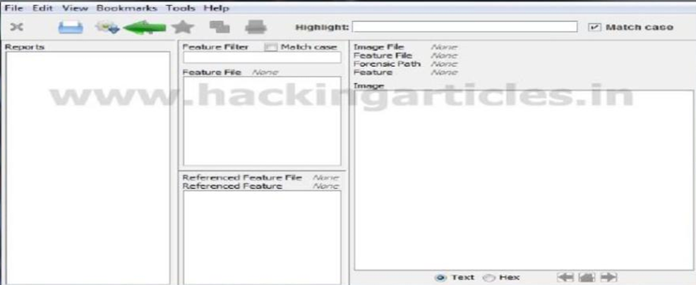
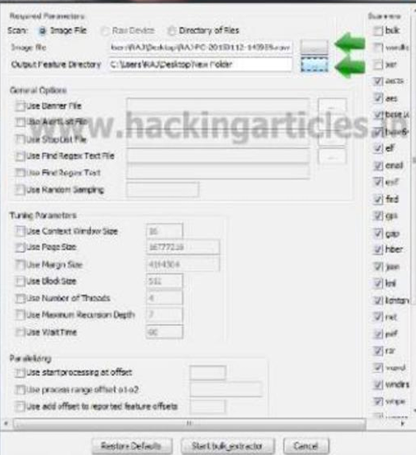
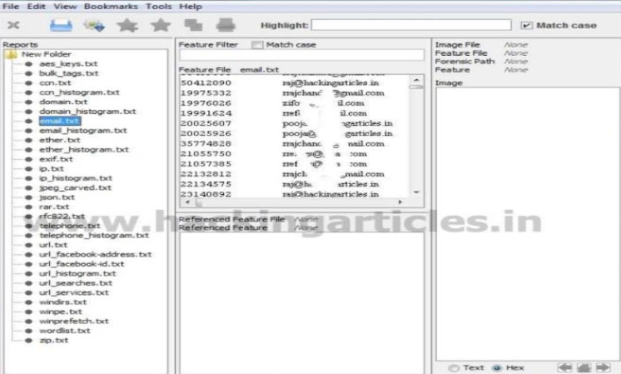
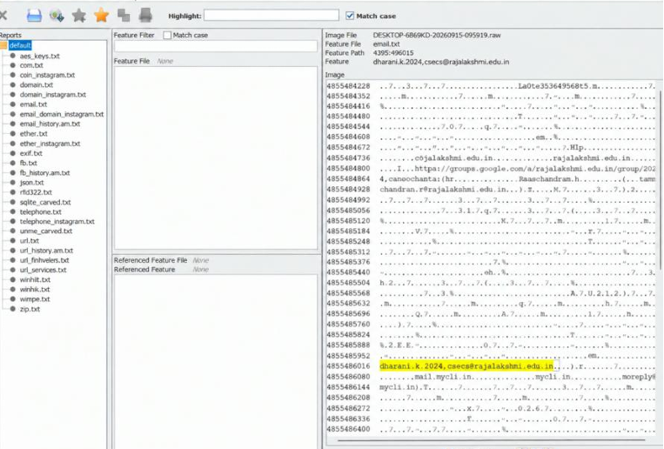

Observation:
Email evidence may contain important information about phishing, fraud, unauthorized access, harassment, and other cyber incidents. The evidence must be collected carefully to preserve its integrity.
S. No | Evidence Type | Information Obtained
1 | Sender and Recipient | Email addresses involved in communication
2 | Subject | Purpose or topic of the email
3 | Date and Time | Available message timestamps
4 | Email Header | Routing details and technical metadata
5 | Message Body | Content of the communication
6 | Attachments | Files shared through the email
7 | Local Mail Files | Stored email data from the email client
8 | Hash Value | Used to verify whether collected files have changed
9 | Evidence Log | Details of collection and handling
Email evidence may be available in a mail server, webmail account, local email client, browser artifacts, or backups. The exact information depends on the email service and the data retained by the system.

Result:
Thus, the methods for collecting and preserving email evidence from a computer were studied. The importance of examining email headers, message content, attachments, and metadata while maintaining evidence integrity was understood.

