EXP NO: 10
EXTRACTION OF EXIF DATA FROM AN IMAGE FILE USING EXIF READER SOFTWARE
Aim:
To extract and examine Exchangeable Image File Format (EXIF) metadata from an image file using EXIF Reader software for digital forensic investigation.
Procedure:
- Start the computer and locate an image file, such as a JPEG photograph, for examination.
- Install or open a suitable EXIF Reader software application.
- Launch the software and select the option to open or browse for an image file.
- Navigate to the folder containing the image and select the required file.
- Load the image into the EXIF Reader software.
- Allow the software to analyze the image and display its available EXIF metadata.
- Examine the metadata fields, including camera manufacturer, camera model, date and time, image dimensions, and orientation.
- Check whether GPS coordinates or location information are present in the image metadata.
- Record the available metadata values in the observation table.
- If supported, export or save the metadata report for documentation.
- Close the software after recording the findings.
Observation:
EXIF metadata is information embedded in an image file by a camera, smartphone, or image-processing application. It can provide useful details about how and when an image was created.
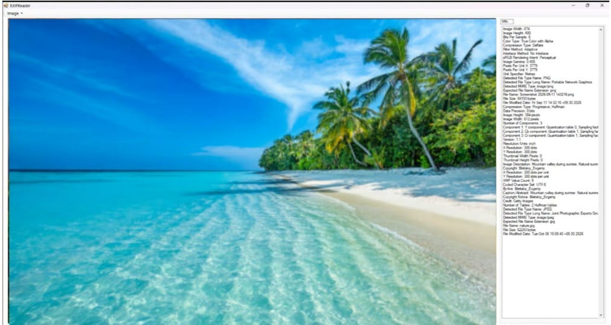
The following information may be obtained using EXIF Reader:
S. No | Metadata Field | Information Obtained
1 | File Name | Name of the examined image
2 | File Format | JPEG, TIFF, or another supported format
3 | Camera Manufacturer | Camera or device manufacturer, if available
4 | Camera Model | Model of the device, if recorded
5 | Date and Time | Recorded image capture date and time, if available
6 | Image Dimensions | Width and height in pixels
7 | Orientation | Orientation information recorded in the metadata
8 | GPS Information | Latitude and longitude, if present
9 | Software Information | Software used to process the image, if recorded
The availability of EXIF data depends on the image format, device, and processing history. Some applications remove metadata when an image is edited or shared. Recorded timestamps may also be inaccurate or affected by incorrect device settings.
Result:
Thus, EXIF metadata was extracted and examined from an image file using EXIF Reader software. The importance of image metadata, including device details, timestamps, image properties, and possible location information, in digital forensic investigations was understood.

