DIGITAL SIGNATURE VERIFICATION USING
RSA AND SHA-256 IN JAVA
Madhumitha P (24UAD112), Ashikaa J (24UAD099)
Department of Artificial Intelligence and Data Science
Kamaraj College of Engineering and Technology, Virudhunagar

1. Introduction
Digital Signature Verification using RSA and SHA-256 is a Java-based cybersecurity project developed to ensure the authenticity and integrity of a message. The application is a simple console program that generates a digital signature for a message entered by the user and then verifies it.
The application uses the Java Security API to generate a 2048-bit RSA key pair consisting of a private key and a public key. The message entered by the user is hashed with SHA-256 and signed with the private key using the SHA256withRSA algorithm. The resulting signature is displayed in Base64 format so that the binary signature is easy to read and store.
The signature is then verified with the public key. The user is asked to enter the message again for verification. If the message matches the original, the output is VALID DIGITAL SIGNATURE; otherwise the output is INVALID DIGITAL SIGNATURE, which shows that the message may have been modified. The project demonstrates important concepts of cryptography such as public-key encryption, hashing, digital signatures, authentication and data integrity.

2. Objectives
The main objectives of the project are:
- To develop a Java-based console application that generates a digital signature for a user-entered message.
- To generate a 2048-bit RSA key pair using the Java Security API.
- To sign the message using the private key with the SHA256withRSA algorithm.
- To display the digital signature in Base64 format.
- To verify the digital signature using the public key and confirm the authenticity of the message.
- To demonstrate that any modification to the message makes the signature invalid.

3. Proposed System
The proposed system is a single Java console program that combines key generation, message signing and signature verification. It uses only the built-in java.security package, so no external library is required.
When the program starts, a 2048-bit RSA key pair is generated using KeyPairGenerator. The user enters a message, which is converted to UTF-8 bytes and signed with the private key using the Signature class and the SHA256withRSA algorithm. The signature is encoded in Base64 and displayed along with the original message. It is then verified with the public key and the result is shown as SUCCESS or FAILED.
Finally, the user enters the message again. The public key is used to verify the stored signature against this new message. If the message is unchanged, the result is VALID DIGITAL SIGNATURE. If even one character is different, for example “hello” and “Hello”, the result is INVALID DIGITAL SIGNATURE.
Key Parameters
Parameter | Value
Language / Interface | Java / Console (Command Prompt)
Key algorithm | RSA, 2048-bit key pair (KeyPairGenerator)
Hash and signature algorithm | SHA-256 with RSA (SHA256withRSA)
Signing key | Private key
Verification key | Public key
Message encoding | UTF-8 bytes
Signature encoding | Base64
Result messages | VALID DIGITAL SIGNATURE / INVALID DIGITAL SIGNATURE
Test messages | “Hello Bro” (valid), “hello” changed to “Hello” (invalid)

4. System Workflow
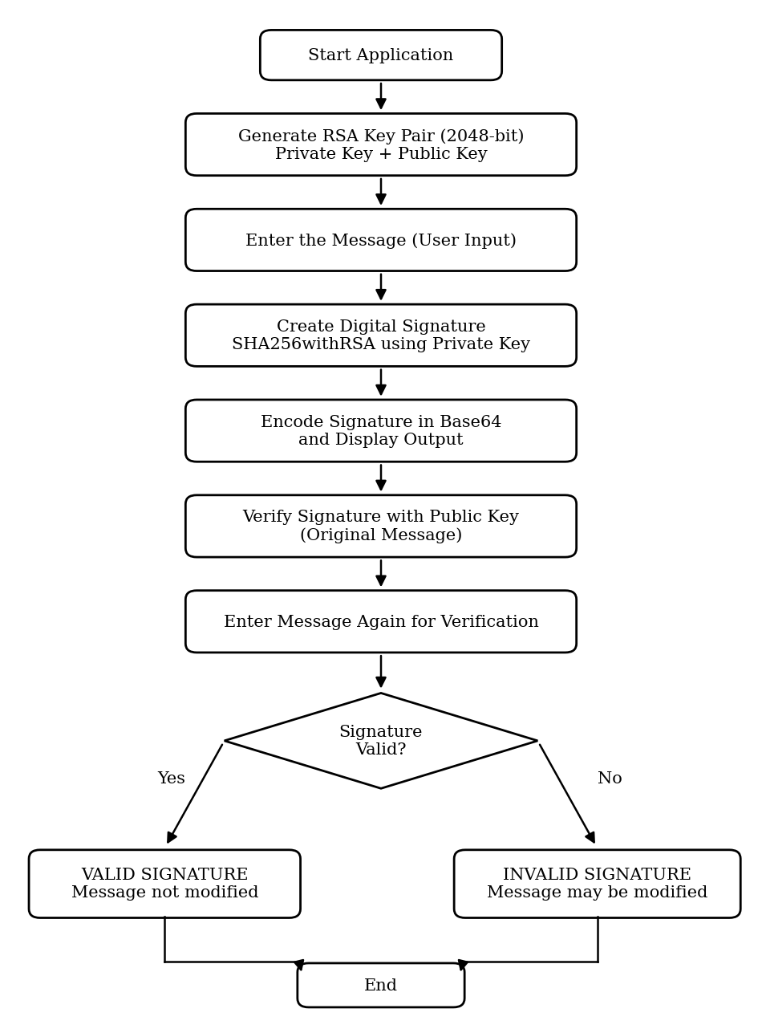
Figure 1: System workflow

5. Implementation and Modules
Module | Description
Key Generation Module | Generates a 2048-bit RSA key pair (private key and public key) when the program starts, using KeyPairGenerator.
Message Input and Signing Module | Reads the message entered by the user, converts it to UTF-8 bytes and signs it with the private key using SHA256withRSA.
Signature Display Module | Encodes the binary signature in Base64 and displays it together with the original message.
Verification Module | Verifies the signature with the public key and displays SUCCESS or FAILED for the original message.
Tamper Detection Module | Asks the user to enter the message again and verifies the stored signature against it. Displays VALID or INVALID DIGITAL SIGNATURE.

6. System Requirements
Hardware requirements
- Computer running Windows operating system
Software requirements
- Java Development Kit (JDK) with the java.security package
- Command Prompt (cmd) to compile and run the program

7. Source Code
7.1 Digital Signature Program (DigitalSignature)
This program generates the RSA key pair, signs the entered message with SHA256withRSA, displays the Base64 signature and verifies it with the public key, including the tamper-detection test.
import java.security.KeyPair;
import java.security.KeyPairGenerator;
import java.security.PrivateKey;
import java.security.PublicKey;
import java.security.Signature;
import java.util.Base64;
import java.util.Scanner;

public class DigitalSignature {

private static final String LINE = "================================";

public static void main(String[] args) throws Exception {

Scanner scanner = new Scanner(System.in);

// ==========================================
// STEP 1: GENERATE RSA KEY PAIR (2048-bit)
// ==========================================
KeyPairGenerator keyGen = KeyPairGenerator.getInstance("RSA");
keyGen.initialize(2048);
KeyPair keyPair = keyGen.generateKeyPair();
PrivateKey privateKey = keyPair.getPrivate();
PublicKey publicKey = keyPair.getPublic();

// ==========================================
// STEP 2: READ MESSAGE FROM USER
// ==========================================
System.out.print("Enter the message: ");
String message = scanner.nextLine();

// ==========================================
// STEP 3: CREATE DIGITAL SIGNATURE
// (SHA-256 hash signed with the private key)
// ==========================================
Signature signer = Signature.getInstance("SHA256withRSA");
signer.initSign(privateKey);
signer.update(message.getBytes("UTF-8"));
byte[] signatureBytes = signer.sign();

// Encode the binary signature in Base64
String signatureBase64 =
Base64.getEncoder().encodeToString(signatureBytes);

System.out.println();
System.out.println(LINE);
System.out.println(" DIGITAL SIGNATURE GENERATED");
System.out.println(LINE);
System.out.println("Original Message: " + message);
System.out.println();
System.out.println("Digital Signature:");
System.out.println(signatureBase64);

// ==========================================
// STEP 4: VERIFY SIGNATURE WITH PUBLIC KEY
// ==========================================
System.out.println();
System.out.println(LINE);
System.out.println(" SIGNATURE VERIFICATION");
System.out.println(LINE);

boolean firstCheck = verify(publicKey, message, signatureBytes);
if (firstCheck) {
System.out.println("Verification: SUCCESS");
System.out.println("The message is authentic.");
} else {
System.out.println("Verification: FAILED");
System.out.println("The message is not authentic.");
}

// ==========================================
// STEP 5: TAMPER-DETECTION TEST
// (message is entered again by the user)
// ==========================================
System.out.println();
System.out.print("Enter message again for verification: ");
String enteredAgain = scanner.nextLine();

byte[] storedSignature = Base64.getDecoder().decode(signatureBase64);
boolean finalCheck = verify(publicKey, enteredAgain, storedSignature);

System.out.println();
if (finalCheck) {
System.out.println("Result: VALID DIGITAL SIGNATURE");
System.out.println("The message has not been modified.");
} else {
System.out.println("Result: INVALID DIGITAL SIGNATURE");
System.out.println("The message may have been modified.");
}

scanner.close();
}

// ==========================================
// VERIFY SIGNATURE
// ==========================================
private static boolean verify(PublicKey publicKey, String message,
byte[] signatureBytes) throws Exception {
Signature verifier = Signature.getInstance("SHA256withRSA");
verifier.initVerify(publicKey);
verifier.update(message.getBytes("UTF-8"));
return verifier.verify(signatureBytes);
}
}

8. Output Screenshots
Valid message: “Hello Bro” (VALID DIGITAL SIGNATURE)
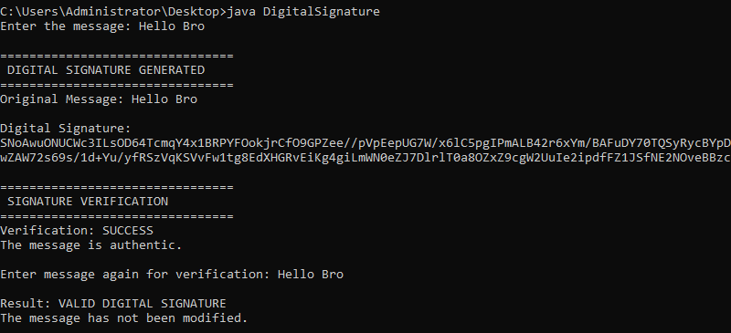
Modified message: “hello” re-entered as “Hello” (INVALID DIGITAL SIGNATURE)
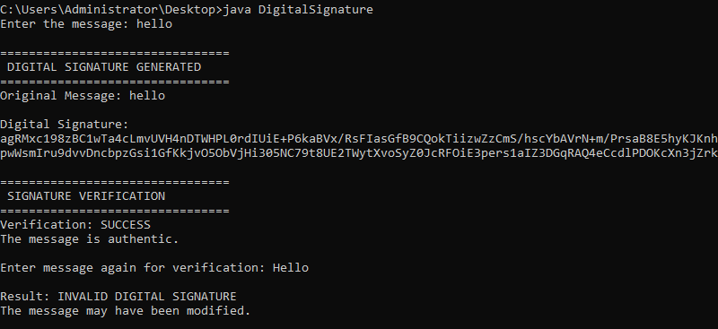

9. Results
The developed system successfully generates an RSA digital signature and verifies it with the public key.
When the same message is entered again, the signature is reported as valid:
- Original Message: Hello Bro
- Verification: SUCCESS
- Result: VALID DIGITAL SIGNATURE
When the message is modified (for example, “hello” changed to “Hello”), the signature is reported as invalid:
- Original Message: hello
- Re-entered Message: Hello
- Result: INVALID DIGITAL SIGNATURE
This shows that the integrity of the message is protected: even a one-character change is detected.

10. Application Areas
- Secure email and electronic document signing
- Software distribution and code signing
- Online banking, e-governance and digital certificates
- Educational labs for teaching cryptography concepts

11. Challenges and Future Enhancements
Challenges
- A new key pair is generated every time the program runs, so a signature cannot be verified after the program closes.
- The program is console based, and the keys and signatures are not stored in files.
- It verifies only text messages and does not verify the identity of the signer through a digital certificate.
Future Enhancements
- Save and load keys and signatures from files.
- Support signing of files and documents.
- Add a graphical user interface.
- Use digital certificates (X.509) to verify the identity of the signer.

12. Conclusion
The Digital Signature Verification project provides a simple Java-based approach to message authentication and integrity checking. It generates an RSA key pair, signs a message using SHA256withRSA, and verifies the signature using the public key. The tamper test clearly shows that any change in the message makes the signature invalid, demonstrating the importance of digital signatures in secure communication.

