**TASK – 1**

1. **Write a program to print the numbers from 10 to 50 using for loop/ While loop.**

**package** Activities;

**public** **class** Exe_1 {

**public** **static** **void** main(String[] args) {

// **TODO** Auto-generated method stub

// iterating to print 10 to 50

**for**(**int** i = 10; i <= 50; i++) {

System.***out***.print(i);

}

}

}

**Output:**

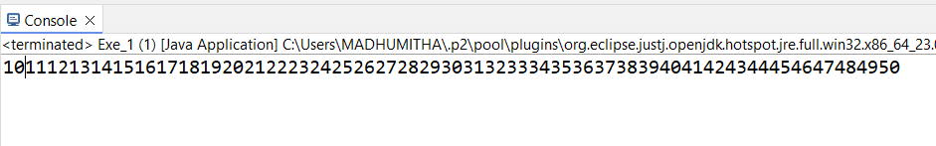

1. **Write a program that find a given number is negative or positive.**

**package** Activities;

**import** java.util.Scanner;

**public** **class** Exe_2 {

**public** **static** **void** main(String[] args) {

// **TODO** Auto-generated method stub

Scanner sc = **new** Scanner(System.***in***);

// getting input from user

System.***out***.println("Enter the number:");

**int** a = sc.nextInt();

// checking condition that the number is greater than zero

**if**(a>0) {

System.***out***.println("Positive Number");

//if the condition gets false, then it will check the number is less than zero

}**else** **if**(a<0) {

System.***out***.println("Negative Number");

// if the both condtions are false, then the number is zero

}**else** {

System.***out***.println("Zero");

}

}

}

**Output:**

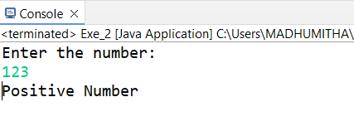

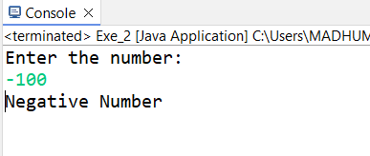

1. **Write down the program to reverse the given number using loops.**

**package** Activities;

**import** java.util.Scanner;

**public** **class** Exe_3 {

**public** **static** **void** main(String[] args) {

// **TODO** Auto-generated method stub

Scanner sc = **new** Scanner(System.***in***);

//getting input from user

System.***out***.println("Enter the number:");

**int** a = sc.nextInt();

**int** rev = 0;

// loop condition to reverse a number

**while**(a>0) {

rev = rev * 10 + a % 10;

a = a / 10;

}

System.***out***.println(rev);

} }

**Output:**

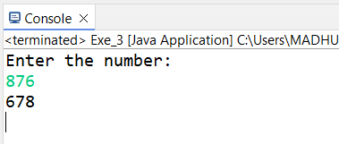

1. **Write a java program to Find the smallest number among three numbers.**

**package** Activities;

**import** java.util.Scanner;

**public** **class** Exe_4 {

**public** **static** **void** main(String[] args) {

// **TODO** Auto-generated method stub

Scanner sc = **new** Scanner(System.***in***);

//getting input from users

System.***out***.println("Enter three numbers :");

**int** a = sc.nextInt();

**int** b = sc.nextInt();

**int** c = sc.nextInt();

// checking condition

**if**(a>b) {

**if**(c>b) {

System.***out***.println(b+ " is a smallest number");

}

**else** **if**(a>c) {

System.***out***.println(c+ " is a smallest number");

}

}

**else** {

System.***out***.println(a+ " is a smallest number");

}

}

}

Output:

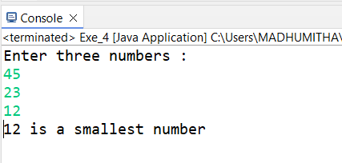

1. **Write a Java program that takes the purchase amount as input and calculates the final payable amount after applying the discount.**

**package** Activities;

**import** java.util.Scanner;

**public** **class** Exe_5 {

**public** **static** **void** main(String[] args) {

// **TODO** Auto-generated method stub

Scanner sc = **new** Scanner(System.***in***);

//Getting input from user

System.***out***.println("Enter the salary amount:");

**double** amount = sc.nextDouble();

**double** discount = 0;

// checking condition

**if**(amount>=500 && amount <= 1000) {

// calculating discount as 10%

discount = amount * 0.10;

}

//if the above condition is false then it will check this if condition

**else** **if**(amount >= 1000){

//calculating discount as 20%

discount = amount * 0.20;

}

//calculating final amount

**double** finalamount = amount - discount;

System.***out***.println("Salary : " +amount);

System.***out***.println("Discount : " +discount);

System.***out***.println("Final Amount : " +finalamount);

}

}

**Output:**

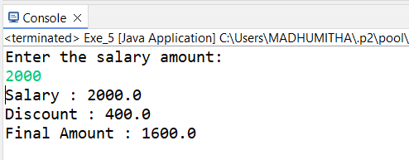

1. **Write a java program to print bellowed pattern ->i and j and k => 5.**

**package** Activities;

**public** **class** Exe_6 {

**public** **static** **void** main(String[] args) {

// **TODO** Auto-generated method stub

//creating new variable and assiging value

**int** n = 5;

// looping for columns

**for** (**int** i = 0; i < 5; i++) {

//Looping for rows

**for** (**int** j = 0; j < 5; j++) {

//checking condition if the j is less than i

**if**(j<i) {

System.***out***.print(n-j);

//if the condition false, else part will work

}**else** {

System.***out***.print(n-i);

}

}

System.***out***.println();

}

}

}

**Output:**

