**OBJECT**

**Creation Of Vendors Object**

|  |  |
| --- | --- |
| **Team id** | AD47707C5D4D5109D5E480002BDB30D50 |
| **Project Tittle** | Build an Event Management System using salesforce |

1. **Click on the gear icon and then select Setup.**

**2.Click on the object manager tab just beside the home tab.**

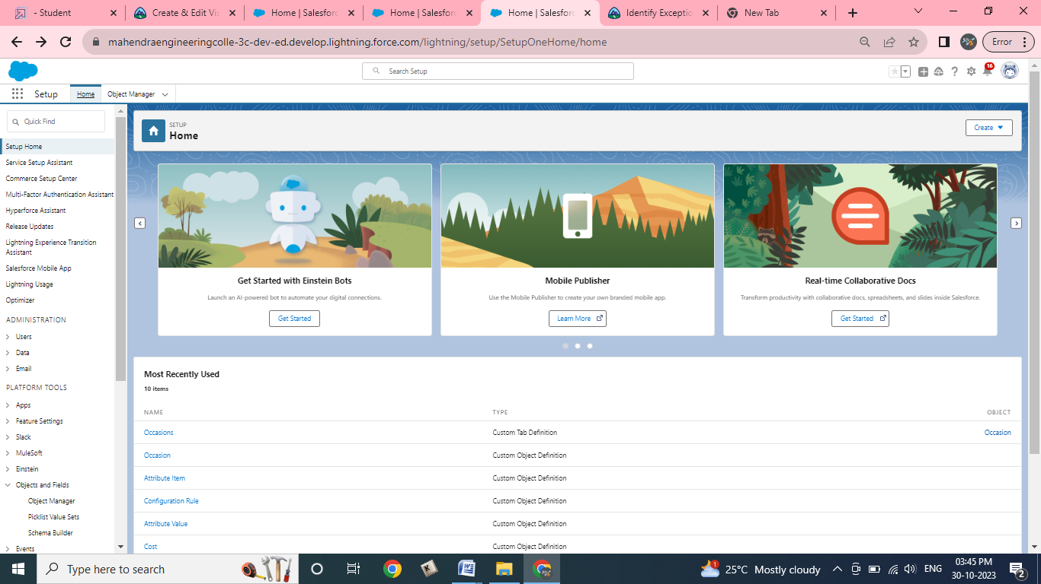

**3. After the above steps, have a look on the extreme right you will find a Create Dropdown click on that and select Custom Object.   
a. On the Custom Object Definition page, create the object as follows:   
b. Label: Vendor   
c. Plural Label: Vendors   
d. Record Name: Vendor Name   
e. Check the Allow Reports checkbox   
f. Check the Allow Search checkbox**

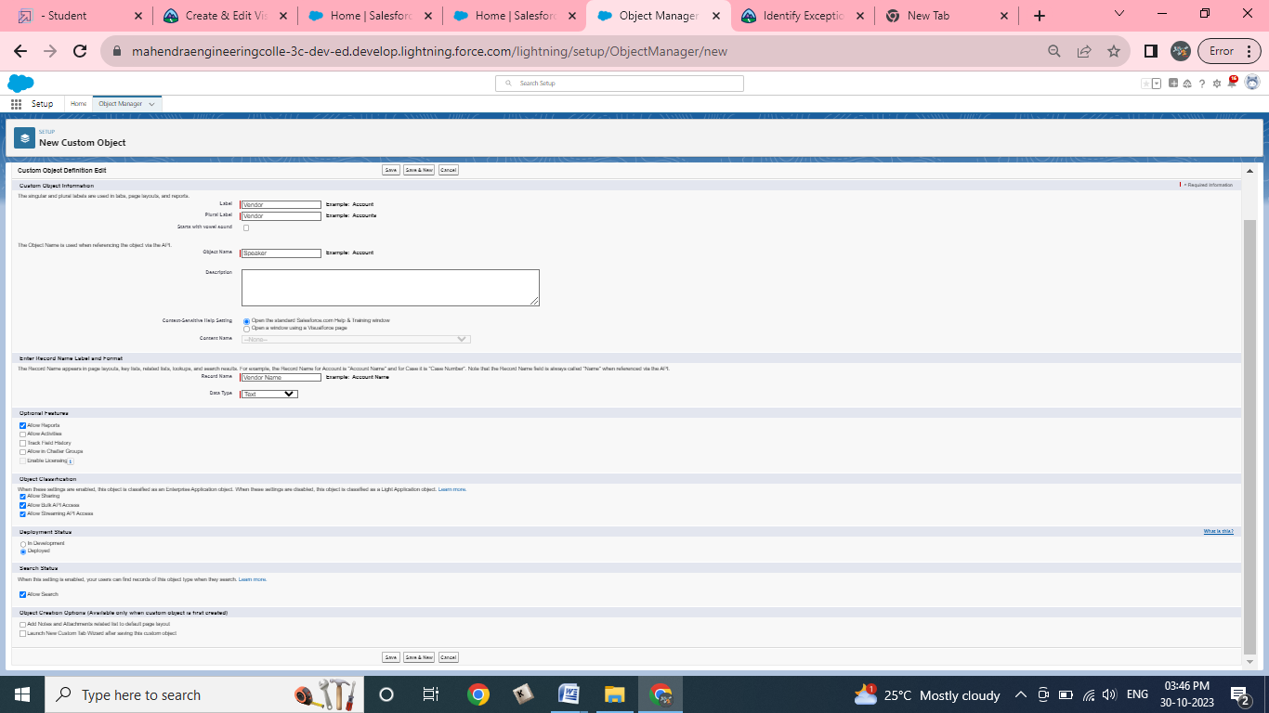

**g.click save.**