**Object**

**Creation of Speakers Object**

|  |  |
| --- | --- |
| **Team Id** | AD47707C5D4D5109D5E480002BDB30D50 |
| **Project Tittle** | Build an Event Management System using salesforce |

1. Click on the gear icon and then select Setup

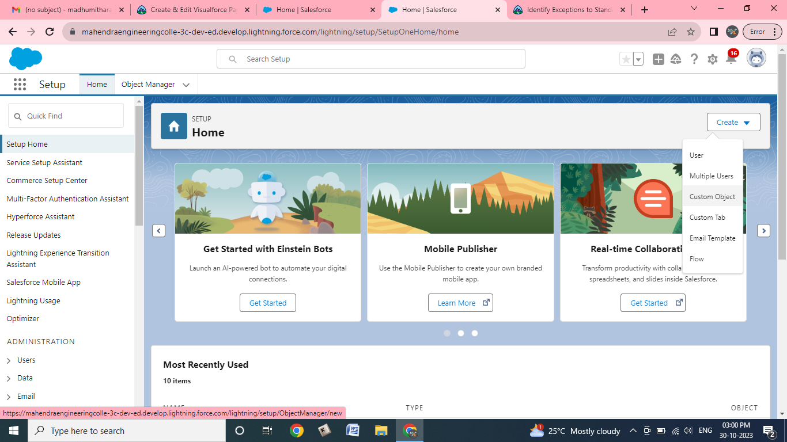

1. . Click on the object manager tab just beside the home tab.   
   3. After the above steps, have a look on the extreme right you will find a Create Dropdown click on that and select Custom Object.   
   a. On the Custom Object Definition page, create the object as follows:   
   b. Label: Speaker   
   c. Plural Label: Speakers   
   d. Record Name: Speaker Name   
   e. Check the Allow Reports checkbox   
   f. Check the Allow Search checkbox

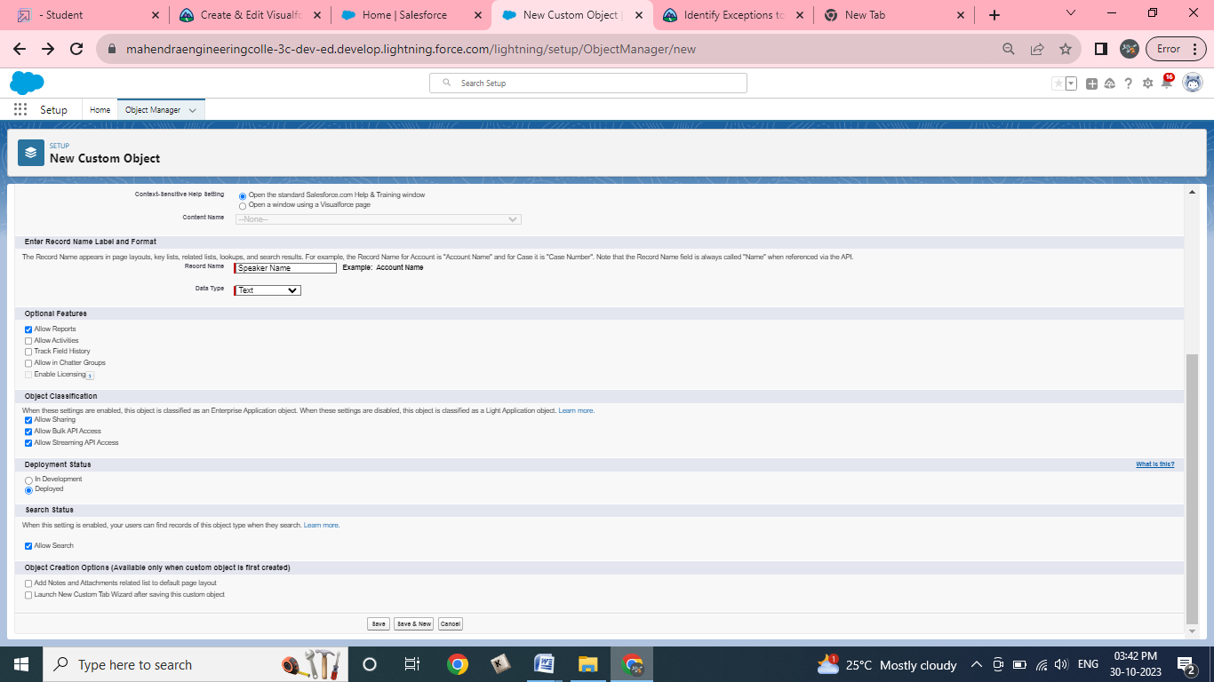

**g.click save.**