**ENVIRONMENTAL MONITORING USING IOT**

**Name:M.MADHUMITHA**

**Reg number:610821106052**

**Phase 5: Document Submission**

**Project:** 223936_team_1_6108_Environmental monitoring

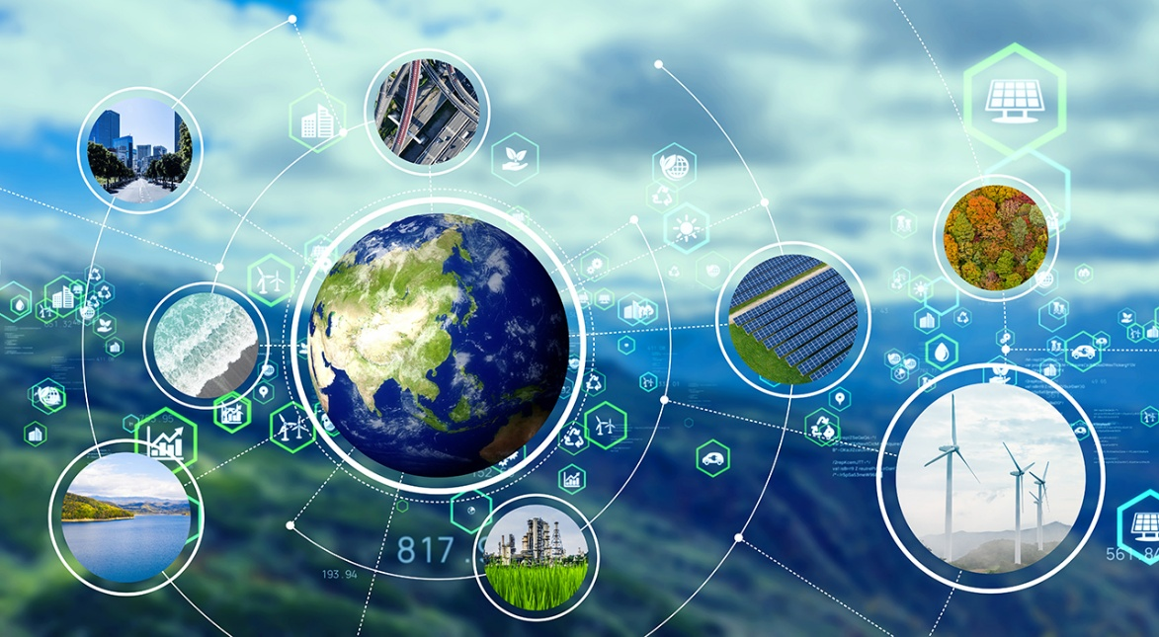

**INTRODUCTION**

Environmental monitoring is the systematic process of observing, measuring, and assessing the natural and man-made components of the environment over time. It plays a crucial role in understanding and managing the Earth’s ecosystems, ensuring the health and sustainability of our planet. This practice encompasses a wide range of parameters, from air and water quality to biodiversity and climate conditions.

**Key Aspects of Environmental Monitoring:**

Data Collection: Environmental monitoring involves the collection of data from various sources, including sensors, satellite imagery, and field measurements. These data help track changes in environmental conditions.

Objective: The primary goal of environmental monitoring is to gain insights into the state of the environment, identifying trends, potential issues, and opportunities for conservation or improvement.

Applications: Environmental monitoring has diverse applications, from assessing the impact of human activities on ecosystems to predicting natural disasters and managing resources sustainably.

Components:

It includes the monitoring of air quality, water quality, soil conditions, climate parameters, biodiversity, and more. Each component is essential in understanding the overall environmental health.

Technological Advancements:

Advances in technology, including the use of remote sensing, IoT (Internet of Things), and data analytics, have revolutionized environmental monitoring, enabling real-time data collection and analysis.

Policy and Regulation: Data gathered through environmental monitoring often inform policy and regulatory decisions, helping governments and organizations make informed choices for the benefit of both the environment and human populations.

Public Awareness: Environmental monitoring promotes public awareness and education about environmental issues, encouraging individuals and communities to take action for conservation and sustainability.

Global Perspective: Many environmental issues transcend borders, making international cooperation and shared data crucial in addressing global challenges such as climate change and biodiversity loss.

**1.INTRODUCTION OF IOT**

**ABSTRACT:**

In recent time, there have been tremendous increase of human activities resulting from population growth and technological advancement. The operational activities resulting from usage of automobiles, industrialization and urbanization have been attributed to detrimental effect which is affecting the human health and other living beings. Industrialization operations and waste especially in urban and metropolitan cities have also been a major factor responsible for release of pollutants in our environment today. In this regard, there is need to develop a system for monitoring the high level of industrial pollution.

**MODULE**:

**1. Sensors and Devices:**

Deploy a variety of sensors and devices to measure environmental parameters such as temperature, humidity, air quality, water quality, soil moisture, noise levels, and more. These sensors can be connected to microcontrollers or IoT modules.

**2. Data Collection:**

The sensors collect data continuously or at regular intervals. This data can include real-time measurements and historical data.

**3. IoT Connectivity:**

Use IoT communication protocols (e.g., Wi-Fi, cellular, LoRa, NB-IoT) to transmit the collected central hub or cloud-based platform.

**4. Cloud Platform:**

The data is sent to a cloud-based platform where it is stored, processed, and analyzed. Popular cloud platforms for IoT include AWS IoT, Azure IoT, Google Cloud IoT, and others.

**5. Data Analysis:**

Perform real-time and historical data analysis to identify patterns, trends, and anomalies. Machine learning algorithms can be used for predictive analysis.

**6. Alerts and Notifications:**

Set up alerting systems to notify stakeholders or authorities when predefined thresholds or anomalies are detected. For example, if air quality deteriorates beyond a certain level, an alert can be sent.

**7. Visualization:**

Create dashboards and visualization tools to display environmental data in a user-friendly format. This can help stakeholders easily interpret the data.

**8. Remote Control:**

In some cases, IoT systems allow for remote control of environmental devices, such as adjusting heating or cooling systems based on temperature data.

**9. Reporting:**

Generate reports and share insights with relevant stakeholders, including government agencies, researchers, and the public.

**10. Maintenance and Scalability:**

Regularly maintain the sensors and devices to ensure accurate data collection. Scalability is essential as more sensors may need to be deployed over time to cover a larger area.

**11.Air and water pollution**

Current monitoring technology for air and water safety primarily uses manual labor along with advanced instruments, and lab processing. IoT improves on this technology by reducing the need for human labor, allowing frequent sampling, increasing the range of sampling and monitoring, allowing sophisticated testing on-site, and binding response efforts to detection systems. This allows us to prevent substantial contamination and related disasters.

**12.Water Quality Monitoring:**

Clean and fresh drinking water is an essential resource for survival, and IoT technology is efficiently used to measure water quality parameters. By using the environmental monitoring solution, it is possible to measure the quality of water in real-time . It significantly results in efficient operations and improved production rate. You can detect turbidity, pH level, temperature, dissolved oxygen, TDS, and salinity to improve water quality for several purposes. The solution helps in gaining water quality information through smart IoT techniques and perform advanced analytics to enhance the production rate.

**13.Farming:**

For decades, agriculture was among the most conservative industries. But times are a-changin’! Farmers have to carefully consider land use and the application of fertilizers and pesticides if they don’t want to face fines. Of course, this doesn’t make farming any easier.

**2.INNOVATION**

Environmental monitoring is the most beneficial IoT application. It uses advanced sensor devices to identify the presence of pollutants in the air and water and promotes better sustainability. You can keep the premises safer and cleaner by utilizing a smart environmental monitoring solution.

An IoT powered environmental monitoring solution is a tool to assess the surrounding’s safety. Closed space areas like offices, homes, warehouses, museums can be monitored with the help of this smart solution.

It Is skillfully developed to reduce the workload, detect the presence of pollutants, and obtain real-time information about the surroundings, while keeping up with safety and health protection. The solution aims on improving your well-being and work efficiency to further enhance overall productivity.

To visualize historical temperature and humidity trends, you can create line graphs or time series plots. Here’s a general approach to incorporate data visualization:

**1.Data Collection:**

Gather historical temperature and humidity data from a reliable source, such as weather stations or databases.

**2.Data Preparation:**

Organize the data into a structured format with columns for date, temperature, and humidity.

**3.Select a Visualization Tool:**

Choose a data visualization tool or library suitable for your needs. Common choices include Python libraries like Matplotlib, Seaborn, or web-based tools like Tableau or Google Data Studio.

**4. Create Line Graphs:**

For temperature trends, plot the temperature data against the timeline (date) on the x-axis and temperature values on the y-axis.

For humidity trends, use a similar approach but plot humidity values on the y-axis.

**5.Time Series Analysis:**

Consider using smoothing techniques like moving averages or trendlines to highlight long-term trends in the data.

**6. Customization:**

Label your axes with appropriate units and titles.

Use colors and legends to differentiate between temperature and humidity lines if necessary.

Add annotations or markers for significant events or points of interest, like record highs or lows.

**7. Interactivity(if applicable):**

If you’re creating an interactive visualization, you can allow users to zoom in on specific time periods or toggle between different data sets.

**8. Export/Share:**

Save or export your visualization in a format suitable for your intendent audience, whether it’s a report, presentation, or an online dashboard.

**3. DEVELOPMENT PART 1**

Deploying IoT devices like temperature and humidity sensors in public parks is a great idea to monitor environmental conditions. Here are some steps to get started:

**1.Device Selection:**

Choose appropriate IoT sensors capable of measuring temperature and humidity. Ensure they are durable and weather-resistant.

**2.Location Planning:**

Identify strategic locations within the parks to place the sensors. Consider factors like shade, proximity to vegetation, and areas with public interest.

**3.Power Supply:**

Ensure a stable power source for the sensors. Options include batteries, solar panels, or nearby electrical outlets.

**4.Data Connectivity:**

Set up a reliable data connectivity method, such as Wi-Fi, LoRaWAN, or cellular, to transmit sensor data to a central server.

**5.Data Storage and Analysis:**

Establish a database or cloud platform to store the collected data. Implement data analytics to extract meaningful insights.

**6.Data Visualization:**

Create user-friendly dashboards or mobile apps for park visitors and administrators to access and interpret the data.

**7.Security:**

Implement security measures to protect the data and devices from potential threats.

**8.Maintenance:**

Regularly maintain and calibrate the sensors to ensure accurate data collection.

**9.Community Engagement:**

Engage with park visitors and local communities to explain the project’s purpose and benefits.

**10.Compliance:**

Ensure compliance with privacy and data protection regulations, especially if personal data is collected.

**11.Continuous Improvement:**

Gather feedback and use the data to make improvements in the park based on environmental insights.

Taking these steps is imperative as the population increases, along with our carbon footprint, and we continue to see the damaging effects of climate change. So — how can IoT help the environment? The answer is in the deployment of sensors, IoT devices, remote connectivity, and edge computing to support rapid detection, reporting, data insights and remediation

By following these steps, you can effectively deploy IoT devices to monitor environmental conditions in public parks, benefiting both park management and the community.

**Python Script**

```python

Import time

Import requests

Import json

From sense_hat import SenseHat # Use the appropriate library for your sensors

# Initialize the sensor

Sense = SenseHat()

# Define the monitoring platform URL

Platform_url = ‘https://your-monitoring-platform.com/api/data’

While True:

# Read sensor data

Temperature = sense.get_temperature()

Humidity = sense.get_humidity()

Pressure = sense.get_pressure()

# Create a JSON payload with the data

Data = {

‘temperature’: temperature,

‘humidity’: humidity,

‘pressure’: pressure

}

# Send data to the monitoring platform

Try:

Response = requests.post(platform_url, json=data)

If response.status_code == 200:

Print(“Data sent successfully”)

Else:

Print(“Failed to send data:”, response.status_code)

Except Exception as e:

Print(“Error:”, str€)

# Send data at a specified interval (e.g., every 5 minutes)

Time.sleep(300)

**4. DEVELOPMENT PART 2**

**Front-End Development:**

**Project Setup:**

Create a project directory and set up the necessary HTML, CSS, and JavaScript files. You may consider using a front-end framework for efficiency.

**User Interface (UI) Design:**

Design a user-friendly and intuitive interface for visualizing temperature and humidity data.

Consider using charts, graphs, and icons to represent environmental conditions.

**HTML Structure:**

Create the HTML structure for your platform. Include sections for displaying data, navigation, and headers.

**CSS Styling:**

Apply CSS to style your platform, ensuring it is visually appealing and responsive.

Focus on presenting data clearly and providing a good user experience.

**JavaScript Functionality:**

Use JavaScript to implement interactive features on your platform.

Utilize AJAX or the Fetch API to request real-time data from the back end.

Update the UI with received data without the need for a full page refresh.

**Implement error handling for data retrieval issues.**

**Javascript**

// Sample JavaScript code to fetch data from your IoT devices

Function fetchData() {

// Make an HTTP request to your IoT data endpoint

Fetch(‘/api/environmental-data’)

.then(response => response.json())

.then(data => {

// Update the temperature and humidity values in the HTML

Document.getElementById(‘temperature’).textContent = data.temperature;

Document.getElementById(‘humidity’).textContent = data.humidity;

});

}

// Fetch data every 5 seconds (adjust the interval as needed)

setInterval(fetchData, 5000);

**Back-End Development:**

Create a back-end API to serve real-time environmental data to the front end. You can use Flask for Python or Express.js for Node.js.

**Python**

# Sample Python (Flask) code to serve environmental data

From flask import Flask, jsonify

App = Flask(__name)

# Define a route to provide real-time data

@app.route(‘/api/environmental-data’)

Def get_environmental_data():

# Replace with code to fetch data from your IoT devices

Temperature = 25.0 # Replace with actual data

Humidity = 50.0 # Replace with actual data

Return jsonify({‘temperature’: temperature, ‘humidity’: humidity})

If __name__ == ‘__main__’:

App.run(debug=True)

**IoT Device Integration:**

Set up IoT devices (e.g., temperature and humidity sensors) to transmit real-time data to your back-end server.

Ensure the data is structured and standardized for processing.

**Server and APIs:**

Develop a server using a technology like Node.js, Python, Ruby, or others to receive, process, and store data from IoT devices.

**Create APIs that the front end can use to request real-time data.**

**Database:**

Store real-time temperature and humidity data in a database for historical tracking and analysis.

Consider using a suitable database system for time-series data, such as InfluxDB, or traditional relational databases.

**Real-Time Updates:**

Implement real-time communication technologies like WebSockets or Server-Sent Events (SSE) to push updates to the front end as soon as new data arrives.

**Security and Authentication:**

Implement security measures to protect sensitive environmental data.

Implement user authentication and authorization if necessary to control access to the platform.

**Testing:**

Thoroughly test the platform to ensure it functions correctly and can handle various scenarios, such as data fluctuations or sensor issues.

Test the platform on different browsers and devices for cross-browser compatibility and responsiveness.

**Deployment:**

Choose a hosting environment (e.g., cloud-based servers, VPS, or shared hosting) for your application.

Deploy both the front-end and back-end components of your application to make it accessible to users.

**DOCUMENTATION**

**Project Objectives:**

The primary objectives of an environmental monitoring IoT project are to collect, analyze, and report data about various environmental parameters in real-time. This data can be used for better decision-making, environmental conservation, and public awareness. Specific objectives may include monitoring air quality, water quality, temperature, humidity, and other environmental factors.

**IoT Device Deployment:**

1. **Sensor Selection:** Choose appropriate sensors for the environmental parameters you want to monitor. For instance, use air quality sensors, temperature and humidity sensors, water quality sensors, and more.
2. **Device Hardware:** Develop or procure IoT devices with the selected sensors. These devices should be capable of data collection and communication.
3. Device Placement: Deploy these devices strategically in the target locations to ensure comprehensive coverage of the area of interest.
4. **Power Supply: E**nsure a stable power supply for the IoT devices, which can be batteries, solar panels, or a combination, depending on the deployment location.

**Platform Development:**

1. **Data Collection:** Create a system to collect data from the IoT devices. This involves setting up communication protocols (e.g., MQTT, HTTP) and ensuring data transmission to a central platform.
2. **Data Storage:** Design a database system to store the collected data securely. Consider using cloud-based services like AWS, Azure, or Google Cloud for scalability and reliability.
3. **Data Processing:** Implement data preprocessing and analysis algorithms to extract meaningful information from the raw data. This may involve data filtering, aggregation, and anomaly detection.
4. **User Interface:** Develop a user-friendly web or mobile application to visualize the environmental data. Include features like real-time updates, historical data access, and alert notifications.
5. **Alerting System:** Create an alerting system to notify stakeholders or authorities when predefined thresholds for environmental parameters are exceeded. This could be through emails, SMS, or app notifications.

**Code Implementation:**

Implementing a real-time environmental monitoring system can be a complex task that involves various technologies and sensors. Below is a simplified example using Python to monitor temperature and humidity using a Raspberry Pi and a DHT sensor. Keep in mind that real-world applications would be more comprehensive and involve various environmental parameters and technologies.

Here’s a basic Python script for monitoring temperature and humidity using a DHT sensor with a Raspberry Pi. Make sure you have the required libraries installed, like `Adafruit_DHT`:

```python

Import Adafruit_DHT

Import time

# Define the sensor type and GPIO pin

Sensor = Adafruit_DHT.DHT22

Pin = 4 # Example GPIO pin (adjust as needed)

While True:

Try:

# Read data from the sensor

Humidity, temperature = Adafruit_DHT.read_retry(sensor, pin)

If humidity is not None and temperature is not None:

# Print the data

Print(f”Temperature: {temperature:.2f}°C”)

Print(f”Humidity: {humidity:.2f}%”)

# You can save this data to a database or send it to a web service for real-time monitoring.

Else:

Print(“Failed to retrieve data from the sensor”)

# Wait for a specified interval before taking the next reading

Time.sleep(60) # Adjust as needed

Except KeyboardInterrupt:

Print(“Monitoring stopped.”)

Break

```

In this example, we use the DHT22 sensor to monitor temperature and humidity and the `Adafruit_DHT` library to interface with the sensor. The script continuously reads data from the sensor and can be modified to store data in a database or send it to a web service for real-time monitoring.

For a comprehensive environmental monitoring system, you would need to incorporate more sensors, data storage, and possibly a web-based dashboard for visualization. The specific implementation would depend on the scale and requirements of your project.

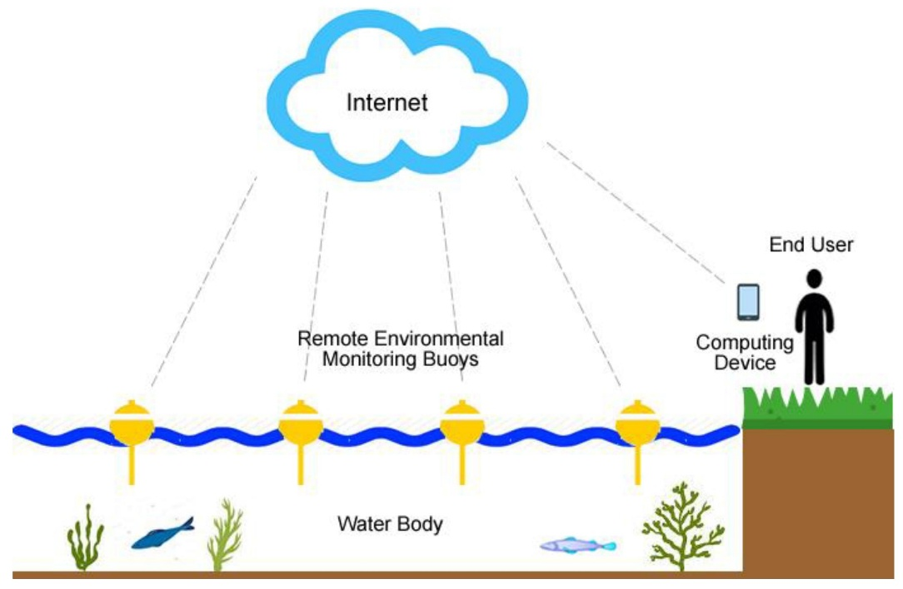**DIAGRAM FOR ENVIRONMENTAL MONITORING:**

**IOT DEVISES:**



**ENVIRONMENTAL MONITORING PLATFORM AND DATA DISPLAY:**

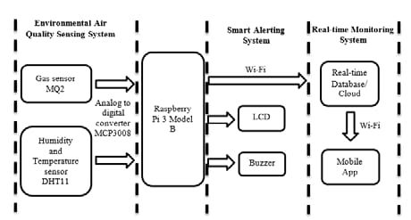

**THE REAL TIME ENVIRONMENTAL MONITORING SYSTEM BENEFITS PARK VISITORS AND PROMOTES OUTDOOR ACTIVITIES:**

A real-time environmental monitoring system offers several benefits to park visitors and promotes outdoor activities in the following ways:

1. **Safety:** Visitors can access real-time weather updates, air quality information, and other environmental data to make informed decisions about their outdoor activities, ensuring their safety. They can avoid risky conditions, such as severe weather or poor air quality.
2. **Planning: T**he system provides up-to-date information on trail conditions, wildlife sightings, and other factors that affect. outdoorexperiences. This helps visitors plan their activities more effectively, ensuring a more enjoyable trip.
3. **Environmental Awareness:** Park visitors gain a deeper understanding of the natural environment through real-time data on factors like temperature, precipitation, and water quality. This knowledge fosters a greater appreciation for the outdoors and encourages responsible stewardship.
4. **Customized Experiences:** Real-time information allows visitors to tailor their experiences. For example, they can choose the best time to see certain wildlife or engage in activities like hiking, biking, or bird-watching based on current conditions.
5. **Interactive Learning:** Monitoring systems often include educational components, enabling visitors to learn about the ecosystem and the park’s history while on-site. This enhances the educational aspect of outdoor experiences.
6. **Efficiency:** Visitors can save time and effort by accessing real-time data on parking availability, restroom locations, and other practical information. This makes the visit more convenient and enjoyable.
7. **Community Building**: Some monitoring systems incorporate social features that encourage visitors to share their experiences and connect with others. This helps build a sense of community among outdoor enthusiasts.
8. **Conservation and Preservation:** The system can collect data on the park’s ecosystem, which can be valuable for conservation efforts. Visitors may also become more environmentally conscious and take an active role in preserving the park.
9. **Promotion of Sustainable Practices:** Real-time data can be used to encourage sustainable outdoor activities. For example, visitors can be alerted to high-traffic areas and encouraged to explore less-visited parts of the park.

In summary, a real-time environmental monitoring system enhances the outdoor experience by providing valuable information, promoting safety, and fostering a deeper connection with nature. These benefits encourage park visitors to engage in outdoor activities while respecting and preserving the natural environment.

**CONCLUSION:**

In conclusion, the implementation of an Environmental Monitoring System using IoT (Internet of Things) technology represents a significant step forward in our ability to observe, analyze, and manage our natural environment. This system harnesses the power of interconnected sensors, data analysis, and real-time communication to provide a comprehensive solution for monitoring various environmental parameters.

The key takeaways from such a system are:

1. **Real-time Insights:** IoT-based environmental monitoring offers real-time data, enabling swift responses to changing conditions or emergencies.
2. **Data-Driven Decision-Making:** The wealth of data collected empowers informed decision-making for resource management, pollution control, and environmental protection.
3. **Cost-Efficiency:** Automation and remote data collection reduce the costs associated with manual monitoring and data acquisition.
4. **Sustainability:** By continuously monitoring environmental factors, the system supports sustainable practices and conservation efforts.
5. **Early Warning and Risk Mitigation:** IoT-based systems enable early warning of environmental threats, reducing risks to human health and ecosystems.
6. **Compliance and Accountability**: Industries and organizations can ensure compliance with environmental regulations, fostering accountability.
7. **Public Engagement:** These systems contribute to public awareness and engagement in environmental issues, encouraging responsible behavior.
8. **Scalability**: The IoT approach allows for easy scaling and adaptation to various environmental monitoring needs.

Overall, an IoT-based Environmental Monitoring System is a valuable tool in the global effort to protect and preserve our environment. By providing timely and accurate data, it supports sustainable development, environmental conservation, and the well-being of both nature and humanity.