Library uses HOG method - histogram of oriented gradients

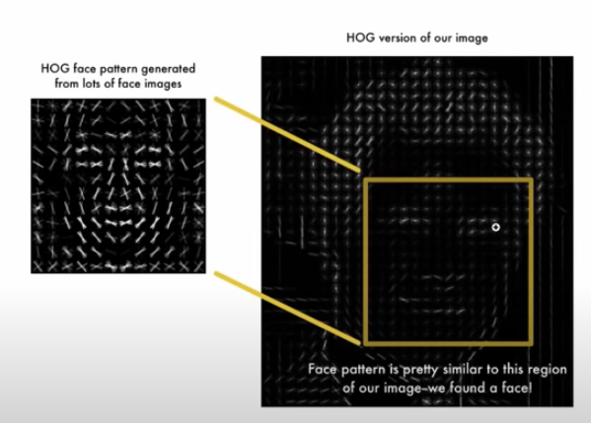

its hard for a network to understand tilted and frontal faces

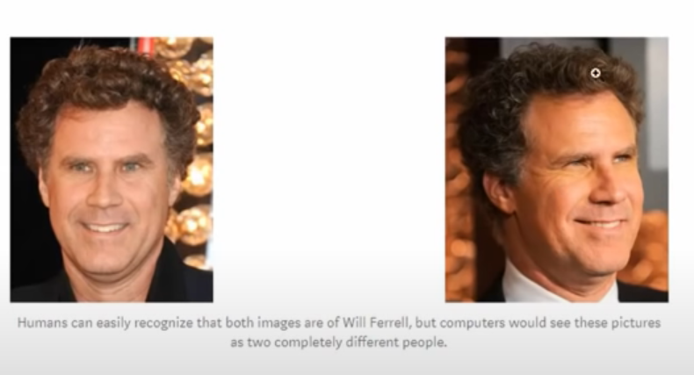

As result, they try to make all images like the below using “dlib” library:

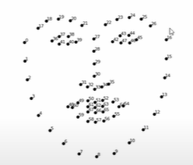

They find the facial landmarks and verb the images accordingly to make it more centred and then compare

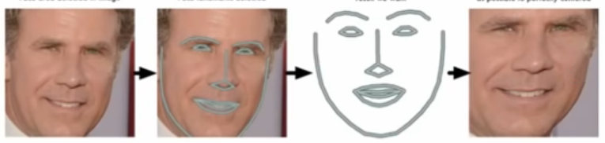

Now, no matter how face is turned, we’ll be able to centre eyes and mouth roughly to a centred position

This is sent to neural network that’s previously trained. this sends us back with encoded features

Network has already been trained to find best measurements out of given image like distance between 2 eyes, size of nose, etc

It generates over 128 measurements per image

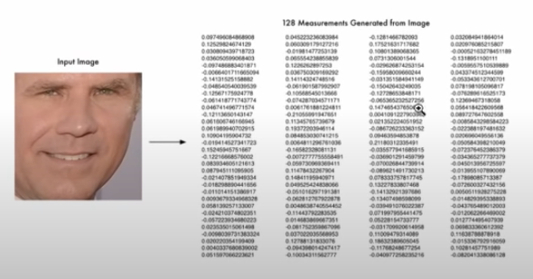

Now find matches using these numbers through “svm classifiers”, using that they differentiate