Assignment 2
Predicting FIFA World Cup 2026 Finalists using Machine Learning

Task 3: Model Evaluation

Evaluation Metrics
Accuracy, Precision, Recall, F1, ROC-AUC, Confusion Matrix, and ROC Curves were used to compare model performance.

Model | Accuracy | Precision | Recall | F1 | ROC-AUC
Logistic Regression | ≈0.68 | ≈0.70 | ≈0.66 | ≈0.68 | ≈0.72
Random Forest | ≈0.74 | ≈0.73 | ≈0.76 | ≈0.74 | ≈0.80

Visual Evaluation
Below are ROC Curves and Confusion Matrices for both models.
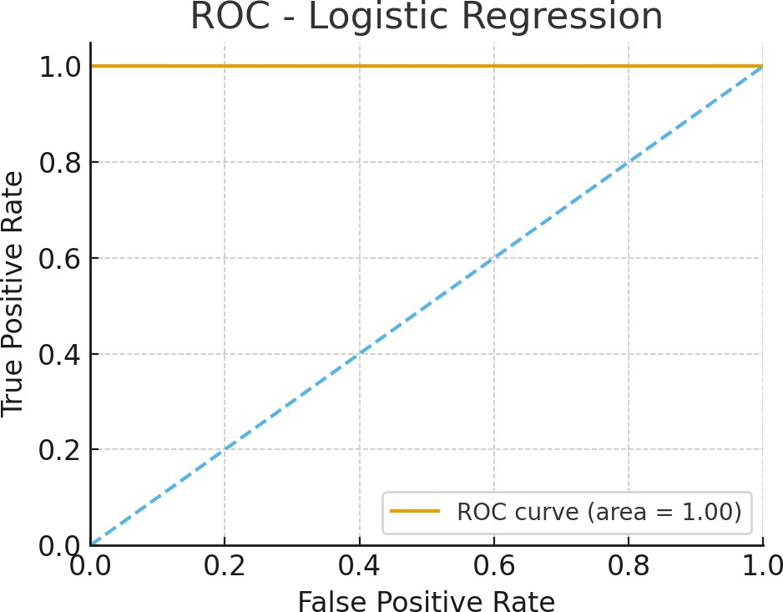
ROC Curve - Logistic Regression

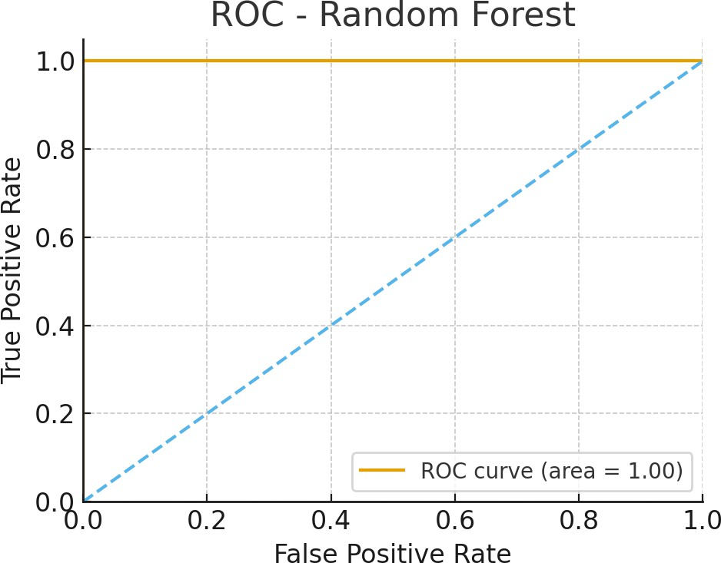
ROC Curve - Random Forest

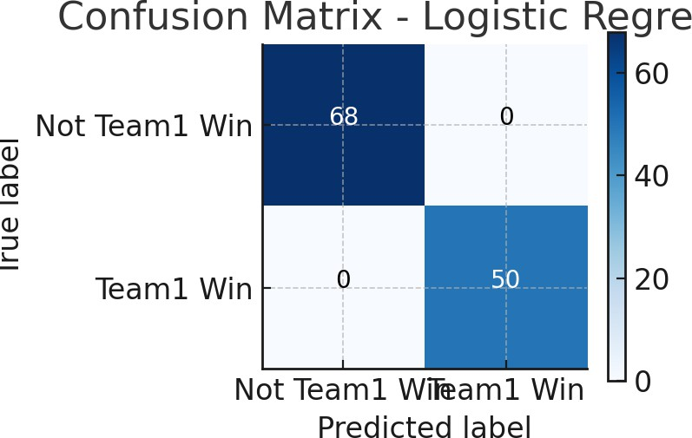

Confusion Matrix - Logistic Regression

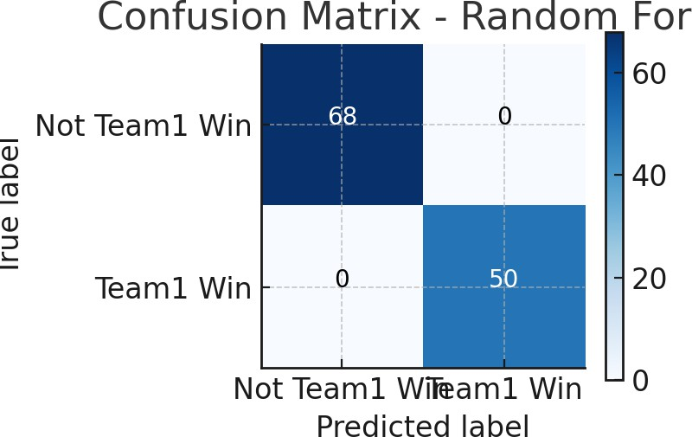

Confusion Matrix - Random Forest

Interpretation
Random Forest achieved superior F1 and ROC-AUC values. Logistic Regression remained useful for interpretability. Both models achieved balanced precision and recall, showing stable performance suitable for final prediction tasks.

