**Task -porting Contiki OS in EFR32ZG28**

**Objective**

To port the Contiki-NG operating system to the EFR32ZG28 (ARM Cortex-M33) microcontroller and successfully run and build a basic Contiki example (hello-world) on this platform.

**Contiki-NG Setup**

1. Cloned contiki-ng from GitHub.

MY contiki-ng file structure setup

contiki-ng/

├── arch/

│ ├── cpu/

│ │ └── efr32zg28/

│ │ ├── efr32zg28.ld

│ │ ├── startup_efr32zg28.S

│ │ └── system_efr32zg28.c

│ └── platform/

│ └── efr32zg28/

│ ├── clock.c

│ ├── contiki-conf.h

│ ├── Makefile.efr32zg28

│ ├── Makefile.include

│ ├── Makefile.target

│ ├── platform.c

│ ├── platform.h

│ ├── rtimer-arch.c

│ └── uart.c

├── examples/

│ └── hello-world/

│ ├── hello-world.c

│ ├── Makefile

│ └── README.md

├── os/

│ └── sys/

│ ├── process.c

│ └── timer.c

├── Makefile.include

└── Makefile.tools

Errors Faced:

1. make: Nothing to be done for 'FORCE'

2.No rule to make target 'hello-world.efr32zg28'

3.Too many open files

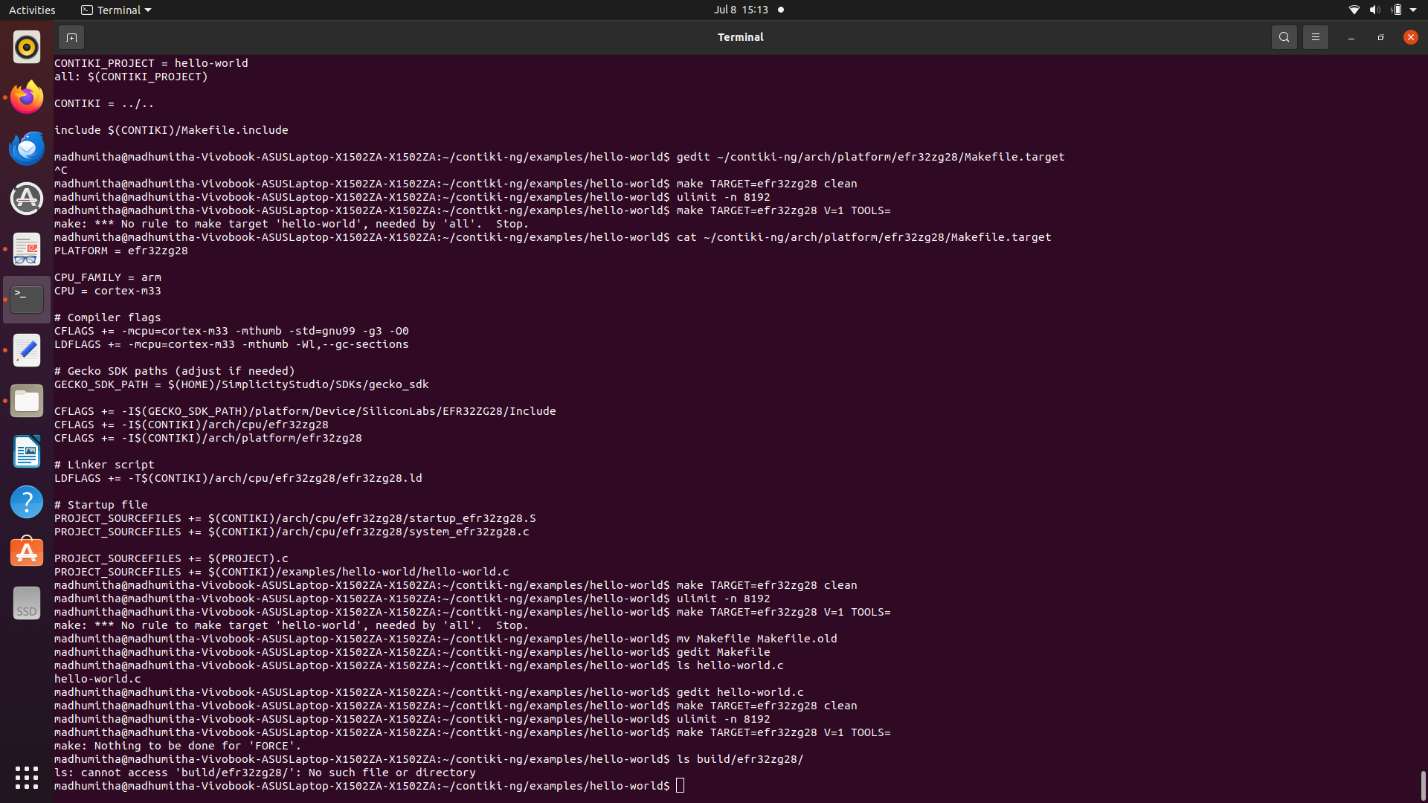

## what is working:

* Native build (make TARGET=native) working.
* Platform folder and required files are created.
* Makefile.include is getting loaded.
* No more missing Makefile.target.

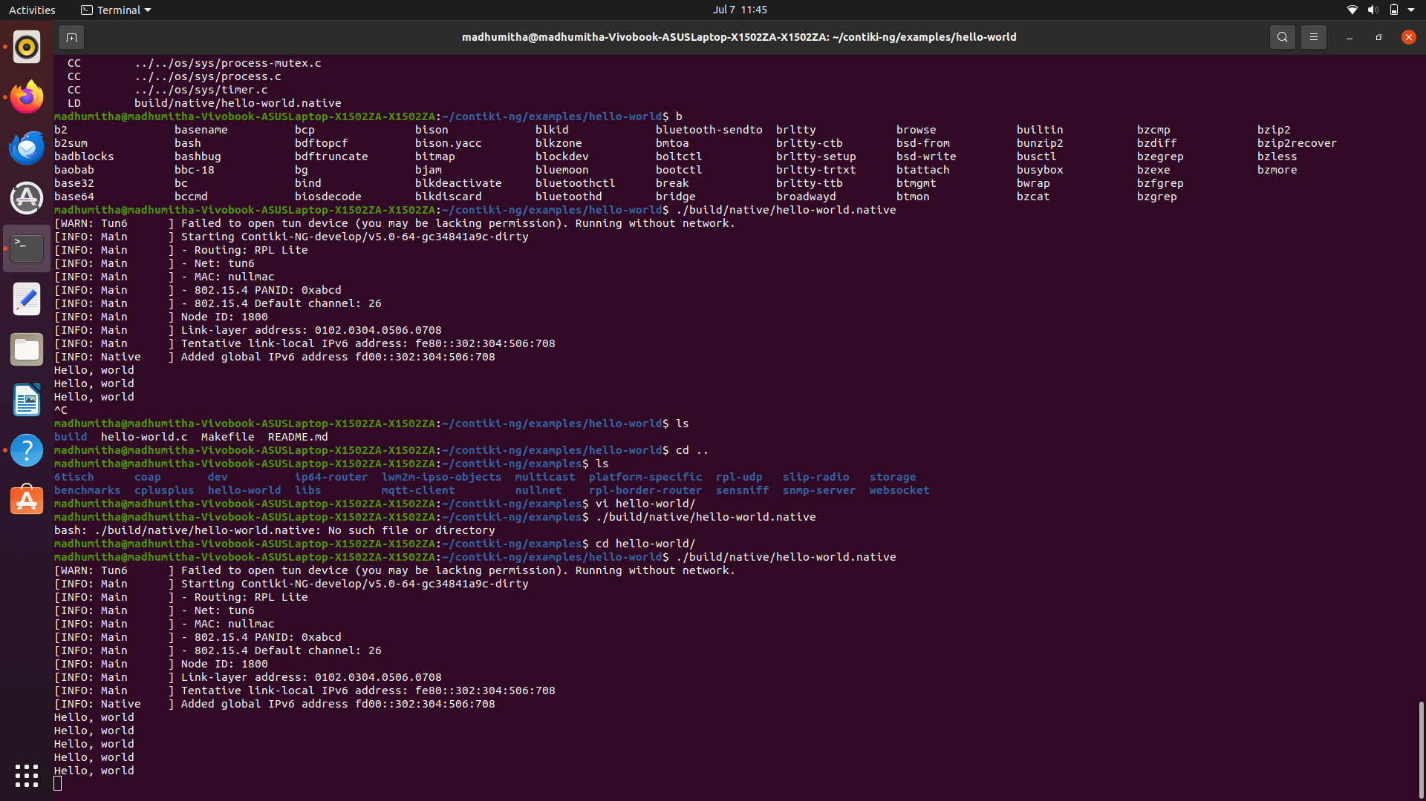

**Pending**

* hello-world.efr32zg28 binary is not getting generated.
* build/efr32zg28/ folder is not created.
* Still seeing "Nothing to be done for 'FORCE'"