Customer Churn Analysis and Prediction
Prepared by: Madhumitha R
Internship Domain: Machine Learning
Company: Saiket Systems

1. Introduction
This project focuses on predicting customer churn using machine learning techniques. The telecom dataset was analyzed, preprocessed, and used to train classification models.

2. Tasks Completed
- Task 1 – Data Preparation
- Task 2 – Train/Test Split
- Task 4 – Model Selection
- Task 6 – Model Evaluation

3. Dataset Information
Total Rows: 7043
Total Columns: 20

4. Models Used
• Logistic Regression
• Random Forest Classifier

5. Model Accuracy
Logistic Regression Accuracy: 0.8162
Random Forest Accuracy: 0.7956

6. Evaluation Metrics
Random Forest Classification Report:
precision recall f1-score support
0 0.83 0.91 0.87 1036
1 0.66 0.47 0.55 373
accuracy 0.80 1409
macro avg 0.74 0.69 0.71 1409
weighted avg 0.78 0.80 0.78 1409

7. Confusion Matrix
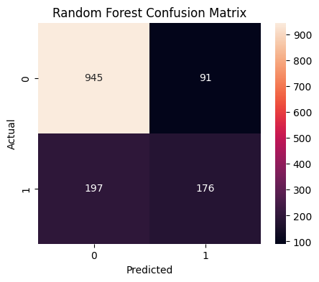

8. Conclusion
The Random Forest model achieved better performance compared to Logistic Regression. The project successfully predicted customer churn and identified important customer behavior patterns.

9. Technologies Used
- Python
- Pandas
- NumPy
- Scikit-learn
- Matplotlib
- Seaborn

10. Final Outcome
This project can help telecom companies identify customers who are likely to leave the service and improve customer retention strategies.

