Sales and Revenue Analysis Dashboard
Project Overview
This project is a Sales and Revenue Analysis Dashboard developed
using Microsoft Power BI. It analyzes sales, profit, quantity,
orders, product performance, categories, customer segments, states, and
monthly trends.
The objective is to practice data visualization, KPI tracking, DAX,
interactive filtering, and business insight generation.
Tools Used
- Microsoft Power BI
- Power Query
- DAX
- CSV
Dataset
The project uses the Sample Superstore dataset, containing
transaction-level information such as Order Date, Ship Date, Country,
State, City, Region, Category, Sub-Category, Product Name, Segment,
Sales, Quantity, and Profit.
Data Preparation
The dataset was imported into Power BI and prepared using Power Query.
- Date fields were converted to the appropriate Date data type.
- Numerical and text fields were checked for appropriate data types.
- The data was checked for missing or inconsistent values.
- The prepared data was used for DAX calculations and dashboard
visualizations.
Dashboard Pages
Page 1 -- Sales and Revenue Analysis
This page provides a high-level view of business performance.
KPI Cards - Top State - Total Profit - Total Sales - Total
Quantity - Total Orders - State-based Peak Sales
Charts - Sales by Product Name - Profit by Sub-Category - Profit by
Segment - Profit by Category and Sub-Category - Sales by Category and
Sub-Category
Slicers - Region - Segment - Category and Sub-Category - Year and
Quarter - State and City
Page 2 -- Detailed Sales Analysis
This page provides geographical, tabular, and time-based analysis.
Visualizations - State and Category geographical analysis -
Year-wise Category and Sub-Category table - Profit by Year and Month -
Sales by Year and Month
The slicers are synchronized so selections can affect the relevant
visuals across dashboard pages.
DAX Measures
Total Sales
Total_sales = SUM('Sample - Superstore'[Sales])
Calculates total sales.
Total Profit
Total_profit = SUM('Sample - Superstore'[Profit])
Calculates total profit.
Total Quantity
Total_quantity = SUM('Sample - Superstore'[Quantity])
Calculates total quantity sold.
Total Orders
Total_orders = DISTINCTCOUNT('Sample - Superstore'[Order ID])
Counts non-blank Order ID values.
Peak State Sales
peak_state_sales =
MAXX(
VALUES('Sample - Superstore'[State]),
[Total_sales]
)
Returns the highest total sales value among the states.
Top State
Top_state_sales=
VAR TopState =
TOPN(
1,
VALUES('Sample - Superstore'[State]),
[Total_sales],
DESC
)
RETURN
CONCATENATEX(
TopState,
'Sample - Superstore'[State],
", "
)
Returns the state with the highest sales.
Key Features
- KPI-based sales and profitability overview
- Monthly sales and profit trends
- Product-level sales analysis
- Category and sub-category analysis
- Segment-wise profit analysis
- State-level geographical analysis
- Interactive slicers and filters
- Year and quarter analysis
- Detailed sales and profit table
Project Structure
Sales-Revenue-Analysis-PowerBI/
│
├── README.md
├── PowerBI/
│ └── Sales_Revenue_Analysis.pbix
├── Dataset/
│ └── Sample-Superstore.csv
├── Screenshots/
│ ├── Dashboard_Page_1.png
│ └── Dashboard_Page_2.png
└── Documentation/
└── DAX_Measures.txt
Dashboard Preview
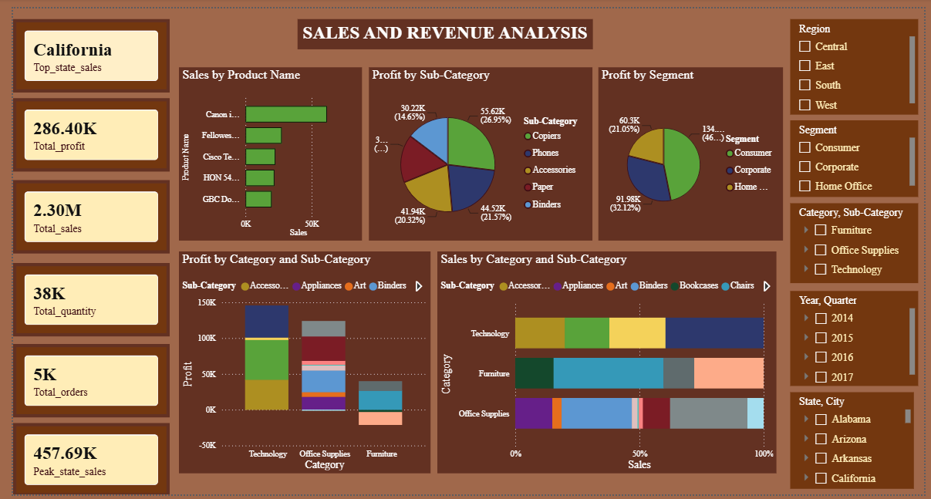
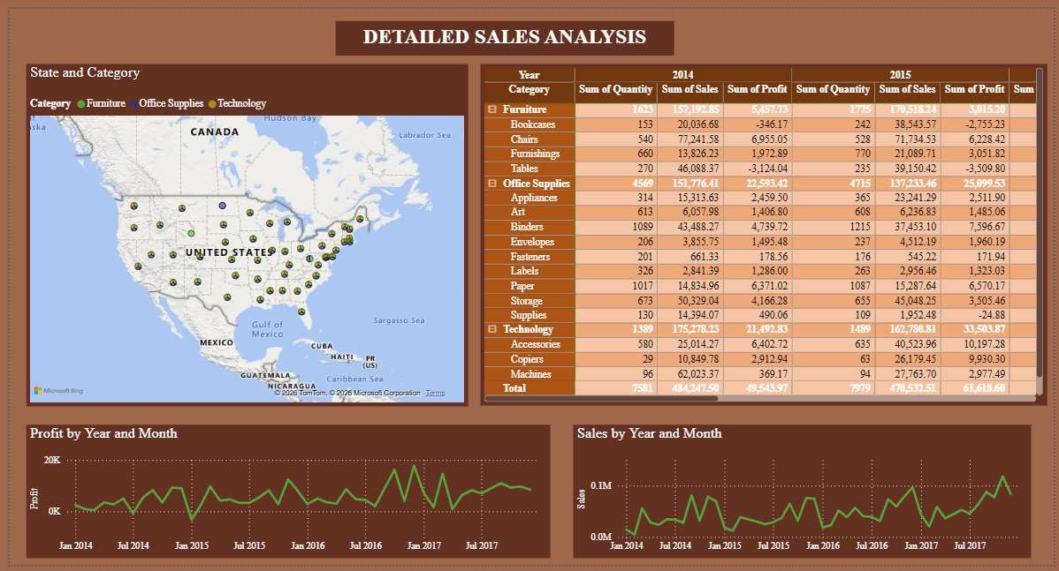
Learning Outcomes
Through this project, I practiced:
- Importing and preparing data in Power BI
- Basic data cleaning with Power Query
- Creating DAX measures
- Designing KPI cards
- Building interactive charts
- Creating monthly trend visualizations
- Using slicers and filters
- Analyzing sales and profitability
- Presenting business data through an interactive dashboard
Conclusion
The Sales and Revenue Analysis Dashboard transforms transactional
Superstore data into an interactive business analysis report. It
provides insights into sales, profit, products, categories, customer
segments, states, and time-based performance using Power BI, Power
Query, and DAX.

