**Disaster Recovery and Business Continuity Plan for On-Premises Virtual Machine on IBM Cloud Virtual Servers**

Phase3: Development Part 1

# In this section begin building our project by loading and preprocessing the dataset.

Building a disaster recovery project with IBM Cloud Virtual Servers involves using IBM Cloud services to manage and analyse your server and disaster-related data. Here's a high-level outline of how to start building your project by loading and preprocessing the dataset using IBM Cloud services:

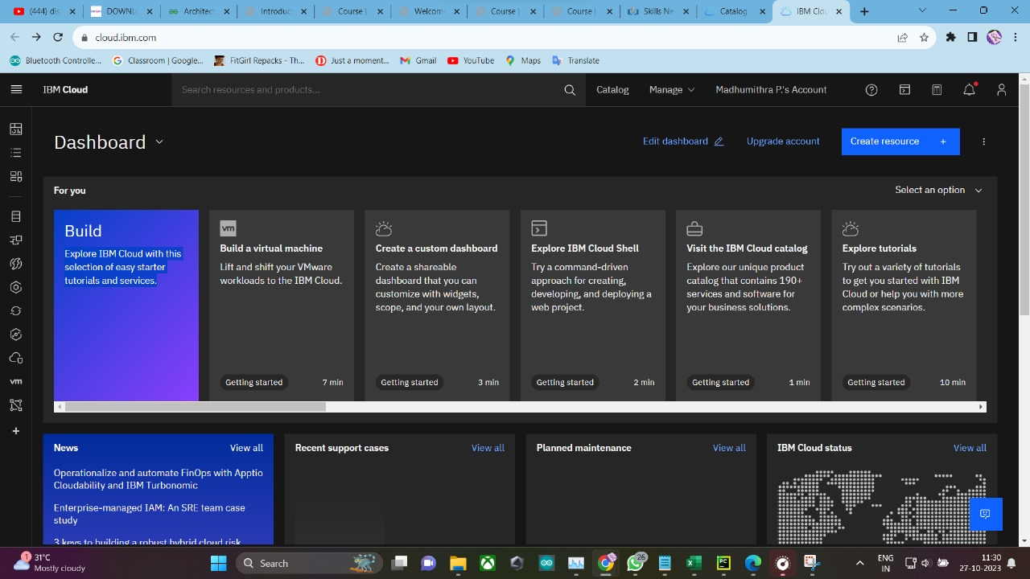

**1. IBM Cloud Account Setup:**

- If we haven't already, sign up for an IBM Cloud account and access the IBM Cloud Console.

**2. Data Sources:**

- Identify the data sources relevant to our disaster recovery project. These sources could include logs, performance metrics, incident reports, or other data generated by our IBM Cloud Virtual Servers. Ensure that we have access to these data sources.

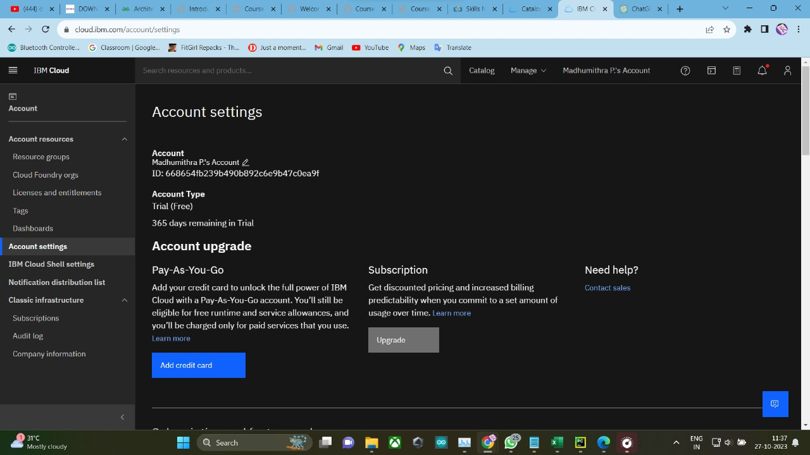

**3. IBM Cloud Services:**

- Utilize IBM Cloud services to access and manage our virtual servers and data. we can use services like IBM Cloud Monitoring, IBM Cloud Log Analysis, and IBM Cloud Databases to collect and store data.

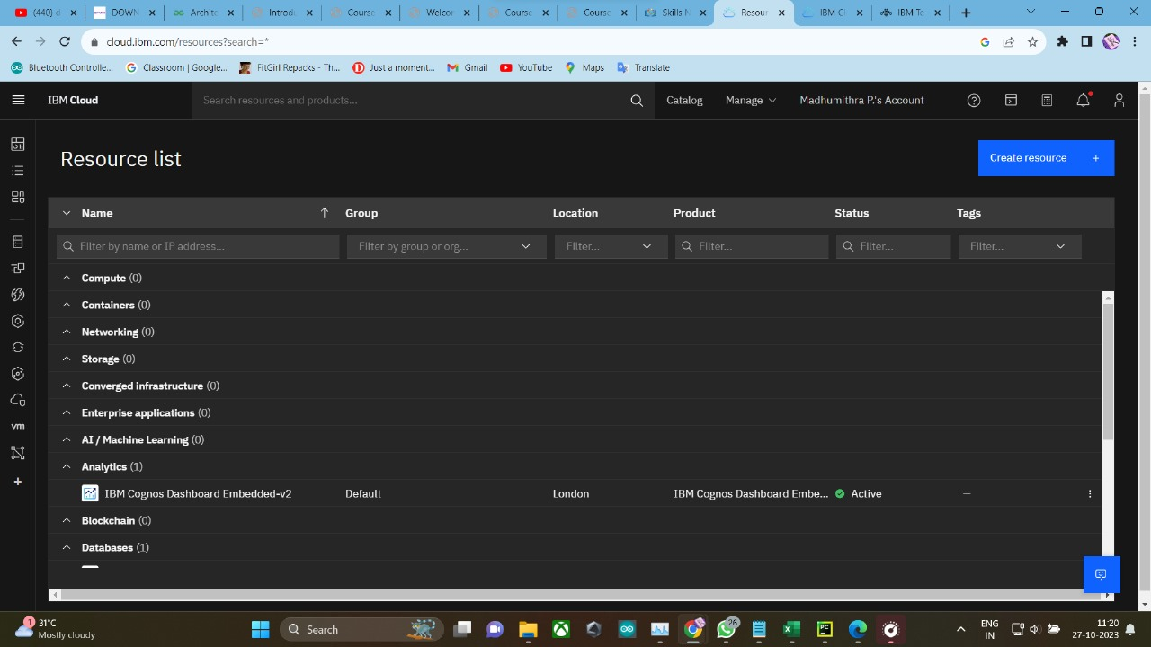

**4. Collecting Data:**

- Set up data collection from our IBM Cloud Virtual Servers. Depending on our data sources, we can use IBM Cloud Monitoring or other monitoring tools to capture server performance metrics and incidents. Configure the monitoring tools to export the data to a storage solution within IBM Cloud.

**5. Data Preprocessing:**

- Once we have the data in your IBM Cloud environment, we can preprocess it. Preprocessing tasks may include data cleaning, data transformation, and handling missing values. we can perform these tasks using cloud-based tools, scripting, or data processing services provided by IBM Cloud.

**6. Data Storage:**

- Choose a suitable storage solution within IBM Cloud to store our pre-processed data. IBM Cloud Object Storage or IBM Db2 databases can be options depending on our data type and requirements.

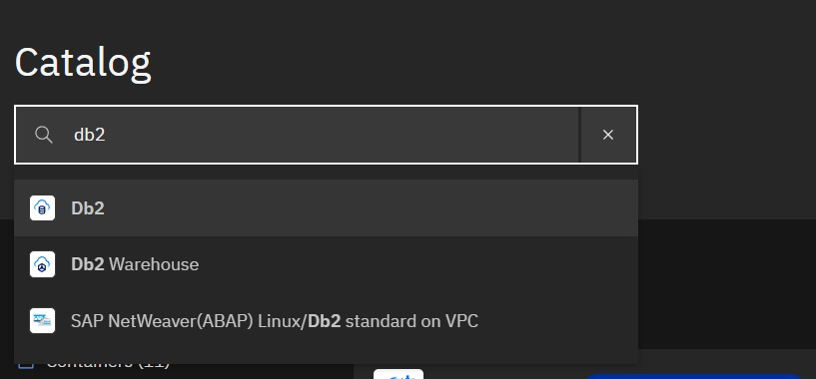

**7. Data Access and Query:**

- Set up access controls and query mechanisms to retrieve and analyse the data stored in IBM Cloud. we can use SQL queries if we're using a database or leverage IBM Cloud's data analysis tools for structured and unstructured data.

**8. Analytics Tools:**

- Depending on the complexity of our project, we might use IBM Cloud's built-in analytics tools or integrate external data analysis tools, such as Jupyter notebooks with Python libraries, for more advanced data analysis.

**9. Security and Compliance:**

- Ensure that we follow security and compliance best practices when handling and analysing your data. IBM Cloud provides security features to help protect our data.

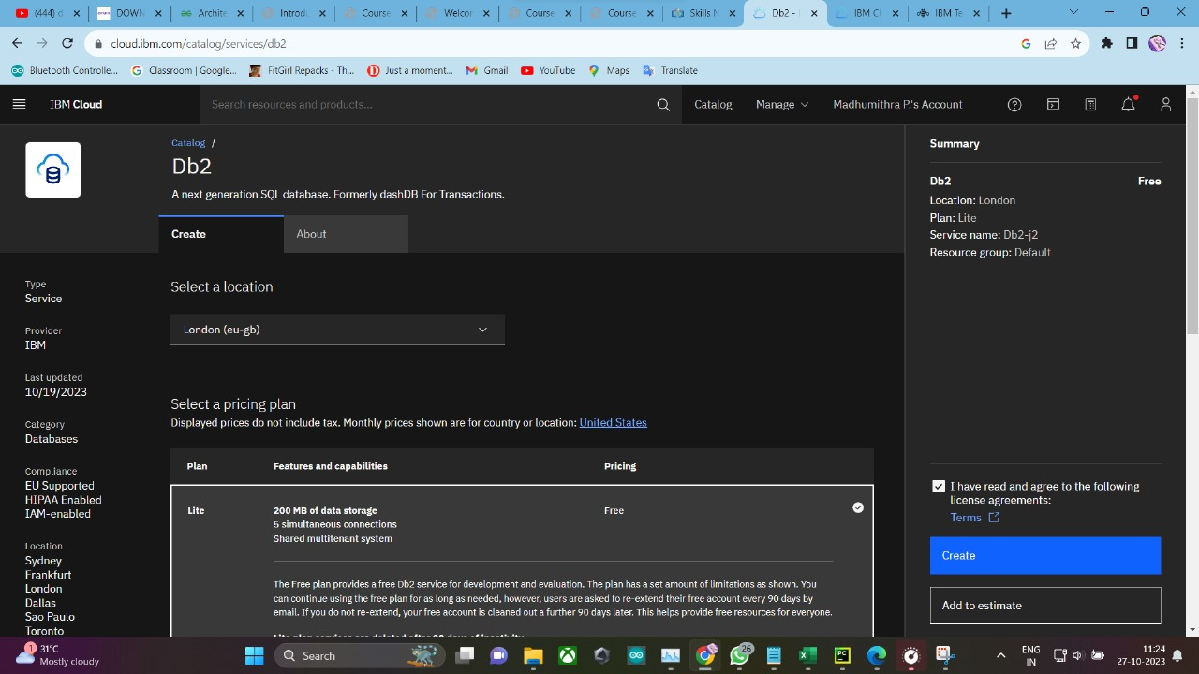

**10. Documentation:**

- Document the entire data loading and preprocessing process, including the tools, services, and configurations used. This documentation will be valuable for our team and any stakeholders.

**11. Iterate and Refine:**

- Disaster recovery projects are iterative. Continuously monitor and analyse data, refine our preprocessing steps, and adapt our approach based on the insights we gain from the data.

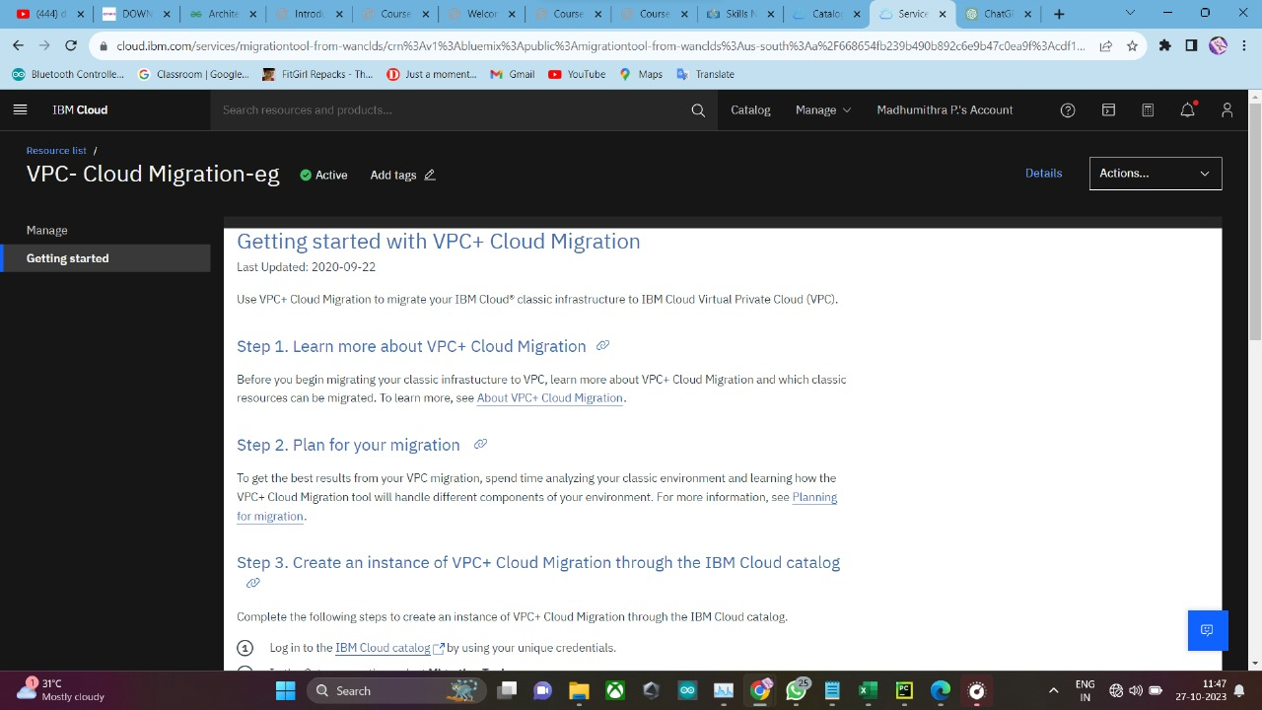

**12. Collaboration and Reporting:**

- Collaborate with our disaster recovery team to make informed decisions based on the data. Use IBM Cloud's collaboration features and reporting tools to share insights and results.

Remember to follow best practices for data privacy and security, especially when working with potentially sensitive disaster recovery data. IBM Cloud provides security features and compliance certifications to help you protect your data and comply with regulations.

In conclusion, the successful integration of the DB2 service expands our resources and empowers us to leverage advanced database functionalities. This streamlined process ensures a seamless experience, enabling us to focus on our core tasks while maximizing the benefits of this powerful tool."

