**Disaster Recovery and Business Continuity Plan for On-Premises Virtual Machine on IBM Cloud Virtual Servers**

**Phase 1: Problem Definition and Design Thinking**

# In this part we will need to understand the problem statement and create a document on what we have to understood and how will we proceed ahead with solving the problem.

Our primary objective is to define a robust disaster recovery strategy encompassing clear recovery time objectives (RTO) and recovery point objectives (RPO). RTO sets the target time for recovery, ensuring minimal disruption, while RPO defines the acceptable data loss in case of an incident

Understanding the Problem

In this section, we will elaborate on our understanding of the problem statement.

a. **Challenges in Disaster Recovery**:

Discuss the unique challenges and complexities of disaster recovery within the context of IBM Cloud Virtual Servers. This might include downtime, data loss, and resource allocation issues.

b. **Data Sources**:

Identify the data sources required for disaster recovery analysis, such as server logs, performance metrics, and incident reports.

c. **IBM Cloud Virtual Servers**:

Provide an overview of IBM Cloud Virtual Servers and how they play a critical role in disaster recovery.

Approach and Design

In this section, we will outline our proposed approach to solving the problem.

a. **Innovative Solution**:

Describe our innovative approach to addressing disaster recovery challenges using IBM Cloud Virtual Servers.

b. **Key Components**:

List the primary components of our solution, including data processing pipelines, machine learning models, and real-time monitoring systems.

c. **Data Collection and Preprocessing**:

Explain how we plan to collect and preprocess data using IBM Cloud services. This may involve IBM Cloud Monitoring and Log Analysis.

d. **Model Training and Deployment**:

Detail the machine learning models we intend to use for predicting and responding to disasters, as well as our deployment strategies.

e. **Integration with IBM Cloud Services**:

Describe how our solution integrates seamlessly with IBM Cloud services, leveraging their capabilities for enhanced disaster recovery.

f. **Security and Compliance**:

Outline the security measures and compliance standards we will adhere to when handling sensitive disaster recovery data.

In conclusion, this disaster recovery and business continuity plan, meticulously designed and implemented for an on-premises virtual machine hosted on IBM Cloud Virtual Servers...

**Backup Configuration:**

Regular backups of critical data and configurations from the on-premises virtual machine will be configured to capture and store vital information securely.

**Replication Setup:**

To ensure up-to-date copies of data and virtual machine images, replication will be implemented from the on-premises virtual machine to IBM Cloud Virtual Servers.

**Recovery Testing:**

A well-designed recovery testing plan will be executed to validate the recovery process and guarantee minimal downtime. This involves simulating disaster scenarios and recovering the virtual machine, ensuring that the recovery objectives are met and the business can swiftly resume operations.

**Business Continuity:**

Our disaster recovery plan will be closely aligned with the organization's overarching business continuity strategy. This alignment will ensure that our disaster recovery efforts seamlessly integrate into the broader framework, further enhancing our ability to maintain business continuity during adverse circumstances.

**Phase 2: Innovation**

# In this section we need to put our design into innovation to solve the problem.

**Introduction**

Provide an introduction to the document, briefly explaining the purpose and importance of the innovative design for disaster recovery.

Innovation and Design Overview

This section is the core of our document. Explain the innovative design that will revolutionize disaster recovery using IBM Cloud Virtual Servers. Consider the following points:

1. **Proposed Solution**:

Describe the innovative solution or approach that we plan to implement. This may involve the use of IBM Cloud services, advanced analytics, machine learning, and automation.

1. **Key Components**:

List the key components of our innovative design, such as data processing pipelines, predictive models, and real-time monitoring systems.

1. **Adaptive Disaster Recovery**:

Explain how our design will adapt to different disaster scenarios. Highlight the flexibility and scalability of our innovative approach.

1. **Real-time Incident Detection**:

Describe how our solution will leverage real-time monitoring and analytics to detect incidents promptly and accurately.

1. **Integration with IBM Cloud Services**:

Explain how our innovative design seamlessly integrates with IBM Cloud Virtual Servers and other relevant IBM Cloud services.

1. **Enhanced Security and Compliance**:

Outline the security measures and compliance standards that are integral to our design, ensuring the protection of sensitive data.

**Technical Architecture**

Provide a high-level technical architecture of our innovative design. Use diagrams, flowcharts, or other visual aids to illustrate the components and their interactions.

**Data Flow and Processing**

Detail how data flows through our system, including data collection, preprocessing, and analysis.

**Machine Learning and Predictive Models**

Explain the machine learning models and algorithms that play a key role in our design. Include information about training, validation, and deployment.

**Real-time Monitoring and Incident Response**

Describe how real-time monitoring is implemented and how our system responds to incidents, triggers alerts, and initiates recovery processes.

**Scalability and Resource Management**

Discuss the scalability of our design and how resources are managed to accommodate fluctuations in workload and incidents of varying severity.

**Integration with Disaster Recovery Teams**

Explain how our design collaborates with disaster recovery teams, both in terms of information sharing and automating response actions.

**Budget and Resource Requirements**

List the resources required for our project, including personnel, hardware, and software. Estimate the budget needed for implementation.

Phase3: Development Part 1

# In this section begin building our project by loading and preprocessing the dataset.

Building a disaster recovery project with IBM Cloud Virtual Servers involves using IBM Cloud services to manage and analyse your server and disaster-related data. Here's a high-level outline of how to start building your project by loading and preprocessing the dataset using IBM Cloud services:

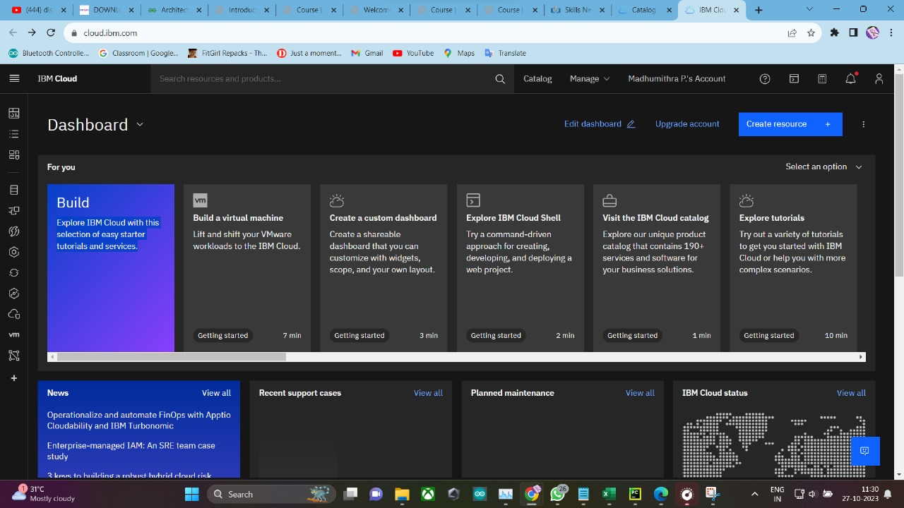

**1. IBM Cloud Account Setup:**

- If we haven't already, sign up for an IBM Cloud account and access the IBM Cloud Console.

**2. Data Sources:**

- Identify the data sources relevant to our disaster recovery project. These sources could include logs, performance metrics, incident reports, or other data generated by our IBM Cloud Virtual Servers. Ensure that we have access to these data sources.

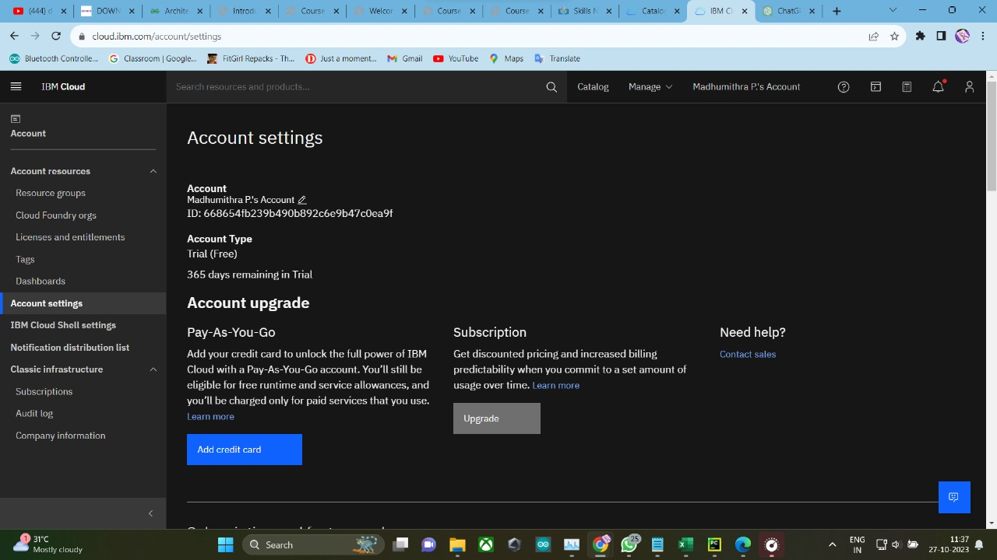

**3. IBM Cloud Services:**

- Utilize IBM Cloud services to access and manage our virtual servers and data. we can use services like IBM Cloud Monitoring, IBM Cloud Log Analysis, and IBM Cloud Databases to collect and store data.

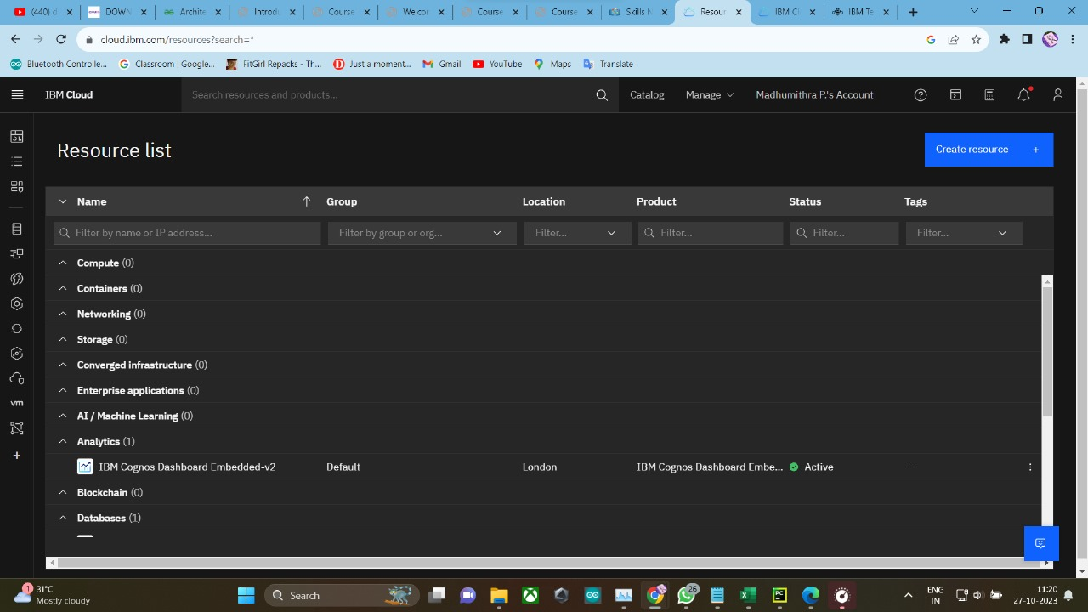

**4. Collecting Data:**

- Set up data collection from our IBM Cloud Virtual Servers. Depending on our data sources, we can use IBM Cloud Monitoring or other monitoring tools to capture server performance metrics and incidents. Configure the monitoring tools to export the data to a storage solution within IBM Cloud.

**5. Data Preprocessing:**

- Once we have the data in your IBM Cloud environment, we can preprocess it. Preprocessing tasks may include data cleaning, data transformation, and handling missing values. we can perform these tasks using cloud-based tools, scripting, or data processing services provided by IBM Cloud.

**6. Data Storage:**

- Choose a suitable storage solution within IBM Cloud to store our pre-processed data. IBM Cloud Object Storage or IBM Db2 databases can be options depending on our data type and requirements.

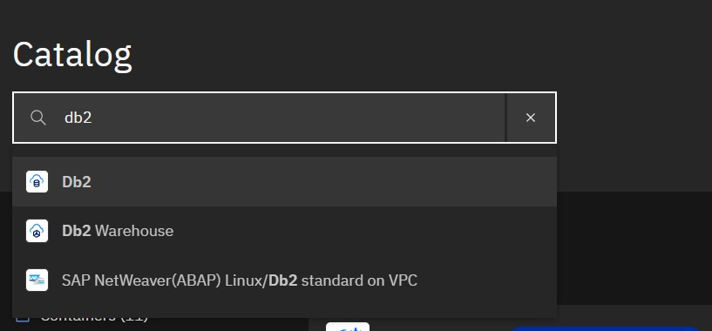

**7. Data Access and Query:**

- Set up access controls and query mechanisms to retrieve and analyse the data stored in IBM Cloud. we can use SQL queries if we're using a database or leverage IBM Cloud's data analysis tools for structured and unstructured data.

**8. Analytics Tools:**

- Depending on the complexity of our project, we might use IBM Cloud's built-in analytics tools or integrate external data analysis tools, such as Jupyter notebooks with Python libraries, for more advanced data analysis.

**9. Security and Compliance:**

- Ensure that we follow security and compliance best practices when handling and analysing your data. IBM Cloud provides security features to help protect our data.

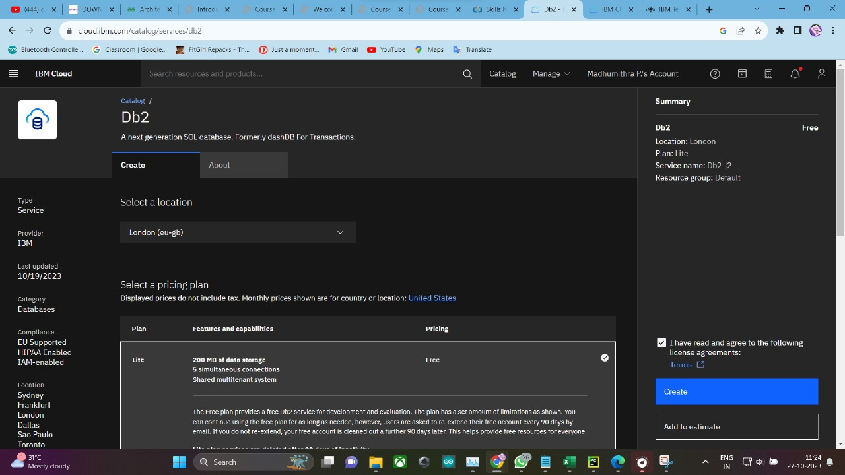

**10. Documentation:**

- Document the entire data loading and preprocessing process, including the tools, services, and configurations used. This documentation will be valuable for our team and any stakeholders.

**11. Iterate and Refine:**

- Disaster recovery projects are iterative. Continuously monitor and analyse data, refine our preprocessing steps, and adapt our approach based on the insights we gain from the data.

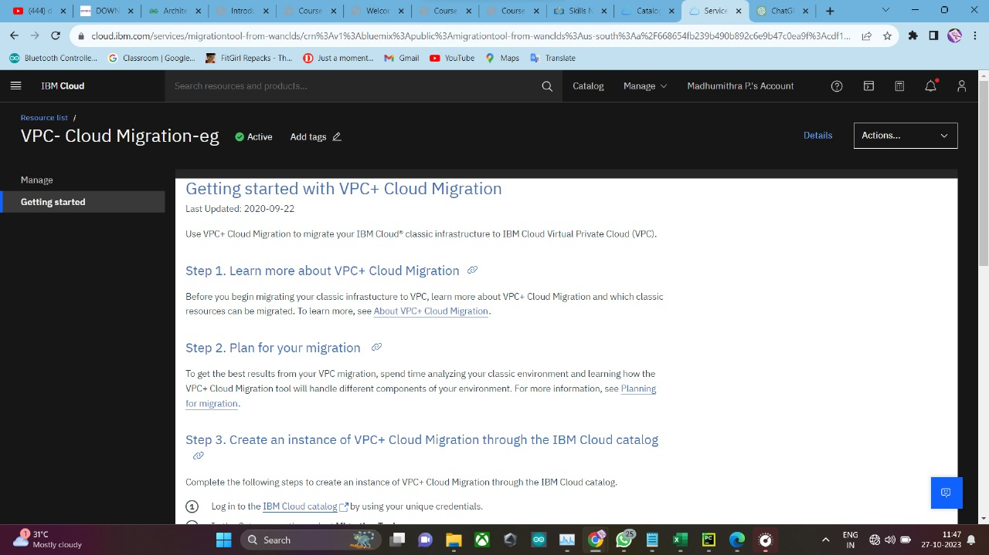

**12. Collaboration and Reporting:**

- Collaborate with our disaster recovery team to make informed decisions based on the data. Use IBM Cloud's collaboration features and reporting tools to share insights and results.

Remember to follow best practices for data privacy and security, especially when working with potentially sensitive disaster recovery data. IBM Cloud provides security features and compliance certifications to help you protect your data and comply with regulations.

In conclusion, the successful integration of the DB2 service expands our resources and empowers us to leverage advanced database functionalities. This streamlined process ensures a seamless experience, enabling us to focus on our core tasks while maximizing the benefits of this powerful tool."

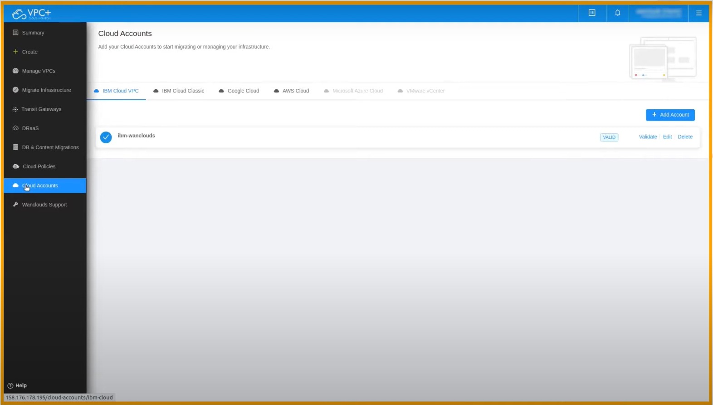

Phase 4: Development Part 2

# In this section continue building the project by performing different activities like feature engineering, model training, evaluation etc as per the instructions in the project.

Continuing with our "Disaster Recovery with IBM Cloud Virtual Servers" project, let's delve into feature engineering, model training, and evaluation using IBM Cloud services. This section assumes that we have already loaded and pre-processed the dataset on the IBM Cloud. Here's how to proceed:

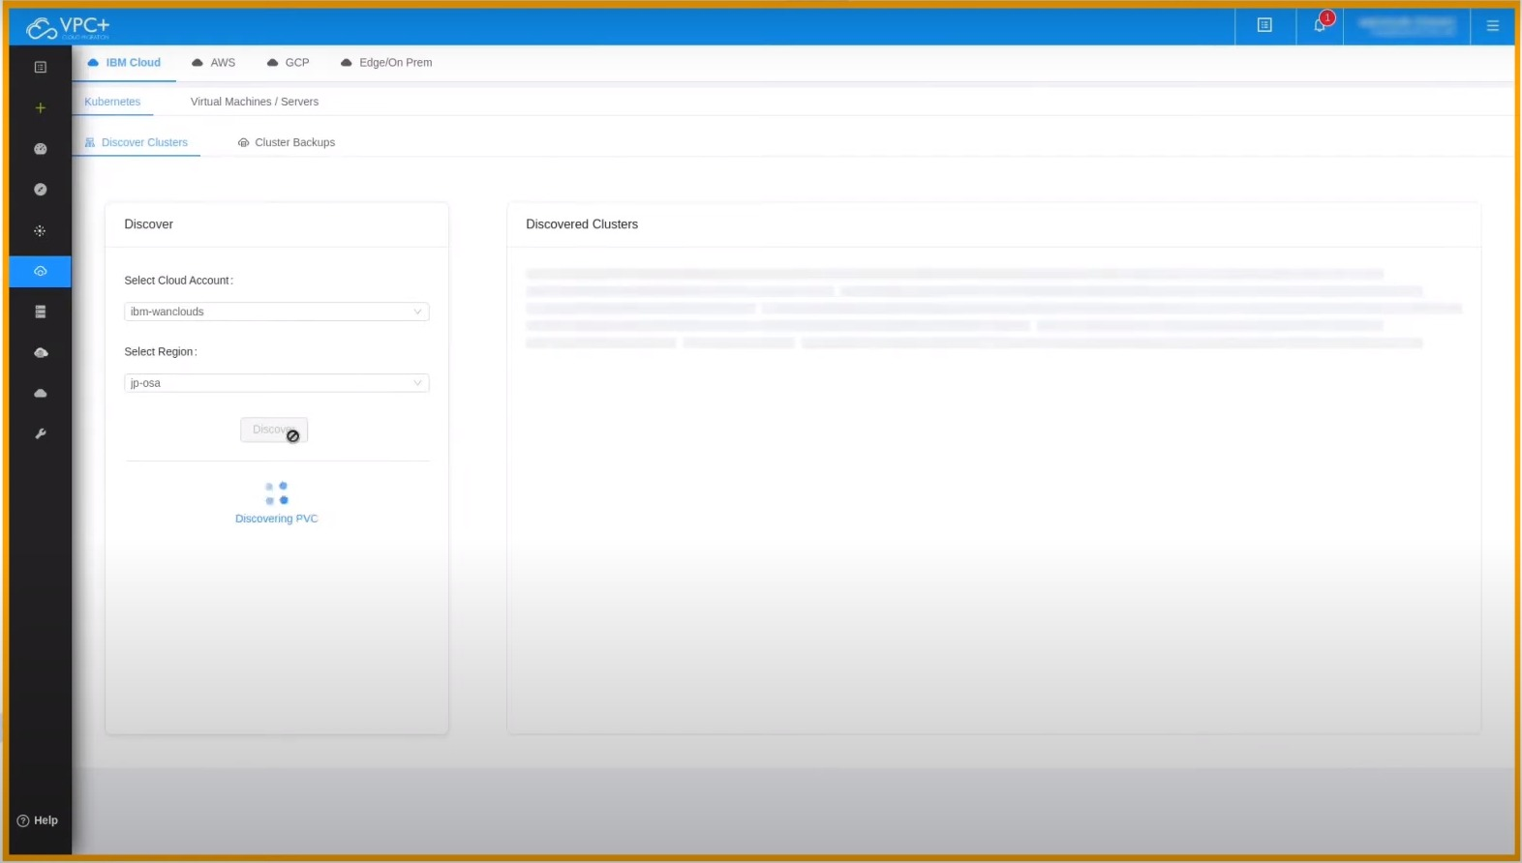

Feature Engineering:

**1. Feature Selection**

- Review the dataset and select the most relevant features for your disaster recovery analysis. This step is crucial for model efficiency and interpretability.

**2. Time-Based Features:**

- Create time-based features that are relevant to disaster recovery scenarios. For example, we can derive features like the time of day, day of the week, or the time since the last incident.

**3. Aggregate Metrics:**

- Compute summary statistics and aggregate metrics from the server data. Metrics such as average CPU usage, memory consumption, and network latency can be valuable features.

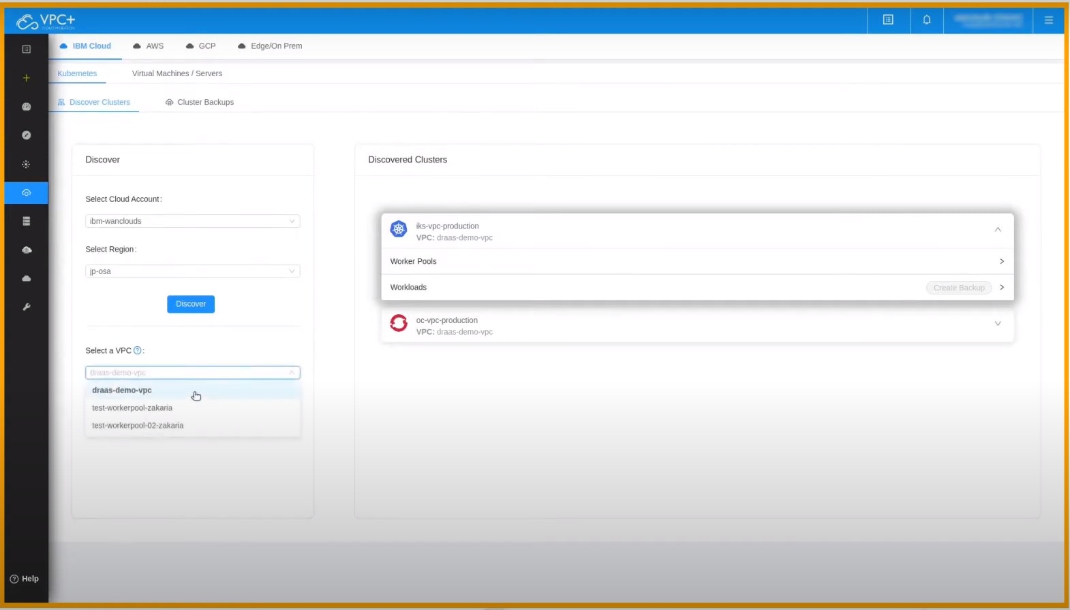

**4. Domain-Specific Features:**

- Introduce features specific to disaster recovery, such as the type of incident, previous recovery actions taken, and the duration of downtime.

Model Training:

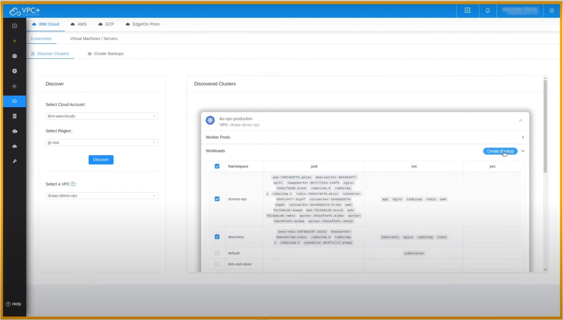

**1. IBM Cloud Machine Learning:**

- Utilize IBM Cloud's machine learning services and environments to develop our predictive model. IBM Watson Studio provides a collaborative environment for data scientists and developers.

**2. Select the Model:**

- Choose the appropriate machine learning algorithm for specific objectives. Common options include decision trees, random forests, support vector machines, or neural networks.

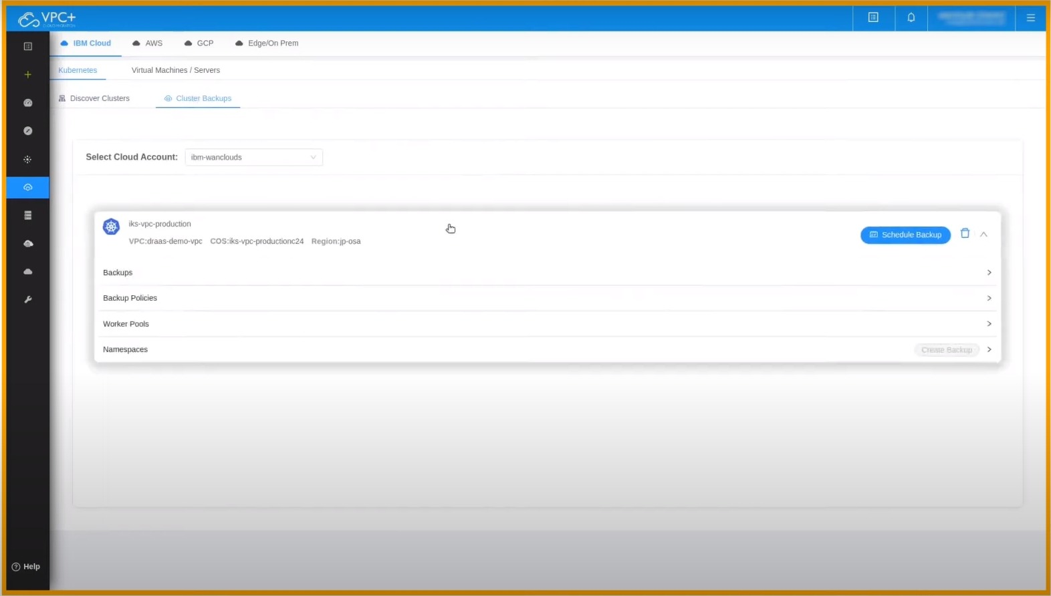

**3. Data Splitting:**

- Split the pre-processed data into training and testing sets to evaluate our model's performance.

**4. Model Training:**

- Train our selected model using the training dataset. Pass the relevant features as input and the desired outcomes (e.g., incident occurrence) as labels.

**5. Hyperparameter Tuning:**

- Optimize our model's hyperparameters to achieve better predictive performance. IBM Cloud may offer tools for hyperparameter tuning and optimization.

**6.** **Validation:**

- Evaluate our model on the testing dataset. Use relevant evaluation metrics, such as accuracy, precision, recall, F1-score, and ROC AUC, based on the specific goals of our disaster recovery model.

Real Time Scenarios:

Model Evaluation:

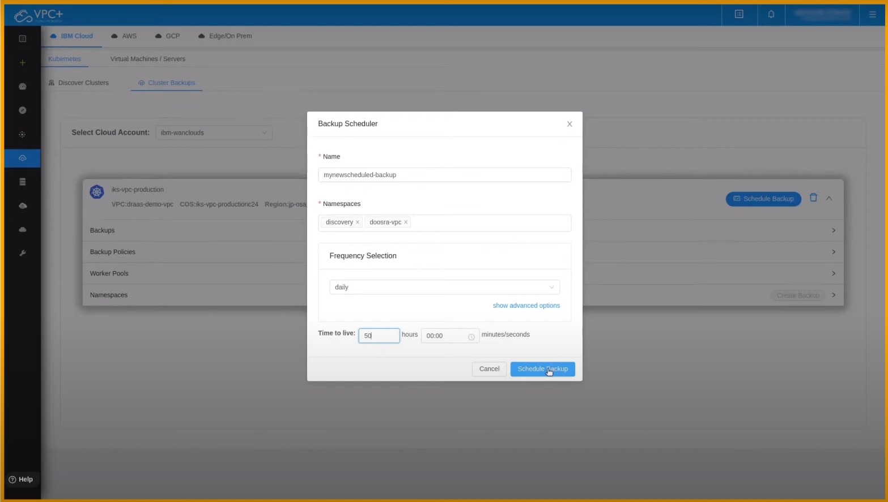

**1. IBM Cloud Tools:**

- Leverage IBM Cloud's data visualization and analytics tools to visualize the model's predictions and performance metrics.

**2. Interpretability:**

- Ensure that our model is interpretable and provides actionable insights. This is crucial for making informed disaster recovery decisions.

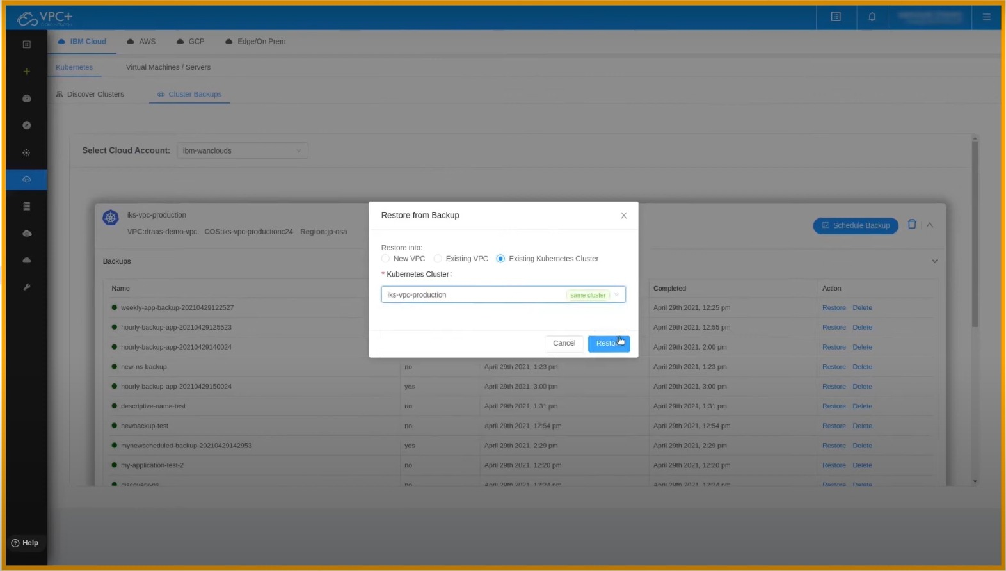

**3. Deployment:**

- If our model performs well, consider deploying it within the IBM Cloud environment, so it can be used for real-time or automated decision-making.

**4. Monitoring and Maintenance:**

- Implement ongoing model monitoring to ensure it remains accurate and relevant. Continuously retrain our model as new data becomes available.

**5. Collaboration and Reporting:**

- Collaborate with our disaster recovery team, share insights, and create reports on the model's performance and recommendations.

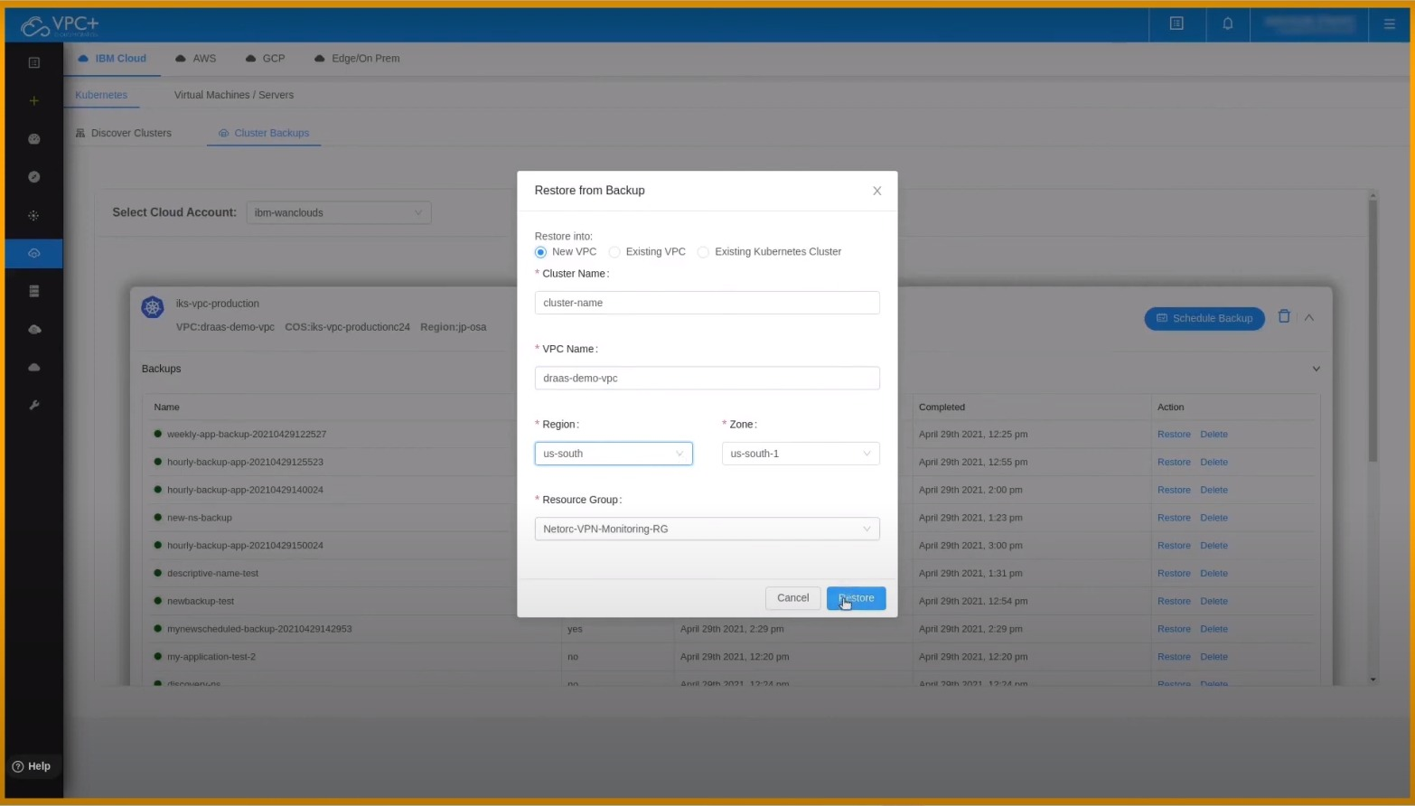

**6. Security and Compliance:**

- Maintain strong security and compliance practices, ensuring that sensitive disaster recovery data is handled securely within the IBM Cloud environment.

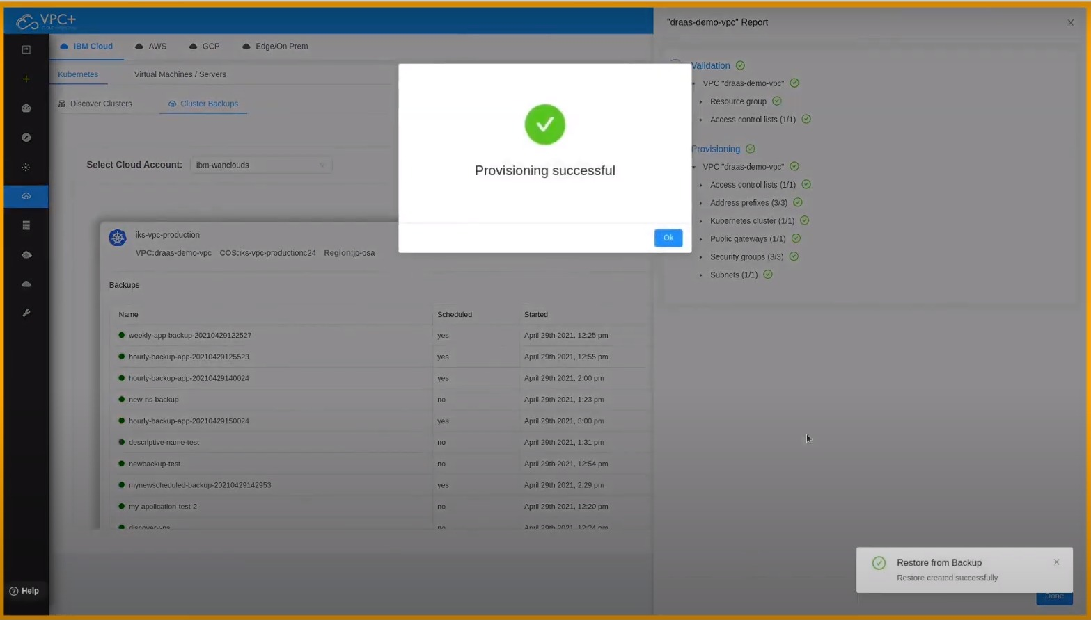

Remember that our disaster recovery model should be flexible and adaptive, as disaster scenarios can change over time. By incorporating regular data updates and model refinements into our project, we can continuously improve your disaster recovery capabilities using IBM Cloud Virtual Servers.