 C:\Users\admin\AppData\Local\Temp\ksohtml9144\wps2.png 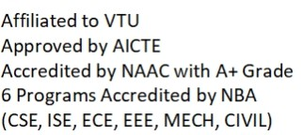

C:\Users\admin\AppData\Local\Temp\ksohtml9144\wps4.png

DEPARTMENT OF CIVIL ENGINEERING

Course: Integrated Waste Management for a Smart City Course Code: BCV654C

Assignment on Smart City Mission

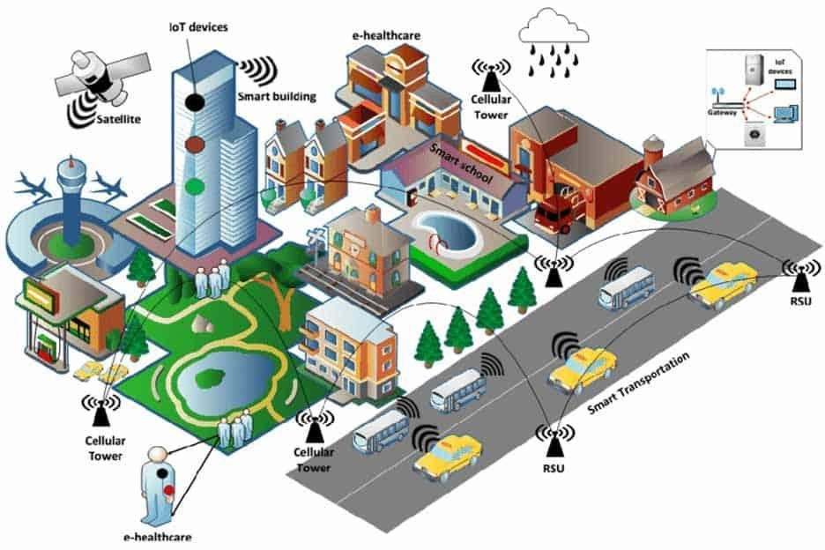

**Smart City:** **______________________**

Name: USN:

Semester: Section: Branch: