Indo-European Language Family Analysis Using NLP Techniques
All Indo-European languages are connected to each other. These languages are known by at least 80% of the entire human population as this family includes very popular languages such as English, Spanish & Hindi and they cover a large portion in the Eurasian area from Iceland to North India. Hence studying the common roots of these languages is important. As the more we know about it the more we know about this common culture. Which everyone has decide to call the Proto Indo-European culture speaking the common but hypothetical Proto Indo-European language (PIE).
The research about the origin of this PIE culture is going on for 200 years. Although no older written records of the original Proto-Indo-Europeans remain, some aspects of their culture and religion can be reconstructed from later evidence in the daughter cultures. The Indo-European family is significant to the field of historical linguistics as it possesses the second-longest recorded history of any known family. Linguists, Genetics, and Archeologists all three agree on one thing that there are definite pieces of evidence of a culture spreading gradually as time passes. But from where this expansion started is the question of the debate. There is no definite solution for this question, only some hypotheses are available.
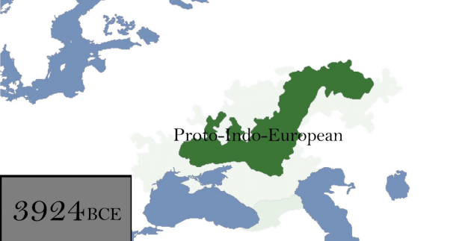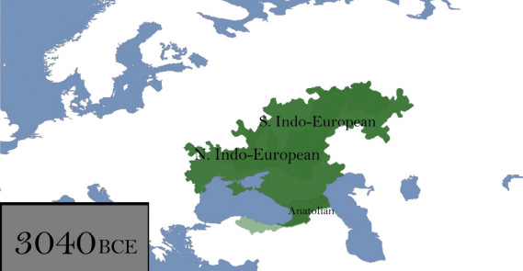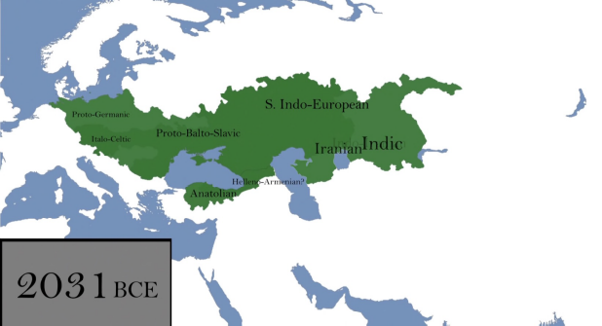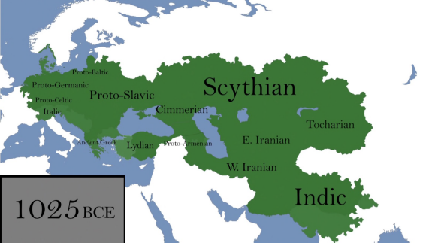
Figure 1: Expansion of the Proto Indo-European culture based on the Kurgan Hypothesis
PIE was a hypothetical language which had no evidence in written form, but was the answer given to the 200 years old questions of, Is there a common origin to all Indo-European Languages? & Is there any explanation for the uncanny similarities found between the languages as far apart as Sanskrit and Icelandic?
So, our current research focuses on applying latest available natural language processing techniques and obtaining valuable insights.
Our prime objectives in this research would be to try to gain insights on two important things.
- In which chronological order did the Indo-European languages evolved.
- Based upon our findings of the semantic and syntactic similarities can the PIE language be reconstructed.
But finding answers to these questions is not an easy task. It will require a lot of research on history, linguistics and machine learning. Apart from the knowledge it will also require efforts on the coding of data collection, cleaning of modeling side. So, for now, we have done some research on history, linguistics and data availability and we have decided to do the initial part of the research in this project and if we are on the right track we will plan to pursue more.
So, in this project our aim would be to,
- Scrape required data from the internet. It includes text from the given list - Rigveda, Avesta, Iliad, Odyssey, Hesiod, Sappho, other relevant texts.
- Get English translated versions of all texts and find common topics in a combined text and also find particular topics for particular texts for comparison and analysis.
- Get original words for the common topics and check for semantic and syntactic similarities. (Maybe using word embeddings)
- Decide after above steps are done.

