*Mini Project Report on*

**NC Ordering Application**

*undergone at*

**Department of Information Technology**

**National Institute of Technology Karnataka, Surathkal**

*under the guidance of*

**Biju R Mohan**

**Associate Professor**

*Submitted by*

**Arpitha Raghunandan: 171IT211**

**Madhuparna Bhowmik: 171IT221**

**M K Apoorva: 171IT121**

**III SemB.Tech (IT)**

*in partial fulfillment for the award of the degree of*

**BACHELOR OF TECHNOLOGY**

*in*

**INFORMATION TECHNOLOGY**



**Department of Information Technology**

**National Institute of Technology Karnataka, Surathkal**.

***November2018***

**ACKNOWLEDGEMENT**

The completion of any work involves the efforts and sacrifices of many people. We have been lucky enough to have received a lot of help and support from many people during the making of this project. So, with great gratitude, we take this opportunity to acknowledge all those people whose guidance and encouragement helped us to emerge successful.

We are greatly indebted to the principal of our college, **K Umamaheshwar Rao** and our head of the department **Ram Mohan Reddy** for the facilities and support extended towards me.

I consider it as my privilege and honor to express sincere gratitude to my guide, **Biju R Mohan**, Associate Professor, Dept. of IT for his invaluable support and encouragement.

We are also much indebted and grateful to the other teaching and non-teaching staff of our department, who extended their unlimited moral support. We would also like to thank our parents and friends for providing continuous encouragement and moral support.

**ABSTRACT**

Java is a popular object-oriented language used to make various applications worldwide. Hence, we’ve decided to use Java to make an application to simplify the ordering of food from night canteens around our campus.

**INTRODUCTION**

Considering the efforts needed to order food from the night canteens around our campus, we decided to make an application to simplify the ordering process. Our application allows one to choose one of the night canteens around campus and place an order after providing their name and phone number. The application also generates and displays a bill for the user.

**CLASS DIAGRAM**

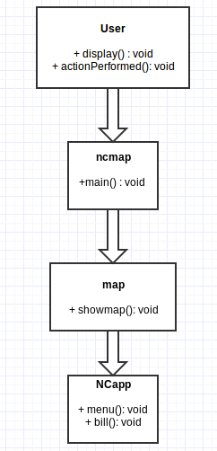

**CODE EXPLANATION**

Our code consists of 3 classes. They are:

* ncmap
* user
* NCapp

The application begins with the ncmap class which displays a map indicating 5 night canteens around campus. The user clicks on any one of the NC buttons and is redirected to the user class. In the user class, the user needs to enter his/her name and phone number. On entering these details, he/she is redirected to the NCapp class. This displays the menu of the selected night canteen. The user selects his order using buttons and on pressing a button named Proceed, he/she is presented with his/her bill and his/her order is placed!

All the three classes use java swing for graphics.

**CODE**

Considering the efforts needed to order food from the night canteens around our campus, we decided to make an application to simplify the ordering process. Our application allows one to choose one of the night canteens around campus and place an order after providing their name and phone number. The application also generates and displays a bill for the user.