#### 1 INTRODUCTION

#### Hydraulic Fracturing

Hydraulic fracturing is a widely used stimulation technique to initiate a high permeability conduit of gas in a low permeability reservoir. During the hydraulic fracturing operation, a fluid is injected into a well at a pressure high enough to fracture the formation. The process also can cause opening up of natural fractures already present in the formation.

For the past 50 years, the technique of hydraulic fracturing has been widely used in energy industry. One of the most important applications of this technique is the stimulation of hydrocarbon wells for increasing oil and gas recovery (e.g., Veatch, 1983a, 1983b; Yew, 1997; Economides and Nolte, 2000). More than 70% of the gas wells and 50% of the oil wells in North America are stimulated using hydraulic fracturing (e.g., Valko and Economides 1995). Hydraulic fracturing can also be applied in the in situ stress measurement (e.g., Haimson, 1978; Shin *et al.,* 2001), and geothermal reservoir stimulations (e.g., Murphy, 1983; Legarth, Huenges, and Zimmermann 2005; Nygren and Ghassemi 2005).

Currently, the most important application of hydraulic fracturing technique is to stimulate the low permeability gas reservoirs. As the economies of most nations in the world continue to expand and the demand for energy continues to increase, more and more unconventional oil and gas resources are being developed to meet the demands for energy.

Tight gas reservoirs, including tight gas sandstones (TG), gas shale (GS), and coal-bed methane (CBM), are typical unconventional gas resources that are accumulated in low-permeability geologic environments. In the 1970s, the United States government defined a tight gas reservoir as a reservoir with an expected value of permeability to gas flow of 0.1 md or less. Holditch (2006) defined a tight gas reservoir as “a reservoir that cannot produce at economical rates nor recover economic volumes of natural gas unless the well is stimulated by a larger hydraulic fracture treatment or produced by use of a horizontal wellbore or multilateral wellbores.” Hydraulic fracturing is an efficient technique to enhance productions from these low permeability reservoirs.

Another application of hydraulic fracturing is to stimulate geothermal production. The production of geothermal energy from dry and low permeability reservoirs is achieved by water circulation in natural and/or man-made fractures, and is often referred to as enhanced or engineered geothermal systems (EGS) (MIT-Lead Report).

In hydraulic fracturing operations, the fracture fluid which is injected into the well can be oil-based, water-based, or acid-based (Veatch, 1983a, 1983b). However, water based hydraulic fracturing are the most common used and the least expensive. Slick- water fracturing combines water with a friction-reducing chemical additive which allows the water to be pumped at higher injection rates into the formation (Palisch *et al.*, 2008).

The process of a hydraulic fracturing operation is shown in Fig.1.1 (Veatch, 1983a). It consists of blending special chemicals to make the appropriate fracturing fluid and then pumping the blended fluid into the pay zone at high enough rates and pressures to wedge and extend a fracture hydraulically (Gidley *et al*. 1989).

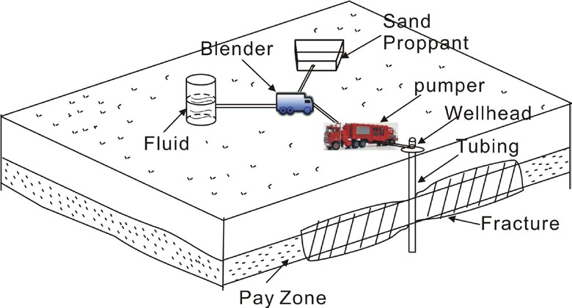

**Fig.1.1Hydraulic Fracturing Process**

#### Fracture Mechanics

During the process of hydraulic fracturing, rock mechanics plays an important role in governing the geometry of propagating fractures (Gidley *et al*., 1989). It is important to understand the mechanisms of fluid-rock interaction in the hydraulic fracturing. In real operations, fractures can be more complicated in Geometry, and we can have complex fracturing and extremely complex fracturing in work (Fig.1.2). The long axis of the fracture network or “fairway” is referred to as the hydraulic fracture “fairway length” while the short axis is typically referred to as “fairway width” (Fisher *et al*., 2004). The volume of this fairway or the stimulated volume can be estimated using the rock mechanics methods for the hydraulic fractures. To do this, it is necessary to know the pore pressure and stress distribution around the fracture or stimulated interval which varies with the geometry of hydraulic fractures, and is affected by mechanical, thermal, and chemical conditions of the surrounding host rock, especially the mechanical properties.

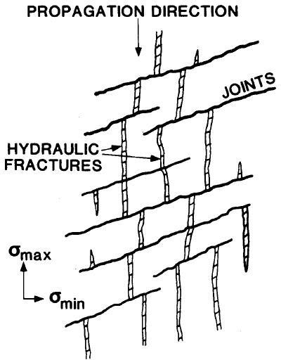

#### Fig.1.2 Geometry of Fracture Network (Modified from Warpinski and Teufel, 1987)

According to previous studies (Gidley *et al*., 1989), some important factors that have effects on fracture propagation include:

* + 1. In situ stresses existing in rock: the local stress fields and variations in stresses between adjacent formations are often though to dominate fracture orientation and fracture growth. A hydraulic fracture will propagate perpendicular to the minimum principal stress.
    2. Relative bed thickness of formations in the vicinity of the fracture.
    3. Mechanical rock properties: such properties as elastic modulus, Poisson’s ratio, and toughness will affect the fracture propagation.
    4. Fluid pressure gradients in the fracture.
    5. Pore pressure distributions in the formation.

#### Fracture Propagation Models

Over the past 50 years, many models have been developed to study fracture propagation, including two-dimensional (Perkins and Kern 1961; Geertsma and Klerk, 1969; Nordgren, 1972; Daneshy, 1973) and three dimensional models (Clifton in Gidley *et al*., 1989). For my research, the traditional 2-D models of the fluid driven fracturing process are reviewed.

#### PKN Model

Perkins and Kern (1961) developed equations to compute fracture length and width for a fixed height. Later Nordgren (1972) improved their model by adding fluid loss to the solution. The PKN model makes the assumption that the fracture has a constant height and an elliptical cross section (Fig.1.3) in both the horizontal plane and the vertical plane.

From the view of solid mechanics, the fracture height, *hf*, is independent of the distance to which it has propagated away from the well. The problem is reduced to 2D by using the plane strain assumption. For the PKN model, plane strain is considered in the vertical direction, and the rock response in each vertical section along the x-direction is assumed independent of its neighboring vertical planes. Plain strain implies that the elastic deformations (strains) to open or close, or shear the fracture are fully concentrated in the vertical planes sections perpendicular to the direction of fracture propagation.

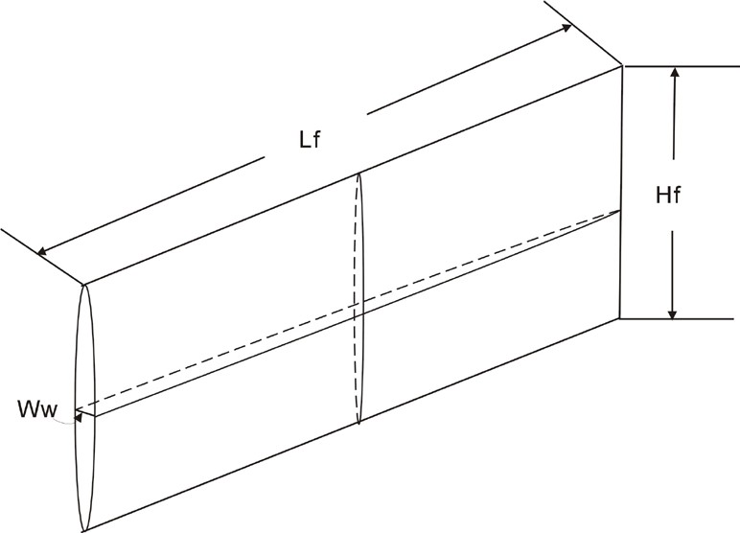

#### Fig.1.3 Geometry of PKN Model

From the view of fluid mechanics, the fluid flow problem in the PKN model is considered in one dimension in an elliptical channel. The fluid pressure, *pf*, is assumed constant in each vertical cross section perpendicular to the direction of propagation.

#### KGD Model

The KGD model was developed by Khristianovic and Zheltov (1955) and Geertsma and de Klerk (1969). In this model, the fracture deformation and propagation are assumed to evolve in a situation of plane strain. The model also assumes that the fluid flow and the fracture propagation are one dimension. The geometry of a traditional KGD fracture propagation model is shown in Fig.1.4.

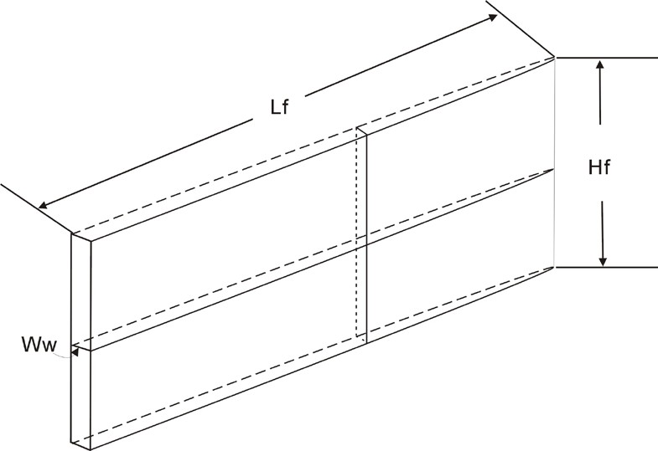

#### Fig.1.4 Geometry of KGD Model (Geertsma and de Klerk 1969)

The KGD model makes six assumptions: the fracture has an elliptical cross section in the horizontal plane; each horizontal plane deforms independently; the fracture height, *hf ,* is constant; the fluid pressure in the propagation direction is determined by the flow resistance in a narrow rectangular, vertical slit of variable width; the fluid does not act on the entire fracture length; and the cross section in the vertical plane is rectangular (fracture width is constant along its height) (Geertsma, 1969).

#### Penny-Shape or Radial Model

In the penny-shape or radial model, the fracture is assumed propagating within a given plane and the geometry of the fracture is symmetrical with respect to the point at which the fluid is injected (Fig.1.5). The study of the penny-shaped fracture in a dry rock mass can be in e.g., Abé *et al*. (1976). Abé *et al*. (1976) assumed a uniform distribution of fluid pressure and constant fluid injection rate.

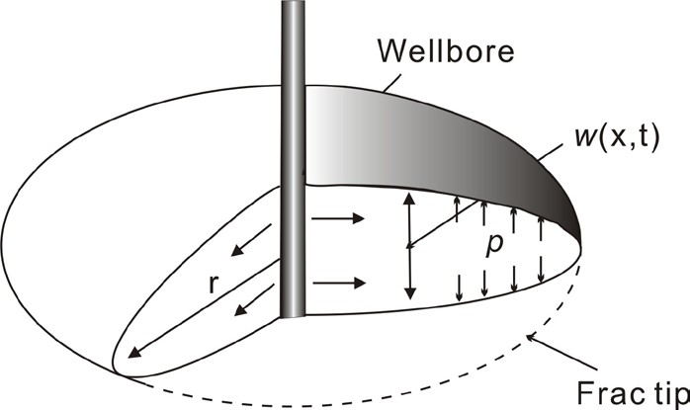

* + 1. **Compare between 2D Models**

|  |  |  |  |  |
| --- | --- | --- | --- | --- |
| **Table.1.1 Comparison between Traditional 2D Hyd****raulic Fracture Models** | | | | |
| Model | Assumptions | Shape | Bottom Hole Pressure | Application |
| PKN | Fixed Height Plain Strain | Elliptical Cross  Section | Increasing with Time | More Appropriate When  Length»Height |
| KGD | Fixed Height Plain Strain | Rectangle Cross Section | Decreasing with Time | More Appropriate When Length«Height |
| Radial | Uniform Distribution of Fluid Pressure, Constant Fluid Injection Rate | Circular Cross Section | Decreasing with Time | More Appropriate When It is Radial |

The traditional 2D hydraulic fracturing models PKN, KGD, and Radial Model can be compared as shown in Table.1.1. The mechanics of the traditional PKN and KGD models and the analysis on sensitivity of some factors will be shown in the appendix A.

#### Poroelasticity

During the propagation of a hydraulic fracture, fluid loss into the permeable formation causes the pore pressure increase in the reservoir, which in turn will cause dilation of the rock around the fracture, and finally, reduce the width of the fracture. Rock deformation also causes pore pressure to increase. The mechanism of poroelasticity will be discussed in detail in Section 2. The design of Hydraulic fracturing and the stress analysis must take into account the influence of pore pressure increase caused by leak off. In addition, pore pressure changes can cause stresses variations in the rock formation. The first detailed studies of the coupling between the fluid pressure and solid stress fields were described by Biot (1941). In poroelastic theory, the time dependent fluid flow is incorporated by combining the fluid mass conservation with Darcy's law; the basic constitutive equations relate the total stress to both the effective stress given by deformation of the rock matrix and the pore pressure arising from the fluid. Biot’s theory of poroelasticity has been reformulated by a number of investigators (e.g. Geertsma, 1957; Rice and Cleary, 1976). Fig.1.6 shows the mechanics of poroelasticity.

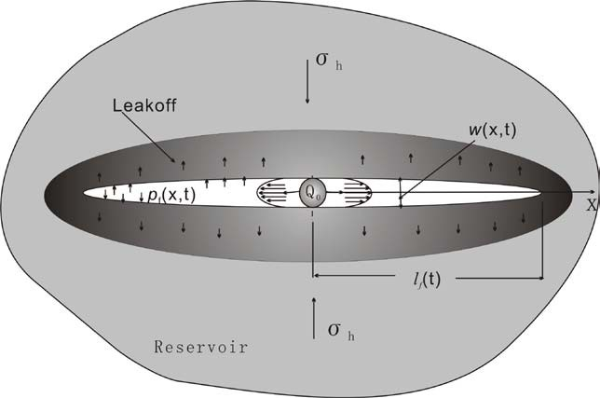

#### Fig.1.6 Mechanics of Poroelasticity

The coupled poroelastic effects can be summarized as follows (Vandemme et.al, 1989):

1. A volumetric expansion of the porous rock is induced by an increase of the pore pressure;
2. Pore pressure is increased from the application of a confining pressure if the fluid is prevented from escaping (undrained condition), an increase of the pore pressure results from the application of a confining pressure.

#### Problems Associated with Rock Mechanics

Fracturing by water injection is often used in both tight and permeable reservoirs. In tight reservoirs fractures are usually induced intentionally to increase the injectivity. In a permeable reservoir, fracturing may occur unintentionally if cold water is injected into a relatively hot reservoir. For example, during water-flooding or other secondary or tertiary recovery processes, fluids at temperatures typically cooler (70-80 ºF) than the in-situreservoir temperatures (200± ºF) are injected into a well. A region of cooled rock forms around an injection well, and grows as additional fluid is injected. The rock within the cooled region contracts and this leads to a decrease in stress concentration around the injection well until the injection pressure minus the hoop stress exceeds the tensile strength of the rock at a critical point on the well boundary and a fracture begins to propagate to orient itself in the direction of maximum in-situ stress. Although the increase in injectivity is favorable, the fracture may or may not have an adverse effect on the sweep efficiency of the water drive in the case of petroleum, or inefficient heat extraction in geothermal reservoirs, depending on the length, height and orientation of the fracture. These fracture parameters can also be of critical importance for a successful application of a tertiary recovery process, and development of geothermal reservoirs.

Fractures can develop considerable shear stress mechanically and the zone of increased shear stress provides a mechanism for microseisms to accurately reflect the length (and height) of the fracture as many microseisms should be induced in the zone as the fracture propagates (Warpinski *et al.,* 2001). These microseisms could be used to estimate the stimulated reservoir volume and the enhanced permeability.

With the distributions of pore pressure and in situ stresses, and the properties of reservoir rock mass, the failed reservoir volume and the enhanced permeability by the stimulation after water injection could be estimated.

Therefore, to analyze these two estimations, two models are developed in our work—the WFPSD model and the FracJStim model. The WFPSD model, which is modeling the water-flood induced fracturing from a single well in an infinite reservoir, is petroleum applications. The FracJStim model has a more general character and can be used in the analysis of pore pressure and stress distributions around a hydraulic fracture, and to assess the permeability enhancement around a hydraulic fracture when appropriate.

In petroleum field operations, injection is at a BHP that is high enough to initiate and extend a hydraulic fracture. The injected fluid then leaks off radically through a large fracture face area. Because of the decreasing in horizontal in-situ rock stresses that result from cold fluid injection, hydraulic fracturing pressures can be much lower than would be expected for an ordinary low leak-off hydraulic fracturing treatment. If the injection conditions are such that a hydraulic fracture is created, then the flow system will evolve from an essentially circular geometry in the plan view to one characterized more nearly as elliptical as shown in Fig.1.7.

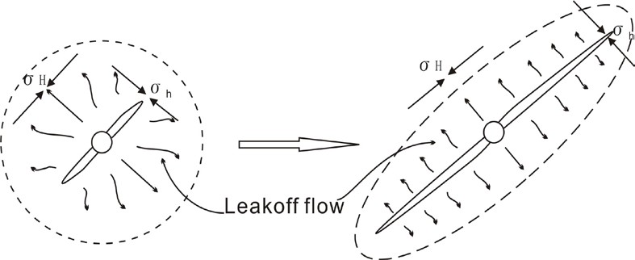

#### Fig.1.7 Evolution of Flow System

#### Literature Review

Geertsma (1966) considered the potential of poroelastic effects for influencing hydraulically-driven fracture propagation. Oil bearing rock is a two-phase system withthe potential for these effects. However, Geertsma concluded that these effects were to be insignificant in practical situations. Cleary (1980) suggested that poroelastic effects can be expressed as “back-stress”. Settari included poroelastic effects through a similar approximation (Settari, 1980).

A poroelastic PKN hydraulic fracture model based on an explicit moving mesh algorithm was set by Detournay (Detournay *et al*. 1990). The poroelastic effects, induced by leak-off of the fracturing fluid, were treated in a manner consistent with the basic assumptions of the PKN model. Their model was formulated in a moving coordinates system and solved using an explicit finite difference technique.

Perkins and Gonzalez (1985) presented a semi-analytical model of a water-flood- induced fracture emanating from a single well in an infinite reservoir. Their model has two important features. First, the leak-off distribution is two-dimensional with the pressure transient moving elliptically outward into the reservoir with respect to the growing fracture. Second, the effect of thermo-elastic changes on reservoir rock stress and therefore on fracture propagation pressure was incorporated. It was shown that cooling of the reservoir rock following injection of cold water may cause fractures to become very long. Koning (1985) presented an analytical model for waterflood-induced fracture growth under the influence of poro- and thermoelastic changes in reservoir stress. In his work, a model is presented in which the leak-off distribution in the reservoir is allowed to range from 1-D perpendicular to 2-D radial with respect to the fracture. A three dimensional calculation of poro-elastic changes in reservoir stress at the fracture face is performed analytically for a quasi steady state pressure profile including elliptical discontinuities in fluid mobility.

In our work, we use the formulation of Koning in the framework of Perking and Gonzales approach to water-flood fracture propagation. The leak-off distribution in the reservoir is allowed to range from 1-D perpendicular to 2D radial with respect to the fracture. Also, an analytical calculation of the poroelastic stress changes at the fracture face is presented. The stress change is induced by a quasi steady-state pressure profile including elliptical discontinuities in fluid mobility. The calculations are performed in two dimensions (plane strain) in elliptical coordinates.

We also include the effect of fracture pressurization in the model using the solution for calculating the stresses distribution around a flat elliptic crack (Jaeger and Cook, 1979). Also, the solution provided by Pollard and Segall (1987) is utilized to improve the expressions for the calculation of the stress changes around an elliptic fracture by including the effect of fracture pressurization.

A lot of work has been done on the joints slip in rock formations.

Jaeger and Cook (1979) gave the Mohr-Coulomb failure criterion for rock joints, and calculated the shear stress and the normal stress on a joint surface using the principal stresses.

Mildren *et al*. (2002) and Nelson *et al*. (2007) introduced the structural permeability diagram technique to estimate the additional treating effective pressure required to reactivate the existing joints in rock formations.