A Project Report

*On*

PHARMA MANAGEMENT

Submitted by

MADHUPRIYA DULLA

845267

CHN19AJ029

1.ABSTRACT

The application is developed for a pharma assistant where he is able to add new medicines, view available stock and update and delete the medicine details. It also has a search module where the assistant can search the medicine names.It can help the growing pharma industry to function smoothly.

The primary aim of is to improve accuracy and enhance safety and efficiency in the pharmaceutical store. Today management is one of the most essential features of all form. Management provides sophistication to perform any kind of task in a particular form. This is pharmacy management system; it is used to manage most pharmacy related activities in the pharmacy. Most Pharmacies are still doing their whole work manually; this manual system requires the pharmacist or workers to manually monitor all the process and to check the presence of each drug in pharmacy.

2. INTRODUCTION

The Pharmacy Management System is a complete

dispensing workflow management system that is designed

to improve accuracy, enhance safety and efficiency.

Most Pharmacies are still doing their whole work manually; this manual system requires the pharmacist or workers to

manually monitor all the process and to check the

presence of the each drug in Pharmacy.

So when the new drugs or new batches of the drug arrive in the Pharmacy the manual entry is done in the register. And this also followed when the drug is given to any patients.

When the month is completed the workers in the Pharmacy have to generate the list or report manually of the drugs in the Pharmacy. This work is done to maintain require stock in the Pharmacy. This kind of work may lead to mistake by workers and lead to a major problems.

Therefore to solve this kind of problems the urgent

need is to develop a Pharmacy management system

that will prove beneficial for the Pharmacy.

By using this software we can generate bill, maintain

the stock very well, we can do cost saving and

maintain inventory control. This system can help

pharmacy, to handle the incomings and outgoings

more smoothly and in a better way.

3. LITERATURE SURVEY

This section discusses the theory used in application design and implementation. It introduces Knowledge Management system’s background with several characteristics of existing solutions such as Spring Framework, Apache Maven, SQL WorkBench , Apache Tomcat 7v.

**Spring FrameWork**

More specifically, this project uses Spring Boot to create the webpages. Spring Framework is provided by Spring Framework is a set of software packages to enable the quick development of new applications. It is modular by design so any of the following packages can be used as per the need of developers.

**Apache Maven**

Maven is maintained by Apache Organization Maven’s primary goal is to allow a developer to comprehend the complete state of a development effort in the shortest period. In order to attain this goal there are several areas of concern that Maven attempts to deal with:

● Making the build process easy

● Providing a uniform build system

● Providing quality project information

● Providing guidelines for best practices development

● Allowing transparent migration to new features Maven manages dependencies for Java projects. It fetches the dependencies and creates a local maven repository. Maven also provides scripts to test, build, and run the project. It maintains the whole lifecycle of the project

|  |
| --- |
|  |

**Apache Tomcat**

Apache Tomcat is an application container, which provides multiple libraries to the application to be able to be accessible on the internet. Apache Tomcat runs on JVM. Spring Boot has Apache Tomcat server embedded and deployed the web server and API server.

Development, testing, and deployment all these stages are planned to be on embedded Tomcat server. This container is very different from the Docker containerization. Docker container will run JVM, Tomcat will run on a JVM, our application will run on the Tomcat server

4. REQUIREMENT SPECIFICATION

Requirement specification reflects the software that would be required by the user for various process.It is with the help of those softwares that a user will develop the application.

1. **Spring Tool Suite IDE** –**Spring tool Suite (STS)** is an Eclipse-based IDE which is dedicated for developing **Spring**-based projects In addition, with Maven integration, **STS** releases developers from manually managing **Spring** jar files in their projects.
2. **MYSQL Workbench**- MySQL Workbench enables a DBA, developer, or data architect to visually design, model, generate, and manage databases. It includes everything a data modeler needs for creating complex ER models, forward and reverse engineering, and also delivers key features for performing difficult change management and documentation tasks that normally require much time and effort.

5. ARCHITECTURE DESIGN

## DATABASE FOR LOGIN

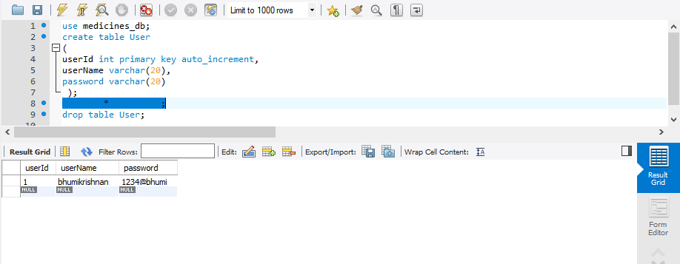

## DATABASE FOR MEDICINES

## 

## LOGIN PAGE

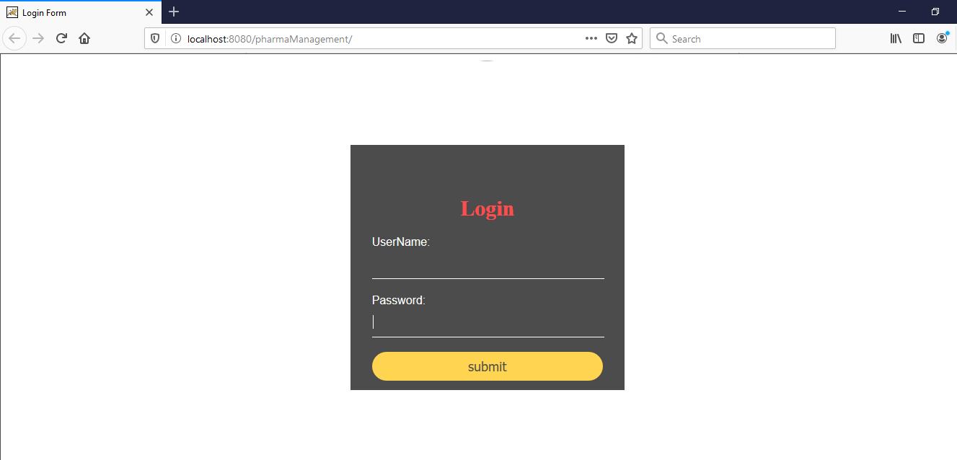

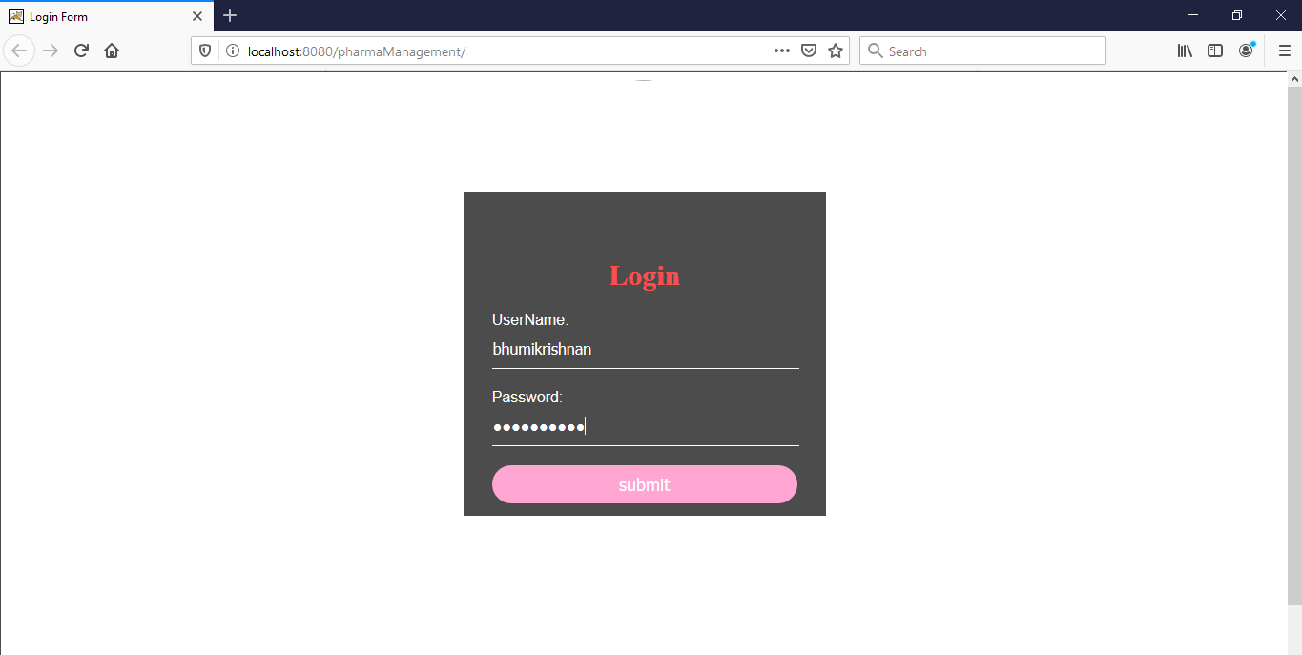

INVALID USERNAME AND PASSWORD :-

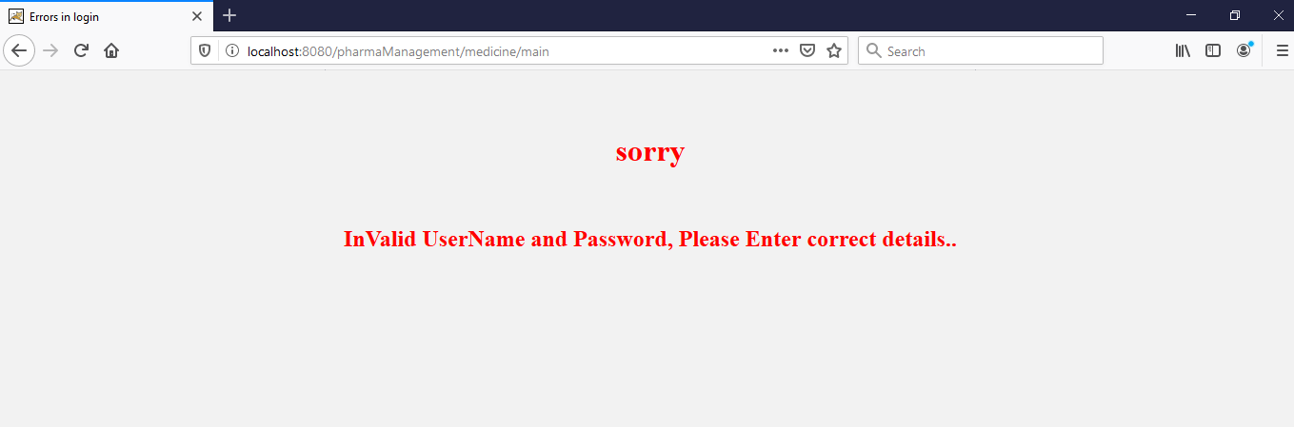

## STORED MEDICAL DATA LIST:

## If username and passwords are correct ,then login button directs medical list.

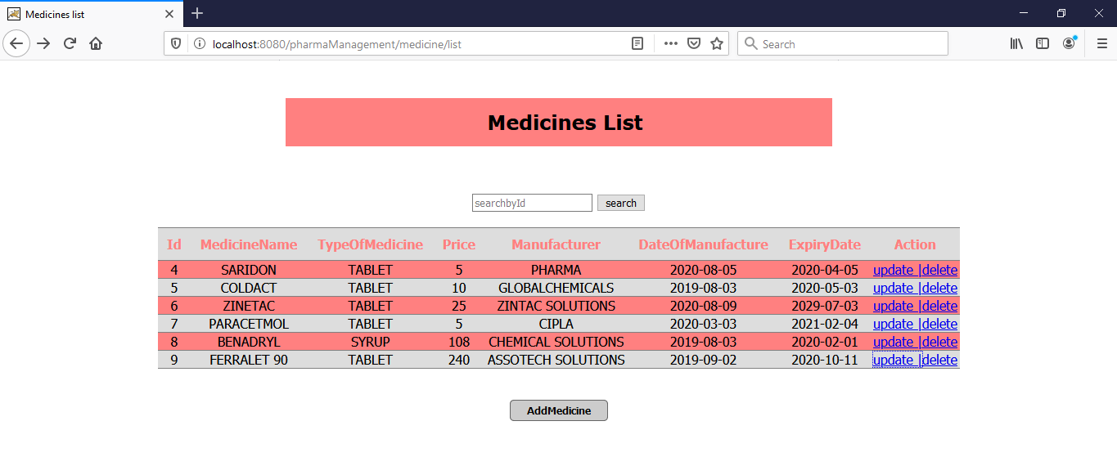

## Data Entry For Medicine

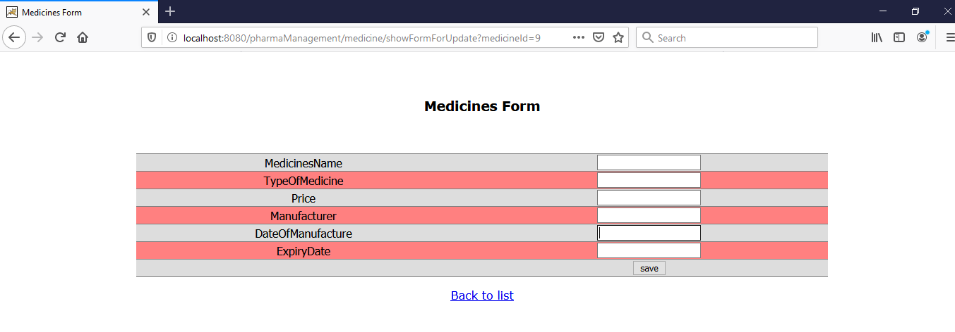

## UPDATE MEDICAL DATA:-

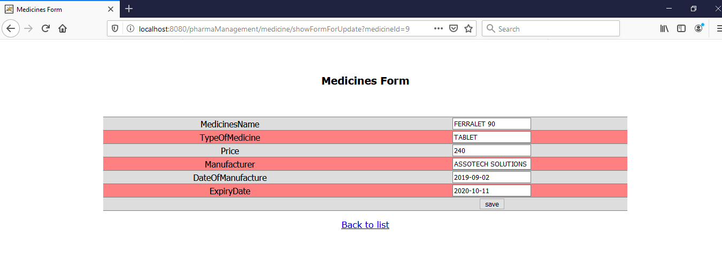

## DELETE MEDICAL DATA:-

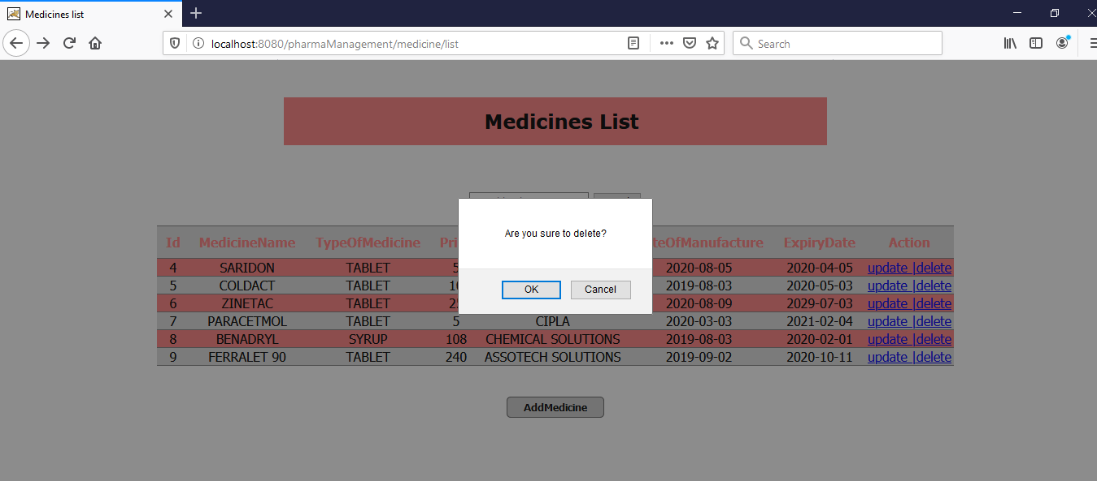

## DATA AFTER DELETE :-

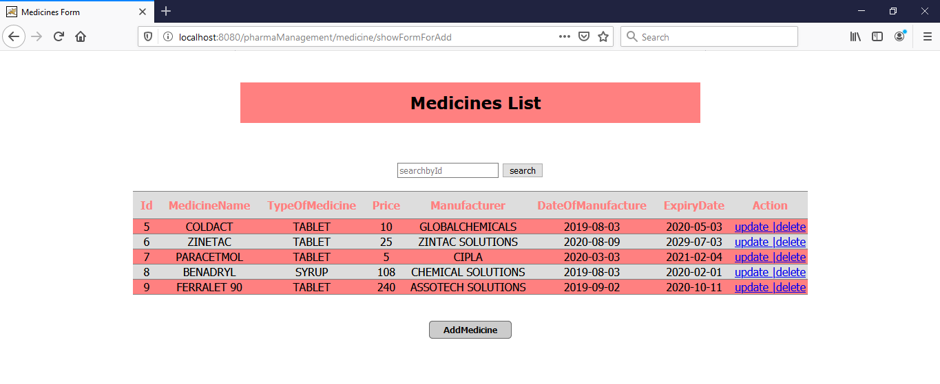

6. CONCLUSION AND FUTURE WORK

In this report pharmacy management system was studied. This system includes the login page and the next page has details like the type of medicine,name,expiry date,its availability. This system helps the pharmacies to maintain records of all the medicines.It shows the availability and unavailability of the medicines.It can be used by various pharmacies because maintaining the records manually may lead to problems and inaccuracy.

Today management is one of the most essential features of all form. Management provides sophistication to perform any kind of task in a particular form. This is pharmacy management system; it is used to manage most pharmacy related activities in the pharmacy. The primary aim is to improve accuracy and enhance safety and efficiency in the pharmaceutical store. In this project we can also include BAR CODE facility using the bar code reader, which will detect the expiry date and the other information about the related medicines.

Future work

1.Developing an application for android devices that

works on the same database which is the mini of

(MySql).

2. Have a barcode device but not the normal one actually special one that can be used in remote connected by either Bluetooth or Wi-Fi network .

7.REFERENCES

1.https://docs.spring.io/spring/docs/current/spring-framework-reference/

2.https://docs.spring.io/spring/docs/current/spring-framework- reference/core.html#spring-core

3.https://docs.spring.io/spring/docs/current/spring-framework-reference/web.html

4.https://hibernate.org/orm/documentation/5.0/

5.https://maven.apache.org/guides/getting-started/index.html