**Operational Analytics & Metric Spike Investigation Using SQL**

**Project Description:**

This project focuses on operational analytics and metric spike investigation for a tech company.

The objective is to analyse organizational data using advanced SQL techniques to uncover insights that support various departments such as operations, marketing, and support.

**Approach:**

The analysis was conducted using **SQL queries** in **MySQL Workbench** to extract and analyse data from a relational database containing jobs, users, events and email information.

The process involved:

* Understanding database schema and relationships.
* Writing optimized SQL queries to answer business questions.
* Interpreting data patterns to derive insights.

**Tech-Stack Used:**

Used SQL and MySQL Workbench as tool to analyse data provided and answer questions posted by the management team.

**Insights:**

**Case Study 1: Job Data Analysis**

1. **Jobs Reviewed Over Time**
   * Identified number of jobs reviewed per hour for each day during November 2020.
2. **Throughput Analysis**
   * The 7-day rolling average of throughput helped smooth out daily fluctuations.
3. **Language Share**
   * Over the last 30 days, **Persian** dominated job reviews with **37.50%,** followed by **English** and **Arabic**.
   * This insight can guide resource allocation for language-specific reviewers.
4. **Duplicate Detection**
   * Detected that there are no duplicate job entries.

**Case Study 2: Metric Spike Investigation**

1. **Weekly User Engagement**
   * User Engagement increased steadily week over week, with a spike observed after new feature rollouts.
2. **User Growth Analysis**
   * Continuous growth in new user signups, with a notable increase in the first week of each month
3. **Weekly Retention**
   * Week 69 retention averaged around 11.50%, with a good increase in Week 70 (15.38%).
4. **Engagement per Device**
   * **Dell Inspiron notebook** device accounted highest user engagement with 49 users active.
   * **Amazon fire phone** device accounted lowest user engagement with just 4 users active for the device.
5. **Email Engagement**
   * Email open rate was approximately **33.58%,** and click-through rate was **~14.79%.**
   * Total no. of emails sent were **60920** and total no. of email opened were **20459**.

**Result:**

* Successfully created SQL queries to answer investor-focused questions.
* Gained hands-on experience in data extraction and pattern recognition using MySQL.
* Developed a deeper understanding of identifying anomalies and engagement trends in user behaviour.
* The project reinforced how simple, structured queries can unlock high-value business insights from raw data.

This analysis can support decision-making around:

* Device and language segmentation can optimize content delivery and user experience strategies
* User engagement and retention are strongly influenced by product changes and marketing timing.
* Rolling averages and cohort analysis provide deeper insights than daily snapshots.

**Drive Link:**

[**https://drive.google.com/drive/folders/1FhaAjbFUdk2z7yxiU36HoG3aeP9LgsiS?usp=drive_link**](https://drive.google.com/drive/folders/1FhaAjbFUdk2z7yxiU36HoG3aeP9LgsiS?usp=drive_link)

SQL Tasks: - Case Study 1-Job Data

1. Jobs Reviewed Over Time: Calculate the number of jobs reviewed per hour for each day in November 2020.

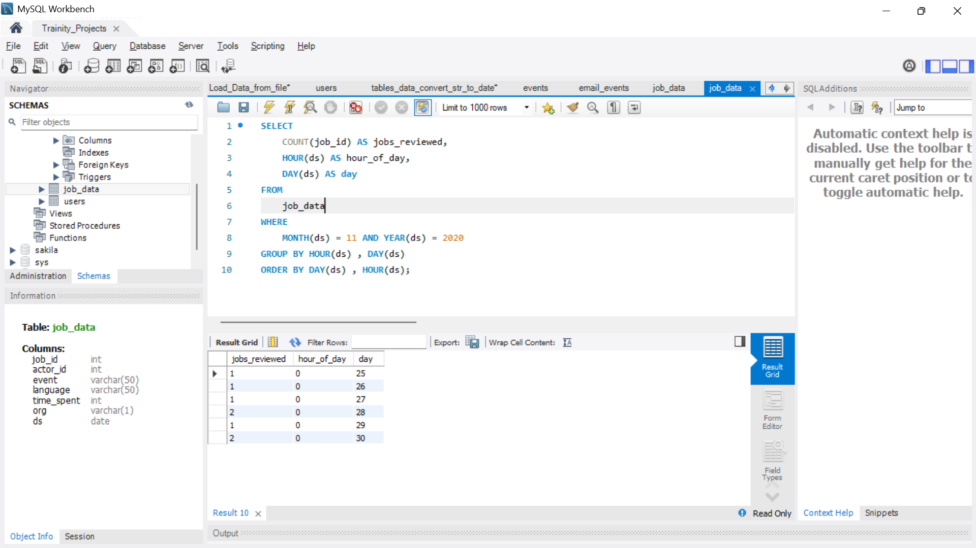

B. Throughput Analysis Task:  Calculate the 7-day rolling average of throughput (number of events per second)

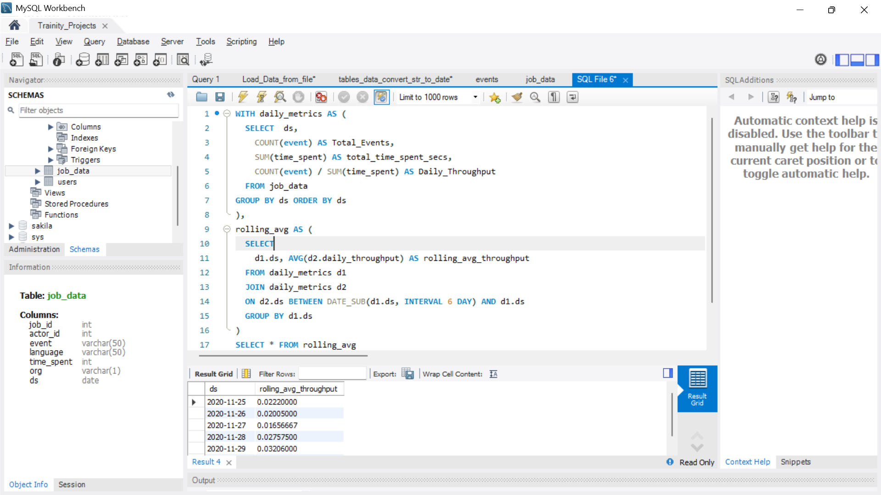

C. Language Share Analysis Task:  Calculate the percentage share of each language in the last 30 days.

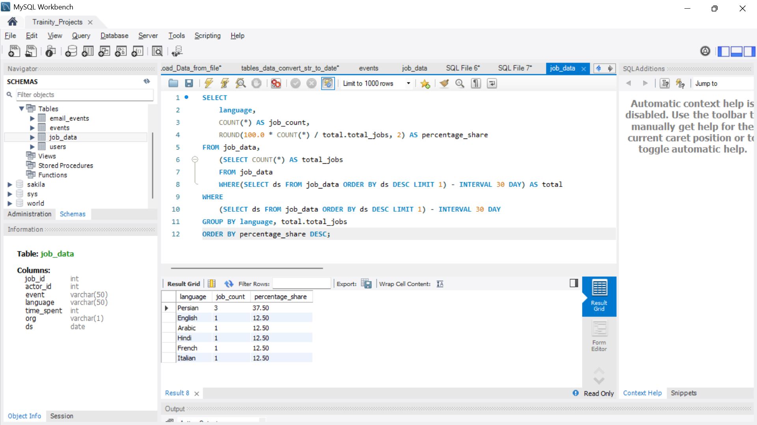

D. Duplicate Rows Detection:  Identify duplicate rows in the data.

Insights: There are no duplicate rows in a table

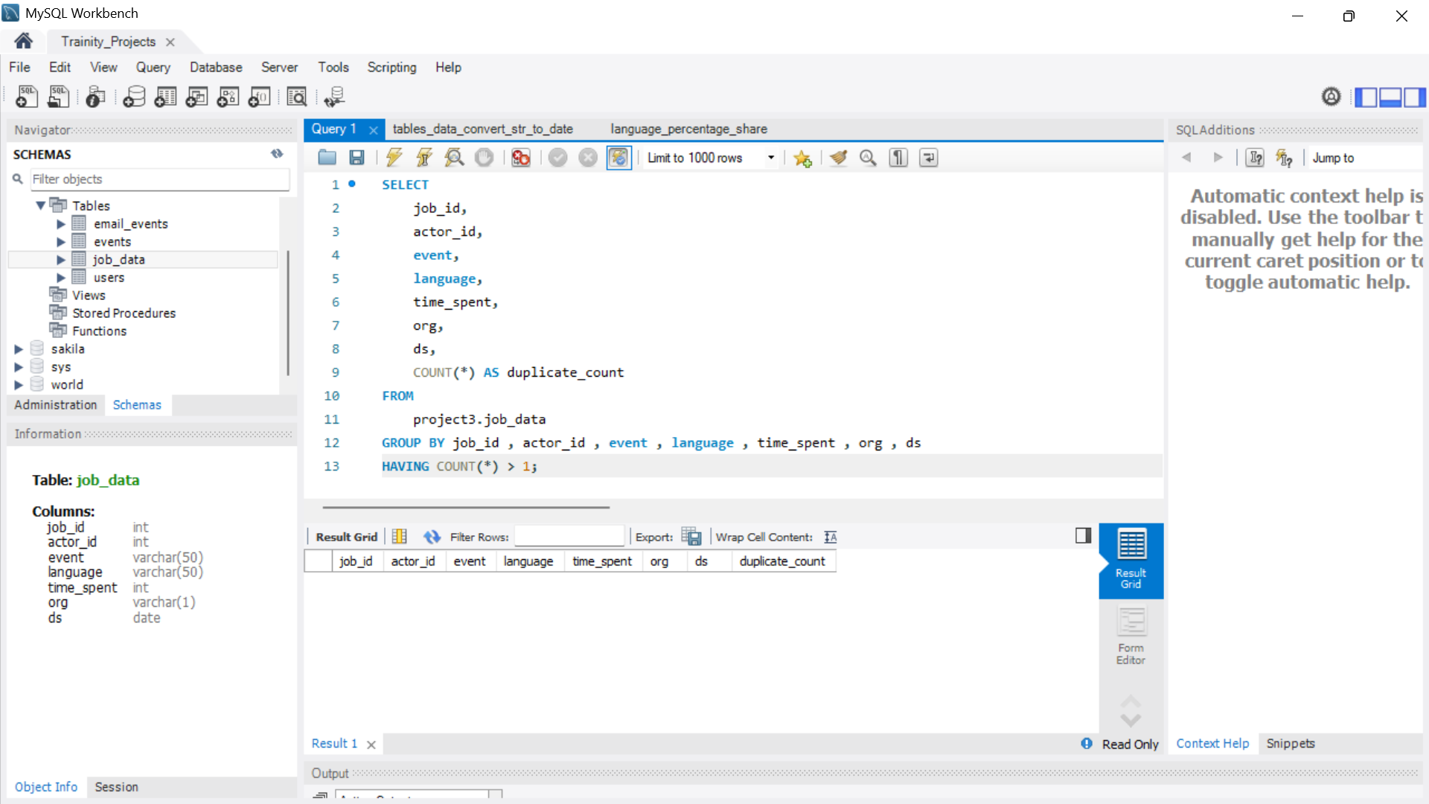

Case Study 2: Investigating Metric Spike

A. Weekly User Engagement: Measure the activeness of users on a weekly basis.

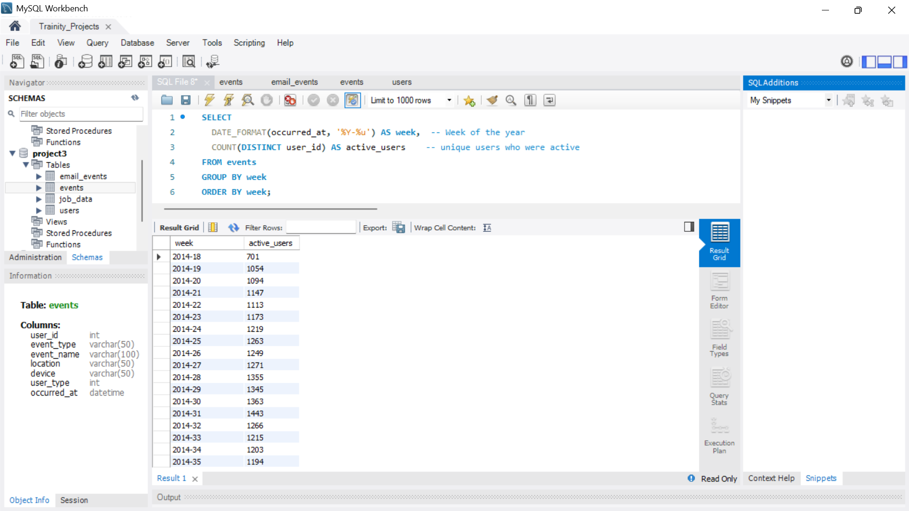

B. User Growth Analysis: Analyse the growth of users over time for a product.

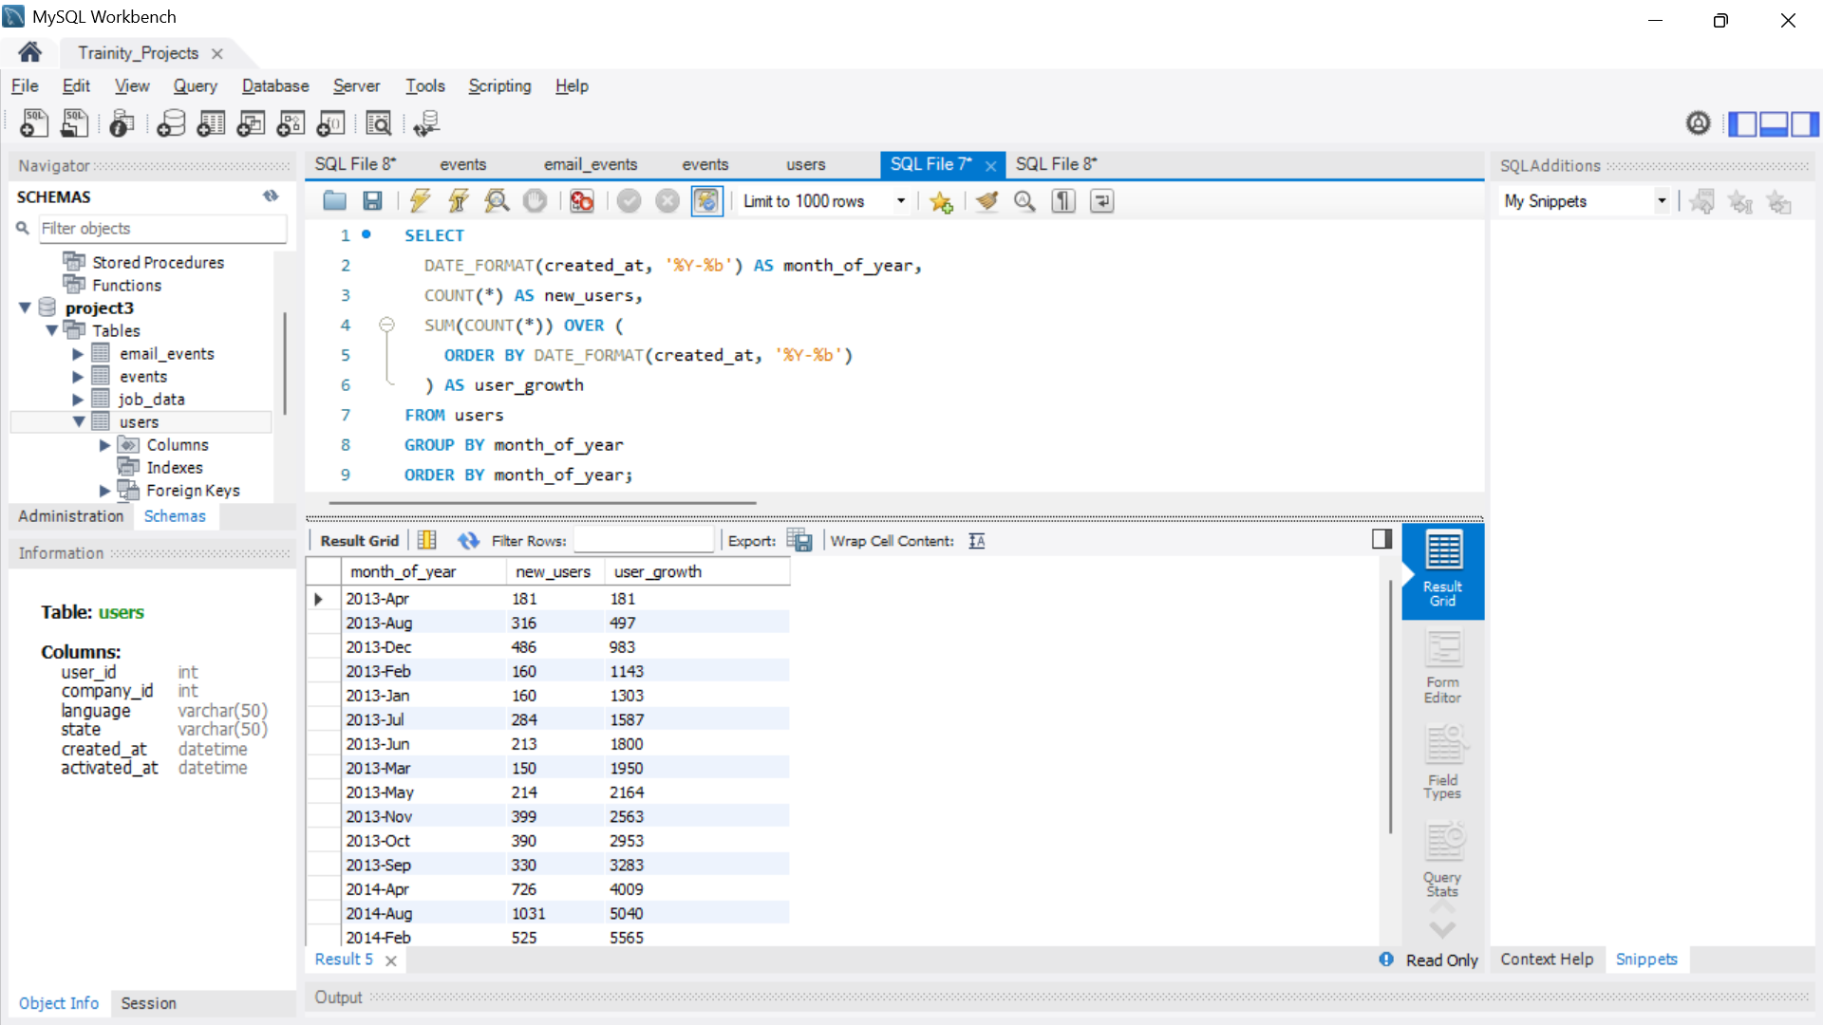

C. Weekly Retention Analysis: Analyse the retention of users on a weekly basis after signing up for a product.

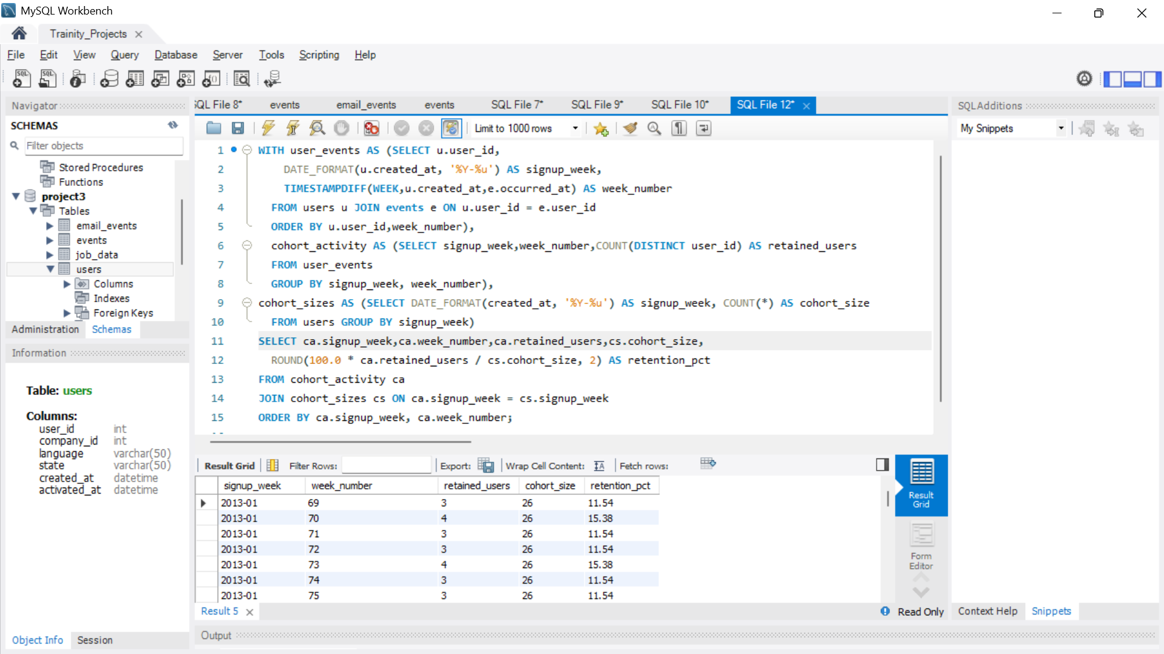

D. Weekly Engagement Per Device: Measure the activeness of users on a weekly basis per device.

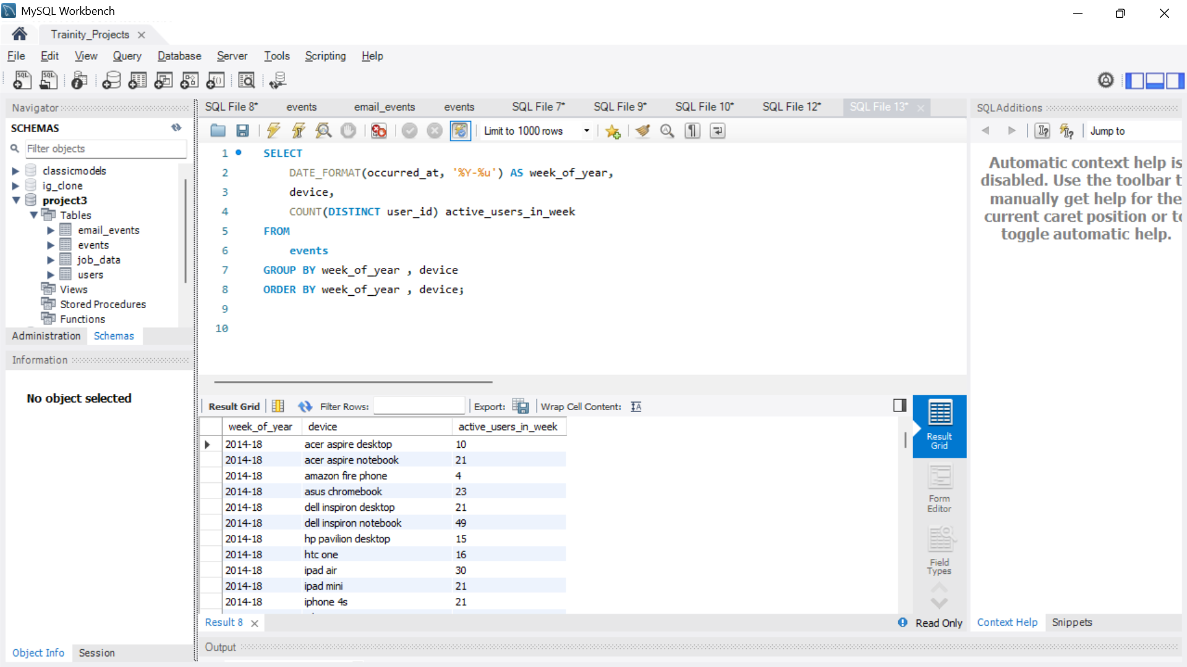

E. Email Engagement Analysis Task: Analyse how users are engaging with the email service.

