# SEA400- Assignment 2

| Total Mark: | 10 marks |
| --- | --- |
| Submission file(s): | * Asg2.docx * search.py with your solution |

Please work in **groups** to complete this lab. This lab is worth 7% of the total course grade and will be evaluated through your written submission, as well as the lab demo. During the lab demo, group members are *randomly* selected to explain the submitted solution. Group members absent during the lab demo will lose the demo mark.

Please submit the submission file(s) through Blackboard. Only one person must submit for the group and only the last submission will be marked.

## **Part I: Search Algorithms**

1. In this assignment, you will be implementing uninformed and heuristic search algorithms. You will be using code from

[Project 1 - Search - CS 188: Introduction to Artificial Intelligence, Spring 2022 (berkeley.edu)](https://inst.eecs.berkeley.edu/~cs188/sp22/project1/)

Download and unzip <https://inst.eecs.berkeley.edu/~cs188/sp22/assets/files/search.zip>.

1. In Anaconda Navigator, go to Environments tab and click on the triangle next to SEA400. Choose “Open Terminal”.

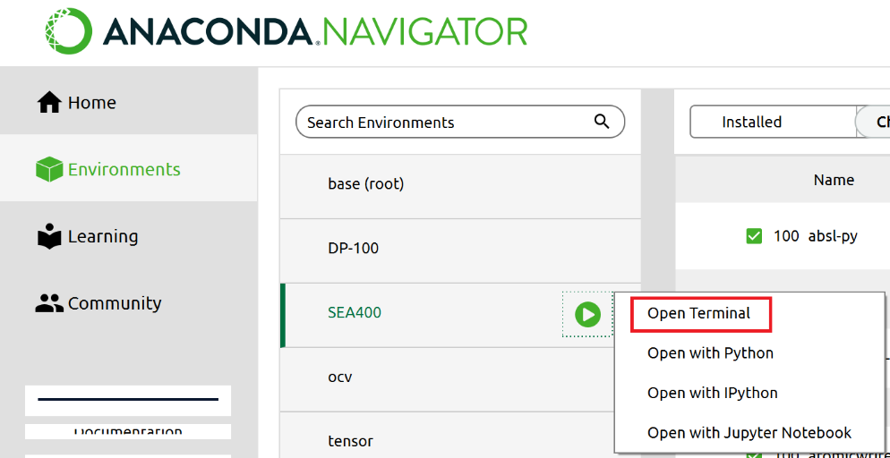

Change directory to the unzipped folder, for example (this may be different from your path):

cd C:\SEA400\search

Keep this terminal open and run code here. For example, you can play a game of Pacman by running:

python pacman.py

1. Open Anaconda Navigator, activate SEA400 environment and launch VS Code (or your editor). Open above unzipped folder.
2. Follow instructions to solve and test questions 1 to 4 from above link (Project 1).
3. If you want to use the debugger in VS code, see:

[Debugging in Visual Studio Code](Debugging%20in%20Visual%20Studio%20Code) <https://code.visualstudio.com/Docs/editor/debugging>

For example, to run the debugger with *autograder.py* test samples for question 1, change *launch.json* to include

"args": ["-q", "q1"],

## **Part II: Run Tests**

Paste screenshots of the results of the following commands here:

python autograder.py -q q1

Result:

python autograder.py -q q2

Result: 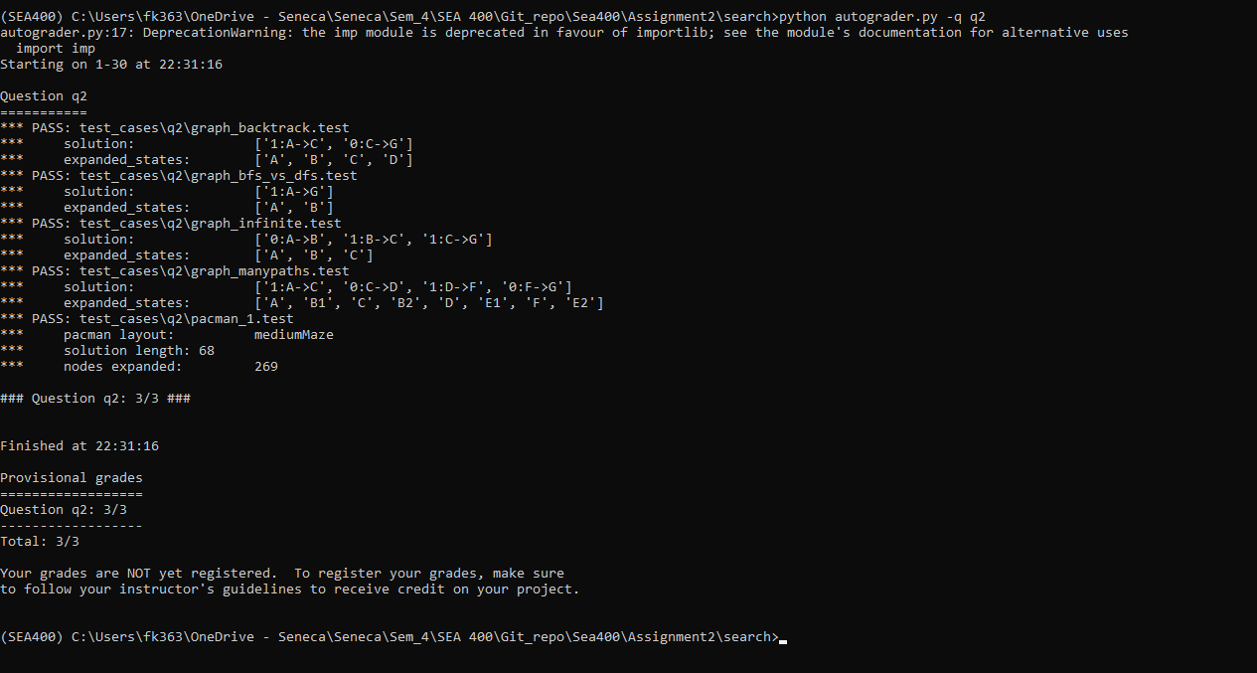

python autograder.py -q q3

Result:

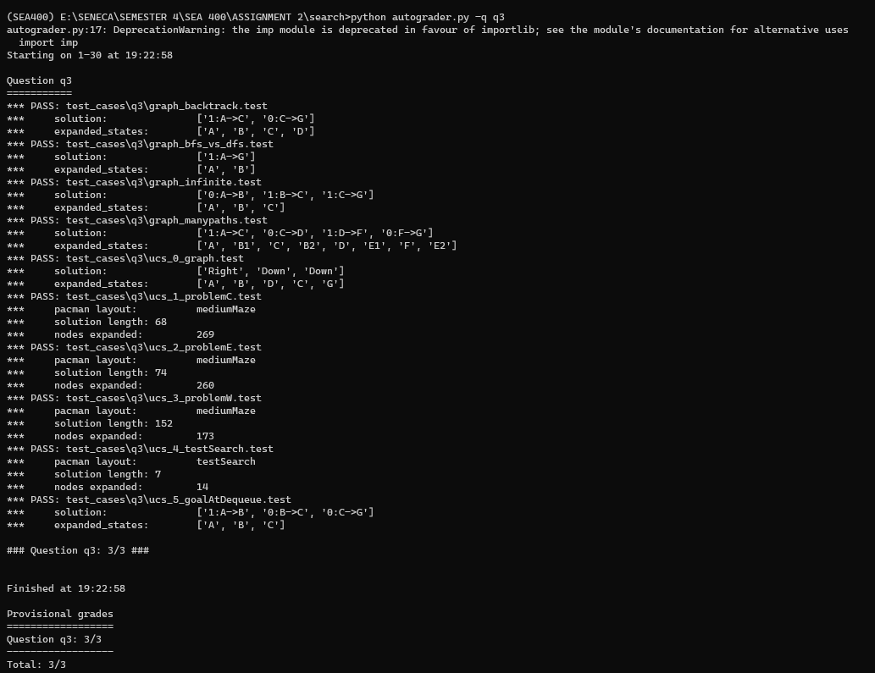

python autograder.py -q q4

Result:

python submission_autograder.py

Result:

## **Part III: Group work**

1. Complete this declaration by adding your names:

We, FAHAD ALI KHAN, TANISH NARESH KALATHIYA, MOHAMMED AERAF KHAN , declare that the attached assignment is our own work in accordance with the Seneca Academic Policy. We have not copied any part of this assignment, manually or electronically, from any other source including web sites, unless specified as references. We have not distributed our work to other students.

1. Specify what each member has done towards the completion of this work:

|  | Name | Task(s) |
| --- | --- | --- |
| 1 | FAHAD ALI KHAN | EVERYONE CONTRIBUTED IN EACH TASK. |
| 2 | TANISH NARESH KALATHIYA | EVERYONE CONTRIBUTED IN EACH TASK. |
| 3 | MOHAMMED AERAF KHAN | EVERYONE CONTRIBUTED IN EACH TASK. |