**Interpreting the Results!!**

1. **Age has a Higher Impact On Re-Admission**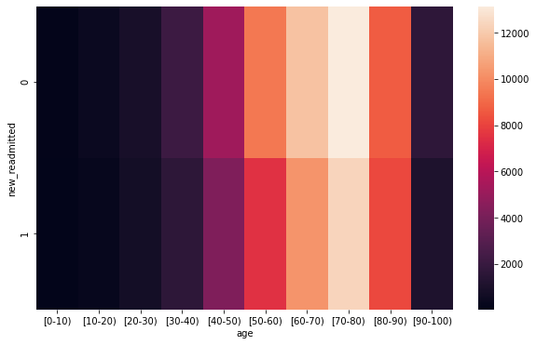

# Here from the above heatmap we can clearly see that "70-80 Age-Group", was mostly Re-Admitted.

# This Age has a Higher impact on Re-Admission.

1. **African-Americans are more likely to be re-admitted than other ethnic groups**

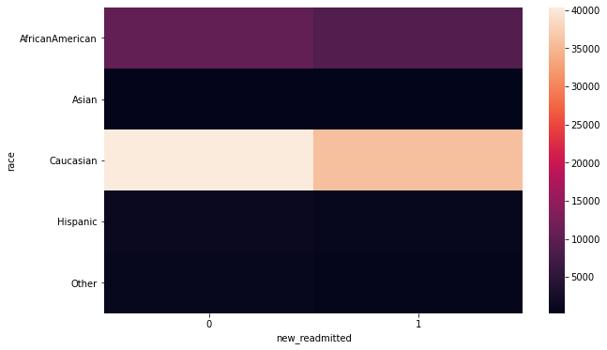

# The above HeatMap shows that the Caucasian Race is more likely to be re-admitted than other ethnic groups.

1. **Women patients are more likely to be re-admitted than men**

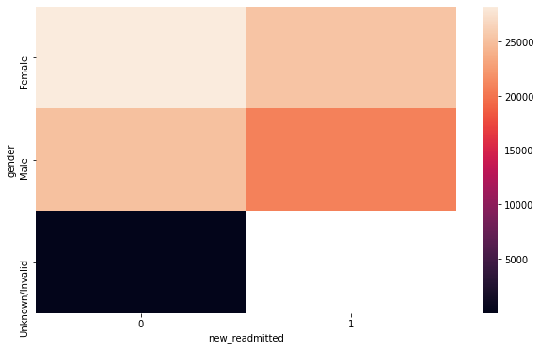# From the above HeatMap we can clearly see that Women patients are more likely to be re-admitted than men.

1. **Diagnose types have a higher impact on re-admission rates. For this purpose, you need to take into account the icd_codes and plot say diag_1 vs readmitted  
   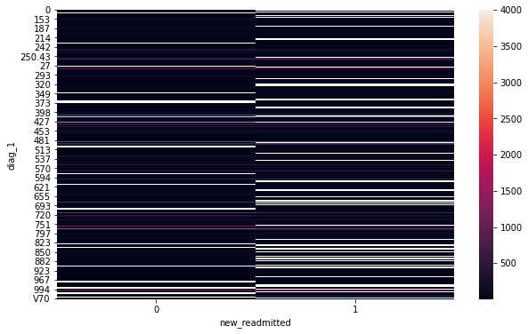**
2. **Diabetic Patient Re-admission Rate**

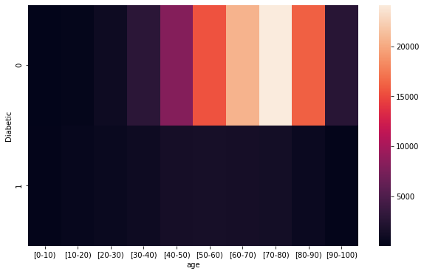

1. **Most occuring- Admitted Age Group**

