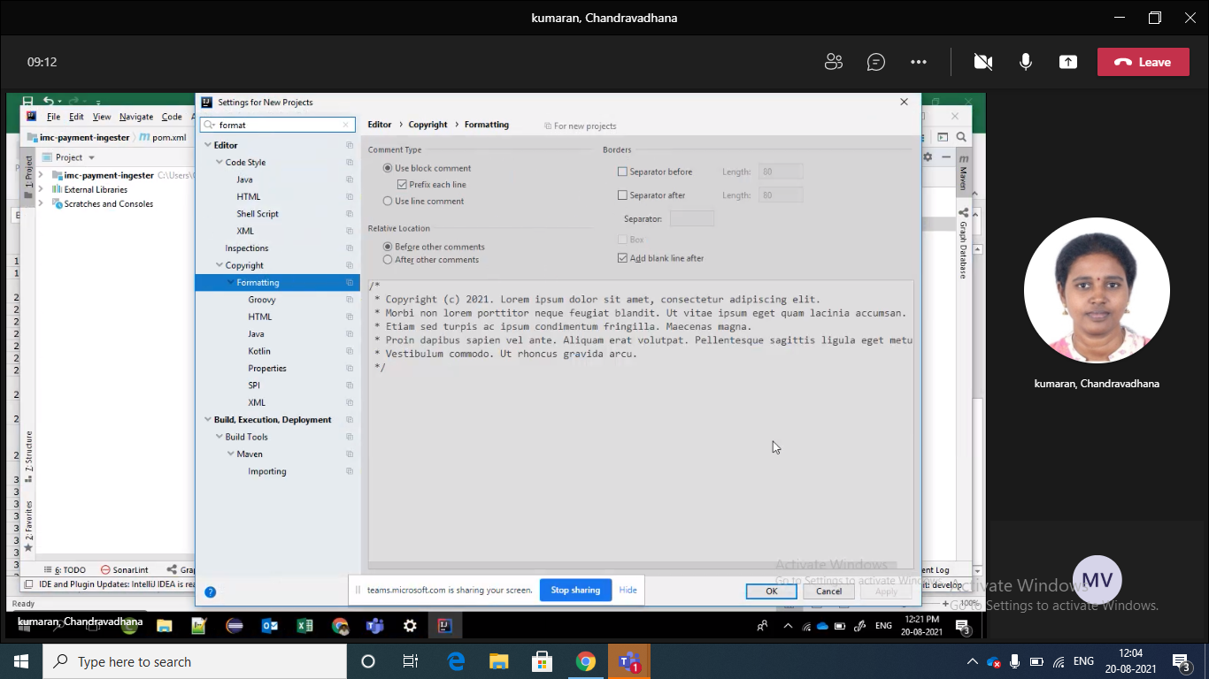

sonarlint

sonar code coverage

dependency

installable

[Yesterday 06:25] kumaran, Chandravadhana

Good videos for SonarLint TekTalk <https://www.youtube.com/watch?v=T3eM5X_ohzI>

​

[Yesterday 06:34] kumaran, Chandravadhana

For maven formatting plugins <https://code.revelc.net/formatter-maven-plugin/examples.html> and <https://code.revelc.net/formatter-maven-plugin/>

What is SonarLint

SonarLint an extension you can add to an IDE such as Visual Studio Code that can provide developers real-time feedback on the quality of the code. It can detect issues in seconds, which can improve productivity. SonarSource describes SonarLint as a capability that can work like a spell checker for text since it detects issues in your code as you go.

1. 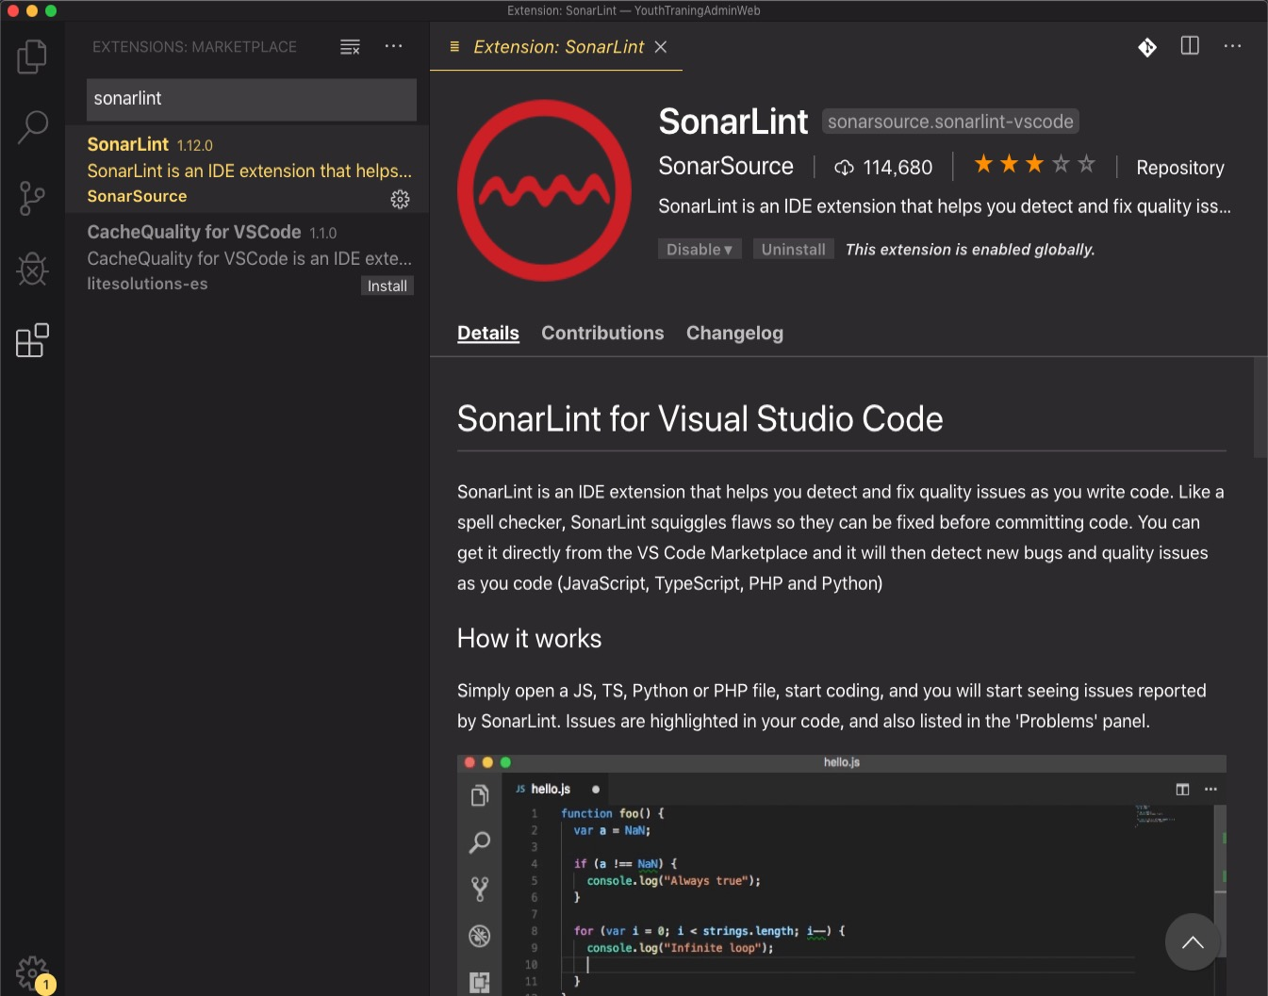
2. Restart/Reload VS Code.
3. In the VS Code Settings, search SonarLint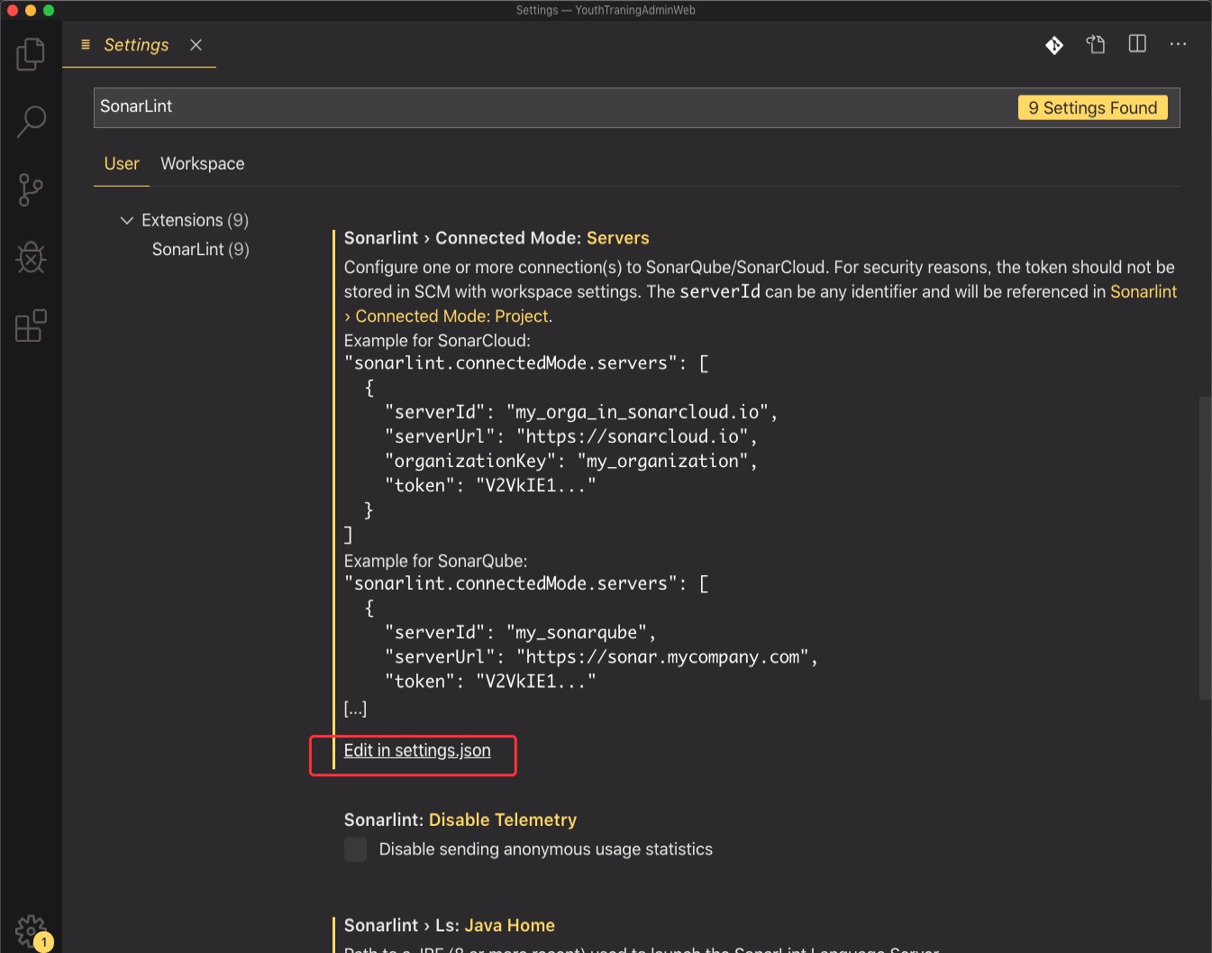
4. Click Edit in settings.json under any setting and set the sonarlint.connectedMode.servers in **User Setings**
5. To configure the SonarLint plugin, you’ll need

* **Add serverId with a value you will remember (it is used locally only)**
* **Add token with a token generated in SonarQube**

Go to the homepage of your SonarQube system, click your avatar in the upper right, select **My Account**and select **Security**. Then you can get a token by entering a token name you like.

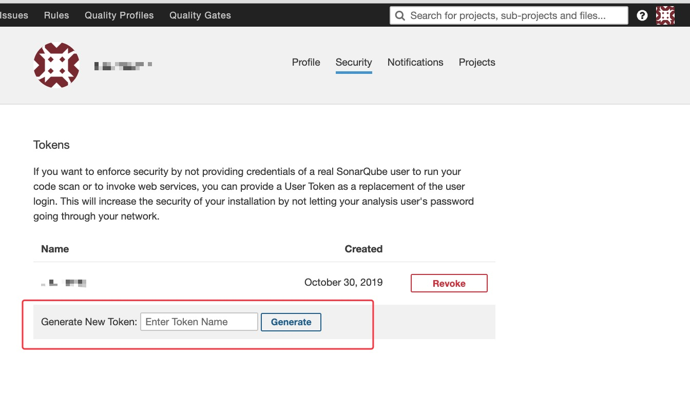

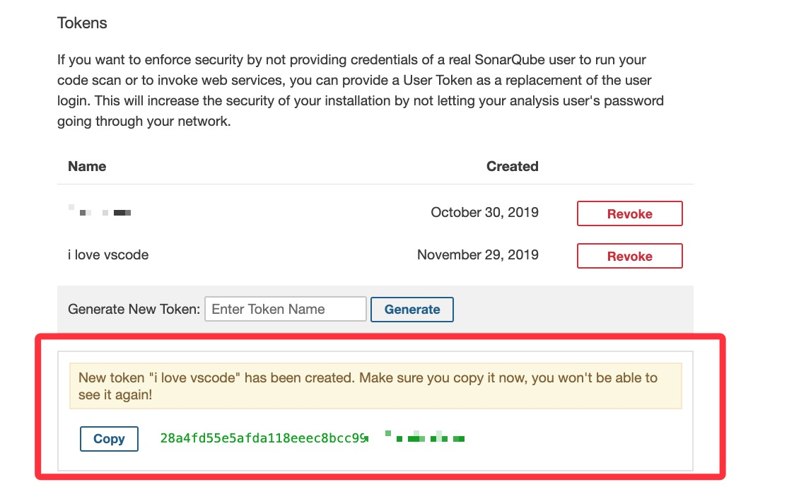

* **Add `serverUrl` as your SonarQube server URL**

You need to be aware of is you can’t copy the address of your SonarQube homepage because the VS Code in our customized operating-system cannot request API with HTTPS protocol. You’ll need to get the server URL with HTTP protocol instead of HTTPS.

For example, the server URL of my project is https://sonarci.wdf.sap.corp:8443/, I set the `serverUrl**`** to `http://sonarci.wdf.sap.corp:8080/sonar`. If you don’t know the server URL with HTTP, you can ask for the platform or project administrator.

You can set several servers.

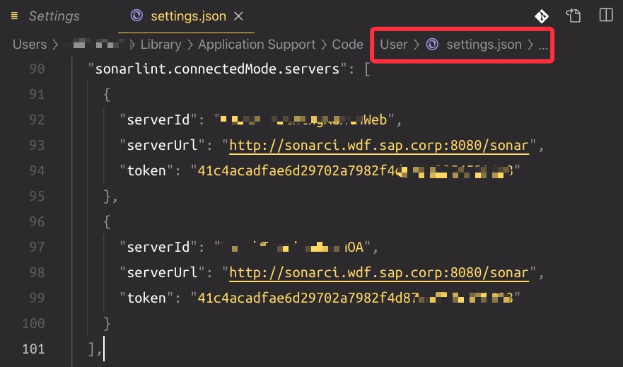

6. set the sonarlint.connectedMode.project in **Workspace Setings**

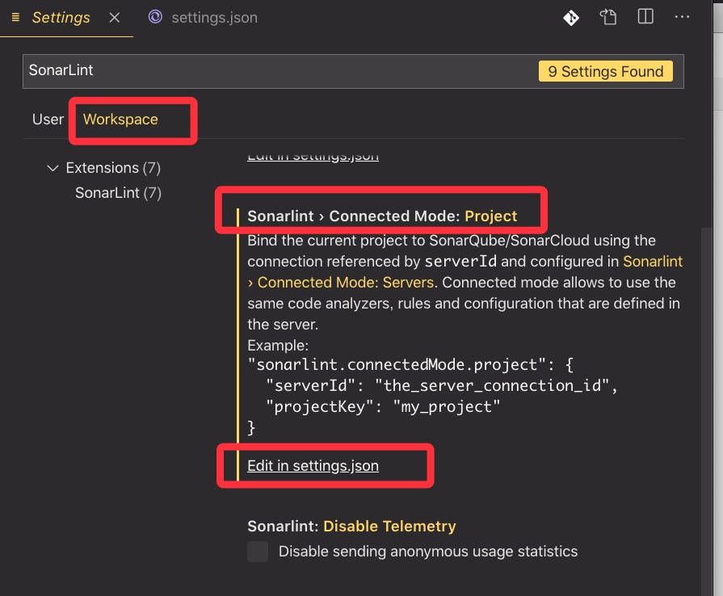

* **Add projectKey with the key of your project on SonarQube server**

Go to the overview page of your project and the key is in the bottom-right corner.

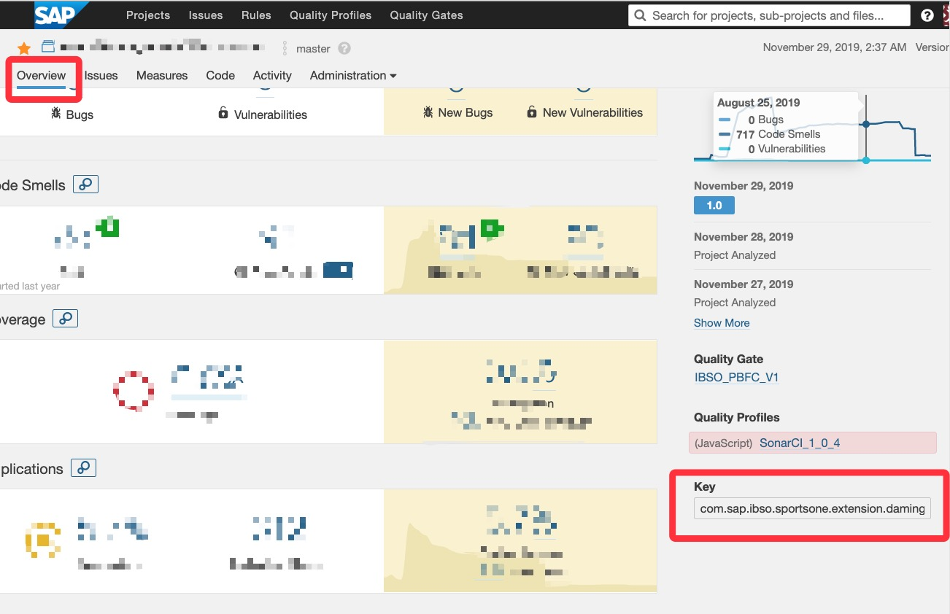

* **Add serverId with the serverId you used when editing your sonarlint.connectedMode.servers settings.**

You can only set one sonar project in the same workspace.

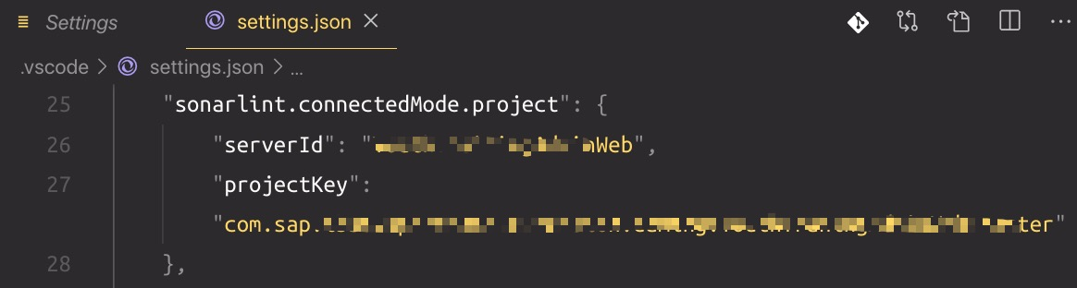

7. Now hit Ctrl+Shift+P (Windows/Linux) or Shift+Command+P(Mac) to open the Command Palette, and type inSonarLint to bring up the SonarLint commands and run “SonarLint: Update all bindings to SonarQube/SonarCloud”. If any changes are made on the SonarQube server you should repeat this step.

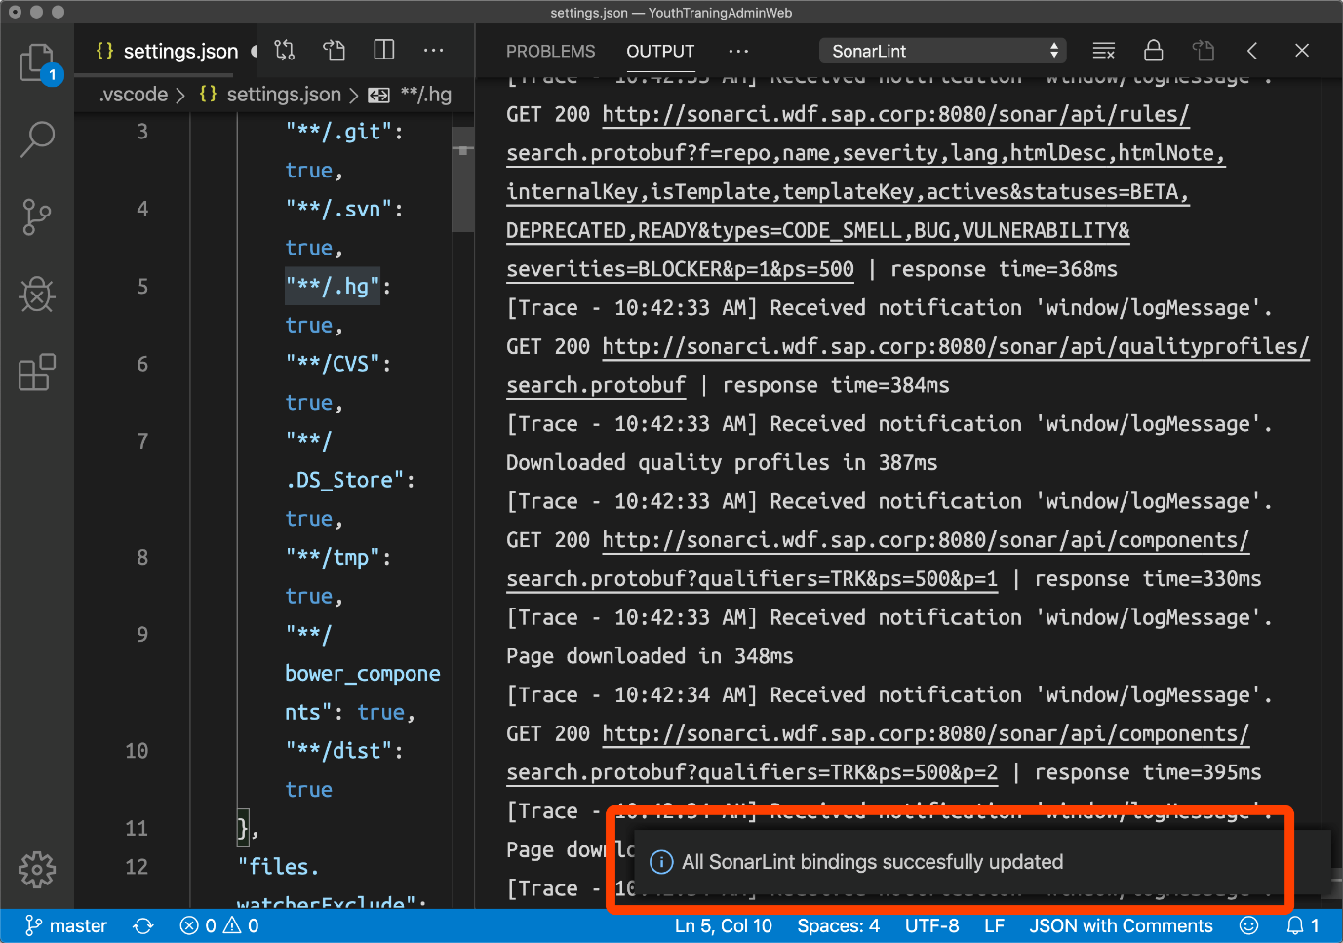

8. Open a file, you will see the issues reported by SonarLint are highlighted(underlined) in your code, and also listed in the ‘Problems’ panel.

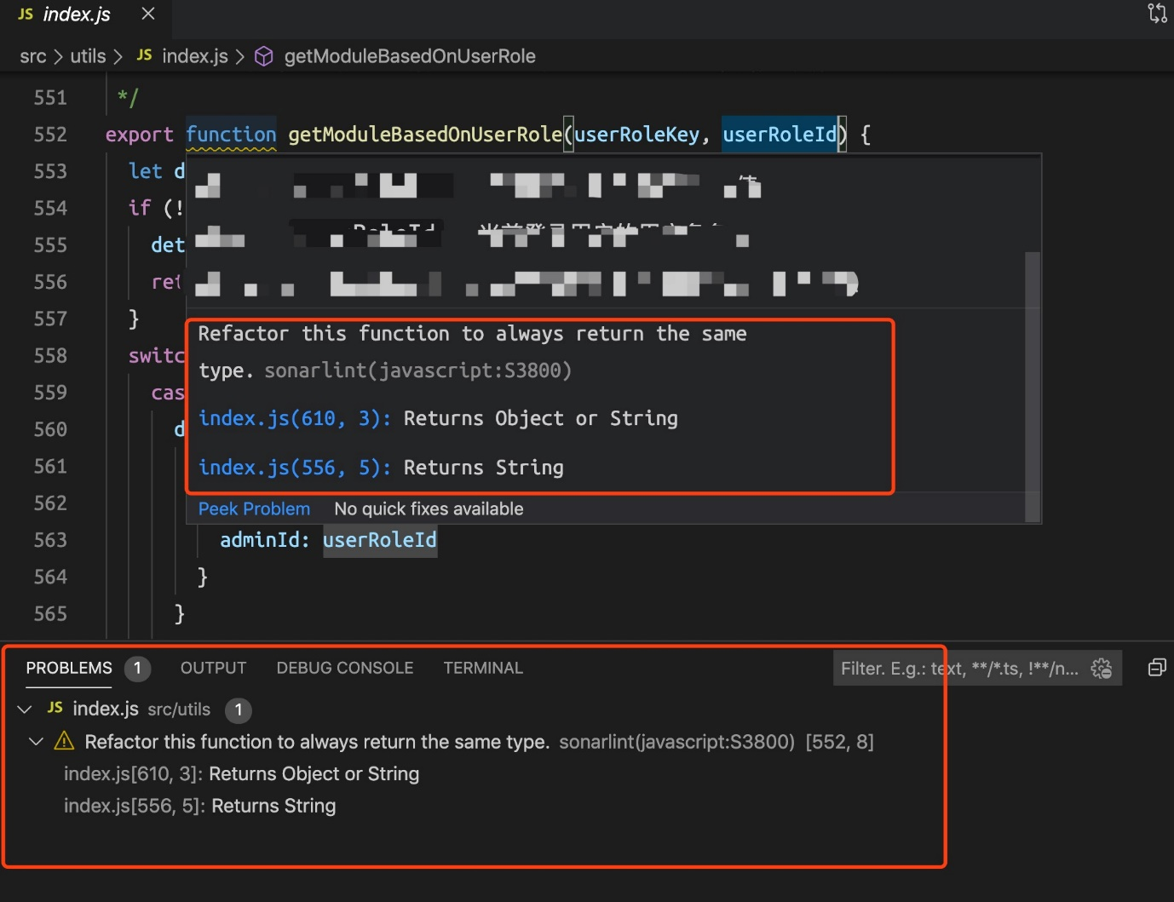

You can access all rules in the SONARLINT RULES section on you right.

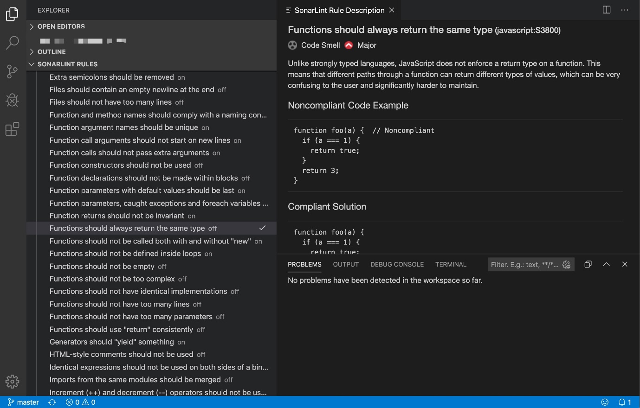

You can also access the detailed rule description directly from your issue in the editor, using the provided contextual menu.

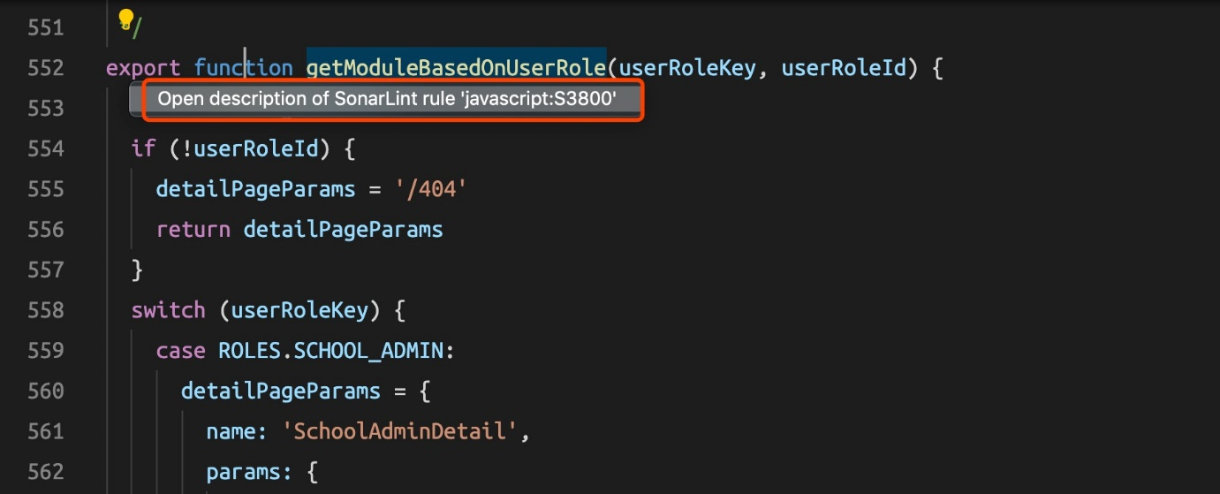

## Conclusion

During my use, I found some tips:

1. If the SonarLint doesn’t work, you can install CodeScan in the Extension Marketplace. CodeScan is almost the same in terms of configuration and uses with SornarLint because the CodeScan repository in GitHub forks SonarLint repository and makes some change. CodeScan even works better when you access F5 VPN with poor network condition.
2. If you change any rule or any information of issue (such as tags, type, severity, assignment, and status)  on SonarQube remote server, besides updating project bindings, you also need to reopen the file in editor.

SonarLint is a wonderful tool, but it also has some drawbacks. I think the biggest weakness of SonarLint (or CodeScan) is that it can’t show all issues of a project locally, you must open a certain file in editor then you can only get issues of this file. If you are interested, you can try to solve this problem.

FollowLikeRSS Feed