**Samsung PRISM**

**Classification of Video into Actions and Events - Group Activity**

**Details of the dataset collected till date:**

Blowing candle:493 videos

Cake cutting: 404 videos

Hugging: 254 videos

Laughing:570 videos

Screaming:320 videos

**MODEL ACCURACY ACHIEVED BY THE TEAM MEMBERS:**

**MODEL: [MADHURA C S -1MS17CS055]**

**Training:**

Number of videos considered for training:1454

Number of videos considered for training for each class: -

Blowing Candle=300

Cake cutting=300

Hugging=254

Laughing=300

Screaming=300

Best Precision:93.960

Epoch:20

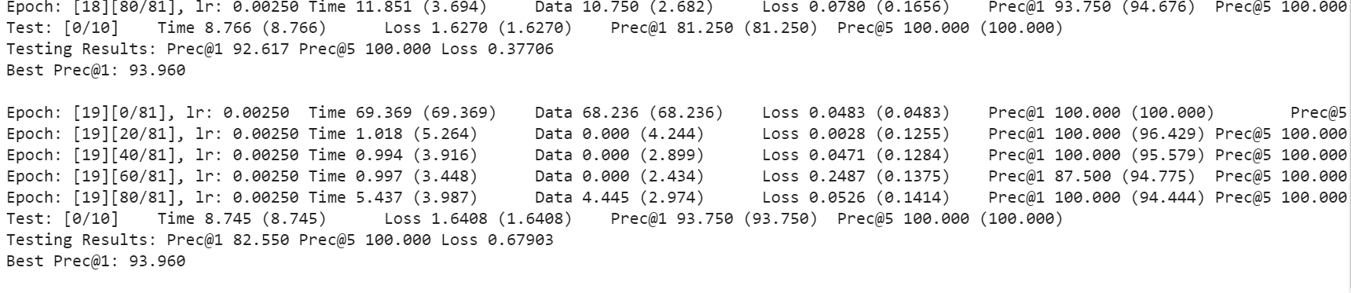

**Testing:**

Number of videos considered for testing (different dataset):50

Class Accuracy achieved:70.00%

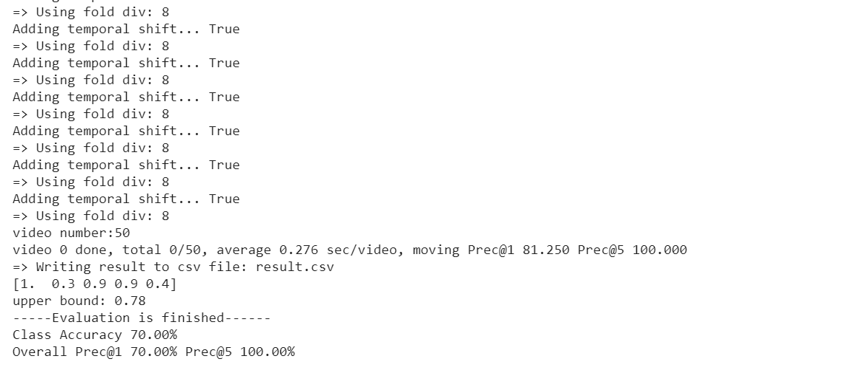

**MODEL: [ROJA -1MS19CN09]**

**Training:**

Number of videos considered for training:1400

Number of videos considered for training for each class: -

Blowing Candle=300

Cake cutting=300

Hugging=200

Laughing=300

Screaming=300

Best Precision:77.5

Epoch:20

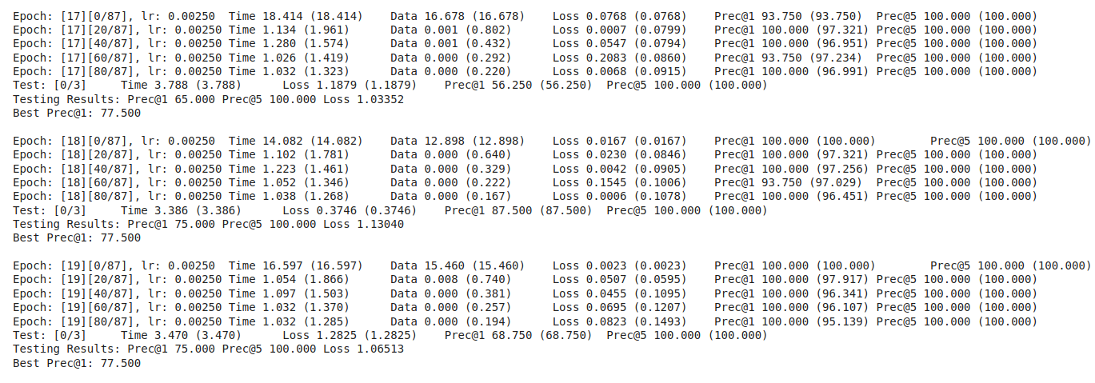

**Testing:**

Number of videos considered for testing (different dataset):40

Class Accuracy achieved:75.24%

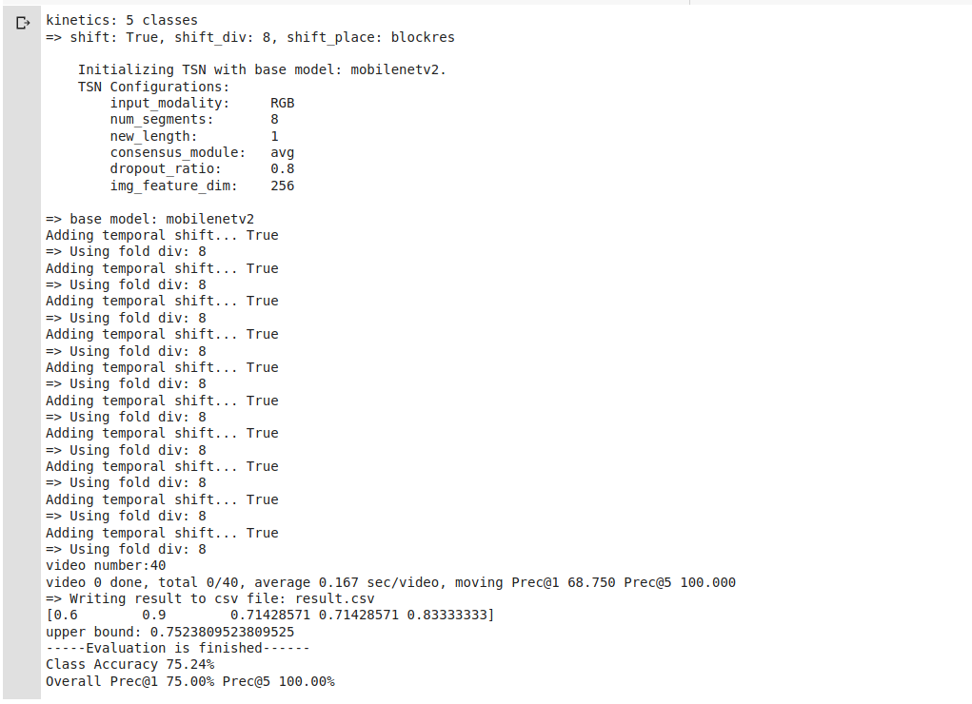

**MODEL**: [SPANDANA S -1MS17CS104]

**Training:**

Number of videos considered for training: 250 (50 videos of each class)

Best precision: 88%

No of epochs: 10

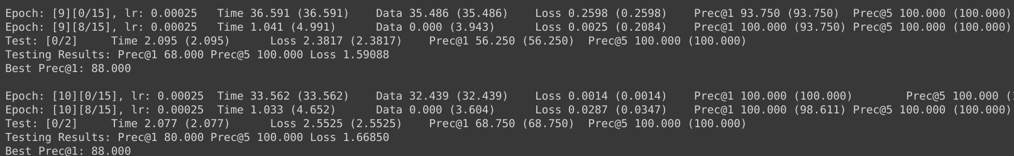

**Testing:**

Number of videos considered for testing: 25 (5 videos of each class)

Class accuracy obtained: 40%

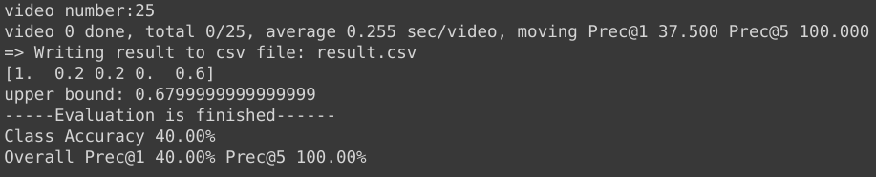

**MODEL:[JASHWANTH-1MS17EC045]**

**Training:**

Number of videos considered for training:800

Number of videos considered for training for each class: -

Blowing Candle=200

Cake cutting=200

Hugging=200

Laughing=200

Best Precision: 56.20%

Epoch:20

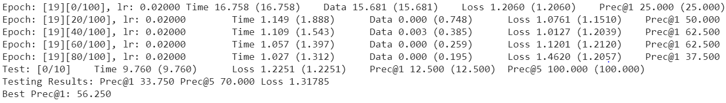

**Testing:**

Number of videos considered for testing (different dataset):120

Class Accuracy achieved:56.67 %

