Assignment No 2A
(Employee Schema)

Create following tables in MYSQL

● Dept ( Dept_id, Dept_name,Dept_location ,)

create table Dept(dept_id int primary key, dept_name varchar(20) not null, dept_location varchar(40));
Query OK, 0 rows affected (0.18 sec)

● Employee( Emp_id, Dept_id, Emp_fname, Emp_lname, Emp_Position, Emp_salary,Emp_JoinDate)

create table Employee(emp_id int primary key, dept_id int, emp_fname varchar(20), emp_lname varchar(20), emp_postion varchar(20), emp_salary int, emp_joindate date)

create table Employee(emp_id int primary key, dept_id int, emp_fname varchar(20), emp_lname varchar(20), emp_pos varchar(30), emp_salary int, emp_joindate Date, CONSTRAINT fkdept FOREIGN KEY (dept_id) references Dept(dept_id)

alter table Employee add constraint fk_dept foreign key(dept_id) referen
ces Dept(dept_id) on delete cascade;
Query OK, 6 rows affected (0.88 sec)
Records: 6 Duplicates: 0 Warnings: 0

● Project( Proj_id,Dept_id ,Proj_Name,Proj_Location,Proj_cost,Proj_year)

create table Project(proj_id int, dept_id int, proj_name varchar(30), proj_location varchar(40), proj_cost int, proj_year int);
Query OK, 0 rows affected (0.17 sec)

alter table Project add constraint fk_deptt foreign key(dept_id) references Dept(dept_id) on delete cascade;
Query OK, 7 rows affected (0.71 sec)
Records: 7 Duplicates: 0 Warnings: 0

1. Insert at least 10 records in the Employee table and insert other tables accordingly

insert into Employee values(1, 101, 'Madhura', 'Pawar', 'Manager', 200000, '2026-06-15');
Query OK, 1 row affected (0.04 sec)

insert into Employee values(2, 101, 'Purti', 'Patil', 'Assisant Manager', 100000, '2026-07-15');
Query OK, 1 row affected (0.06 sec)

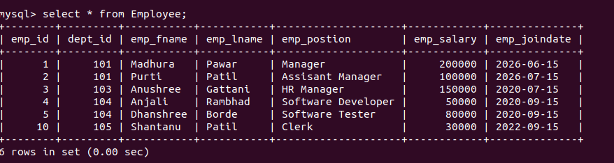
insert into Dept values(102, 'Sales','Pune');
Query OK, 1 row affected (0.04 sec)

mysql> insert into Dept values(103, 'HR','Banglore');
Query OK, 1 row affected (0.03 sec)

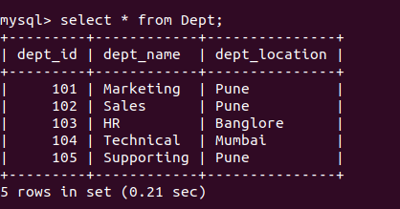

Insert into Project values(5,103,'Hiring', 'Banglore', 100000, 2023 );
Query OK, 1 row affected (0.04 sec)

mysql> Insert into Project values(6,104,'App dev project', 'Mumbai', 400000, 2022 );
Query OK, 1 row affected (0.03 sec)

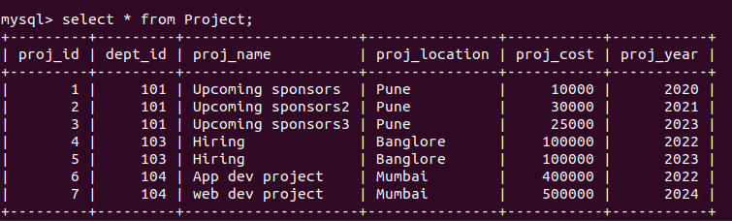

2. Display all Employee details with Department ‘HR’ and ‘Technical’ and Employee first name starting with 'a' or 'h'.

select * from Employee where(dept_id in (select dept_id from Dept where dept_name='HR' or dept_name='Technical') and emp_fname like 'a%' or emp_fname like 'd%');

mysql> select * from Employee inner join Dept on Employee.dept_id = Dept.dept_id where (Dept.dept_name = "HR" OR Dept.dept_name = "Sales") AND (Employee.emp_fname LIKE 'a%' OR Employee.emp_fname LIKE 'h%');

SELECT e.*
FROM Employee e
INNER JOIN Dept d ON e.dept_id = d.dept_id
WHERE (d.dept_name = 'HR' OR d.dept_name = 'Sales')
AND (e.emp_fname LIKE 'a%' OR e.emp_fname LIKE 'h%');

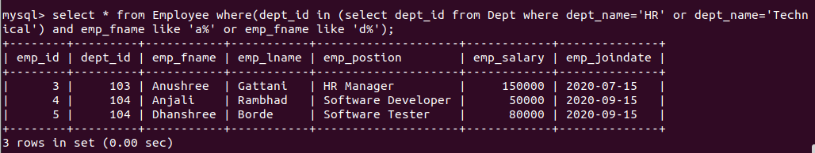

3. lists the number of different Employee Positions.

mysql> select distinct emp_postion from Employee;

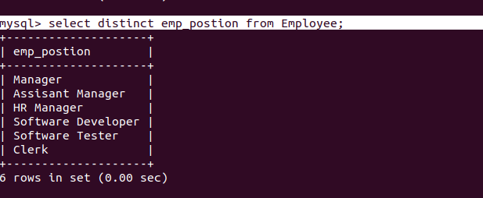

4. Give 10% increase in Salary of the Employee whose joining year is before 2023.

update Employee set emp_salary = emp_salary*1.1 where year(emp_joindate) < 2023;
Query OK, 4 rows affected (0.04 sec)
Rows matched: 4 Changed: 4 Warnings: 0

5. Delete Department details which location is ‘Mumbai’.

delete from Dept where dept_location='mumbai';
Query OK, 1 row affected (0.02 sec)

6. Find the names of Projects with location ‘pune’ .

7. Find the project having cost in between 100000 to 500000.
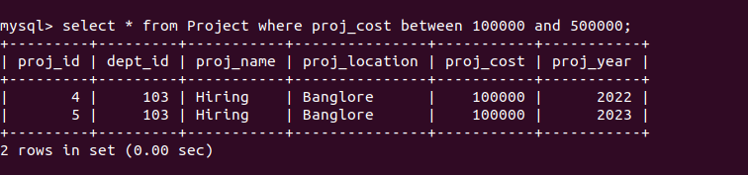

8. Find the project having maximum price and find average of Project cost

select max(proj_cost) as maxcost, avg(proj_cost) as totalcost from Project;

9.Display all employees with Emp _id and Emp name in decreasing order of Emp_lname

select emp_id, concat(emp_fname,' ', emp_lname) as emp_name from Employee order by emp_lname desc;

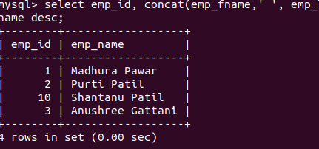

10.Display Proj_name,Proj_location ,Proj_cost of all project started in 2024,2020

mysql> select proj_name, proj_location, proj_cost from Project where(proj_year=2023 or proj_year=2021);

or

by IN operator

mysql> select proj_name, proj_location, proj_cost from Project where proj_year in (2021, 2023);

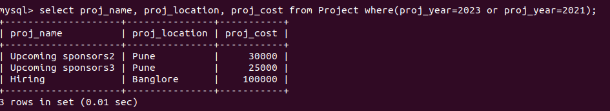

View

1)Simple View

create view EmployeeView as select emp_id , emp_fname, emp_lname, emp_salary from Employee;

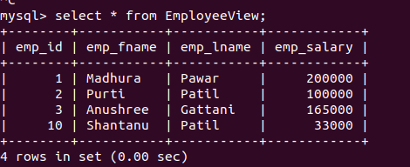

2)Complex View

CREATE VIEW DPEView AS
SELECT d.dept_id, d.dept_name, d.dept_location,
p.proj_id, p.proj_name, p.proj_cost,
e.emp_id, e.emp_fname, e.emp_lname, e.emp_salary
FROM
Dept d
LEFT JOIN
Project p ON d.dept_id = p.dept_id
LEFT JOIN
Employee e ON d.dept_id = e.dept_id;
Query OK, 0 rows affected (0.04 sec)

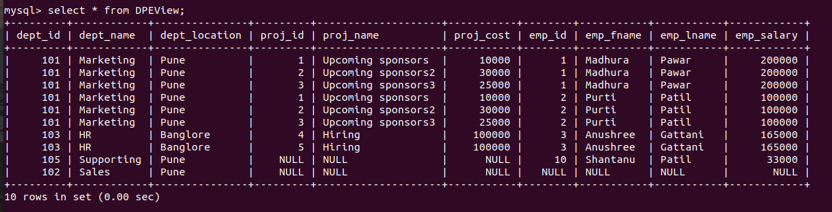

Index

1) Simple Index

mysql> CREATE INDEX idx_dept_location ON Dept (dept_location);
Query OK, 0 rows affected (0.16 sec)

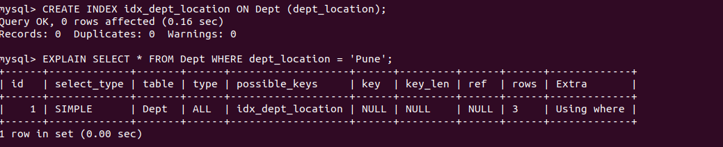

2) Unique Index

mysql> create unique index idx_proj_id on Project (proj_id);
Query OK, 0 rows affected (0.23 sec)

3) Composite Index

mysql> create index idx_name ON Employee (emp_lname, emp_fname);
Query OK, 0 rows affected (0.14 sec)
show index from Employee;

Sequence

ALTER TABLE Employee MODIFY emp_id INT(11) NOT NULL AUTO_INCREMENT;

INSERT INTO Dept (dept_name, dept_location)
-> VALUES ('HR', 'Building A');
Query OK, 1 row affected (0.03 sec)

mysql> INSERT INTO Employee (dept_id, emp_fname, emp_lname, emp_postion, emp_salary, emp_joindate) VALUES (106, 'John', 'Doe', 'HR', 50000, '2024-01-01');

