ASSIGNMENT 3

1. Find Employee details and Department details using NATURAL JOIN

mysql> select e.emp_fname, d.dept_name from Employee as e Natural Join Dept as d;

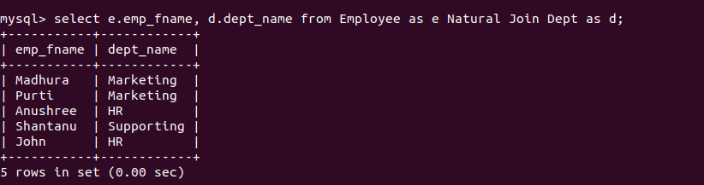

2. Find the emp_fname,Emp_position,location,Emp_JoinDate who have same Dept id.

Select e.emp_fname,
e.emp_postion,
d.dept_location,
e.emp_joindate
From Employee e
Inner Join Dept d on e.dept_id = d.dept_id
where e.dept_id in (select dept_id from Employee group by dept_id having count(emp_id) > 1) order by e.dept_id, e.emp_fname;
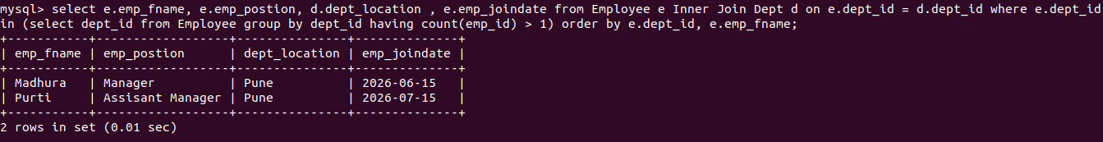

3. Find the Employee details ,Proj_id,Project cost who does not have Project
location as ‘Banglore’.

Select
e.emp_id,
e.emp_fname,
e.emp_lname,
e.emp_postion,
e.emp_salary,
p.proj_id,
p.proj_cost
From
Employee e
Left Join
Project p on e.dept_id = p.dept_id
where p.proj_location IS NULL or p.proj_location <> 'Banglore';

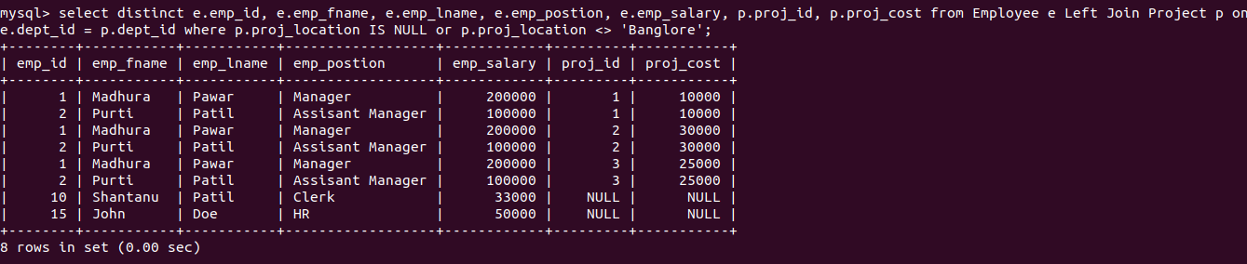

4. Find Department Name ,employee name, Emp_position for which project year
is 2020.

Select
d.dept_name,
CONCAT(e.emp_fname, ' ', e.emp_lname) AS employee_name,
e.emp_postion
from Employee e
Inner Join
Dept d ON e.dept_id = d.dept_id
Inner Join
Project p ON e.dept_id = p.dept_id
where p.proj_year = 2020;

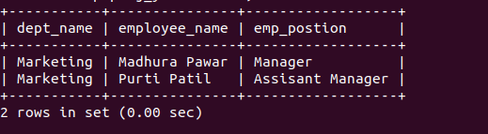

5. Display emp_position,D_name who have Project cost >30000.

Select
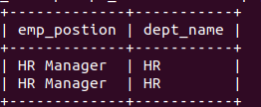
e.emp_postion,
d.dept_name
from Employee e
Inner Join
Dept d ON e.dept_id = d.dept_id
Inner Join
Project p ON e.dept_id = p.dept_id
wherep.proj_cost>30000;

6. Find the names of all the Projects that started in the year 2021.

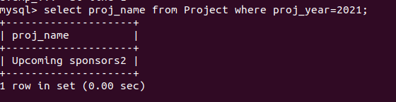

7. List the Dept_name having no_of_emp=2.

Select
d.dept_name
from Dept d
inner join Employee e ON d.dept_id = e.dept_id
group by d.dept_id, d.dept_name
having count(e.emp_id) = 2;

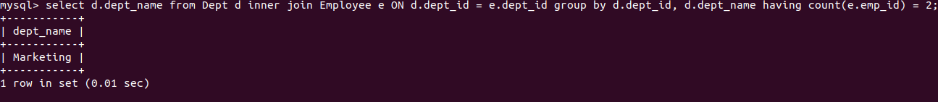

8.Display the total number of employee who have joined any project before 2021.

Select
count(distinct e.emp_id) as total_emp
from Employee e
inner join Project p on e.dept_id = p.dept_id where p.proj_year < 2021;

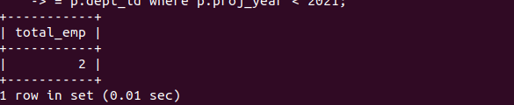

9. Create a view showing the employee and Department details.

CREATE VIEW DEView AS
SELECT d.dept_id, d.dept_name, d.dept_location,
e.emp_id, e.emp_fname, e.emp_lname, e.emp_salary
FROM
Dept d
LEFT JOIN
Employee e ON d.dept_id = e.dept_id;
Query OK, 0 rows affected (0.04 sec)

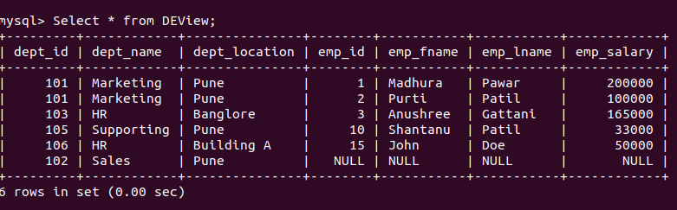

10. Perform Manipulation on simple view-Insert, update, delete, drop view.

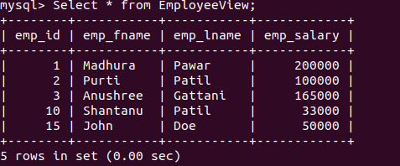

Insert into View

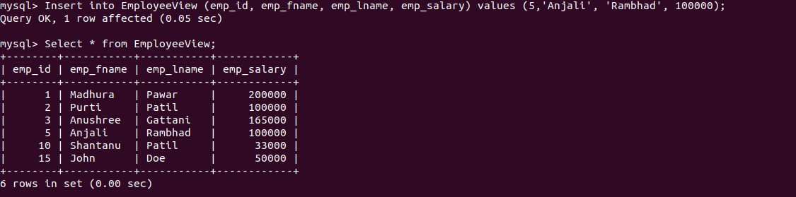

Update View

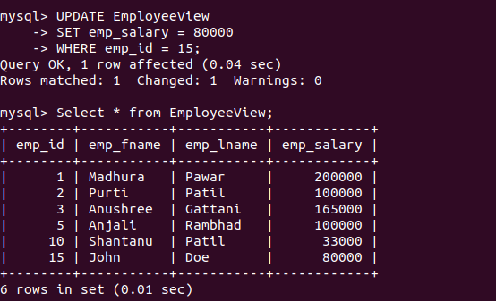

Delete View

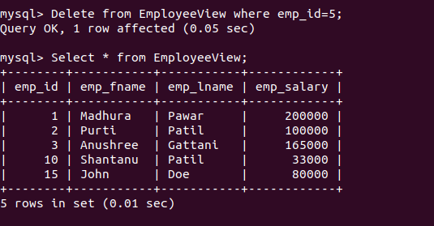

Drop View

