Assignment 4

Unnamed PL/SQL code block:
Use of Control structure and Exception handling is mandatory. Write a PL/SQL block of code for the following requirements:-
Schema: 1. Borrower(Rollin, Name, DateofIssue, NameofBook, Status)
2. Fine(Roll_no,Date,Amt) Accept roll_no & name of book from user.
Check the number of days (from date of issue), if days are between 15 to 30 then fine amount will be Rs 5per day. If no. of days>30, per day fine will be Rs 50 per day & for days less than 30, Rs. 5 per day. After submitting the book, status will change from I to R. If condition of fine is true, then details will be stored into fine table.

DELIMITER //

CREATE PROCEDURE ReturnBook3(
IN p_rollno INT,
IN p_nameofbook VARCHAR(30)
)
BEGIN
DECLARE v_dateofissue DATE;
DECLARE v_currdate DATE;
DECLARE v_days INT;
DECLARE v_fineamount INT DEFAULT 0;
DECLARE v_count INT;

SET v_currdate = CURDATE();

SELECT COUNT(*) INTO v_count
FROM Borrower
WHERE b_id = p_rollno AND b_nameofbook = p_nameofbook;

IF v_count = 0 THEN
SIGNAL SQLSTATE '45000'
SET MESSAGE_TEXT = 'Book entry not found.';
END IF;

SELECT b_dateofissue INTO v_dateofissue
FROM Borrower
WHERE b_id = p_rollno AND b_nameofbook = p_nameofbook;

SET v_days = DATEDIFF(v_currdate, v_dateofissue);

IF v_days > 30 THEN
SET v_fineamount = (v_days - 30) * 50 + (30 * 5);
ELSEIF v_days >= 15 THEN
SET v_fineamount = v_days * 5;
ELSE
SET v_fineamount = 0;
END IF;

UPDATE Borrower
SET status = 'Returned'
WHERE b_id = p_rollno AND b_nameofbook = p_nameofbook;

IF v_fineamount > 0 THEN
INSERT INTO Fine (fine_bid, fine_date, fine_amount)
VALUES (p_rollno, v_currdate, v_fineamount);
END IF;

SELECT CONCAT('Book returned. Fine amount: Rs ', v_fineamount) AS result;

END //

DELIMITER ;

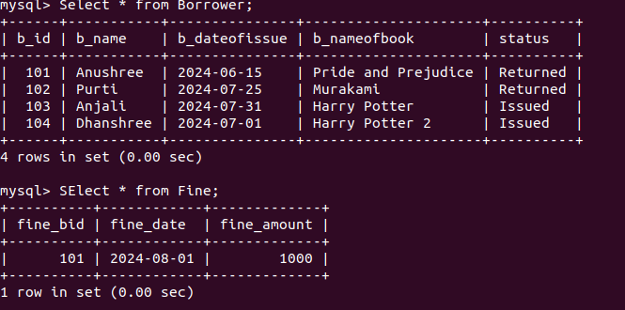

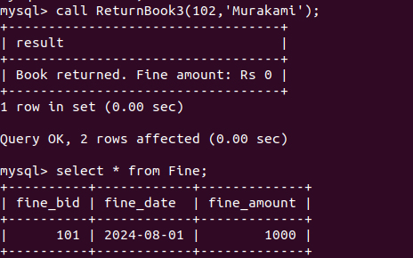

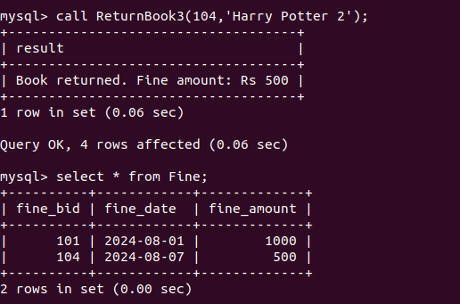

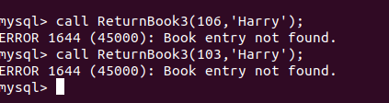

Write a PL/SQL code block to calculate the area of a circle for value of radius varying from 5 to 9. Store the radius and the corresponding values of calculated area in an empty table named areas, consisting of two columns, radius and area.

DELIMITER //

CREATE PROCEDURE CalculateArea(IN radius FLOAT)
BEGIN
DECLARE area FLOAT;

IF radius >= 5 AND radius <= 9 THEN
SET area = 3.1415 * radius * radius;
SELECT 'Area calculated successfully' AS message;
INSERT INTO area(radius, area) VALUES (radius, area);
ELSE
SIGNAL SQLSTATE '45000'
SET MESSAGE_TEXT = 'Please enter a radius between 5 and 9';
END IF;
END //

DELIMITER ;

