IT Ticketing System Data Platform - Full Interview Prep

1. Project Overview
This is an end-to-end IT Ticketing System Data Platform built as a customized version of IBM’s Data Engineering Capstone. The project simulates how IT support teams handle tickets, users, departments, and comments, and then transforms that data into a data warehouse for analytics and dashboards. It demonstrates OLTP, ETL, Warehousing, Big Data (Spark), and BI.

2. OLTP Database (ticketing_db)
We created the following main tables:
- **tickets**: ticket_id (PK), issue, employee_name, issue_category, priority, target_resolution_hours, created_at, resolved_at, status
- **users**: user_id (PK), name, email, role
- **departments**: dept_id (PK), dept_name
- **comments**: comment_id (PK), ticket_id (FK logical), user_id (FK logical), message, created_at
Below is the simplified ER diagram of the OLTP schema:
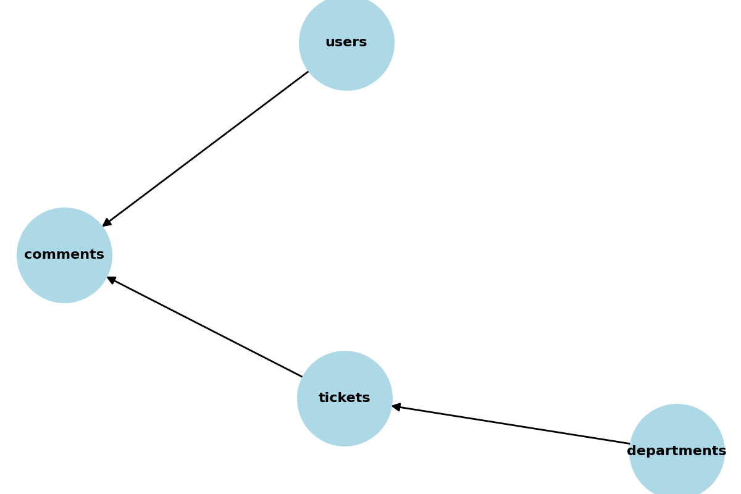

3. ETL & Cleaning with Staging Tables
Raw CSVs were imported into staging tables (all VARCHAR). Cleaning applied before moving to final tables:
- Used TRIM() to remove extra spaces.
- Used CAST(... AS UNSIGNED) for numeric fields like ticket_id/user_id.
- Used STR_TO_DATE() to convert date strings into DATETIME.
- Used CASE to handle blanks → NULL.
- Used REGEXP filters to allow only valid numeric IDs.
- Used JOIN inserts to ensure only rows with matching tickets/users were loaded.

4. Data Warehouse (ticketing_dwh)
Designed a star schema optimized for analytics:
- **fact_tickets**: ticket_id, user_key, dept_key, priority_key, status_key, created_date_key, resolved_date_key, target_resolution_hours, actual_resolution_hours, sla_met_flag
- **dim_user**: user_key, name, email, role
- **dim_department**: dept_key, dept_name
- **dim_priority**: priority_key, priority_name
- **dim_status**: status_key, status_name
- **dim_date**: date_key, date, year, month, day, quarter, week, day_of_week

5. Analytics & KPIs
We implemented key business questions:
- SLA compliance % (tickets resolved within target hours).
- Average resolution time by department, priority, or agent.
- Backlog trend (open vs resolved tickets over time).
- Ticket distribution by category/priority.
- Conversation logs per ticket (via joins with comments).

6. Spark Extension (Optional)
- Simulated high-volume ticket logs (millions of comments).
- Used Spark to parallelize analysis: escalation detection, team overload identification.
- Spark is optional here, but it demonstrates big data scalability.

7. Interview Q&A
Q: *What did you build in your SQL project?*
A: I built an IT Ticketing System data platform with OLTP (MySQL), ETL pipelines (staging → clean tables), a Data Warehouse with a star schema, analytics queries (SLA %, backlog, avg resolution), and dashboards in Power BI. Spark was added as a scalability demonstration.
Q: *What problems did you face?*
A: Messy CSVs (dates as strings, blank IDs, extra spaces) and orphaned comments. Solved using staging tables, TRIM/CAST/STR_TO_DATE, CASE for NULL handling, and JOIN inserts to filter invalid rows.
Q: *Why did you use Spark?*
A: To show I can scale. MySQL is fine for thousands of rows, but real helpdesk logs can be millions. Spark processes those faster. In this project, Spark is optional — the system works fully without it.
Q: *Why this project?*
A: Because ticketing systems exist in every IT company. It shows I can do end-to-end pipelines: OLTP → ETL → DWH → Analytics → BI.
Q: *Difference between OLTP and DWH in your project?*
A: OLTP (`ticketing_db`) stores day-to-day transactions (tickets, comments). DWH (`ticketing_dwh`) is optimized for reporting with fact/dimension tables and pre-computed measures.

8. Step-by-Step Process Recap
1. Designed OLTP schema (tickets, users, departments, comments).
2. Imported raw CSVs into staging tables.
3. Cleaned & transformed using TRIM, CAST, STR_TO_DATE, CASE.
4. Inserted clean rows into final OLTP tables.
5. Built star schema warehouse in `ticketing_dwh`.
6. Populated dimensions and fact_tickets.
7. Wrote SQL queries for KPIs (SLA %, backlog, resolution time).
8. Added visualization dashboards.
9. (Optional) Simulated big data analysis with Spark.
10. Packaged everything into a GitHub repo with README and screenshots.

9. Wrap-Up
This project demonstrates:
- OLTP database design.
- ETL & staging table cleaning.
- Star schema warehouse modeling.
- SQL analytics for business KPIs.
- BI dashboards for visualization.
- Spark extension for big data.
Together, this makes it a complete, interview-ready project.

