Analysis of Kickstarter campaigns

# Background

Over two billion dollars have been raised using the massively successful crowdfunding service, Kickstarter, but not every project has found success. Of the over 300,000 projects launched on Kickstarter, only a third have made it through the funding process with a positive outcome.

Since getting funded on Kickstarter requires meeting or exceeding the project's initial goal, many organizations spend months looking through past projects in an attempt to discover some trick to finding success.

# Analysis

We are analyzing ~4100 projects to determine the parameters that influence the outcome of these projects/ campaigns. An exploratory analysis is performed by summarizing and charting the outcome in relation to

* Category
* Sub-category
* Launch date
* Goal amount set for campaigns

# Findings – Three key conclusions on Kickstarter projects

Based on the analysis, following are three conclusions that we can derive

1. **Higher success rate in entertainment categories (i.e., Music, theater and Film &Video)**

The given dataset is divided into 9 categories and 41 sub-categories. When we summarize the outcome by category and derive a success rate, we find the below observations,

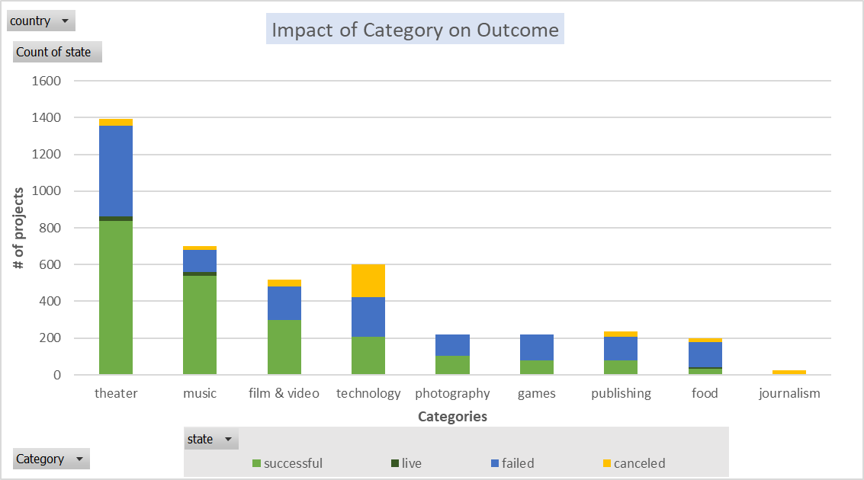

* **Music (70%) and Theater (60%) have most success rate.**
* **More than 50% of projects fall under Music, Theater and Film & Video categories (2613 projects)**
* **Food & Journalism: record the lowest success rates**

1. **Lower goal better success rate**

A successful outcome is having an inverse relationship with the goal (amount to be raised).

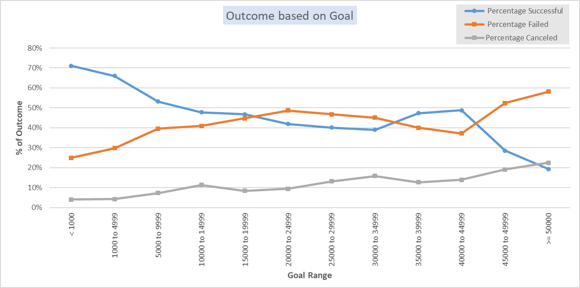

**Maximum success rate is observed in projects whose goal are below 10,000 currency value.**

Outliers (for further investigation): However, there are 86 projects who have raised and exceeded over 50,000.

1. **Choosing the right time to launch**

The launch date of projects also determines to an extent the success of the outcome.

For instance, a project launched in first half of the year (Jan to Jun) is having higher success rate compared to a project launched latter half.

|  |  |  |  |  |  |  |  |
| --- | --- | --- | --- | --- | --- | --- | --- |
| **Half Year** | **Total Projects** | **Successful** | **% Successful** | **Quarters** | **Total Projects** | **Successful** | **% Successful** |
| HY1 | 2110 | 1203 | **57%** | Q1 | 1016 | 565 | **56%** |
| Q2 | 1094 | 638 | **58%** |
| HY2 | 1954 | 982 | **50%** | Q3 | 1016 | 507 | **50%** |
| Q4 | 938 | 475 | **51%** |

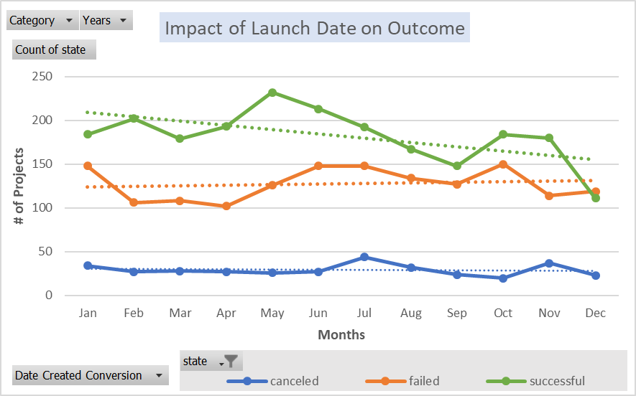

* **Qtr2 has the highest success rate**

## Limitations of the Kickstarter dataset

Some limitations of the given dataset are

* Availability of a clear data dictionary: A guide to what data is being captured, format of the data captured and how it is captured will help in better analysis
* Marketing / Promotion details: No data is provided for this metric. Some key details like below could provide a new way of analyzing the data
  + type of channels used by projects to promote
  + Funding split by channels
* Uniformity in currency of the goal and funded amount will help in setting standard for analysis Thus will not skew the analysis.
* Current dataset is more focused on US region. Nearly 74% of the data is US-based.

## Further Analysis – Other possible tables / graphs

There are metrics in the dataset that has an impact on the project outcome positively/negatively.

Some of the metrics that is worth further analyzing are

1. Staff pick vs. Outcome
2. Average Donation vs. Outcome
3. Spotlight vs. Outcome
4. Backers count vs. Category