SIMATS ENGINEERING

ASSESSMENT TOOL 1

COURSE NAME: Artificial Intelligence COURSE CODE: CSA1708

COURSE OUTCOME COVERED

CO1: Apply AI basics such as intelligent agents and uninformed search methods to solve problems effectively. (BL3)

Assessment Tool Weightage: 50%

QUESTIONS: 5 Duration : 1 Hour
Total Marks:50
Annexure A

Analytical Problem Solving

Code of Conduct:
I M Kavya 192472370 (Name / Reg No) certify that this submission is my original work and that I have adhered to the guidelines specified for this assessment.
I understand that any violation of academic integrity rules will result in disciplinary action.

Signature of the student:

Annexure A

Analytical Problem Solving

- Solve the Water Jug problem: you are given 2 jugs, a 4-gallon one and 3-gallon one. Neither has any measuring maker on it. There is a pump that can be used to fill the jugs with water. How can you get exactly 2 gallons of water into 4-gallon jug? Explicit assumptions: A jug can be filled from the pump, water can be poured out of a jug onto the ground, water can be poured from one jug to another and that there are no other measuring devices available.

- Find out how Mars Rover, analyse and explore the samples on Mars by answering the following questions.
  - What are the percept’s for this agent?
  - Characterize the operating environment.
  - What are the actions the agent can take?
  - How can one evaluate the performance of the agent?
  - What sort of agent architecture do you think is most suitable for this agent? Why?
- Explore the search space using search strategies and formulate the problem components for the 8-Queens problem using the following information: Place 8 queens on a chessboard such that none of the queen’s attack any of the others. A configuration of 8 queens on the board as shown in the figure below, but this does not represent a solution as the queen in the first column is on the same diagonal as the queen in the last column.

- A customer wants to travel from the one location to another location using OLA Cab booking mobile application. The customer can select the any of the cab type as mini, micro, sedan, shared, prime and so on based on his comfort to reach the destination. Identify what type of problem-solving agent can be used and write the pseudocode for the above problem.
- A logistics company operates a delivery network where packages must be transported between warehouses at minimum cost. Each route between warehouses has an associated travel cost (fuel + time). The company wants to determine the least-cost path from the starting warehouse S to the destination warehouse G using the Uniform Cost Search (UCS) algorithm.
The delivery network is represented as a weighted graph:

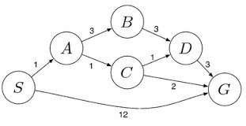

SOLUTIONS:

Question 1: Water Jug Problem
Problem Statement
You are given two jugs:
- A 4-gallon jug
- A 3-gallon jug
Neither jug has any measurement markings. A pump is available to fill the jugs completely, water can be poured from one jug to another, and water can also be emptied onto the ground. The objective is to obtain exactly 2 gallons of water in the 4-gallon jug.
Solution:
Represent each state as:
(Water in 4-gallon jug, Water in 3-gallon jug)
Initial State:
(0,0)
Goal State:
(2,x)
where x can be any amount.
Step-by-Step Solution
Step | Action | State
1 | Fill the 3-gallon jug | (0,3)
2 | Pour it into the 4-gallon jug | (3,0)
3 | Fill the 3-gallon jug again | (3,3)
4 | Pour water into the 4-gallon jug until it becomes full | (4,2)
5 | Empty the 4-gallon jug | (0,2)
6 | Transfer the remaining 2 gallons into the 4-gallon jug | (2,0)

State Space Diagram
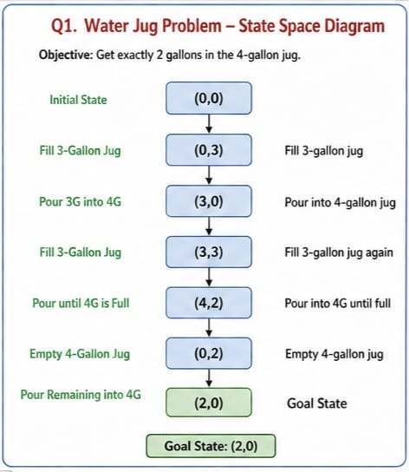
Explanation
The Water Jug problem is a state-space search problem. Each state represents the amount of water in both jugs. AI search techniques systematically explore these states until the goal state is reached.
Conclusion
The goal state (2,0) is achieved successfully. Therefore, exactly 2 gallons are obtained in the 4-gallon jug.

Question 2: Mars Rover Intelligent Agent
Problem Statement
The Mars Rover is an autonomous robot that explores Mars, collects samples, analyzes rocks and soil, and sends scientific information back to Earth. Identify its percepts, operating environment, actions, performance measures, and suitable agent architecture.
i) Percepts
Percepts are the information received through the rover's sensors.
- Camera images
- Rock and soil composition
- Surface temperature
- Atmospheric pressure
- Radiation levels
- Obstacles
- Wheel movement
- Battery status

ii) Operating Environment
The Mars Rover operates in an environment that is:
- Partially Observable
- Dynamic
- Sequential
- Continuous
- Single-Agent
- Mostly Deterministic

iii) Actions
The Mars Rover can:
- Move forward
- Turn left/right
- Stop
- Capture photographs
- Drill rocks
- Collect soil samples
- Analyze samples
- Send information to Earth
- Recharge through solar panels

iv) Performance Measure
The rover's performance is evaluated based on:
- Successful sample collection
- Navigation accuracy
- Battery efficiency
- Safe obstacle avoidance
- Quality of scientific data
- Mission completion

v) Suitable Agent Architecture
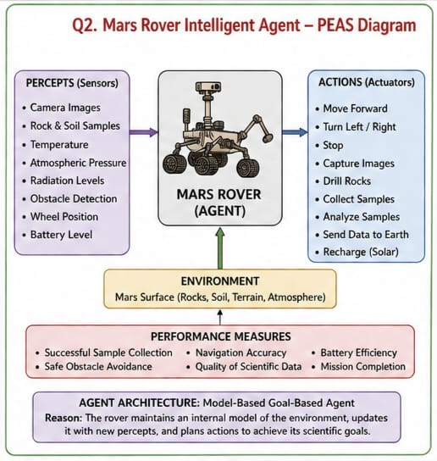
Model-Based Goal-Based Agent
Reason
The rover cannot observe the complete environment at all times. It maintains an internal model of the surroundings and plans actions to achieve scientific goals while avoiding hazards. This makes a Model-Based Goal-Based Agent the most suitable architecture.
Conclusion
The Mars Rover is an intelligent autonomous agent capable of perceiving its environment, making decisions, and achieving exploration goals without continuous human intervention.

Question 3: 8-Queens Problem
Problem Statement
Place eight queens on a chessboard such that no queen attacks any other queen. No two queens should be in the same row, column, or diagonal.
Problem Formulation
Initial State
Empty chessboard.
State Space
Any arrangement of queens on the chessboard.
Operators
- Place a queen in a safe position.
- Move a queen if conflicts occur.
Goal State
Eight queens placed without attacking each other.
Constraints
- One queen per row
- One queen per column
- No diagonal attacks
Search Strategy
Depth First Search (DFS) with Backtracking.

Example Solution
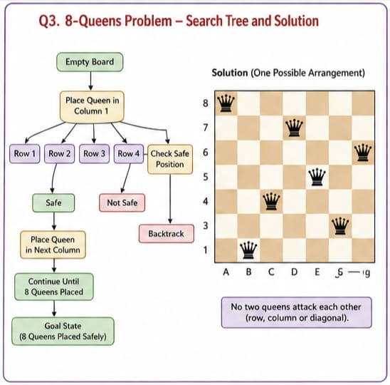
Explanation
The algorithm places queens one by one. If a conflict occurs, it backtracks and tries another position until all eight queens are safely placed.
Conclusion
The 8-Queens problem demonstrates how AI search and backtracking efficiently solve constraint satisfaction problems.

Question 4: OLA Cab Booking
Problem Statement
A customer wants to travel using the OLA mobile application. Different cab types such as Mini, Micro, Sedan, Shared, and Prime are available. Identify the suitable problem-solving agent and write its pseudocode.
Suitable Problem-Solving Agent
Goal-Based Agent
Reason
The customer's goal is to reach the destination. The agent evaluates available cab options and selects one that best satisfies the user's preferences, such as comfort, cost, and availability.
Pseudocode
START

Input pickup location
Input destination

Display available cab types

User selects preferred cab

Check availability

IF cab is available THEN
Calculate fare
Confirm booking
Assign driver
Start trip
ELSE
Display "Cab Not Available"
ENDIF

Reach destination

STOP
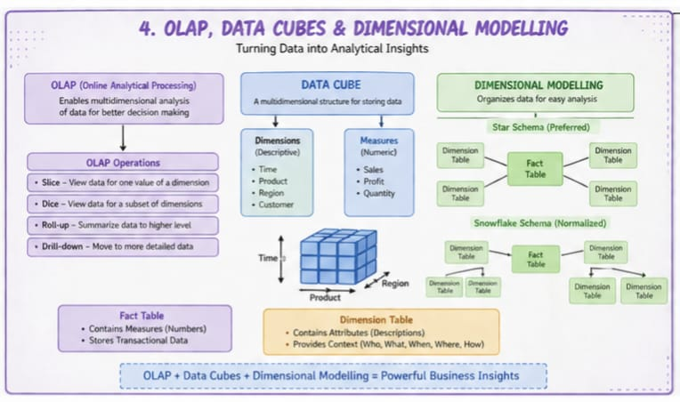
Explanation
The Goal-Based Agent compares different options before choosing the most appropriate one to achieve the customer's goal.
Conclusion
A Goal-Based Agent helps the customer reach the destination efficiently by selecting the most suitable cab.

Question 5: Uniform Cost Search (UCS)
Problem Statement
A logistics company wants to determine the least-cost path from warehouse S to warehouse G using the Uniform Cost Search (UCS) algorithm. The delivery network is represented as a weighted graph.
Edge Costs
- S → A = 1
- S → G = 12
- A → B = 3
- A → C = 1
- B → D = 3
- C → D = 1
- C → G = 2
- D → G = 3
Uniform Cost Search Process
Step | Expanded Node | Path | Cost
1 | S | S | 0
2 | A | S → A | 1
3 | C | S → A → C | 2
4 | D | S → A → C → D | 3
5 | B | S → A → B | 4
6 | G | S → A → C → G | 4
Cost Comparison
- S → G = 12
- S → A → B → D → G = 10
- S → A → C → D → G = 6
- S → A → C → G = 4 (Minimum Cost)
Least-Cost Path
S → A → C → G
Minimum Cost
4
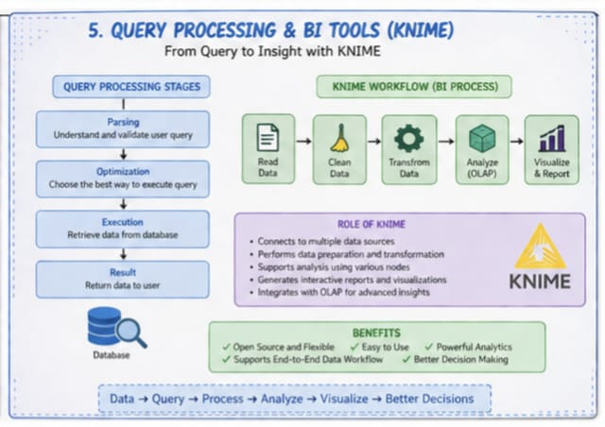

Explanation
Uniform Cost Search expands the node with the lowest cumulative cost first. Since it always chooses the least expensive path, it guarantees the optimal solution when all edge costs are non-negative.
Conclusion
The optimal delivery route is:
S → A → C → G
with a minimum total cost of 4. Hence, UCS successfully finds the least-cost path.

RUBRICS FOR CALCULATION:

Criteria | Weightage | Level 4 (Exemplary) | Level 3 (Proficient) | Level 2 (Developing) | Level 1 (Beginning)
Problem Understanding | 20% | Clearly interprets problem, identifies all parameters and requirements accurately | Understands problem with minor gaps | Partial understanding; misses key elements | Misinterprets or unable to understand problem
Method Selection | 20% | Selects most appropriate method/formula with strong justification | Selects correct method with minor errors | Inappropriate or partially correct method | Unable to select method
Solution Process | 25% | Logical, systematic steps with correct approach throughout | Mostly correct steps with minor mistakes | Disorganized steps; multiple errors | No clear process
Accuracy of Calculation | 20% | All calculations accurate; correct final answer | Minor calculation errors | Frequent errors; incorrect final answer | No valid calculations
Interpretation of Results | 15% | Clearly interprets results with units and engineering relevance | Basic interpretation with minor omissions | Limited or unclear interpretation | No interpretation
Problem Understanding | 20% | Clearly interprets problem, identifies all parameters and requirements accurately | Understands problem with minor gaps | Partial understanding; misses key elements | Misinterprets or unable to understand problem

