**Experiment-1 ( Requirement Specification)**

1. **Aim:** To learn & implement SRS.
2. **Objective**: To implement Software Requirement Specification (SRS) and design the documentation for given project.
3. **Background:** A software requirement specification (SRS) is a comprehensive description of the intended purpose and environment for software under development. The SRS fully describes what the software will do and how it will be expected to perform.
4. **Prerequisite:** The general format of SRS consists of:

### Functional Requirements Definition

* + - Functional requirements are a subset of the

overall system requirement.

* + - These requirements are used to consider system

behavior.

software issues.

* Trade-offs may be between hardware and

### Non-functional Requirements Definition

* + - It measures the documentation and the inputs

for the various requirements in the system.

### System Evolution

* + - Starting from the specification and the database

schema, on how the system should be designed.

**Software Requirements**

**Specification**

**for Attendance Management Software**

**Version 1.0**

**Prepared by**

**Madhuresh**

**Tejas**

**Lakshmanan**

**Jagan**

**Jushwa**

**2 December 2022**

# Table of Contents

### Table of Contents

1. **Introduction**
   1. Purpose
   2. Product Scope
   3. References

### Overall Description

* 1. Product Perspective
  2. Product Functions
  3. User Classes and Characteristics
  4. Operating Environment
  5. Design and Implementation Constraints
  6. User Documentation
  7. Assumptions and Dependencies

### External Interface Requirements

* 1. User Interfaces
  2. Hardware Interfaces
  3. Software Interfaces
  4. Communications Interfaces

### Functional Requirements

1. **Nonfunctional Requirements**
2. **Use-case Diagram**
3. **Conclusion**

# Introduction

## Purpose

The Aim of this Web App is to provide an easy and intuitive way to track attendance of students.This makes it easier for the attendance coordinator to manage attendance of different departments and respective students. It allows students to view their attendance and also enables attendance department to generate different attendance reports.

Features includes:

* + - Online Attendance Tracking
    - Employee Reporting
    - Calculate Defaulter Categories.
    - Class and Student Management.

## Product Scope

The scope of this project is developing a attendance tracking product system which can be used in by lecturers to manage their class’s attendance. It targets large organizations which include many classes and Students. It also targets normal lecturers for keeping track for attendance and thus taking and managing attendance online.

## References

* + - Website: url [ <http://www.cse.msu.edu/~cse870/IEEEXplore-SRS-template.pdf>]
* *Website: url [*[*https://www.scribd.com/doc/56207840/Student-Attendance-Management-*](https://www.scribd.com/doc/56207840/Student-Attendance-Management-System-PF)[*System-PF*](https://www.scribd.com/doc/56207840/Student-Attendance-Management-System-PF) *]*
* *Website: url [ -* [*www.wikipedia.com*](http://www.wikipedia.com/) *]*
* *“Roger Pressman”,”Software Engineering”,Seventh Edition, Page: 119-153*

# Overall Description

## Product Perspective

The Tracking software can be accessed Online in which the organisation intends to track.The site allows to take and store attendance online and store it in database.It enables users to generate various reports on attendance. The Attendance Management System is intended to replace the manual model of attendance record

keeping by means of roll call and paper records. The roll call and paper records are replaced with a single interaction between the professor and the Attendance Management System. Professors will be able to view details regarding attendance of individual students on their PC and quickly maintain attendance records. The features expressed in this Software Requirements Specification document are intended to be fully implemented in version 1.0. Then system will be developed in such a way to provide easy addition of enhanced features, which may be desired in subsequent versions.

## Product Functions

The main feature of the Attendance Managemant System is that it keeps a record of all essentials details of each individual student.At the end of a specified period this system create a defaulties list as well as the non- defaulties list. Attendance Percentage of each student in every subject would be displayed in this list Also, the system allows the professor to view pertinent statistics on student’s attendance record for the specified class. Finally, another feature of Attendance Management System is its flexibility and ease of use.

## User Classes and Characteristics

### Administrator:

The administrator will have overall control over the system.The admin maintains the site and service. It has privilege to access the entire system and distribute the permissions to group of users.

### Lecturer:

Lecturer is responsible in taking attendance. It maintains classes, keeps a track of the students. It also assists the other departments like attendance and HR department.

### Student:

They are allowed to only view their attendance details for knowledge.

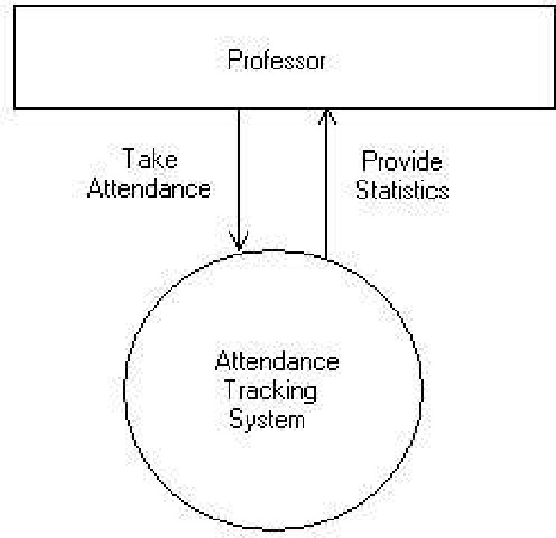

Figure 1: Context diagram for Attendance Management System.

## Operating Environment

* + - The Attendance Management System shall function on the PC provided by the college. This entails the system to operate on the Windows CE platform.
    - The Attendance Management System shall interface between Windows CE designated to

store the attendance records. The Web Server and Database Software have not been established at this point.

* + - The Attendance Management System will record all the essentials details of each particular

student.

* + - Pentium 3.0 GHz or higher RAM must be 1 Gb or more and Hard Drive 10 GB or more.

## Design and Implementation Constraints

* + - The time allotted for this project will be limited to the end of this semester.
    - The language for the project will be PHP at the server side..
    - All the HTML code for the user manual will conform to the HTML 4.0 standard.
* *Programming is done in CSS & HTML.*

## User Documentation

* + - The system will provide an online user manual in HTML that describes the functionality and options available to the user.
    - The system will provide a hard copy of the user manual, which is identical to the manual outlined above

## Assumptions and Dependencies

* + - The database mentioned within this Software Requirements Specification document is previously administered with the correct information needed by the Attendance Management System.
    - For attendance policies, since professors do not usually tabulate tardiness, it is assumed a

student is either present or absent. The system also assumes that detail regarding each student would be made correctly.

* + - Class data being used for setup and student recognition is dependent on information in a

database administered outside of the capabilities of the Attendance Management System.

* + - Statistics on student attendance is dependent on a professor’ s consistent utilization of the system for each class period.

# External Interface Requirements

## User Interfaces

* + - The Attendance Management System shall provide details of students in the class to aid in taking roll.
    - These details can be clicked with a mouse in order to view a particular student’s attendance

record.

* + - All modifications to the database will be done through a keyboard.
    - Application will be accessed through a Browser Interface. The interface would be viewed best using 1024 x768 and 800 x 600 pixels resolution setting.
    - The program will provide a page that produces current statistics on class attendance

## Hardware Interfaces

##### Server Side:

* + - Operating System: Windows 7/xp ,Windows ME
    - Processor: Pentium 3.0 GHz or higher
    - RAM: 1 GB or more
    - Hard Drive: 10 GB or more

##### Client side:

* + - Operating System: Windows 7 or above, MAC or UNIX.
    - Processor: Pentium III or 2.0 GHz or higher.
    - RAM: 1 GB or more

## Software Interfaces

#### Attendance Management System

* + - This software will transmit the attendance of a class to a database on a machine via Internet.
    - The user will be allowed to modify attendance records at any time.
    - If the user forgets to transmit the information, the system will automatically send it for them at the end of the class.

#### Database

The Attendance Management System will communicate with the database to perform the following options.

* + - To allow a user to enter attendance.
    - To allow a user to modify attendance.
    - To allow a user to query a system to gain statistics concerning individual and class attendance.

## Communications Interfaces

* + - The security of a user must be consistent through the use of passwords.
    - The Attendance Management System will communicate to the database through Internet.

# 4 Functional Requirements:

#### Registered Lecturers:

* + He or she can add classes.
  + He/she can add students to that class.
  + Lecturer can take attendance online.
  + He/she can view the attendance according to the date.

#### Provide Registration Form:

* + Allows users to fill the sign-up forms and get registered
  + It allows customers to rate the products and services.

#### Suggestions & online survey:

* + This section helps the organization to fulfil the new customer's demands

about the products, service, user-interface, etc.

* + And hence enhance the product functionality and improves services.

#### Take online attendance:

* + It allows to take attendance roll number wise and store them in database.

#### Report generation:

* + Monthly reports
  + Student wise reports
  + Defaulter List
* **Manage the attendance of students for special lectures.**

## Non - Functional Requirements

### Security:

Security is concerned with the privacy of client’s personal information.The attendance made by the clients are dealt confidentially.The complaints and suggestions made by customers must be only accessed by administrative authorities.

### Maintainability:

The maintainability requirements are concerned with the maintenance issues of the system.The report time of Attendance Tracking System shall be under a half hour.System downtime for maintenance should be less than 6 hours per quarter of a year.

### Browser Compatibility and Responsive:

It ensures that the site runs consistently in all browsers without making change in Style of web page.Responsiveness ensures it works on every screen resolutions like mobile , tablets, desktop PCs.

#### Performance Requirements

* + The program must be able to be run concurrently by multiple professors. During peak times of usage (9:00 AM to 2:00 PM).
  + Transmission of roll data shall occur in under 5 seconds.
  + Acknowledgement of roll received (confirmation) shall be returned within 8

seconds.

* + Queries upon the database shall be performed in less than 5 seconds.
  + Upon start of the roll program, roll information shall be displayed on the

instructor’ s Pocket PC within 10 seconds.

* + Email messages to absent students shall be sent within one hour of the conclusion of a class.
  + The program shall support taking roll for class sizes of up to 100 students.

With a maximum class size, performance must still conform to all performance requirements.

#### Safety Requirements

* + System would be protected by a password.
  + As it is connected via LAN and MAN an antivirus has been installed on system for its safety purpose

#### Security Requirements

* + An instructor shall permitted to view and edit absence information in the database for only his/her classes.
  + In order to take roll or edit database information, the instructor shall be

required to enter a password. This password shall be stored on the instructor’ s PC after initial entry in order that it must only be entered once.

* + Passwords shall be stored in an instructor database and verified upon each

session of roll or database modification.

* + An instructor shall be allowed to change his/her password only by supplying his/her existing password. The updated password shall be stored in the instructor database and on the instructor’s PC*.*

#### Software Quality Attributes

* + The system shall be available to all instructors through Information Systems during their normal hours of operation.
  + Due to the use of a wireless network, reliability of the system at all times is

not guaranteed. However, overall reliability of the system and roll information shall be achieved through the process of database manipulation.

* + The system shall be able to be reused for each new semester.
  + If no network connection can be established to receive the roll information, the instructor shall be allowed to e
  + nter roll later.
  + If a network connection is lost during roll, the program shall allow the instructor to transmit roll information at a later time.
  + The system shall allow for addition or deletion of instructors, students, and

classes while incorporating new semesters.

* + Usability of the system shall be achieved through an online help pages and an introductory training session for all instructors upon installation of the program on their Pocket PCs.

## 7. Use-Case Diagram :

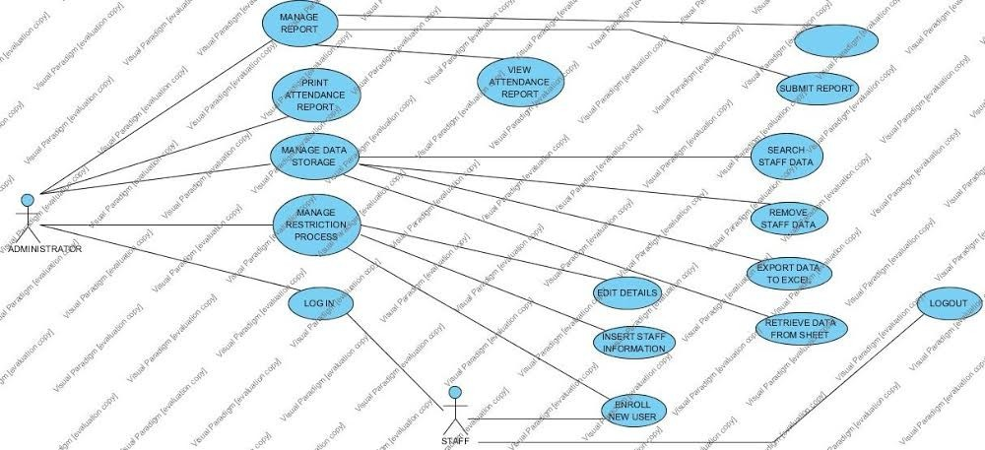

The purpose of use case diagram is to capture the dynamic aspect of a system. But this definition is too generic to describe the purpose.Use case diagrams are used to gather the requirements of a system including internal and external influences. These requirements are mostly design requirements. So when a system is analyzed to gather its functionalities use cases are prepared and actors are identified.

#### Actors:

* Staff
* Administrator
* System

#### Use-case:

* Login
* Manage registration process
* Enroll new user
* manage data storage
* print attendance report
* logout
* view attendance report
* submit report
* edit details
* export data to excel

## Conclusion:

The requirements of all the entities are taken care of to be fulfilled. The system proves to be a helpful source for the Colleges to manage attendance easily and without involving much complex calculation. The management becomes comparatively easy and also efficient giving more time to the users to focus on other important issues.