# API Test Documentation

## TC01 - GET /posts

* **Description:** Verify status code is 200 for fetching all posts
* **Method:** GET
* **Endpoint:** /posts
* **Expected Result:** Status 200 OK
* **Actual Result:** Pass – Status code 200 OK received
* **Test Status:** ✅ Passed

**Screenshot –** Refer to **Figure 1**

## TC02 - GET /posts

* **Description:** Verify response is a JSON array
* **Method:** GET
* **Endpoint:** /posts
* **Expected Result:** Response is a JSON array
* **Actual Result:** Pass – Response body is a JSON array
* **Test Status:** ✅ Passed

**Screenshot –** Refer to **Figure 1**

## TC03 - GET /posts

* **Description:** Validate structure of each post object
* **Method:** GET
* **Endpoint:** /posts
* **Expected Result:** Each post contains userId, id, title, body
* **Actual Result:** Pass – All posts contain required keys
* **Test Status:** ✅ Passed

**Screenshot –** Refer to **Figure 1**

**Figure 1:** GET /posts response & test results for TC01, TC02, TC03

**Screenshot – Response:**

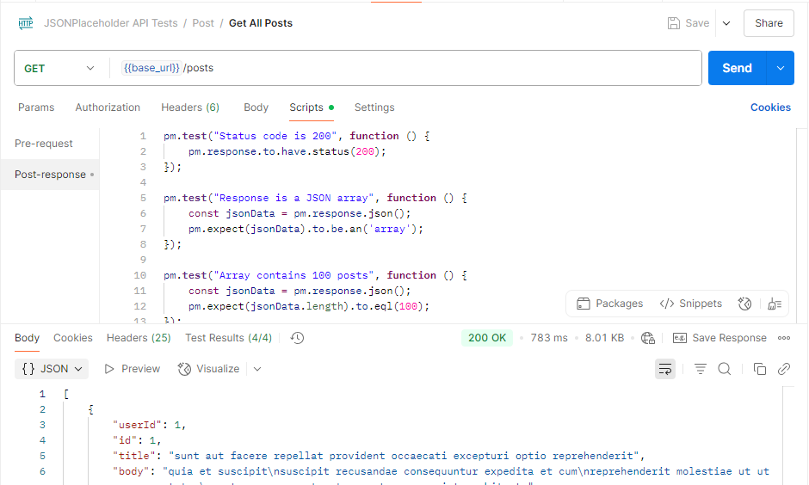

**Screenshot – Test Result:**

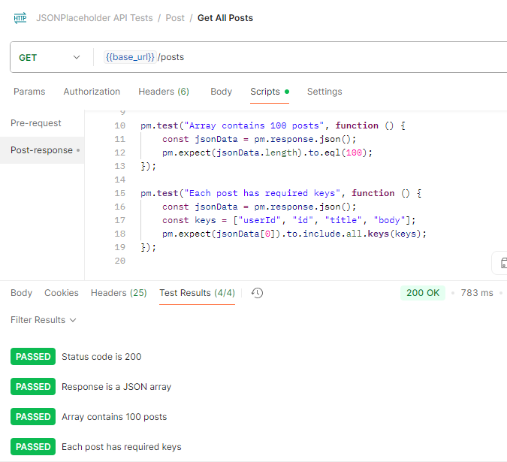

## TC04 - GET /posts/1

* **Description:** Get post with valid ID
* **Method:** GET
* **Endpoint:** /posts/1
* **Expected Result:** Status 200 OK, JSON object with required keys
* **Actual Result:** Pass – Post with ID 1 returned correctly
* **Test Status:** ✅ Passed

**Screenshot – Response:**

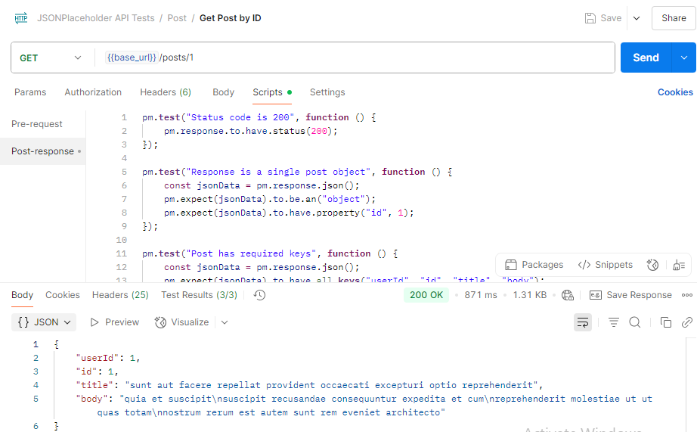

**Screenshot – Test Result:**

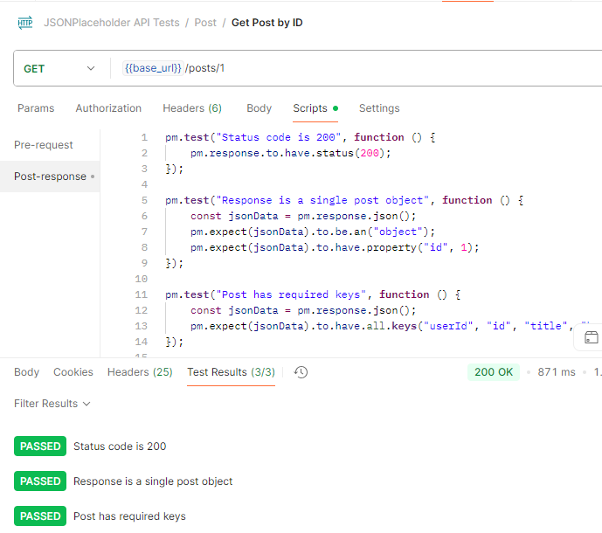

## TC05 - GET /posts/0

* **Description:** Get post with invalid ID = 0
* **Method:** GET
* **Endpoint:** /posts/0
* **Expected Result:** Status 404 Not Found, empty object {}
* **Actual Result:** Pass – Status 404 with {} returned
* **Test Status:** ✅ Passed

**Screenshot – Response:**

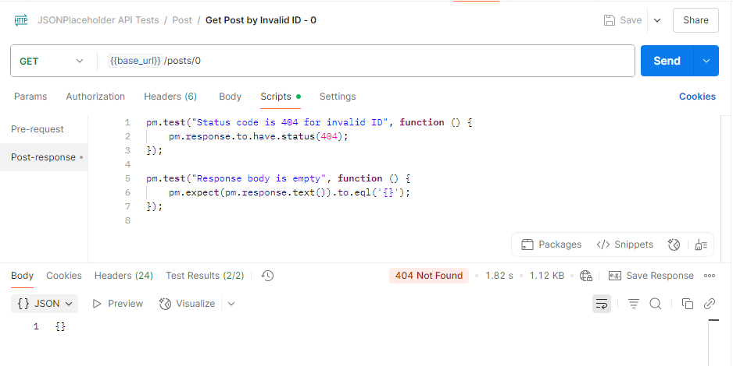

**Screenshot – Test Result:**

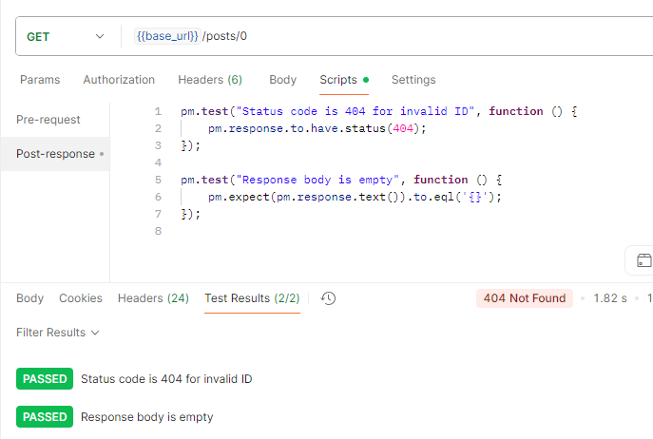

## TC06 - GET /posts/abc

* **Description:** Invalid non-numeric ID
* **Method:** GET
* **Endpoint:** /posts/abc
* **Expected Result:** 404 Not Found, {}
* **Actual Result:** Pass – Status 404 and response {}
* **Test Status:** ✅ Passed

**Screenshot – Response:**

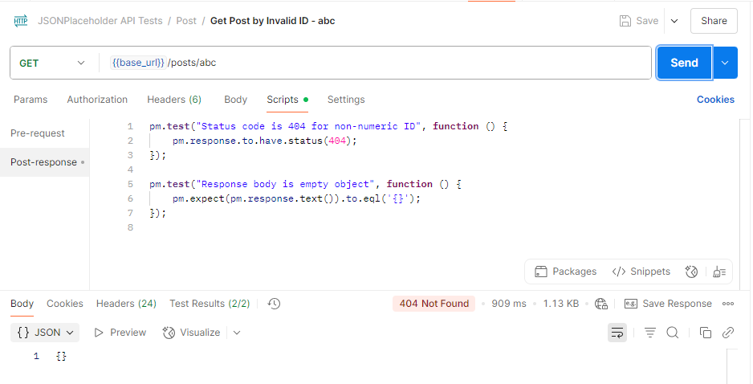

**Screenshot – Test Result:**

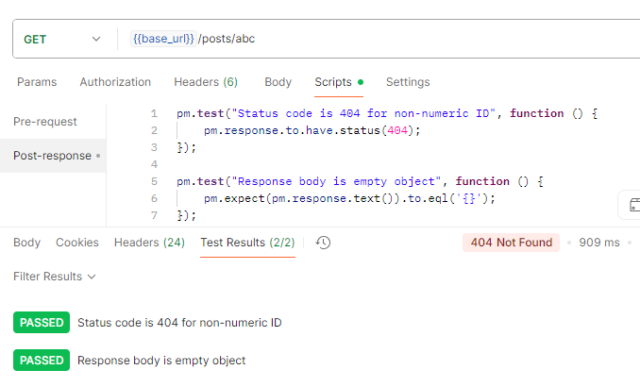

## ****TC07 – GET**** /posts/555

* **Description:** Get post by non-existent ID
* **Method:** GET
* **Endpoint:** /posts/555
* **Expected Result:** 404 Not Found or empty {}
* **Actual Result:** Pass – Status 404 with empty object {} received (mock API behaviour)
* **Test Status:** ✅ **Passed**

**Screenshot – Response:**

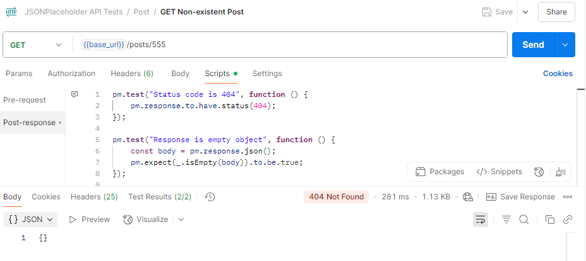

**Screenshot – Test Result:**

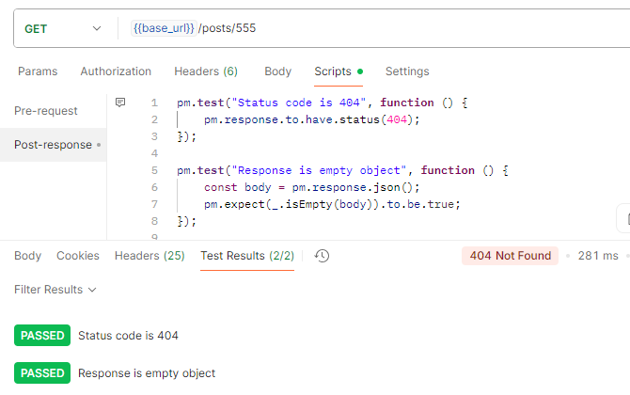

## TC08 - POST /posts

* **Description: Create a post with a valid payload**
* **Method: POST**
* **Endpoint: /posts**
* **Expected Result: 201 Created, response contains all sent fields + new id**
* **Actual Result: Pass – Status 201 Created, response contains all sent fields + new id**
* **Test Status: ✅ Passed**

**Screenshot – Response:**

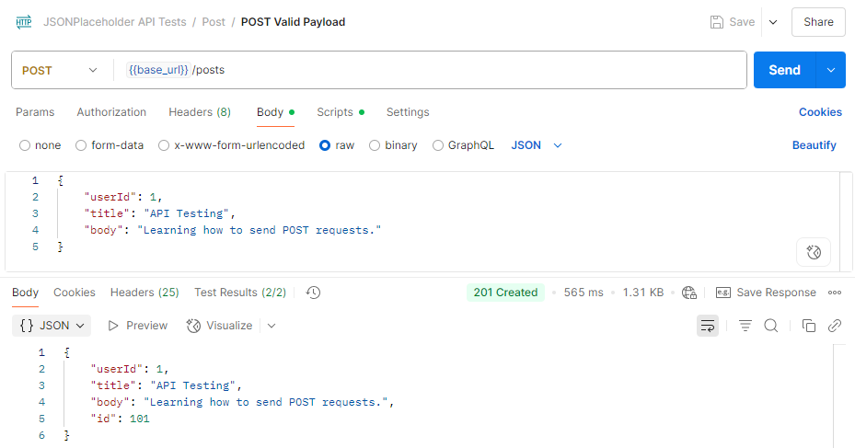

**Screenshot – Test Result:**

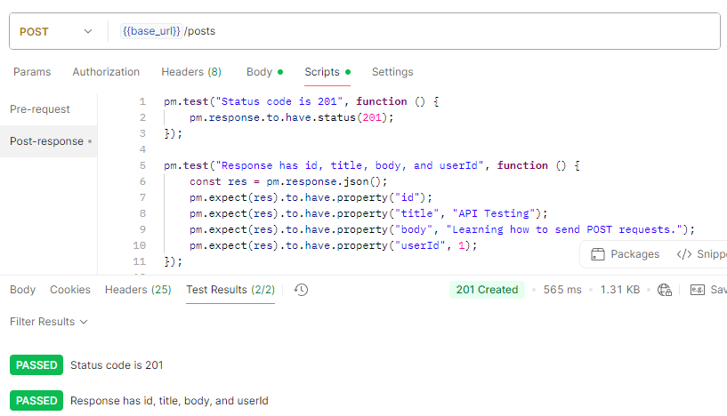

TC09 - POST /posts

* **Description:** Create post with missing title
* **Method:** POST
* **Endpoint:** /posts
* **Expected Result:** Simulated 201 Created (mock API)
* **Actual Result:** Pass – Status 201 Created, response contains id only
* **Test Status:** ✅ Passed

**Screenshot – Response:**

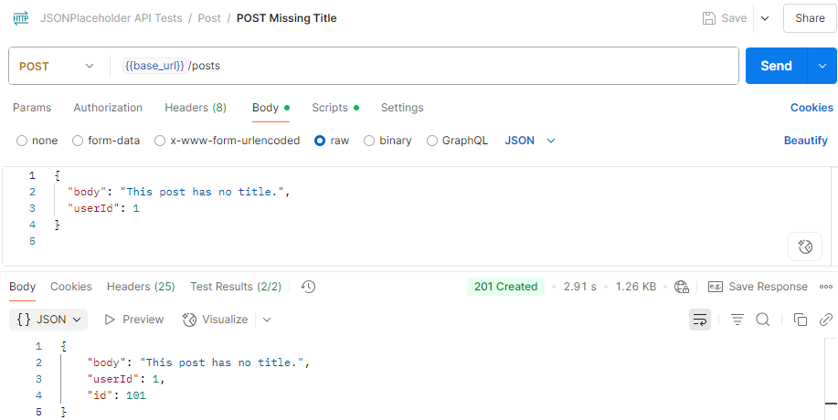  
**Screenshot – Test Result:**

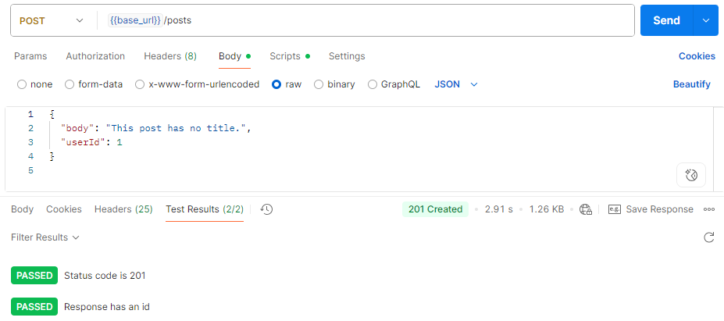

## TC10 - POST /posts

* **Description:** Create post with missing body
* **Method:** POST
* **Endpoint:** /post
* **Expected Result:** Simulated 201 Created (mock API)
* **Actual Result:** Pass – Status 201 Created, response echoed title, userId, and new id
* **Test Status:** ✅ Passed

**Screenshot – Response:**

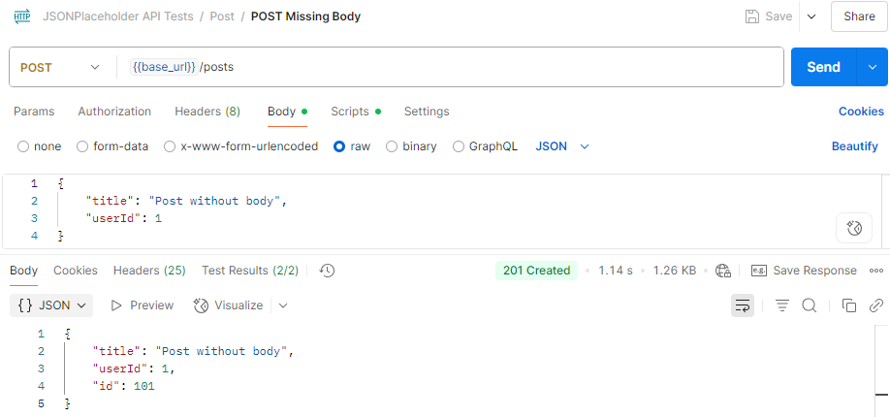  
**Screenshot – Test Result:**

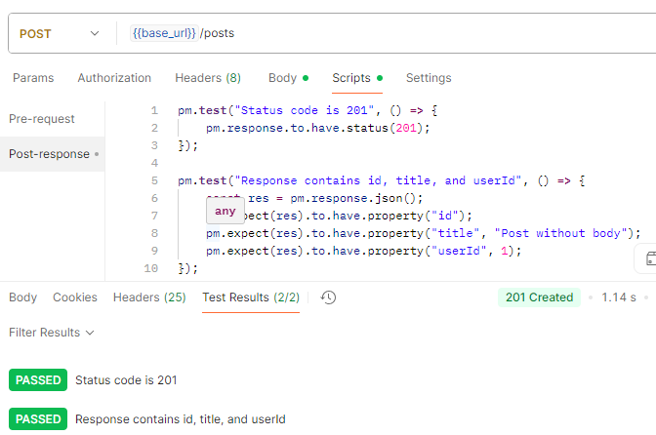

## TC11 - POST /posts

* **Description:** Send empty body
* **Method:** POST
* **Endpoint:** /post
* **Expected Result:** Simulated 201 Created (mock API)
* **Actual Result:** Pass – Status 201 Created, response contains only id
* **Test Status:** ✅ Passed

**Screenshot – Response:**

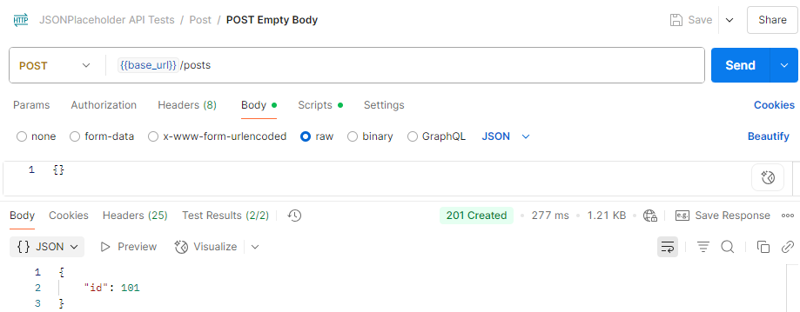  
**Screenshot – Test Result:**

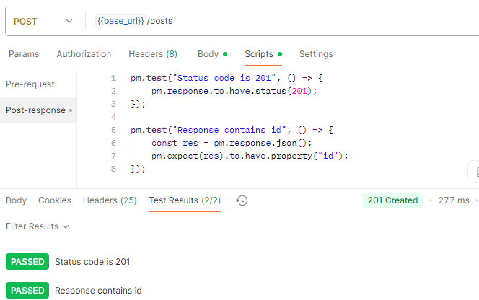

## **TC12 - POST /posts**

* **Description:** Extra fields in payload
* **Method:** POST
* **Endpoint:** /post
* **Expected Result:** Simulated 201 Created (mock API)
* **Actual Result:** Pass – Status 201 Created, all extra fields and id returned in response
* **Test Status:** ✅ Passed

**Screenshot – Response:**

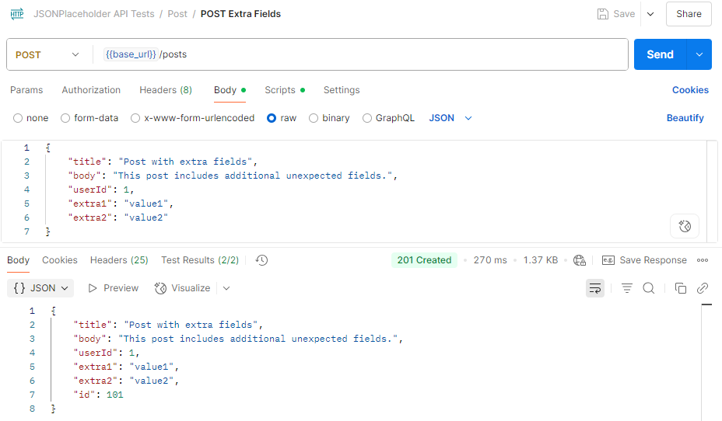

**Screenshot – Test Result:**

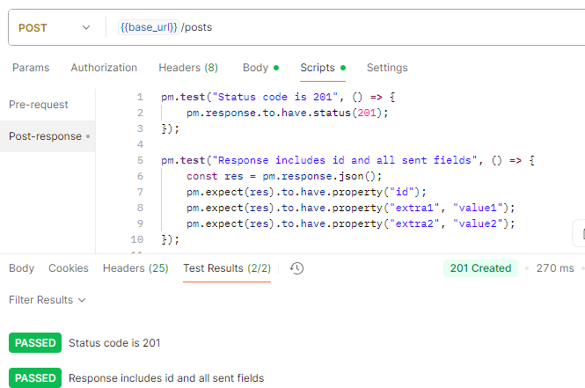

## **TC13 - POST /posts**

* **Description:** Invalid data types (number for title/body)
* **Method:** POST
* **Endpoint:** /post
* **Expected Result:** Simulated 201 Created (mock API)
* **Actual Result:** Pass – Status 201 Created, numeric title/body accepted and returned
* **Test Status:** ✅ Passed

**Screenshot – Response:**

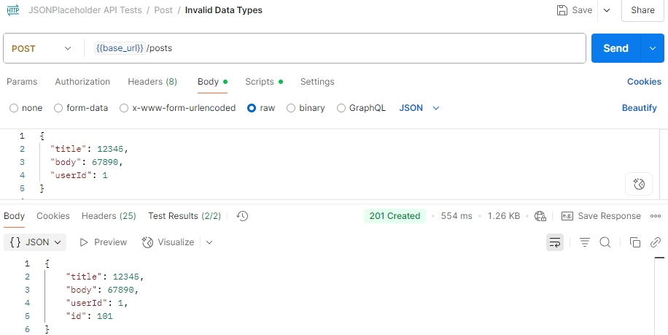

**Screenshot – Test Result:**

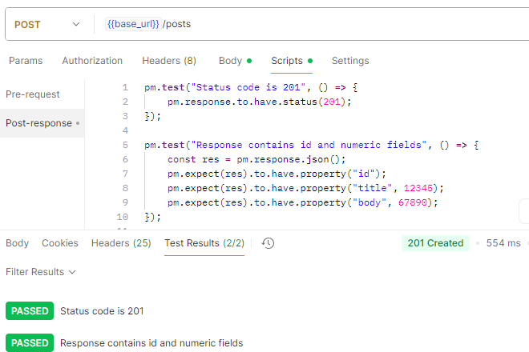

## **TC14 - PUT /posts/1**

* **Description:** Update title only
* **Method:** PUT
* **Endpoint:** /posts/1
* **Expected Result:** 200 OK
* **Actual Result:** Pass – Status 201 Created, response contains updated title only
* **Test Status:** ✅ Passed

**Screenshot – Response:**

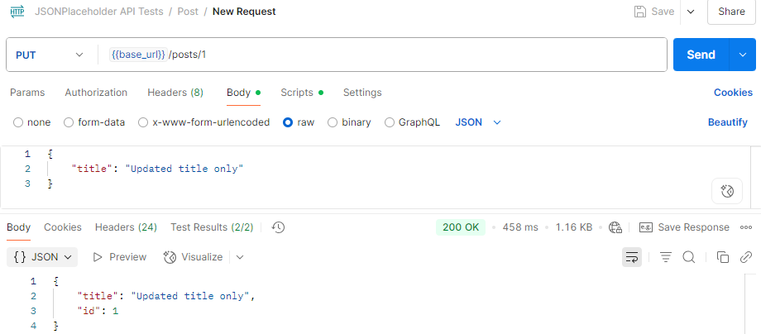  
**Screenshot – Test Result:**

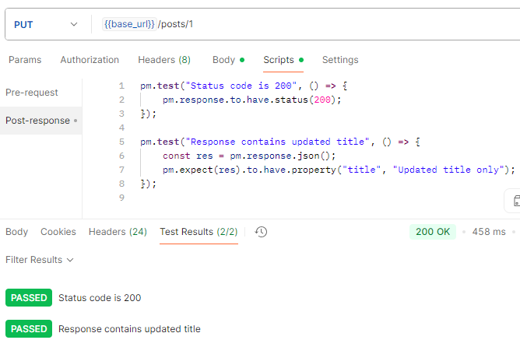

## **TC15 - PUT /posts/1**

* **Description:** Update body only
* **Method:** PUT
* **Endpoint:** /posts/1
* **Expected Result:** 200 OK
* **Actual Result:** Pass – Status 200 OK, response contains updated body only
* **Test Status:** ✅ Passed

**Screenshot – Response:**

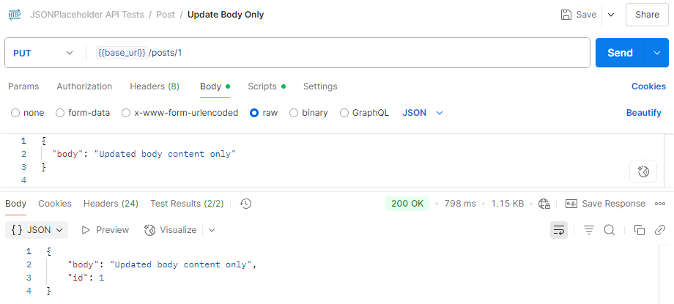  
**Screenshot – Test Result:**

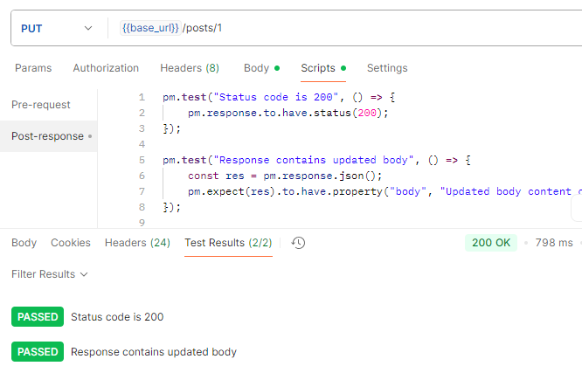

## **TC16 - PUT /posts/1**

* **Description:** Update with empty body
* **Method:** PUT
* **Endpoint:** /posts/1
* **Expected Result:** 200 OK
* **Actual Result:** Pass – Status 200 OK, response unchanged
* **Test Status:** ✅ Passed

**Screenshot – Response:**

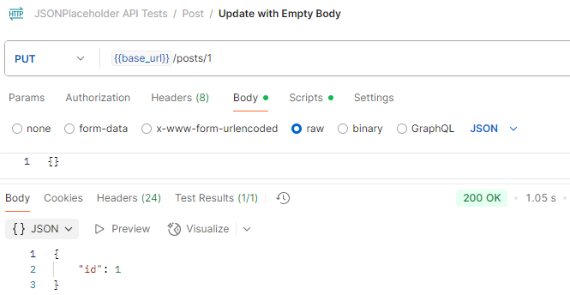

**Screenshot – Test Result:**

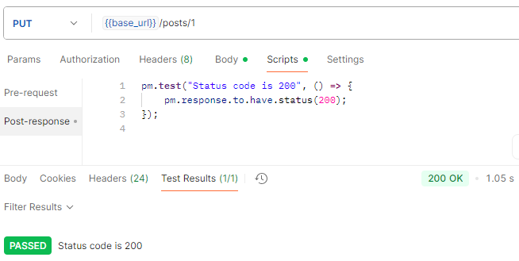

## **TC17 - PUT /posts/1**

* **Description:** Update with invalid types
* **Method:** PUT
* **Endpoint:** /posts/1
* **Expected Result:** 200 OK
* **Actual Result:** Pass – Status 200 OK, invalid fields ignored, only id returned in response
* **Test Status:** ✅ Passed

**Screenshot – Response:**

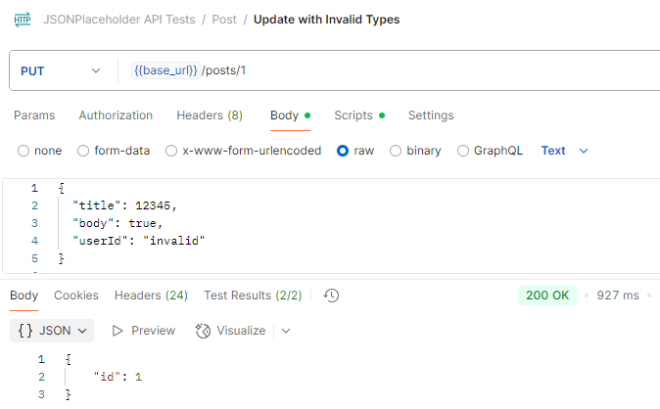  
**Screenshot – Test Result:**

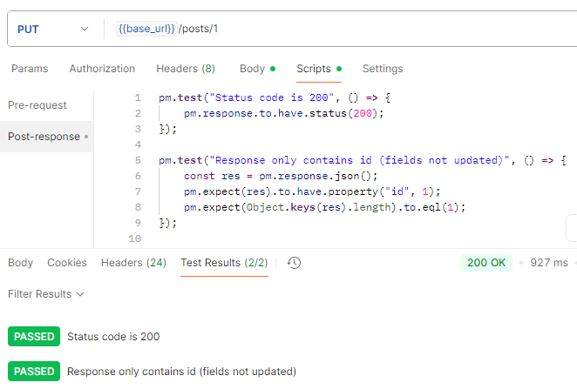

## **TC18 - PUT /posts/100**

* **Description:** Update boundary post (simulate non-existent behaviour)
* **Method:** PUT
* **Endpoint:** /posts/100
* **Expected Result:** 200 OK (mocked)
* **Actual Result:** Pass – Status 200 OK, response returned with updated title, body, userId, and id
* **Test Status:** ✅ Passed

**Screenshot – Response:**

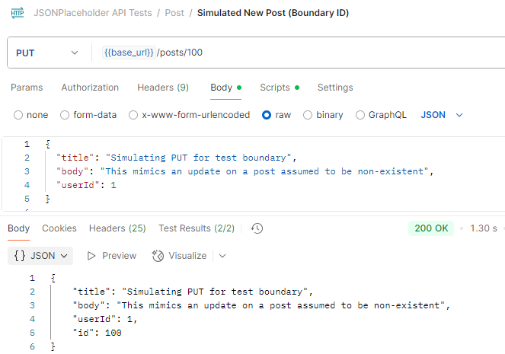  
**Screenshot – Test Result:**

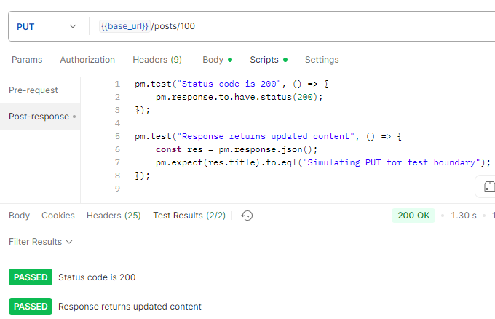

## **TC19 - PUT /posts/1**

* **Description:** Update with missing fields
* **Method:** PUT
* **Endpoint:** /posts/1
* **Expected** **Result:** 200 OK
* **Actual** **Result:** Pass – Status 200 OK, response returned with updated title only
* **Test Status:** ✅ Passed

**Screenshot – Response:**

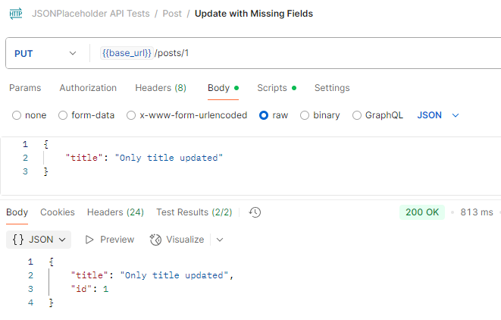

**Screenshot – Test Result:**

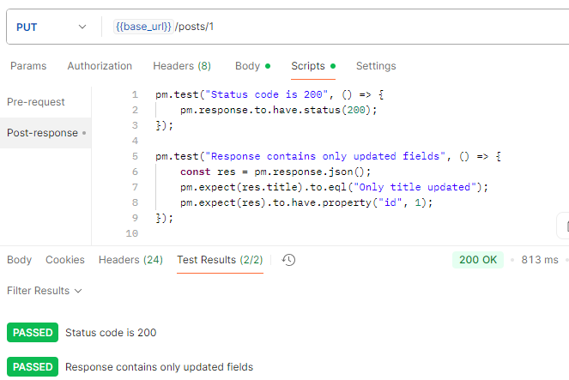

## **TC20 - PUT /posts/1**

* **Description:** Update with extra fields
* **Method:** PUT
* **Endpoint:** /posts/1
* **Expected** **Result:** 200 OK
* **Actual** **Result:** Pass – Status 200 OK, response includes extra fields from the request
* **Test Status:** ✅ Passed

**Screenshot – Response:**

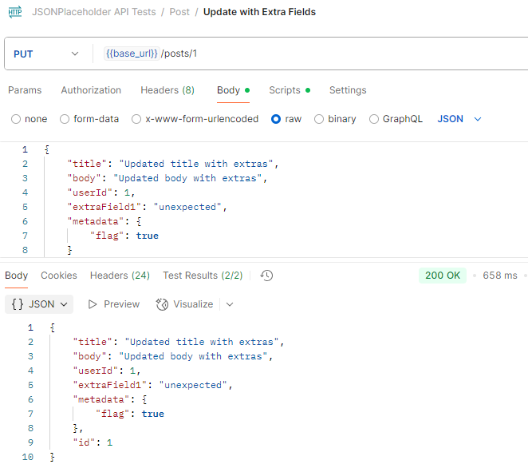

**Screenshot – Test Result:**

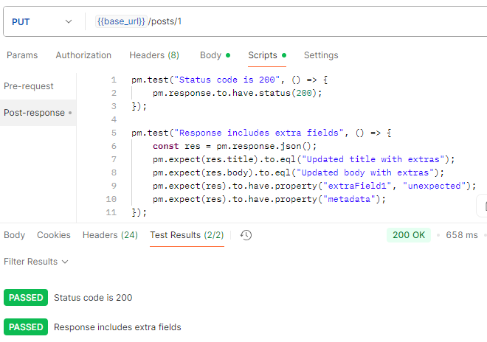

## **TC21 – DELETE /posts/1**

* **Description:** Valid delete request
* **Method:** DELETE
* **Endpoint:** /posts/1
* **Expected** **Result:** 200 OK
* **Actual** **Result:** Pass – Status 200 OK, received, empty response body
* **Test Status:** ✅ Passed

**Screenshot – Response:**

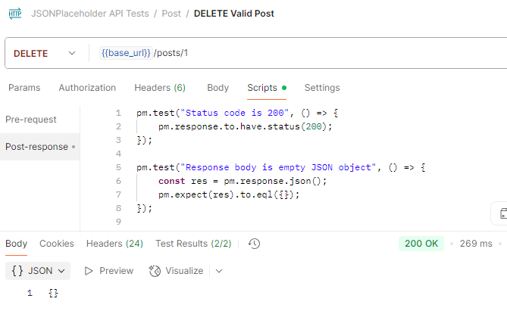  
**Screenshot – Test Result:**

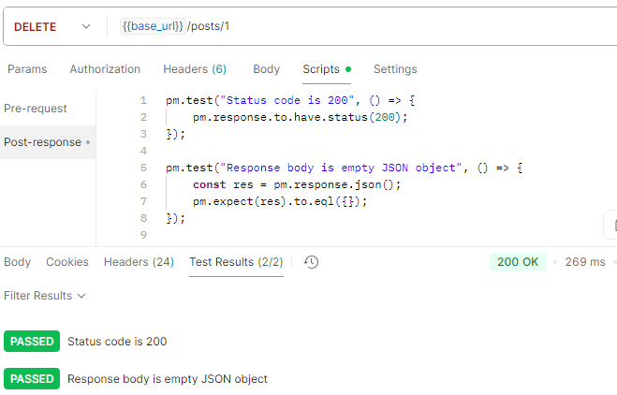

## **TC22 – DELETE /posts/0**

* **Description:** Delete invalid ID
* **Method:** DELETE
* **Endpoint:** /posts/0
* **Expected** **Result:** 200 OK (mocked)
* **Actual** **Result:** Pass – Status 200 OK, returned with empty {} response
* **Test Status:** ✅ Passed

**Screenshot – Response:**

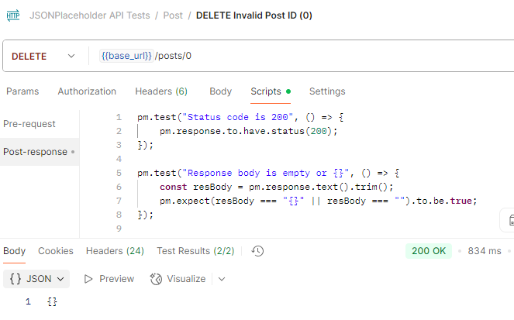  
**Screenshot – Test Result:**

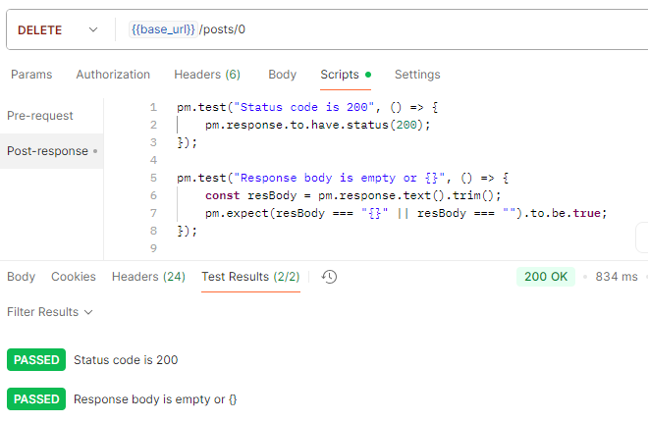

## **TC23 – DELETE /posts/abc**

* **Description:** Delete with string ID
* **Method:** DELETE
* **Endpoint:** /posts/abc
* **Expected** **Result:** 200 OK (mocked)
* **Actual** **Result:** Pass – Status 200 OK, response returned empty {}
* **Test Status:** ✅ Passed

**Screenshot – Response:**

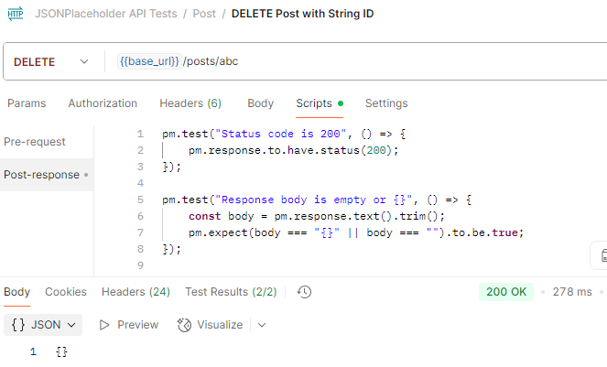  
**Screenshot – Test Result:**

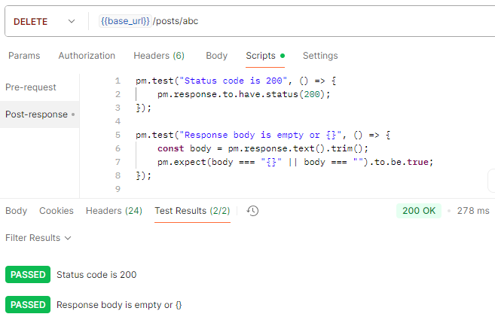

## **TC24 – DELETE /posts/9999**

* **Description:** Delete non-existent ID
* **Method:** DELETE
* **Endpoint:** /posts/9999
* **Expected** **Result:** 200 OK (mocked)
* **Actual** **Result:** Pass – Status 200 OK, returned with empty {} response
* **Test Status:** ✅ Passed

**Screenshot – Response:**

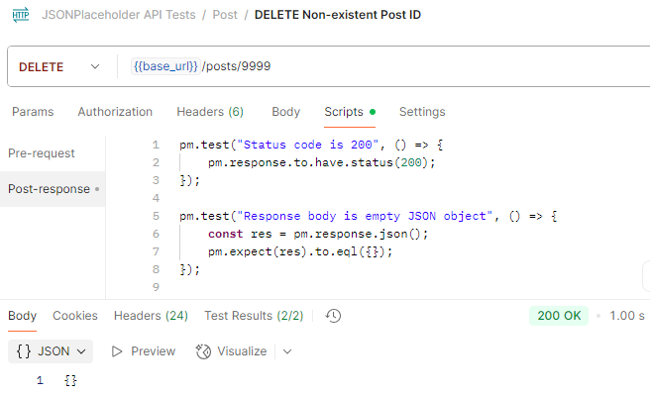  
**Screenshot – Test Result:**

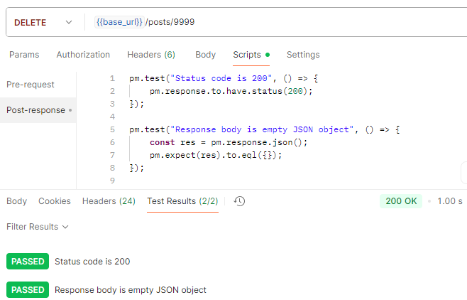

## **TC25 – GET /posts**

* **Description:** Response time under 1000ms
* **Method:** GET
* **Endpoint:** /posts
* **Expected** **Result:** Response time < 1000ms
* **Actual** **Result:** Pass – Response time recorded under 1000ms
* **Test Status:** ✅ Passed

**Screenshot – Response:**

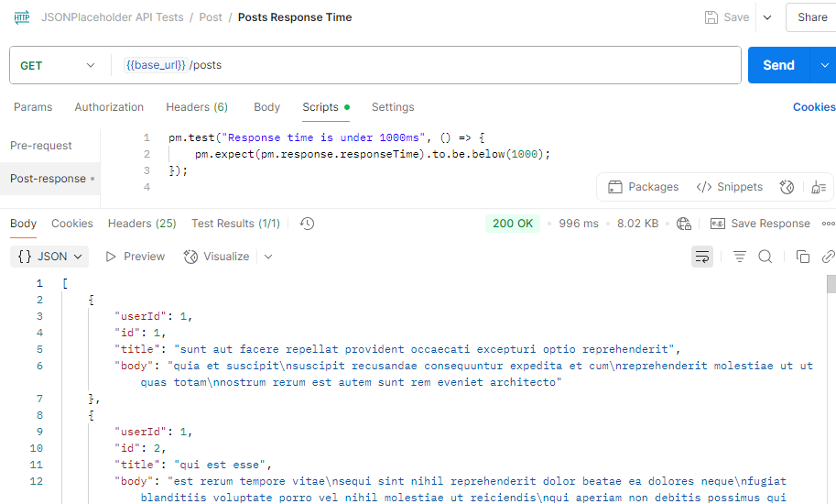

**Screenshot – Test Result:**

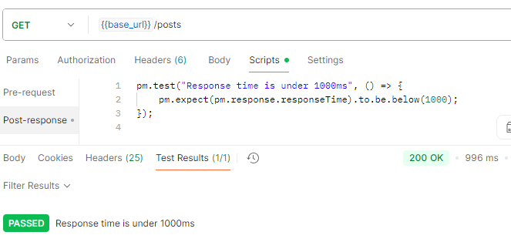

## **TC26 – GET /posts**

* **Description:** Response header contains Content-Type: application/json
* **Method:** GET
* **Endpoint:** /posts
* **Expected** **Result:** Response header includes Content-Type: application/json
* **Actual** **Result:** Pass – Response header includes Content-Type: application/json
* **Test Status:** ✅ Passed

**Screenshot – Response:**

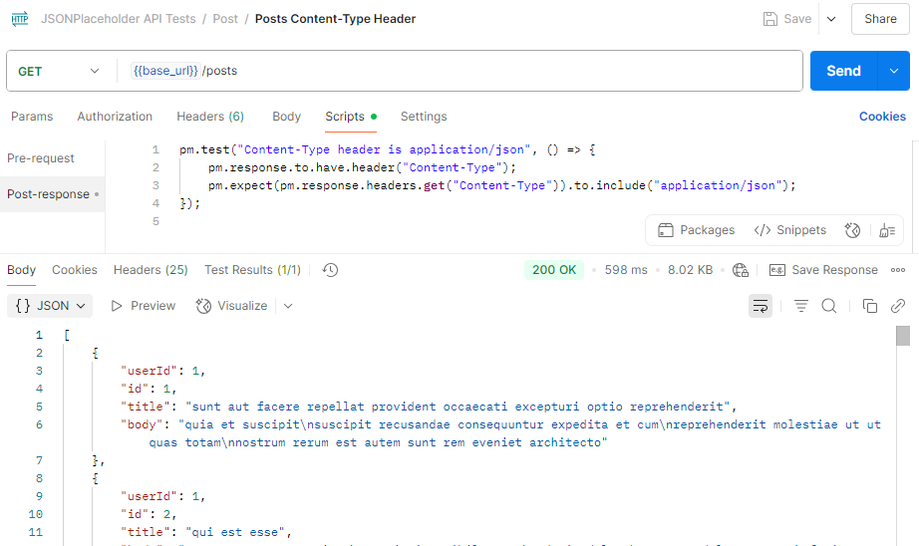  
**Screenshot – Test Result:**

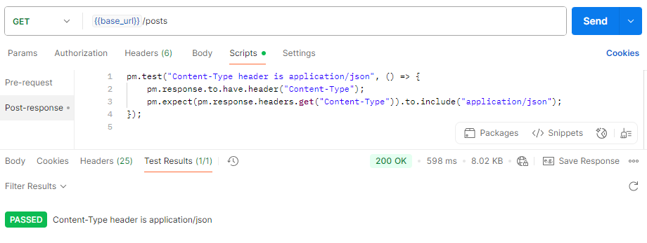

## TC27 - GET /posts/1

* **Description:** Validate schema of a single post object
* **Method:** GET
* **Endpoint:** /posts/1
* **Expected Result:** Response has keys userId, id, title, body
* **Actual Result:** Pass – JSON schema matched expected structure
* **Test Status:** ✅ Passed

**Screenshot – Response:**

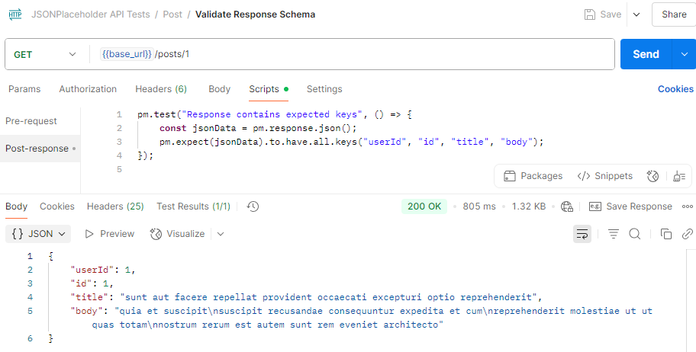

**Screenshot – Test Result:**

