HEALTHRISK AI DASHBOARD
- INTRODUCTION
HealthRisk AI Dashboard is a Machine Learning based healthcare analytics system developed using Python and Streamlit. The system predicts healthcare-related risks using trained machine learning models and provides an interactive dashboard for users.
The project contains four major modules:
• Heart Disease Prediction
• Insurance Risk Prediction
• Hospital Risk Assessment
• Pharma Recommendation System
• HealthRisk Lab Simulator
- PROBLEM STATEMENT
Healthcare organizations generate large amounts of data. Manual analysis of healthcare data is time-consuming and prone to errors. The objective of this project is to build an AI-powered dashboard capable of predicting healthcare risks and assisting in decision-making.
- OBJECTIVES
• Predict heart disease risk
• Predict insurance risk levels
• Assess hospital financial risk
• Provide pharma investment recommendations
• Integrate all models into a single dashboard
- TECHNOLOGIES USED
• Python
• Pandas
• NumPy
• Scikit-Learn
• Streamlit
• Joblib
- DATASETS USED
Heart Disease Dataset
Features:
Age, Sex, ChestPainType, RestingBP, Cholesterol, FastingBS, RestingECG, MaxHR, ExerciseAngina, Oldpeak, ST_Slope
Target:
HeartDisease
Insurance Dataset
Features:
Age, Sex, BMI, Children, Smoker, Region
Target:
Risk
Hospital Dataset
Features:
Revenue, DebtRatio, ReadmissionRate, PatientSatisfaction
Target:
Risk
Pharma Dataset
Features:
RDSpend, RevenueGrowth, TrialSuccess
Target:
Recommendation
- MACHINE LEARNING MODELS
The following machine learning models were trained and saved as .pkl files:
• Heart Disease Model
• Insurance Risk Model
• Hospital Risk Model
• Pharma Recommendation Model
- DASHBOARD IMPLEMENTATION
A Streamlit dashboard was developed to:
• Load trained models
• Accept user inputs
• Generate predictions
• Display results interactively
- TESTING RESULTS
8.1 Home Page Screenshot
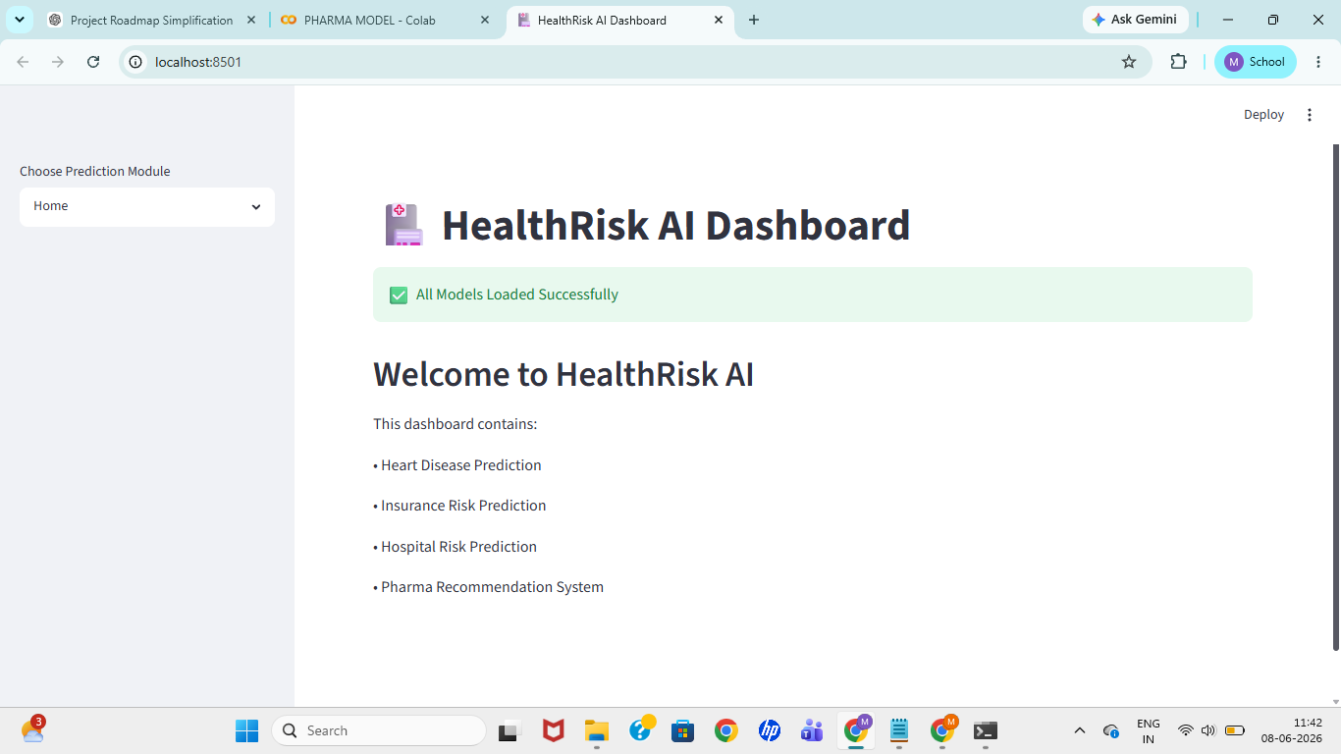
8.2 Heart Disease Prediction Screenshot
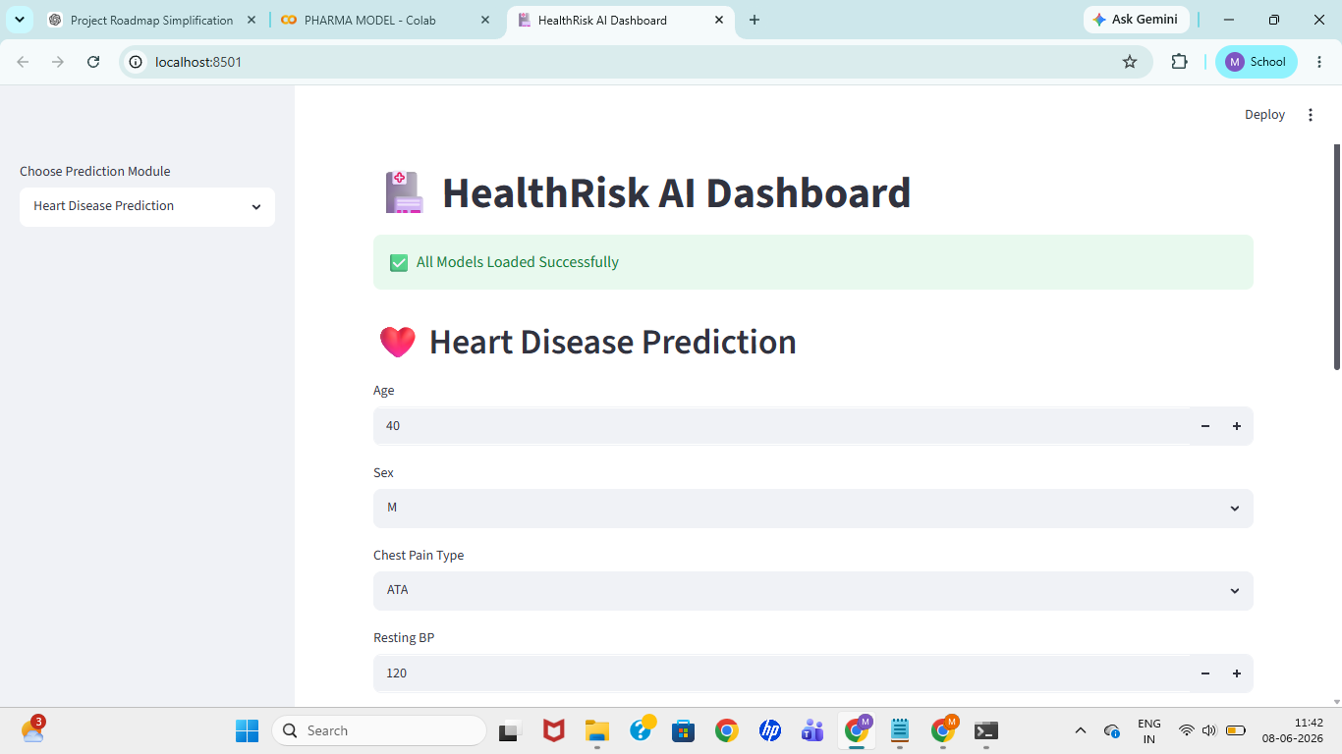
8.3 Insurance Risk Prediction Screenshot
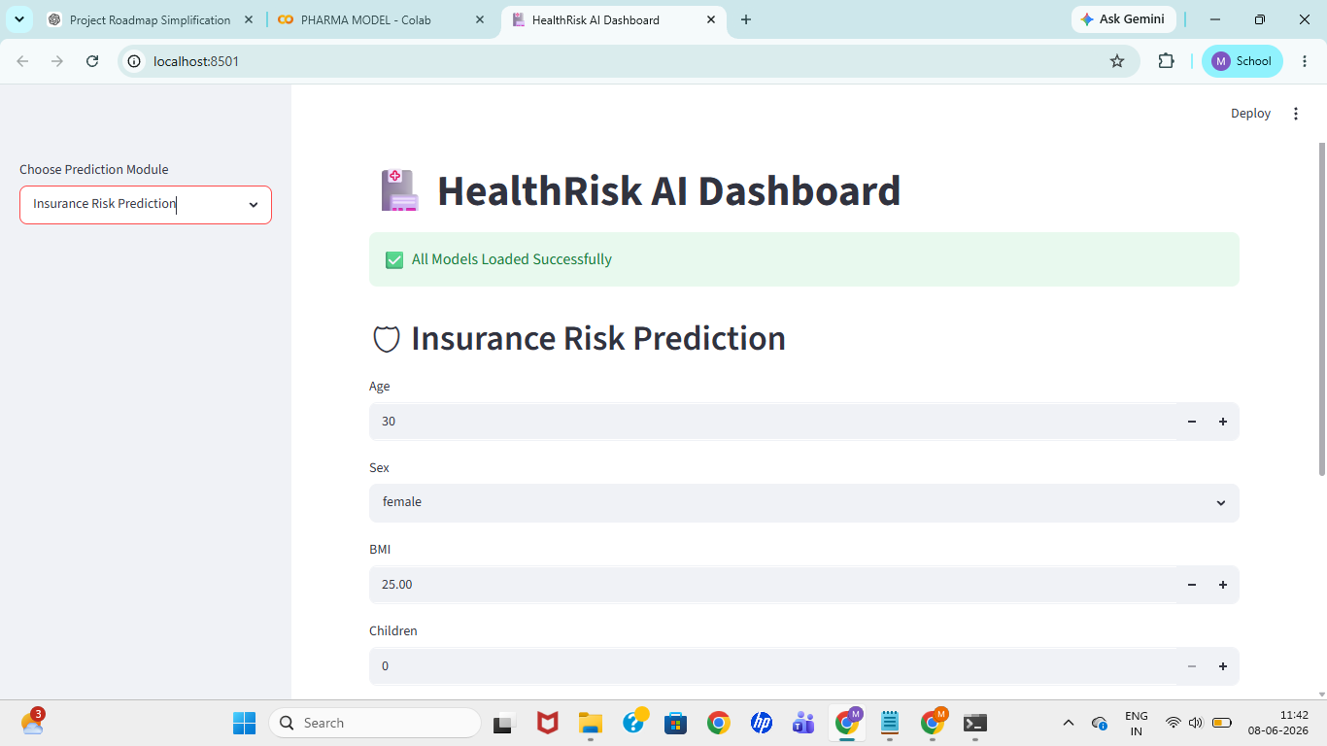
8.4 Hospital Risk Prediction Screenshot
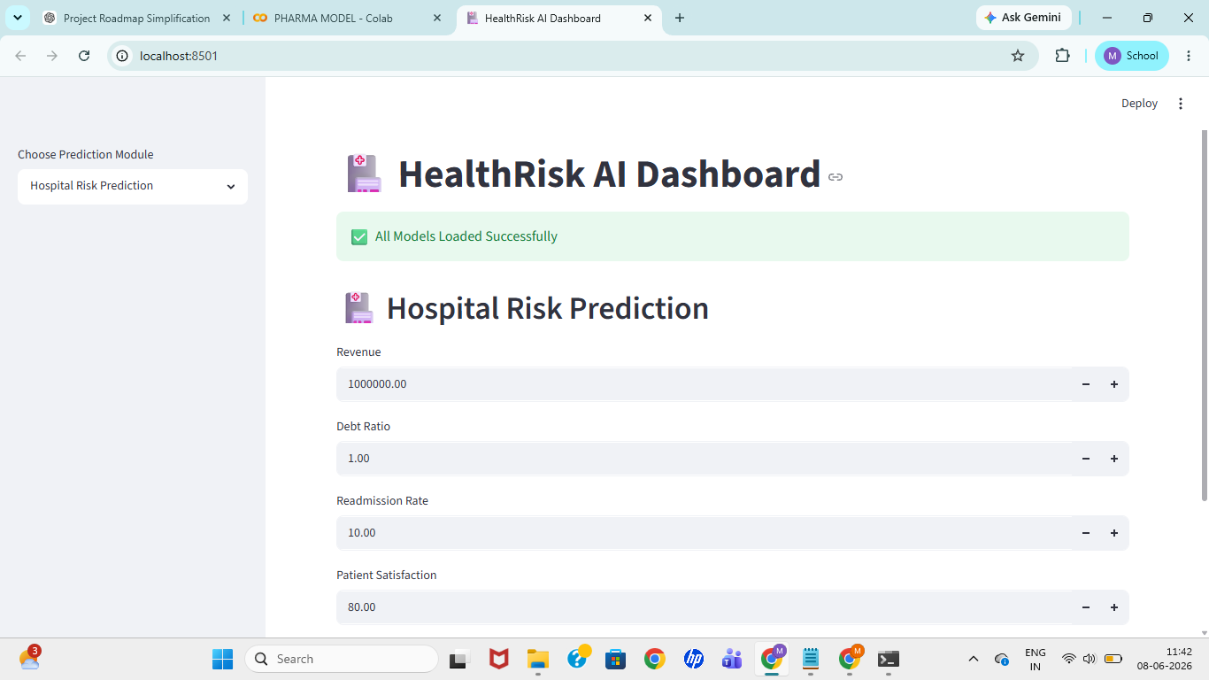
8.5 Pharma Recommendation Screenshot
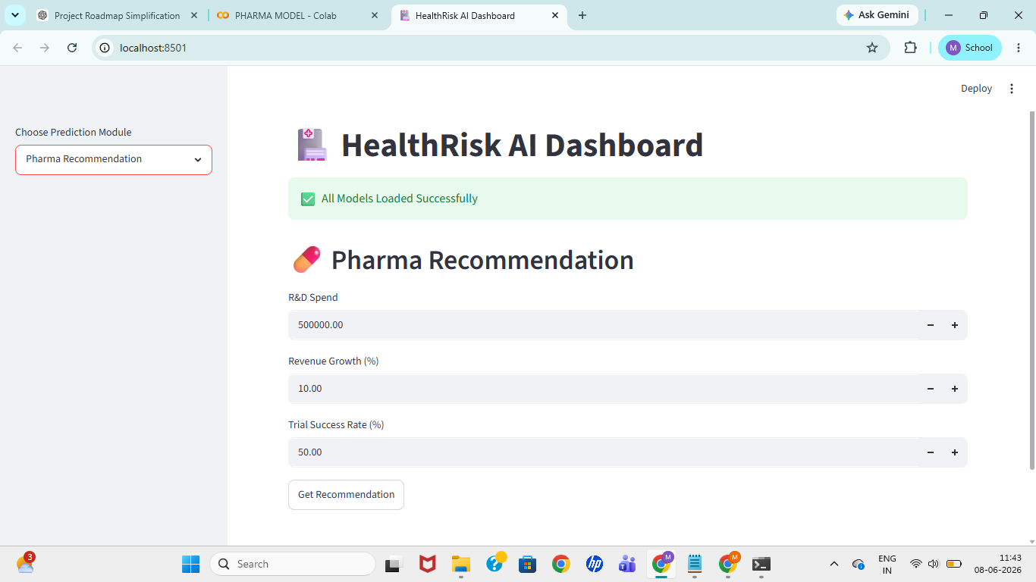
8.6 HealthRisk Lab Simulator Screenshot
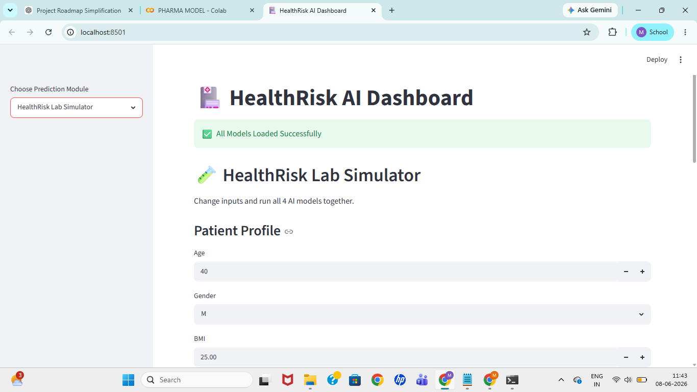
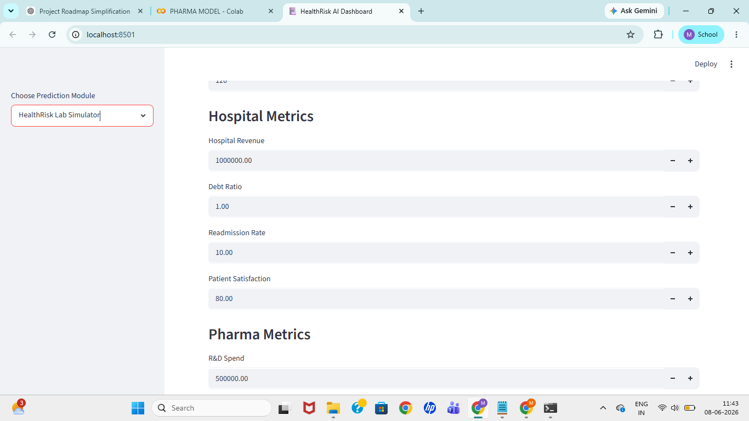
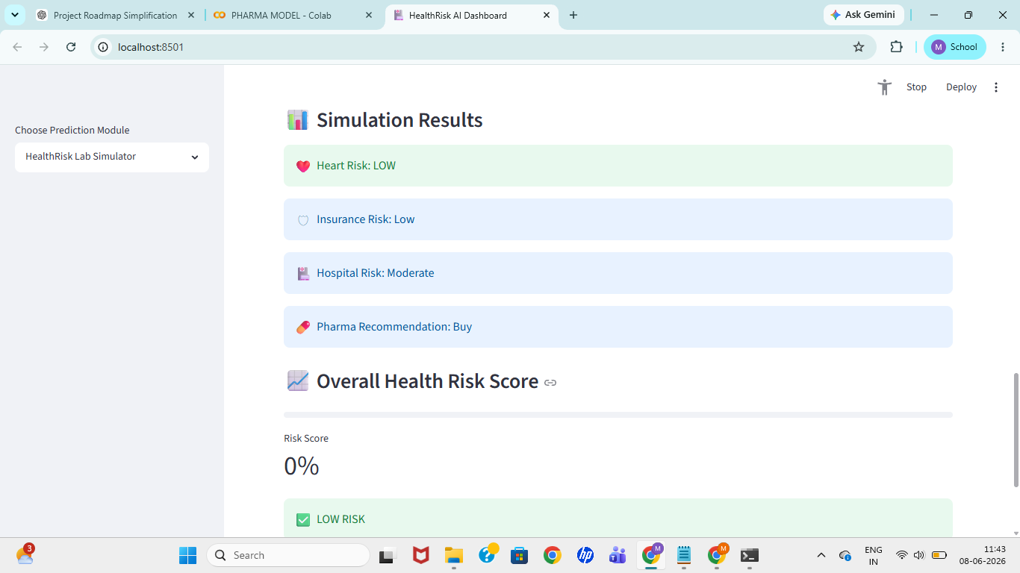
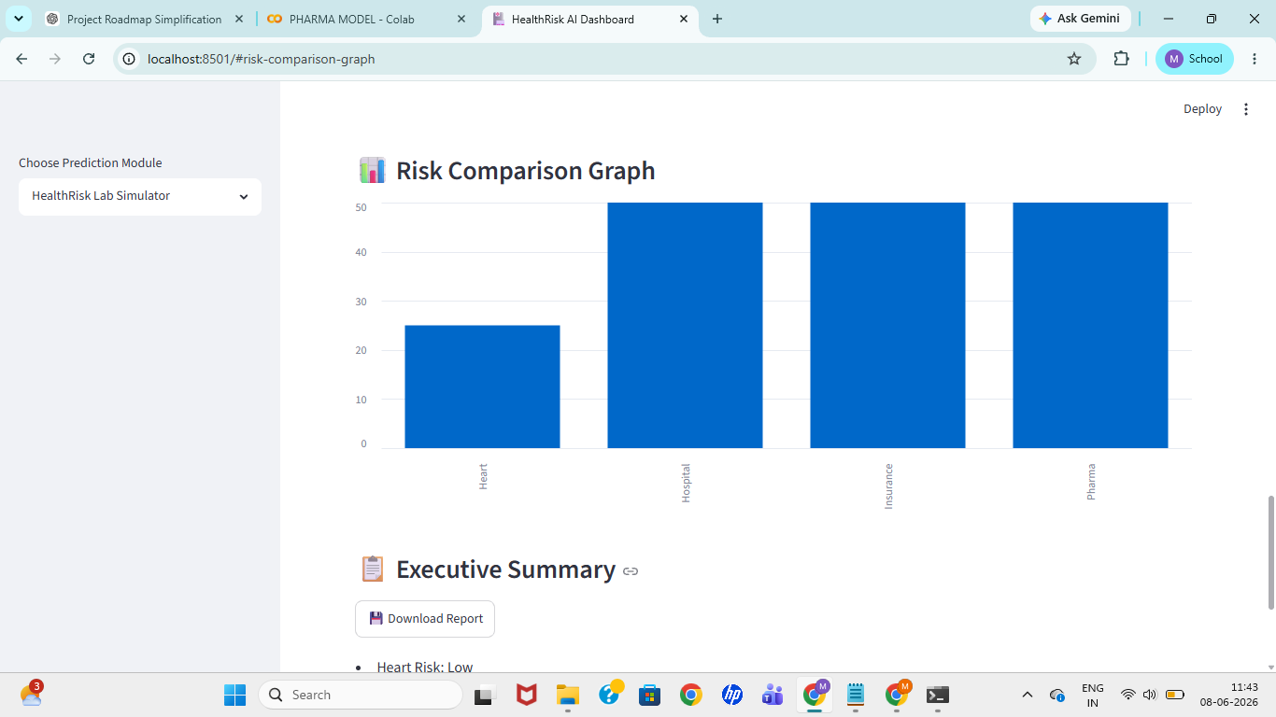
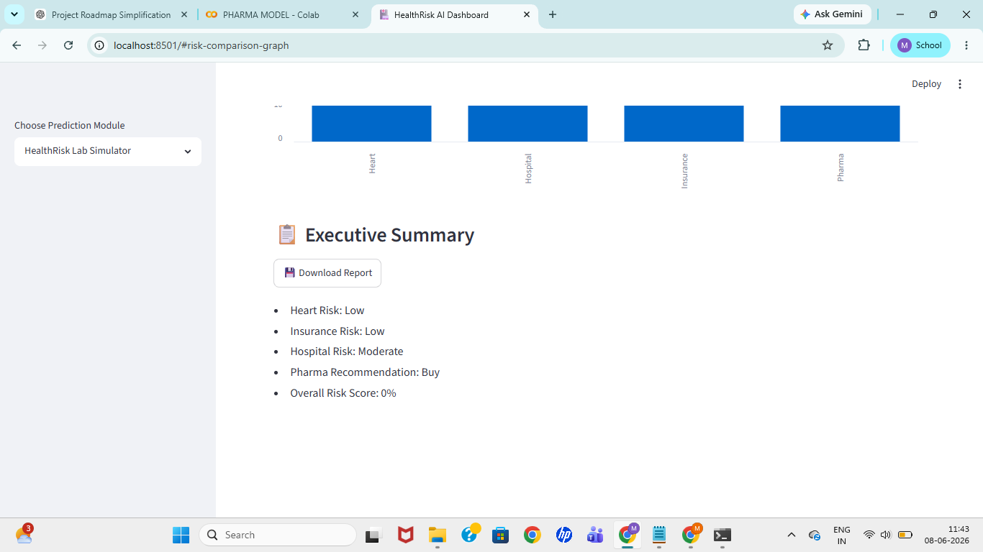
- CONCLUSION
HealthRisk AI Dashboard successfully demonstrates the application of Machine Learning in healthcare analytics. The system integrates multiple predictive models into a single interactive platform and provides risk assessment capabilities for healthcare-related decision making.
- FUTURE SCOPE
• Cloud Deployment
• Real-time Data Integration
• Deep Learning Models
• Advanced Healthcare Analytics
• Mobile Application Development
Author:
Madhuri Kumari

