**Assignment**

**Title**: To Perform CRUD operation on Employee Management System using Web API.

**Technologies -**  
I used Asp.net mvc,Entity framework ,sql sever,c#,css3 and html5.

**Description:**

In this project I worked on the CRUD operations.First I created the table

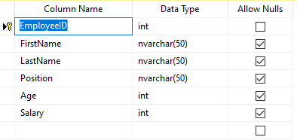

Table Script:

USE [EMS]

GO

/****** Object: Table [dbo].[Employee] Script Date: 14-11-2024 15:32:02 ******/

SET ANSI_NULLS ON

GO

SET QUOTED_IDENTIFIER ON

GO

CREATE TABLE [dbo].[Employee](

[EmployeeID] [int] IDENTITY(1,1) NOT NULL,

[FirstName] [nvarchar](50) NULL,

[LastName] [nvarchar](50) NULL,

[Position] [nvarchar](50) NULL,

[Age] [int] NULL,

[Salary] [int] NULL,

CONSTRAINT [PK_Employee] PRIMARY KEY CLUSTERED

(

[EmployeeID] ASC

)WITH (PAD_INDEX = OFF, STATISTICS_NORECOMPUTE = OFF, IGNORE_DUP_KEY = OFF, ALLOW_ROW_LOCKS = ON, ALLOW_PAGE_LOCKS = ON, OPTIMIZE_FOR_SEQUENTIAL_KEY = OFF) ON [PRIMARY]

) ON [PRIMARY]

GO

Used this table as edmx model.

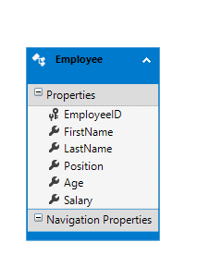

When run the application saved record will be display.

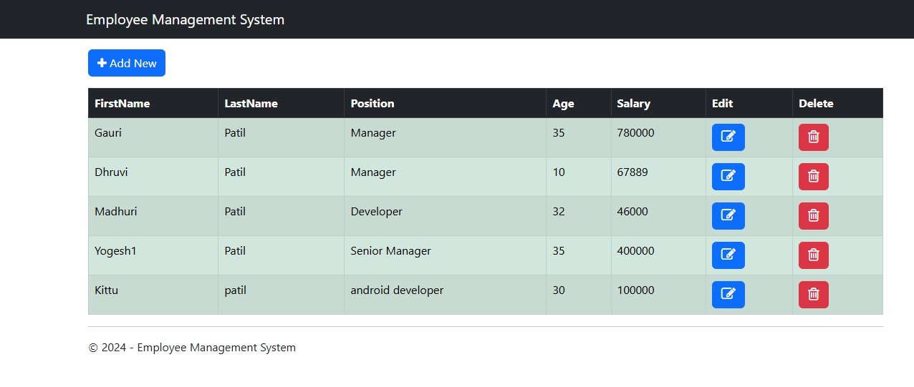

When Clicked on button ,below screen appear.Without entering data clicked on save button it shows Error Message

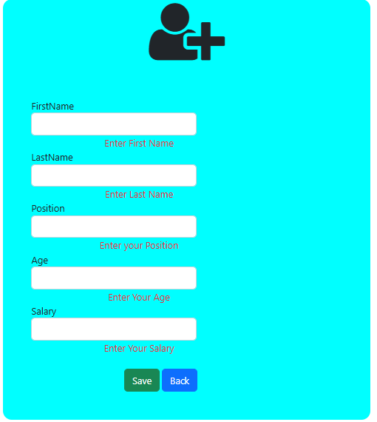

Using below page add the Employee

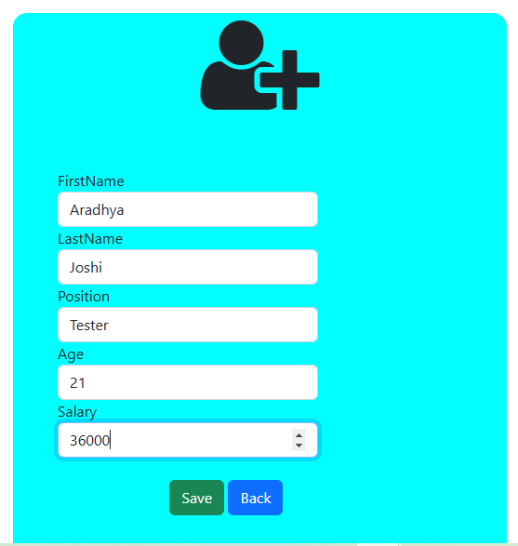

Saved Record display in Table

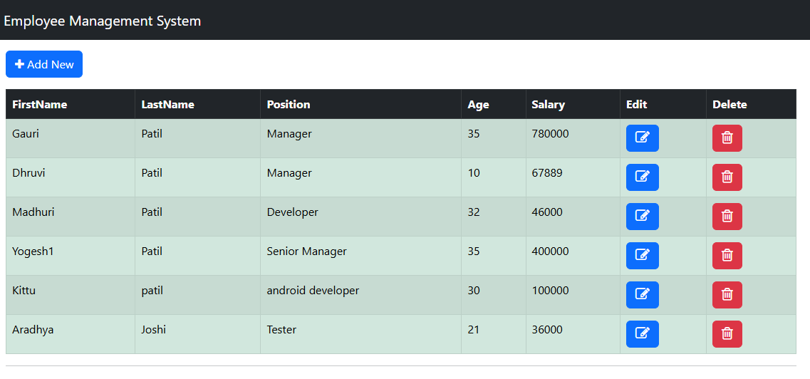

Update the record Aradhya in that its Lastname and Salary has been updated

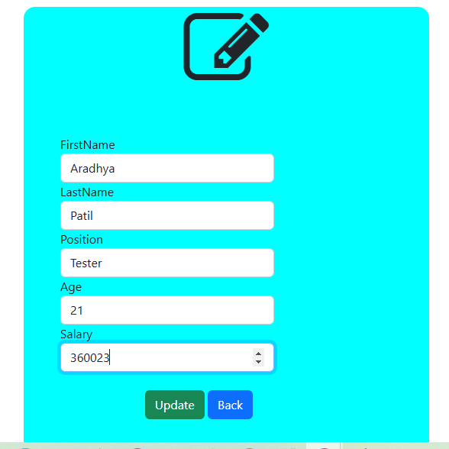

Updated data Display in table

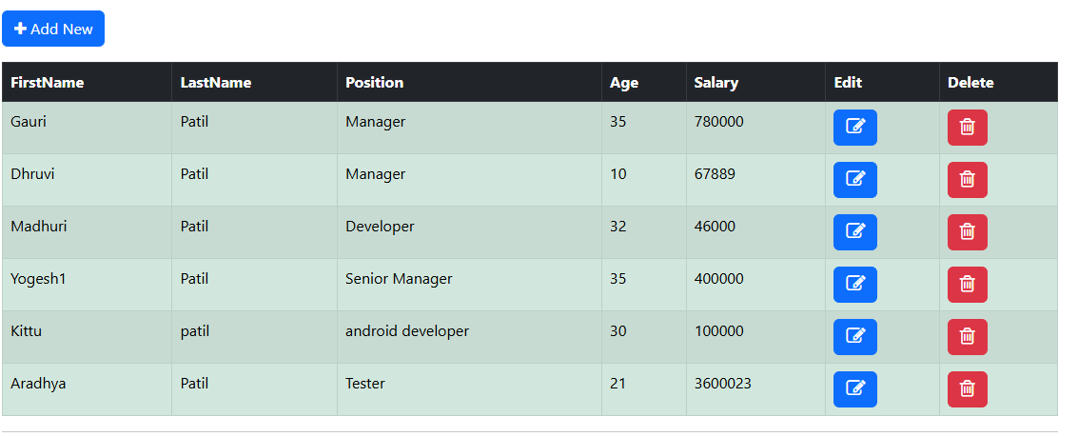

Delete the selected record

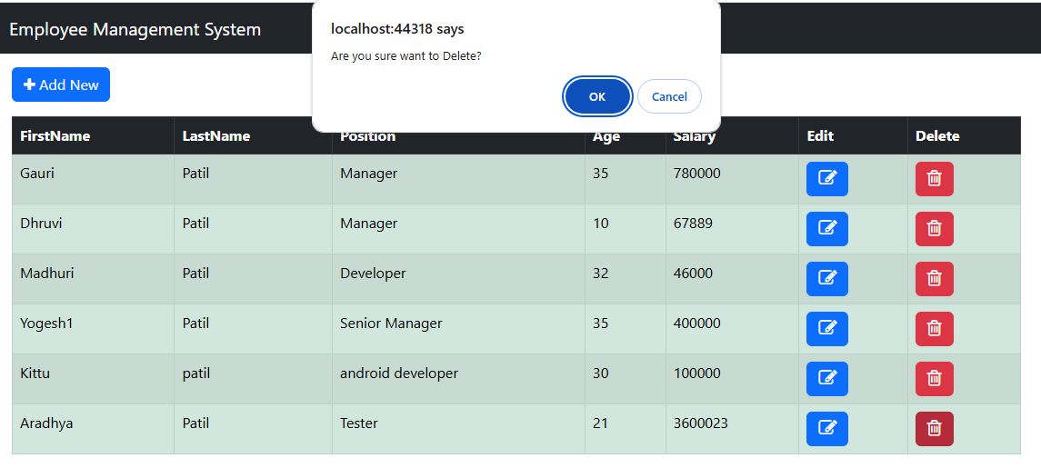

Record deleted and remove from table also. Alert message aplly for Add,Update and Delete operation.

