Question 1:
Define Power BI and what are the key components of the Power BI ecosystem? Briefly explain: ● Power BI Desktop ● Power BI Service ● Power BI Mobile ● Power BI Gateway

Power BI Definition
Power BI is a business intelligence (BI) and data visualization tool developed by Microsoft.
It allows users to connect to various data sources, transform raw data into meaningful insights, and create interactive dashboards and reports that can be shared across the organization.

1. Power BI Desktop
- A Windows application used by data analysts and developers to:
  - Connect to multiple data sources (Excel, SQL, etc.)
  - Perform data cleaning and modeling using Power Query and DAX
  - Build interactive reports and dashboards
- Once the report is ready, it can be published to the Power BI Service for sharing.

Power BI Service (PowerBI.com)
- A cloud-based platform where reports and dashboards created in Power BI Desktop are published.
- Enables collaboration, sharing, and real-time updates.
- Users can:
  - View and interact with dashboards
  - Set up data refresh schedules
  - Manage permissions and access

Power BI Mobile
- A mobile app (available for Android, iOS, and Windows).
- Allows users to view and interact with dashboards and reports on the go.
- Ensures decision-makers have real-time access to insights anytime, anywhere.

Power BI Gateway
- A bridge between on-premises data sources and the Power BI Service.
- It allows data from local databases (e.g., SQL Server, Oracle) to be securely refreshed in the Power BI cloud without moving the data permanently.
- Two modes:
  - Personal Gateway – for individual use.
  - Enterprise Gateway – for team or organization-wide use.

Question 2:
Compare the following Power BI visuals: ● Pie Chart vs Donut Chart ● Bar Chart vs Column Chart when would you prefer one over the other? Give one example for each pair.

Pie Chart vs Donut Chart
A Pie Chart shows data as slices of a circle, where each slice represents a category’s proportion of the total. It is best suited for displaying part-to-whole relationships when there are only a few categories (for example, showing sales contribution by region such as North – 40%, South – 35%, etc.).
A Donut Chart is similar to a pie chart but has a blank circle at the center. This makes it easier to read and allows you to display additional information, such as the total value, in the center. It is often preferred when you want to emphasize both individual proportions and the total, for instance, market share by product category with the total sales amount shown in the center.

In short, use a Pie Chart for a simple, clear view with fewer categories, and use a Donut Chart when you want a cleaner look or need space to highlight totals.

Bar Chart vs Column Chart
A Bar Chart uses horizontal bars to represent values. It is ideal when you have long category names or many items to compare side by side. For example, comparing sales by product name works well in a bar chart because horizontal bars make long labels easy to read.
A Column Chart, on the other hand, uses vertical bars and is best for showing trends over time or comparisons across time periods, such as monthly revenue from January to December.
In general, choose a Bar Chart for categorical comparisons and a Column Chart for time-series or trend analysis.
Question 3:
Explain the significance of: ● Star schema vs Snowflake schema ● Primary key vs Foreign key in relationships (Power BI) Why is cardinality important?

Star Schema vs Snowflake Schema
A Star Schema is a simple database design where a central fact table (containing quantitative data like sales, revenue, or transactions) is directly connected to dimension tables (such as Date, Customer, Product). Each dimension table is independent and not linked to other dimensions.
It is widely used in Power BI because it provides fast query performance, is easy to understand, and helps build efficient relationships for data modelling.
Example: A Sales fact table linked to Product, Customer, and Date dimension tables.
A Snowflake Schema is a more complex form of the star schema where the dimension tables are normalized into multiple related tables. This reduces data redundancy but can make the model slower and harder to maintain.
Example: A Product dimension split into Product → Category → Department tables.
In short, Star Schema is preferred in Power BI for simplicity and performance, while Snowflake Schema is used when minimizing data duplication is more important.
Primary Key vs Foreign Key in Relationships (Power BI)
A Primary Key is a unique identifier in a table, ensuring that each record is distinct (for example, CustomerID in the Customer table).
A Foreign Key is a field in another table that refers to the primary key of the related table (for example, CustomerID in the Sales table).
In Power BI, relationships are built using these keys. The Primary Key exists on the one side of the relationship, and the Foreign Key exists on the many side — forming a one-to-many relationship between tables.

Importance of Cardinality
Cardinality defines the type of relationship between two tables — such as one-to-one, one-to-many, or many-to-many.
It is important because it determines how data filters and aggregates flow between tables in Power BI.
If cardinality is set incorrectly, measures and visuals may show wrong totals or duplicate results. Setting the right cardinality ensures accurate relationships and correct data analysis.
Question 4:
Differentiate between: ● Calculated column vs Measure Also, define Row context and Filter context with simple examples.
Calculated Column vs Measure
A Calculated Column is created within a table using DAX (Data Analysis Expressions) and is evaluated row by row.
It becomes a new column in the data model and stores the calculated result for each row.
Calculated columns are useful when you need to use the result in visuals as a field or when creating relationships.
Example:
If you have columns Price and Quantity, you can create a calculated column:
TotalAmount = Price * Quantity
This value is stored for each row in the table.
A Measure, on the other hand, is a calculation that is evaluated dynamically based on the filters or context applied in a report.
It does not store data, but computes results on the fly, making it more efficient.
Example:
Total Sales = SUM(Sales[TotalAmount])
This measure recalculates automatically depending on slicers or filters in the report.
In summary, use a Calculated Column when the value is needed per row, and use a Measure for aggregated or dynamic calculations in visuals.

Row Context and Filter Context
Row Context refers to the current row that Power BI is evaluating in a table.
It exists automatically in calculated columns or iterating functions like SUMX or FILTER.
Example: In a calculated column Profit = Sales[Revenue] - Sales[Cost], Power BI evaluates each row separately — that’s row context.
Filter Context refers to the set of filters applied to a calculation, such as through slicers, visuals, or DAX formulas.
Example: If a user selects “Region = East” in a slicer, the measure Total Sales = SUM(Sales[Revenue]) will only calculate for that region — that’s filter context.
Question 5:
What is the difference between a report and a dashboard in Power BI?

Report vs Dashboard in Power BI
A Report in Power BI is a detailed, multi-page visualization created from a single dataset.
It allows users to explore data deeply using multiple visuals, filters, and pages.
Reports are interactive, meaning users can click visuals, apply slicers, and drill through to see underlying details.
Example: A “Sales Performance Report” may include pages for sales by region, product, and month — all linked to one dataset.
A Dashboard, on the other hand, is a single-page summary view (also called a canvas) that provides key insights at a glance.
It is created in the Power BI Service, often by pinning visuals from one or more reports or datasets.
Dashboards are used mainly by executives or decision-makers who need a quick overview rather than detailed analysis.
Example: A “Company KPI Dashboard” showing total sales, profit margin, and customer growth in one concise view.

In short:
- Report → Multi-page, detailed, interactive analysis.
- Dashboard → Single-page, high-level summary view (from multiple reports or datasets).
Question 6:
Using the Sample Superstore dataset: ● Create a Clustered Bar Chart to display Total Sales by Sub-Category ● Create a Donut Chart for Sales % by Region Provide screenshots of both visuals.
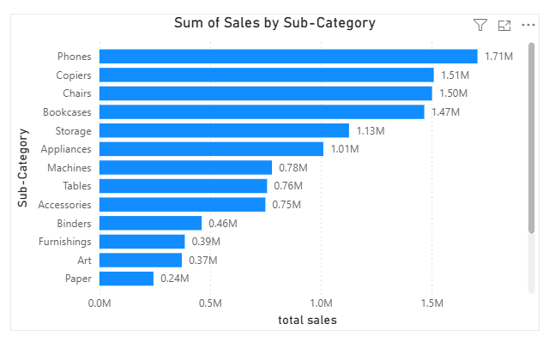
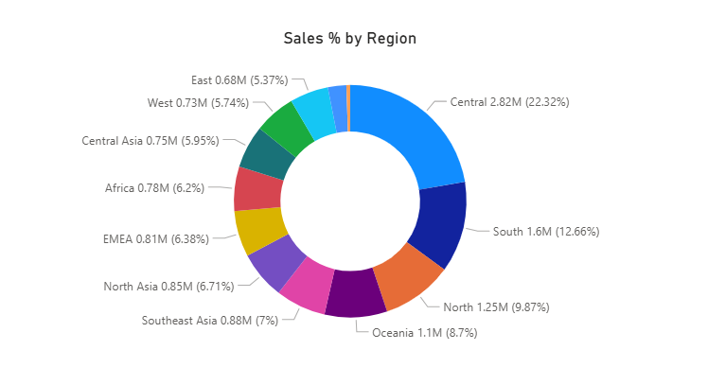
Question 7 :
Write and apply the following measures: ● Total Profit = SUM([Profit]) ● Average Discount = AVERAGE([Discount]) Display both in a KPI Card, and use a Line Chart to show profit trend over months. Add visuals and DAX formulas.
dax_total_profit = SUM (Global_Superstore2 [Profit])
dax_average_discount = AVERAGE (Global_Superstore2 [Discount])
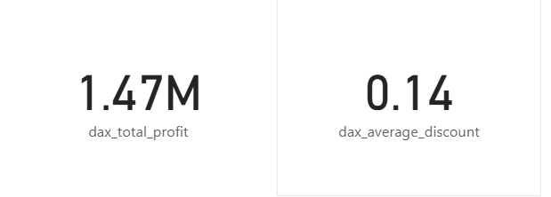

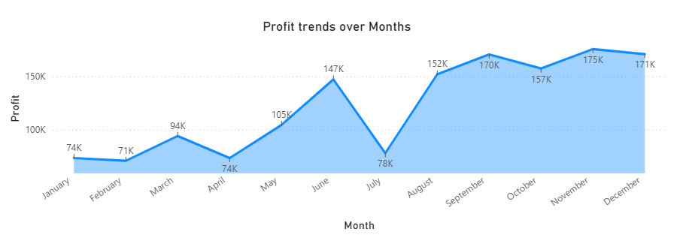
Question 8 :
Implement a DAX measure that calculates the percentage of total sales by product category.

Sales by Product Category
Product Category | Sales Amount (₹)
Electronics | 5,000
Clothing | 3,000
Home Appliances | 7,000
Books | 2,000
Tables & Chairs | 8,000
Toy | 1,500
Sports Equipment | 1,200
Office Supplies | 1,000
Beauty Products | 4,400
Garden Supplies | 1,000
Jewellery | 1,800
Automotive | 2,600

% of Total Sales =
DIVIDE (
SUM (Sales [Sales Amount]),
CALCULATE (SUM (Sales [Sales Amount]), ALL (Sales)),
0)

Question 9 :
● Create a DAX Measure for Total Profit ● Use it in a Waterfall Chart to analyse how different Sub-Categories contribute to overall profit ● Add a Slicer for Region to filter the visual ● Write brief business insights (4–5 lines) from the chart and provide 2–3 data-driven recommendations to improve profit. Provide a steps, screenshot of the Waterfall chart and the DAX formula
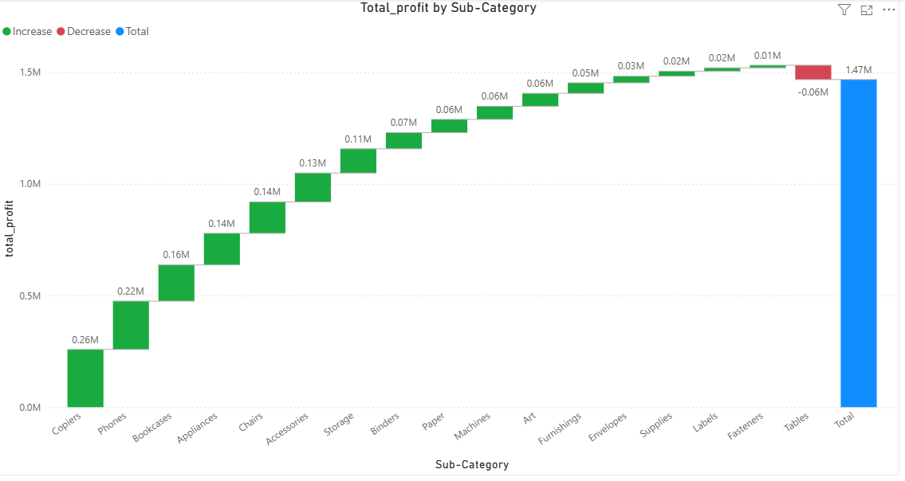
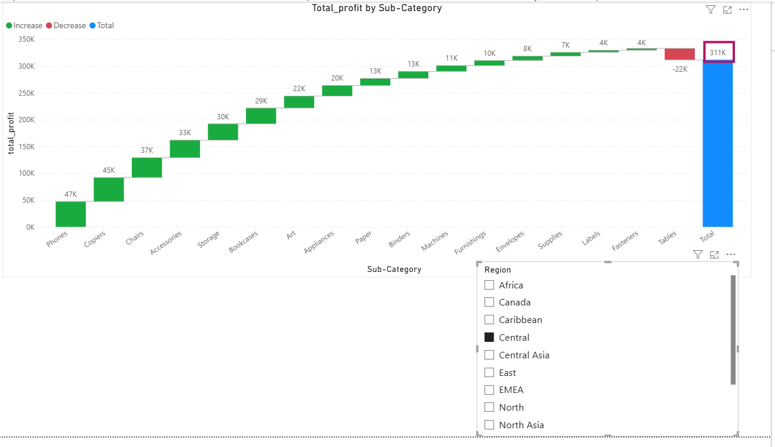

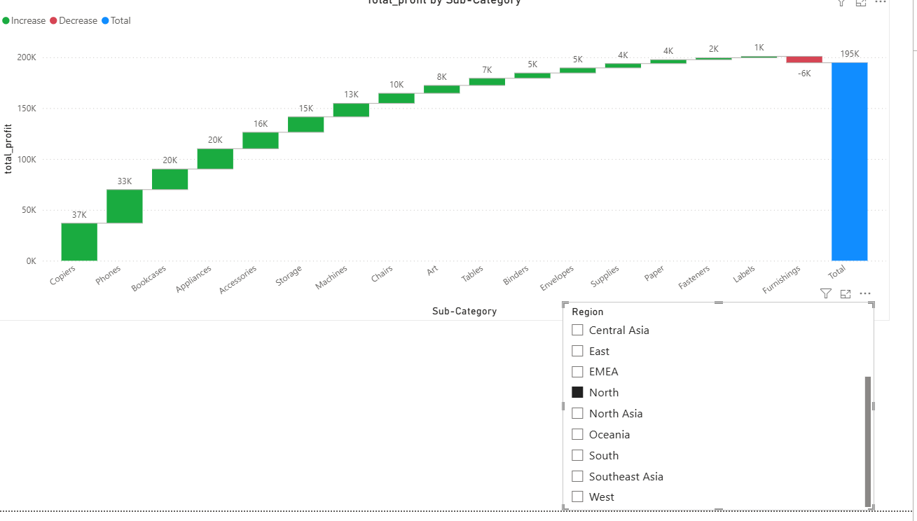
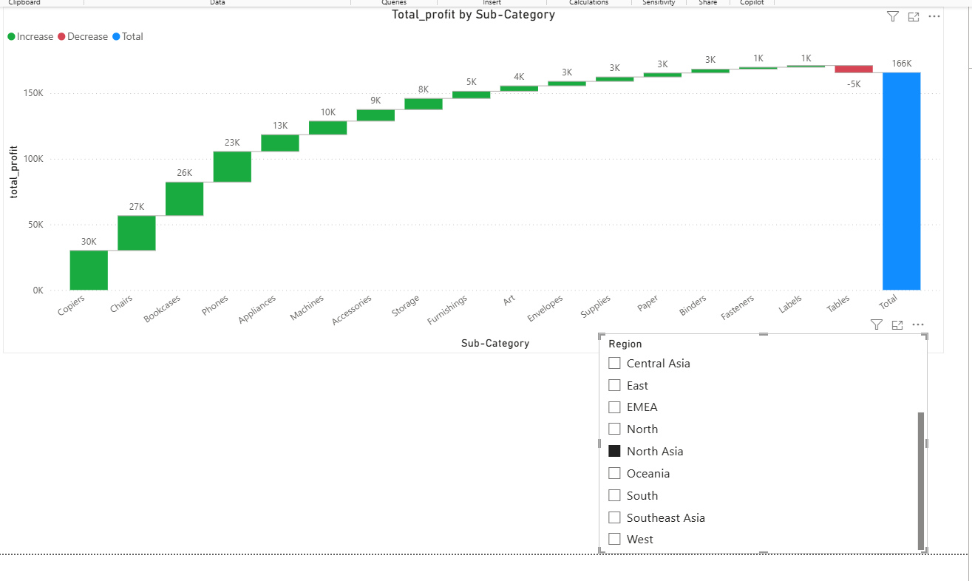
Insights:
- Central region is contributing more profits – 311k – good choice to sale products
- South-East Asia had loss in various subcategories: labels, arts, fasteners, envelopes, paper, supplies, accessories, tables and gives less profits – better not to sale products in this region
- 2nd and 3rd highest profit regions are North – with 195k profits and North Asia – with 166k profits
- Central with 311k profits standing in 1st position – highest profits contributing subcategories are: phones – 47k, copiers-45k
- North with 195k profits standing in 2nd position - highest profits contributing subcategories are: copiers-37k, phones – 33k
- North-Asia with 166k profits standing in 3rd position - highest profits contributing subcategories are: copiers-30k, chairs-27k
Question 10:
Scenario:
VitaTrack Wellness, a digital health company in FitZone, has collected data on users’ daily habits and health vitals. The analytics team is tasked with drawing actionable insights from this data to improve lifestyle suggestions and prevent heart-related risks.
Your Task:
Using the provided dataset (includes Age, Gender, BMI, Steps, Calories, Sleep, Heart Rate, Blood Pressure, Smoking, Alcohol, Exercise, Diabetic & Heart Disease status): Build a one-page Power BI dashboard that answers:
1. Are users maintaining a balanced lifestyle (Steps, Sleep, Calories)
2. What lifestyle patterns (Smoking, Alcohol, BMI, etc.) indicate heart disease risk?
3. Is there any visible relationship between Sleep and Physical Activity?
4. How does BMI vary across Age Groups and Genders?
5. What is the impact of smoking and alcohol on heart rate and blood pressure? 6. Segment people based on their health activity to suggest lifestyle changes
6. Segment people based on their health activity to suggest lifestyle changes

New columns created:
balanced_lifestyle = IF(health_activity_data[Daily_Steps]>=7000 && health_activity_data[Daily_Steps]<=10000 && health_activity_data[Calories_Intake]>=1800 && health_activity_data[Calories_Intake]<=2500 && health_activity_data[Hours_of_Sleep]>=7 && health_activity_data[Hours_of_Sleep]<=9,"Balanced","Not Balanced")

heart_risk_by_BMI = IF(health_activity_data[BMI]>=25,"Heart risk","No risk")

BP = SWITCH(true(),
health_activity_data[Blood_Pressure] = "120/80","Normal",
health_activity_data[Blood_Pressure] < "120/80","Low BP",
"High BP"
)

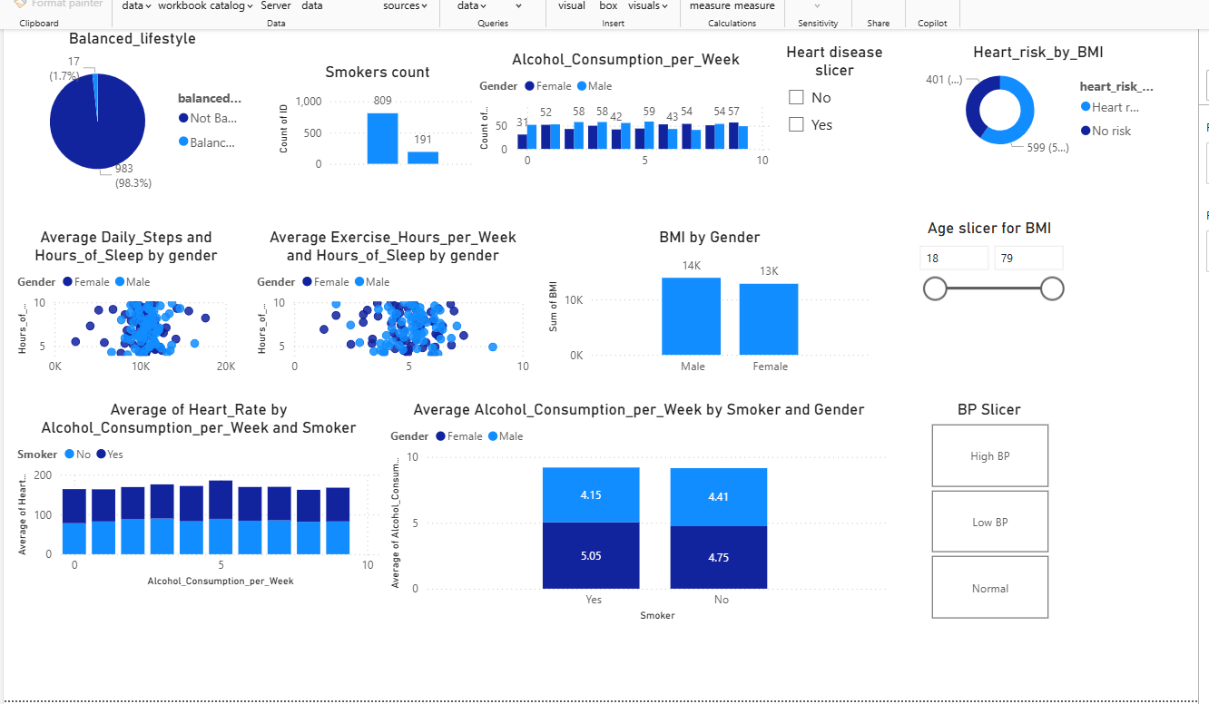

Segment people based on their health activity to suggest lifestyle changes
lifestyle = IF(health_activity_data[Daily_Steps]>=7000 && health_activity_data[Daily_Steps]<=10000 && health_activity_data[Calories_Intake]>=1800 && health_activity_data[Calories_Intake]<=2500 && health_activity_data[Hours_of_Sleep]>=7 && health_activity_data[Hours_of_Sleep]<=9,"Healthy","Un-Healthy")

