TASK2- JAVASCRIPT

Script.js

// task1: Complete the below statement to initialize the variable 'transactions' as an empty array.

let transactions = [];

let isEditing = false;

let editingTransactionId = null;

document.getElementById('transactionForm').addEventListener('submit', async function (event) {

    event.preventDefault(); // Prevent default form submission

    // task2: Retrieve 'payee', 'amount', and 'reason' values from form inputs using document.getElementById().

    // Replace '' with code to access 'payee' input value from HTML document

    const payee = document.getElementById("payee").value;

    // Replace '' with code to access 'amount' input value from HTML document and convert it to float

    const amount = parseFloat(document.getElementById("amount").value);

    // Replace '' with code to access 'reason' input value from HTML document

    const reason = document.getElementById("reason").value;

    if (payee === '' || amount <= 0 || isNaN(amount)) {

        alert('Please enter valid transaction details or check your script code.');

        return;

    }

    if (isEditing) {

        updateTransaction(editingTransactionId, payee, amount, reason);

        isEditing = false;

        editingTransactionId = null;

        document.querySelector('button[type="submit"]').textContent = 'Add Transaction';

        await updateTotalTransactionAmount();

    } else {

        addTransaction(payee, amount, reason);

    }

    clearForm();

    updateTransactionTable();

    await updateTotalTransactionAmount();

});

function addTransaction(payee, amount, reason) {

    // Note: Generated a unique 'id' for each new transaction

    const id = transactions.length > 0 ? transactions[transactions.length - 1].id + 1 : 1;

    // task3: Complete the 'newTransaction' object by replacing the placeholder values with appropriate data.

    const newTransaction = {

        id: id,

        payee: payee,

        amount: amount,

        reason: reason

    };

    // task4: Complete the below statement to add the 'newTransaction' object into the 'transactions' array using the 'push' method.

    transactions.push(newTransaction);

}

function updateTransaction(id, payee, amount, reason) {

    // task5: Complete the below statement to find the transaction object in the 'transactions' array that matches the provided 'id' parameter.

    const transaction = transactions.find(t=> t.id===id);

    if (transaction) {

        transaction.payee = payee;

        transaction.amount = amount;

        transaction.reason = reason;

    }

}

function editTransaction(id) {

    const transaction = transactions.find(t => t.id === id);

    if (transaction) {

        document.getElementById('payee').value = transaction.payee;

        document.getElementById('amount').value = transaction.amount;

        document.getElementById('reason').value = transaction.reason;

        isEditing = true;

        editingTransactionId = id;

        document.querySelector('button[type="submit"]').textContent = 'Edit Transaction';

    }

}

async function deleteTransaction(id) {

    const index = transactions.findIndex(t => t.id === id);

    if (index !== -1) {

        // task6: Complete the below statement to remove a transaction from the 'transactions' array by the index value

        transactions.splice(index,1);

        updateTransactionTable();

        await updateTotalTransactionAmount();

    }

}

// task7: Convert below function 'updateTotalTransactionAmount' to use async/await.

/\*

 a. Convert the 'updateTotalTransactionAmount' function to an async function.

 b. Update all occurrences of 'updateTotalTransactionAmount' across the script to use await and ensure their calling functions are marked as async.

\*/

async function updateTotalTransactionAmount() {

    let totalAmount = 0;

    transactions.forEach(transaction => {

        totalAmount += transaction.amount;

    });

    document.getElementById('totalTransactionAmount').textContent = totalAmount.toFixed(2);

}

function updateTransactionTable() {

    const tbody = document.querySelector('#transactionTable tbody');

    tbody.innerHTML = '';

    if (transactions.length === 0) {

        const noTransactionMessage = document.createElement('tr');

        noTransactionMessage.innerHTML = `<td colspan="6">No Transactions found.</td>`;

        tbody.appendChild(noTransactionMessage);

    } else {

        transactions.forEach(transaction => {

            const row = document.createElement('tr');

            row.innerHTML = `

                <td>${transaction.id}</td>

                <td>${transaction.payee}</td>

                <td>${transaction.amount.toFixed(2)}</td>

                <td>${transaction.reason}</td>

                <td><button class="edit-button" onclick="editTransaction(${transaction.id})">Edit</button></td>

                <td><button class="delete-button" onclick="deleteTransaction(${transaction.id})">Delete</button></td>

            `;

            tbody.appendChild(row);

        });

    }

}

function clearForm() {

    document.getElementById('payee').value = '';

    document.getElementById('amount').value = '';

    document.getElementById('reason').value = '';

}

After Two Transactions:

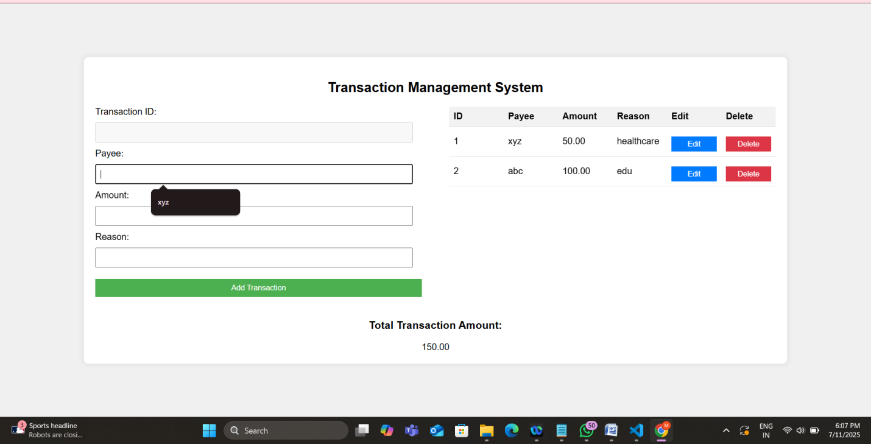

After Updating Transaction 1:

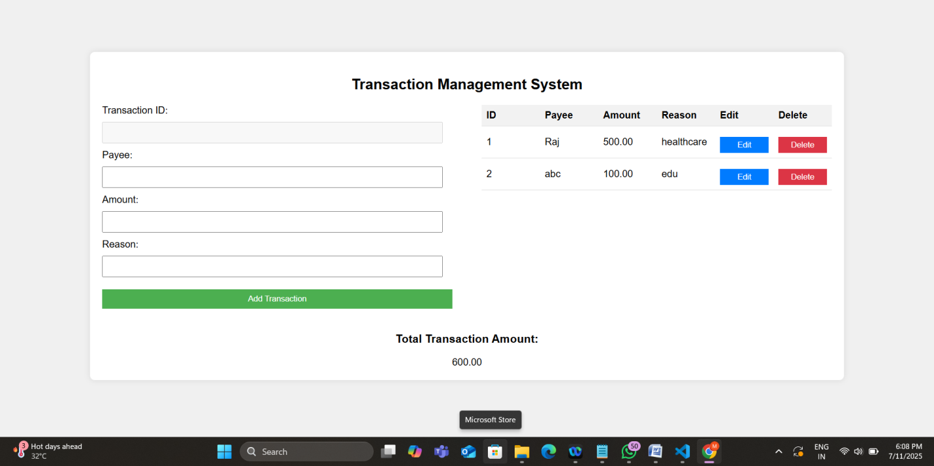

After Deleting Transaction 1:

