SCALABLE E-COMMERCE PLATFORM
Microservices Architecture Design Document
Weekly Architecture Design Task
Prepared as a hypothetical reference design

Document item | Details
Architecture style | Microservices with event-driven integration
Primary capabilities | Registration, product discovery, cart, checkout, payments, inventory and orders
Design priorities | Scalability, availability, security, maintainability and operational visibility
Assumptions | Cloud-hosted platform; multiple application instances; external payment service provider

Contents
- 1. Overview of the Architecture
- 2. Detailed Description of Each Microservice
- 3. Data Flow Diagrams
- 4. Technology and Tool Selection
- 5. Security Measures
- 6. Scalability, Reliability and Deployment
- 7. Conclusion

1. Overview of the Architecture
The proposed platform uses independently deployable microservices. Each service owns a focused business capability and its data. Clients communicate through an API Gateway, while internal services communicate synchronously for immediate queries and asynchronously through an event bus for workflows that do not need an immediate response.
The design avoids a single shared application database. Separate data stores reduce coupling and allow each service to scale according to its workload. For example, catalog reads can scale independently from payment processing, while the cart can use a fast in-memory data store.
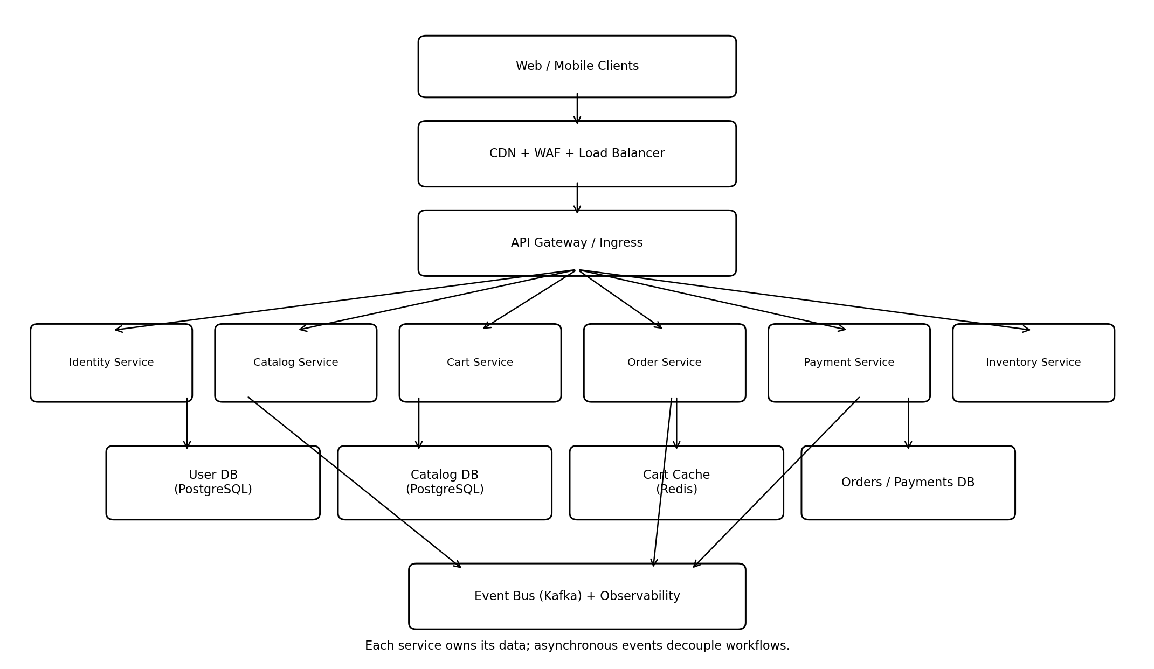

1.1 Main architectural layers
Layer | Responsibilities
Client layer | Responsive web and mobile applications; sends HTTPS requests and displays results.
Edge layer | CDN caches static assets; WAF filters malicious traffic; load balancer distributes requests.
API layer | API Gateway authenticates requests, applies rate limits, routes traffic and supports API versioning.
Service layer | Business-focused microservices implement user, catalog, cart, order, payment and inventory functions.
Data layer | Each service controls its own database or cache; no service directly edits another service's data.
Messaging layer | Kafka transports domain events and enables asynchronous, loosely coupled processing.
Operations layer | Centralized logs, metrics, traces, alerting, deployment automation and secrets management.

1.2 Design principles
- Single responsibility: each service owns one business capability and a clearly defined API.
- Database per service: data ownership remains local to the service that creates and updates it.
- Loose coupling: use events for cross-service updates and avoid long chains of synchronous calls.
- Stateless compute: keep application instances stateless where practical so they can scale horizontally.
- Resilience: use timeouts, retries with backoff, circuit breakers and graceful degradation.
- Consistency: use eventual consistency for cross-service workflows and strong consistency within a service transaction.

2. Detailed Description of Each Microservice

2.1 API Gateway / Edge Gateway
Single public entry point for web and mobile clients. It validates access tokens, routes requests, enforces quotas and rate limits, applies request-size limits, and records correlation IDs. It should not contain core business logic.
Interfaces: HTTPS REST/JSON; routes to internal services; returns standardized error responses.
Scaling and operational notes: Stateless replicas behind a load balancer; cache safe public responses only; protect with WAF and throttling.

2.2 Identity and User Service
Supports registration, login, logout, profile management, password reset, email/phone verification and role management. Passwords are stored using a strong adaptive hash such as Argon2id or bcrypt; plaintext passwords are never stored.
Interfaces: POST /users, POST /sessions, POST /password-resets, GET /profile; emits UserRegistered and UserUpdated events.
Scaling and operational notes: Scale authentication replicas horizontally; use database indexes and a separate read path for profile queries. Apply login throttling and account lockout/risk controls.

2.3 Product Catalog Service
Manages product names, descriptions, categories, images, attributes, variants, prices and publication status. Product search can be delegated to a search index updated from catalog events.
Interfaces: GET /products, GET /products/{id}, GET /categories, search endpoint; emits ProductCreated, ProductUpdated and PriceChanged events.
Scaling and operational notes: Use PostgreSQL for authoritative catalog data, Redis for hot product data and OpenSearch for full-text and faceted search. Use CDN for product images.

2.4 Cart Service
Creates and updates customer carts, adds or removes items, changes quantities and calculates an indicative subtotal. At checkout, the Order Service revalidates prices, promotions and stock; a cart price is not a final guarantee.
Interfaces: GET /cart, POST /cart/items, PATCH /cart/items/{id}, DELETE /cart/items/{id}.
Scaling and operational notes: Use Redis for low-latency cart operations with persistence/replication and expiry. Associate carts with authenticated users or secure guest-cart identifiers.

2.5 Order Service
Owns order lifecycle: pending, awaiting payment, confirmed, processing, shipped, delivered, cancelled and refunded. It snapshots item descriptions and prices at order creation so later catalog edits do not alter historical orders.
Interfaces: POST /orders, GET /orders/{id}, GET /orders; consumes payment and inventory events; emits OrderCreated, OrderConfirmed and OrderCancelled.
Scaling and operational notes: Use PostgreSQL transactions for order state. Apply the Saga pattern to coordinate stock reservation and payment without a distributed database transaction.

2.6 Payment Service
Creates payment intents, communicates with an external payment gateway, handles authorization/capture/refund and processes signed provider webhooks. It stores provider references and status, not raw card numbers or CVV.
Interfaces: POST /payments/intents, POST /payments/{id}/capture, POST /refunds; emits PaymentSucceeded, PaymentFailed and RefundCompleted.
Scaling and operational notes: Isolate payment workloads; use idempotency keys to prevent duplicate charges. Reconcile provider records and internal records regularly.

2.7 Inventory Service
Tracks stock by SKU and warehouse, reserves stock during checkout, commits deductions after successful payment and releases reservations on failure or timeout.
Interfaces: GET /inventory/{sku}, POST /reservations, POST /reservations/{id}/release; emits StockReserved, StockReservationFailed and StockReleased.
Scaling and operational notes: Use a transactional relational database and atomic conditional updates to prevent overselling. Partition or shard by warehouse/SKU if scale requires it.

2.8 Notification Service
Sends order confirmations, payment receipts, shipping updates, verification messages and password-reset notifications through email, SMS or push providers.
Interfaces: Consumes domain events and dispatches messages through provider APIs; tracks delivery status and retries temporary failures.
Scaling and operational notes: Scale workers based on queue depth. Use dead-letter queues for repeated failures and templates with localized content.

2.9 Search Service (supporting service)
Maintains a query-optimized index for product search, filtering, sorting and autocomplete. It is a derived read model rather than the authoritative product database.
Interfaces: Consumes catalog events and exposes search endpoints through the gateway.
Scaling and operational notes: Use OpenSearch/Elasticsearch replicas and index aliases for safe reindexing. Rebuild the index from catalog data if it becomes inconsistent.

2.10 Service ownership and data stores
Service | Primary data store | Data owned
Identity/User | PostgreSQL | User profile, credential hash, roles, verification state
Catalog | PostgreSQL | Products, variants, categories, product metadata
Cart | Redis | Active cart items and cart expiry metadata
Order | PostgreSQL | Order header, line-item snapshots, order state
Payment | PostgreSQL | Payment intent, provider reference, transaction status
Inventory | PostgreSQL | SKU stock, warehouse quantities, reservations
Search | OpenSearch | Searchable product projection
Notification | PostgreSQL + Kafka | Message status and event-consumer state

3. Data Flow Diagrams
The following diagrams show simplified end-to-end flows. Actual implementation should include validation, error handling, tracing and retry paths.
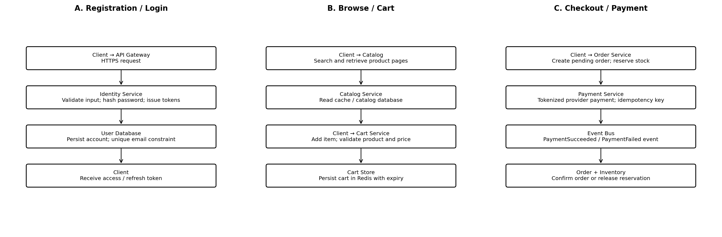

3.1 Registration and login flow
- The client sends registration details over HTTPS to the API Gateway.
- The gateway applies rate limits and forwards the request to the Identity Service.
- The Identity Service validates fields, checks for duplicate email/phone and hashes the password.
- The service commits the user record and publishes UserRegistered through the event bus using an outbox pattern.
- The client receives a verification response; the Notification Service sends the verification message.
- For login, the Identity Service verifies the password and issues short-lived access and refresh tokens.

3.2 Product browsing and cart flow
- The client requests a product list or search results through the API Gateway.
- The Catalog/Search services read from cache or their query stores and return product details.
- The customer adds a product to the cart; the Cart Service validates item identifiers and stores the quantity.
- The Cart Service returns the updated cart and an indicative subtotal.
- At checkout, the Order Service retrieves current price and availability rather than trusting stale cart values.

3.3 Checkout and payment flow
- The client submits a checkout request with a unique idempotency key.
- The Order Service validates the cart and creates a pending order.
- The Order Service requests an inventory reservation. Inventory atomically reserves the required quantity or rejects it.
- The Payment Service creates a payment intent with the external provider using a provider-side idempotency key.
- On verified payment success, the Payment Service records the result and publishes PaymentSucceeded.
- The Order Service consumes the event and marks the order confirmed; Inventory commits the reservation and Notification sends confirmation.
- If payment fails or times out, the Saga workflow marks the order failed/cancelled and releases the inventory reservation.
- A scheduled reconciliation job checks unresolved payment states against the provider to handle missed webhooks.

3.4 Event and consistency approach
Kafka events are delivered at least once in common configurations, so consumers must be idempotent. Use a transactional outbox to atomically save business changes and an event record, then publish the event. Consumers keep an inbox/deduplication record. Eventual consistency is acceptable for search indexes, notifications and cross-service order status propagation; payment and inventory operations require carefully controlled state transitions.

4. Technology and Tool Selection
Technology / tool | Purpose | Justification
Java 21 + Spring Boot | Microservice implementation | Mature ecosystem, strong typing, production support, security and observability integrations.
Spring Cloud Gateway or Kong | API Gateway | Routing, authentication integration, throttling, request filtering and API management.
PostgreSQL | Transactional databases | ACID transactions, constraints, indexing and reliable relational modelling for orders, payments and stock.
Redis | Cart and hot-data cache | Low-latency reads/writes, TTL support and high-throughput in-memory operations.
Apache Kafka | Event streaming | Durable event log, partition-based scale, consumer groups and asynchronous service integration.
OpenSearch | Product search | Full-text search, filters, facets, sorting and autocomplete.
Docker | Container packaging | Consistent runtime across developer machines, test and production environments.
Kubernetes | Orchestration | Horizontal scaling, service discovery, rolling deployments, health checks and self-healing.
Cloud object storage + CDN | Product images/static assets | Durable low-cost media storage and geographically distributed delivery.
OAuth 2.0 / OpenID Connect | Identity federation and tokens | Standards-based authorization and integration with an identity provider.
Prometheus + Grafana | Metrics and dashboards | Tracks latency, traffic, errors, saturation and service health.
OpenTelemetry + centralized logs | Tracing and logs | End-to-end request correlation across service boundaries.
GitHub Actions / CI pipeline | Build and delivery automation | Automated tests, image scanning, build and controlled deployments.

4.1 Why microservices are appropriate
- Independent scaling: catalog browsing can scale more aggressively than payment or user-profile workloads.
- Independent deployment: a catalog change can be released without redeploying the entire platform.
- Fault isolation: a notification provider outage should not prevent a customer from browsing products.
- Technology flexibility: services can adopt specialized stores where justified while maintaining API contracts.
- Team ownership: teams can own services, operational metrics and release pipelines end to end.

4.2 Trade-offs and mitigations
Trade-off | Mitigation
More operational complexity | Use Kubernetes standards, service templates, centralized observability and automation.
Network latency and partial failures | Set timeouts, bounded retries, circuit breakers and asynchronous events.
Distributed data consistency | Use Saga workflows, outbox/inbox patterns, idempotency and reconciliation.
Harder local development and testing | Provide Docker Compose development dependencies, contract tests and end-to-end test environments.
Higher infrastructure cost | Start with a small number of services and scale only measured bottlenecks.

5. Security Measures
Control area | Implementation
Transport security | Enforce HTTPS/TLS 1.2+ externally and TLS or mutual TLS between sensitive internal services.
Authentication | Use OpenID Connect/OAuth 2.0 with short-lived access tokens, secure refresh-token rotation and multifactor authentication for administrators.
Authorization | Apply role-based access control and least privilege. Check ownership of carts, orders and profiles on every request.
Password protection | Hash passwords with Argon2id or bcrypt using appropriate parameters and unique salts; never store plaintext passwords.
Payment security | Use a PCI-DSS-compliant payment provider and hosted/tokenized payment fields. Do not store CVV or raw card data.
Input and API protection | Validate schemas, encode output, prevent injection, restrict payload size, configure CORS carefully and apply rate limits.
Secrets management | Store database passwords, signing keys and provider credentials in a managed secrets vault; rotate them and avoid source-control exposure.
Data protection | Encrypt sensitive data at rest, minimize collected personal data, restrict access and define retention/deletion policies.
Network isolation | Keep databases and Kafka private; expose only the gateway publicly; use network policies and security groups.
Audit and monitoring | Record security-relevant actions, administrator activity, payment state changes and authentication anomalies without logging secrets.
Supply-chain security | Scan dependencies and container images, sign build artifacts, patch base images and protect CI/CD credentials.
Backup and recovery | Encrypt backups, restrict restore permissions, test restores and define recovery point/time objectives.

5.1 Threats and protections
Threat | Protection
Credential stuffing / brute force | Rate limiting, breached-password checks, MFA, anomaly detection and progressive delays.
Unauthorized object access | Server-side ownership checks and authorization on every resource request.
Duplicate payment requests | Idempotency keys, provider reference uniqueness and payment reconciliation.
Overselling inventory | Atomic reservations, transaction isolation and reservation expiry.
Message spoofing / replay | Authenticated event producers, TLS, schema validation, event IDs and deduplication.
DDoS and bot traffic | CDN, WAF, bot controls, quotas, autoscaling and upstream traffic filtering.

6. Scalability, Reliability and Deployment

6.1 High-traffic strategy
- Place static assets and product images behind a CDN; cache safe catalog responses at the edge.
- Run multiple stateless replicas of each service behind internal load balancing.
- Scale services horizontally using CPU, memory, request rate and queue-lag metrics.
- Use Redis for hot product data and active carts, with explicit cache invalidation through catalog events.
- Partition Kafka topics by a stable key such as order ID or SKU where ordering is required.
- Use database indexes, connection pooling, read replicas for read-heavy workloads and partitioning when measurements justify it.
- Apply backpressure and queue-based buffering so spikes do not overwhelm downstream providers.

6.2 Reliability patterns
Pattern | How it is used
Health checks | Readiness and liveness probes prevent unhealthy replicas receiving traffic.
Timeouts and retries | Use bounded retries with exponential backoff and jitter; retry only safe/idempotent operations.
Circuit breaker | Stop repeatedly calling an unavailable dependency and fail gracefully.
Bulkheads | Separate thread pools and resource limits for critical workflows.
Saga | Coordinate order, stock and payment through compensating actions.
Dead-letter queue | Retain messages that repeatedly fail processing for investigation and replay.
Graceful degradation | Allow browsing when recommendations or notifications are temporarily unavailable.

6.3 Deployment pipeline
- Developer commits code and opens a pull request.
- CI runs unit tests, static analysis, dependency scanning and contract tests.
- A versioned container image is built, scanned and stored in a container registry.
- CD deploys to staging, runs smoke and integration tests, then promotes using rolling or canary deployment.
- Kubernetes monitors health and rolls back if release metrics breach defined thresholds.

6.4 Suggested service-level objectives
Measure | Initial target (illustrative)
Catalog read API availability | 99.9% monthly
Checkout API latency | p95 below 500 ms, excluding external payment-provider time
Cart API latency | p95 below 200 ms under normal load
Payment correctness | No duplicate capture; every payment reaches a reconciled terminal state
Recovery | Define service-specific RPO/RTO through business impact analysis
These are starting targets, not guarantees. Load testing and business requirements should determine production SLOs.

7. Conclusion
This design provides a scalable foundation for an e-commerce platform by separating business capabilities into independently deployable microservices. An API Gateway protects and routes client traffic, service-owned databases preserve clear data boundaries, and Kafka enables asynchronous workflows. Kubernetes, caching, CDN delivery, observability and security controls support high traffic and operational resilience. The most critical workflow—checkout—uses idempotency, inventory reservations, a Saga process and payment reconciliation to reduce duplicate charges and overselling. The architecture can begin with a modest deployment and expand as traffic and business needs grow.

Appendix: Key assumptions
- The platform is a hypothetical online store and does not assume a specific cloud vendor.
- Payment card entry and processing are delegated to a PCI-DSS-compliant payment provider.
- The platform supports guest browsing and may support guest carts using secure identifiers.
- The initial architecture is logical; exact capacity, instance sizes and partition counts require workload testing.
- Personal data handling must comply with applicable privacy, consumer and payment regulations in the deployment regions.

