

A Project Report on

InaniHub



Submitted By:

Gujarat Technological University, Ahmedabad

June, 2023

In a Partial Fulfillment for the award of the Degree of Master of Computer Application in

**Guide By:**

Pooja Bhadauriya

**Developed By:**

Pethani Madhuri 215490694010

Thummar Komal 215490694007



INTERNSHIP CERTIFICATE

**Date: 25th May 2023**

**TO WHOM IT MAY CONCERN**

This is to certify that **Miss Pethani Madhuri** has completed an internship as a Web Development from 20th Jan 2023 to 25th May 2023.

During this period, she developed a web application using Html, CSS, React JS, she easily understand the project tasks and requirement. she also design a UI from Figma to Html, CSS, JS.

We found her to be highly sincere, hardworking, result-oriented and innovative during her tenure with us. We wish her all the best in all her future endeavors.

**Best Regards,**



**Aimbrill Techinfo**

**437 Maruti Plaza, Opp Vijay Park BRTS, Ahmedabad-382350 Gujarat, India Website:** [**www.aimbrill.com**](http://www.aimbrill.com/) **mail:** [**info@aimbrill.com**](mailto:info@aimbrill.com) **Mo: +91 977 342 6554**







INTERNSHIP CERTIFICATE

**Date: 25th May 2023**

**TO WHOM IT MAY CONCERN**

This is to certify that **Miss Thummar Komal** has completed an internship as a Web Development from 20th Jan 2023 to 25th may 2023.

During this period, she developed a web application using Html, CSS, React JS, she easily understand the project tasks and requirement. she also design a UI from Figma to Html, CSS, JS.

We found her to be highly sincere, hardworking, result-oriented and innovative during her tenure with us. We wish her all the best in all her future endeavors.

**Best Regards,**



**Aimbrill Techinfo**

**437 Maruti Plaza, Opp Vijay Park BRTS, Ahmedabad-382350 Gujarat, India Website:** [**www.aimbrill.com**](http://www.aimbrill.com/) **mail:** [**info@aimbrill.com**](mailto:info@aimbrill.com) **Mo: +91 977 342 6554**

**Preface**

The main objective of any computer science student is to get practical knowledge as possible. Being able to have a practical knowledge by developing a project is a lifetime experience. As practical knowledge is important as theoretical knowledge we are thankful of having a project.

Through the development of the project we had a great experience of various strategies that can be applied in development of the project. This project is the stepping stone for our career.

We are pleased to present this project report. Proper case has been taken while organizing the report so that it is easy to comprehend. Also, various software engineering concepts have been implemented.

**Acknowledgement**

We are student of MCA sem-4 Studying in the R.B Institute of Management studies, Ahmedabad . We Thanks to the entire person who has given their support in shaping of the system.

We thanks Mrs. Pooja Bhadauriya for giving us guidance and Co-operation in understanding the system. We also thanks them for their unconditional help in making of this project.

We have great deal of gratitude towards our head of department who encourage us in taking up this activity. We thank all faculties and administrative staffs of the institute.

Thanks to all !

1. Introduction

* 1. Existing System --------------------------------------------------------- 2
  2. Need for the New system ---------------------------------------------- 2
  3. Objective of new system -------------------------------------------- 5
  4. Core Components ----------------------------------------------- 5
  5. Project profile ----------------------------------------------- 6
  6. Advantages and limitation of proposed system ----------------- 7

1. Requirement determination and Requirement analysis
   1. Requirement Determination -------------------------------------- 8
   2. Requirement Analysis ------------------------------------------------ 9
   3. Targeted User ---------------------------------------------------- 10
2. System Design
   1. Use-Case Diagram ------------------------------------------------- 12
   2. Activity Diagram ------------------------------------------------- 20
   3. Interaction Diagram -------------------------------------------------- 25
   4. Data Dictionary ------------------------------------------------- 33
3. Screenshots of main modules -------------------------------------------- 70

5. Project Management ---------------------------------------------------- 77

6. Conclusion ---------------------------------------------------------------- 79

7. Bibliography ------------------------------------------------------------------ 81

# Introduction

### Existing System

* + - E-platform means that the all the people can sell or buy all the thing online at the one platform.
    - There are many e-platforms available in market.
    - It is as follows –
      * Craigslist
      * Facebook Marketplace
      * Geebo
      * eBay
      * Gumtree
      * Oodle
    - Our web-site is make for the same facility for all the users at world wide web.

### Need for the new System

* + - In the old system not an every thing is cover in site. But in our site we have cover up all things for all the type of persons.
    - We provide the cash on delivery to all the users.
    - We provide 24/7 service.
    - So full fill the all the requirement we make a new design for the users.

### Objective of new System

* Provide the process project the capability to book different kind of passenger.
* Provide a ticketless flight travel using the proposed project ticketing system feature.
* Build the proposed project with the capability to include special handling procedure to a booking reference.

Build the proposed project with the capability to make rebooking

### Problem Definition

* Our project basically created for manage sell and purchase the products at on the one platform.
* We are provided REACT.JS as front end and NODE.JS as back end. The project processed through a sequence of well designed forms provided with validation to ensure.
* Consistency reliability and most importantly correctness of information in to the database.
* We provide the facility for sell and purchase at one platform.

### Core Components

* UI/UX Web Application Components – This includes activity logs, dashboards, notifications, settings, statistics, etc.
* These components have nothing to do with the operation of a web application architecture. Instead, they are part of the interface layout plan of a web app
* Structural Components – The two major structural components of a web app are client and server sides.
* Client Component - The client component is developed in CSS, HTML, and JS. As it exists within the user’s web browser, there is no need for operating system or device- related adjustments. The client component is a representation of a web application’s functionality that the end-user interacts with.
* Server Component - The server component can be build using one or a combination of several programming languages and frameworks, including Java, .Net, NodeJS, PHP, Python, and Ruby on Rails. The server component has at least two parts; app logic and database. The former is the main control centre of the web application while the latter is where all the persistent data is stored.

### Project Profile

|  |  |  |
| --- | --- | --- |
| Sr. No | Title | Detail |
| 1. | Group No | 25 |
| 2. | Project Title | Inani Hub |
| 3. | Front-End Tool | REACT.JS |
| 4. | Back-End Tool | Mongo DB |
| 5. | Project Type | Web Application |
| 6. | Project Duration | 4 months |
| 7. | Project Team Size | Two(2) |
| 8. | Submitted By | Pethani Mahduri (215490694010)  Thummar Komal (215490694007) |
| 9. | Stream | MCA(Sem 4) |
| 10. | Guide By | Prof. Pooja Bhadauriya |
| 11. | Submitted To | R B INSTITUE OF MANAGEMENT AND STUDIES |

* 1. Assumptions and Constraints
* Enani Hub is mainly used for buy and sell the Goods for buyers and sellers.
* Information every time they book,Saving a lot of time of all the users.
* it is confirmed that flight booking system has removed a lot of burden from the authorities and made the life of the customers very easy.

### Advantages

* 24/7 all the Services available for all the users.
* Generated automated emails and SMS for the status.
* Real-time update.
* Easy cancellation process for Goods buy or sell.

### Limitation

* Users can only pay after retirving or selling their products.
* We don’t provide online payment method

# Requirement Analysis

## Tools & Technology

### ReactJS

* ReactJS is a declarative, efficient, and flexible JavaScript library for building reusable UI components.
* A ReactJS application is made up of multiple components, each component responsible for outputting a small, reusable piece of HTML code. The components are the heart of all React applications
* It is an open-source, component-based front end library responsible only for the view layer of the application

### Importance of ReactJS

* + - * Fast
      * Moduler
      * Sacalable
      * Flexible
      * Popular
      * Easy to learn
      * Reusable UI Components

### New Features of ReactJS

* Better language support
* Programmable control
* Event driven programming
* User authentication which account and role
* Increased performance compiled code

### Benefit of of ReactJS

* Easy to learn
* [Reduced Coding](https://www.fastcomet.com/blog/advantages-and-disadvantages-of-react-js#h-reduced-coding)
* [Reusable Components](https://www.fastcomet.com/blog/advantages-and-disadvantages-of-react-js#h-reusable-components)
* [Performance Enhancement](https://www.fastcomet.com/blog/advantages-and-disadvantages-of-react-js#h-performance-enhancement)
* [Support for Handy Tools](https://www.fastcomet.com/blog/advantages-and-disadvantages-of-react-js#h-support-for-handy-tools)
* [Clean Abstraction](https://www.fastcomet.com/blog/advantages-and-disadvantages-of-react-js#h-clean-abstraction)

### 2.2.1 Mongodb

* MongoDB, the most popular NoSQL database, is an open-source document-oriented database.
* The term ‘NoSQL’ means ‘non-relational’.
* It means that MongoDB isn’t based on the table-like relational database structure but provides an altogether different mechanism for storage and retrieval of data.
* This format of storage is called BSON ( similar to JSON format)

### * Features

* + It is a non-relational and document-oriented database
  + It is suitable for hierarchical data storage
  + It has dynamic schema
  + In terms performance , it Is much faster

* Advantages

* + - is easy to install, use and schema-less database.
    - Due to it is the ability of a schema-less database, the code which we create defines the schema
    - Data is stored in Binary JSON format, which is key-value pair, no joins complexity is needed

### 2.3.1 JavaScript

* Java script is a scripting language often used to client side web development.
* Java script was influenced by many language and was designed to have similar work to java but be easier for non- programmers to work with.

### *Features

* + In the community of web developers and surfers java script is highly popular as client side scripting language for the web browser.

### *Support of object

* + Java script is an object oriented language however the way java script handles object inheritance is bit different from conventional objected programming language like java due to this java script support most of the object oriented concepts while being simple to learn and use.

### 2.4.1 CSS

* Css cascading style sheets.
* Css use to control the style and layout of multiple web pages all once.
* Styles are normally stored in style sheets. External style sheets are stored in css file.
* Styles ware added to html to solve a problem.
* Multiple style definition will cascaded in to one

### User Characteristic

* + - * User should be comfortable with English language.
      * Basic knowledge about computer.
      * Use able to put required in formation secure user login account.
      * These users are usually responsible for insuring that
      * A design is feasible and software.
      * More often than not software is design for a client

### Education level

* + - * User should be conformable with English language

## Hardware & Software

**2.1 Hardware**

|  |  |
| --- | --- |
| **Hard disk** | 500GB |
| **Process** | 2.33GHZ |
| **System Type** | 64 bit operating system |
| **RAM** | 4.00GB |

**2.3 Software**

|  |  |
| --- | --- |
| **Operating System** | Microsoft windows-10 |
| **Development Tools &** | React.js (visual studio -code) |
| **Technology Back End** | Mongodb |

## Targeted Users

* + - These users are the users for whom we create our site for those to do their work more fast , reliable and efficiently.

# System Design

**3.1 Use Case Diagram**

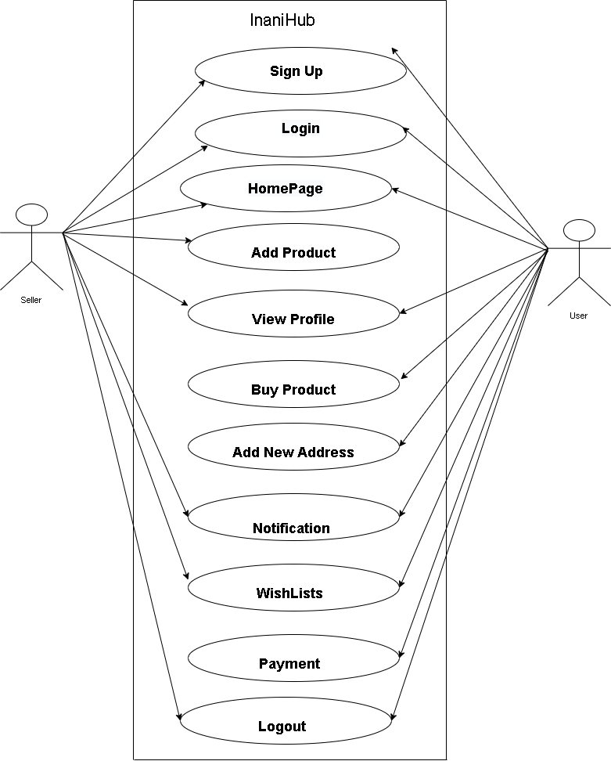

**3.1 Class Diagram**

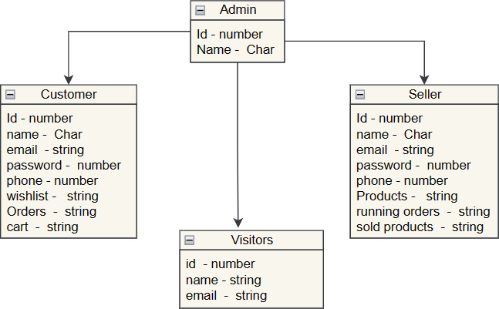

* 1. **Activity Diagram**

**Registration**

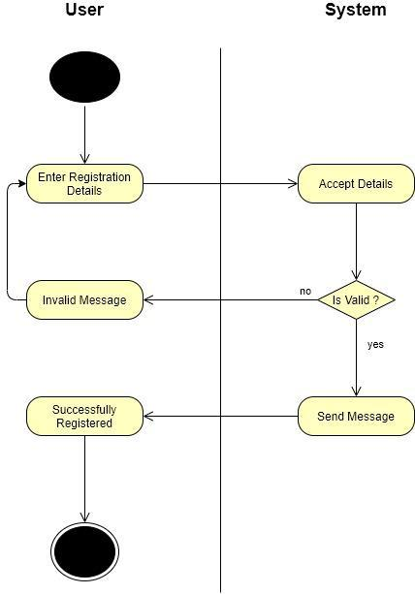

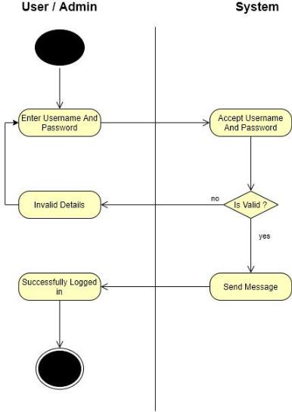**Login**

**Select Product**

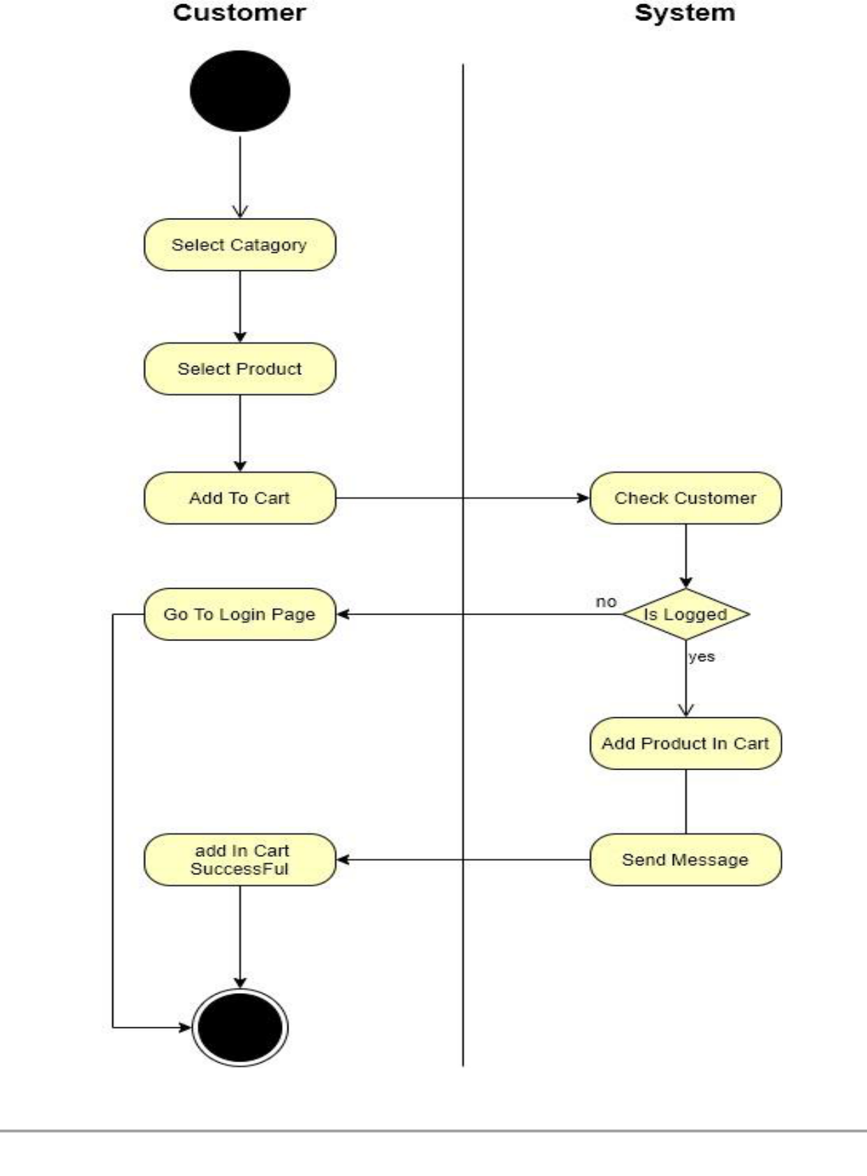

**Interaction Diagram for Login:-**

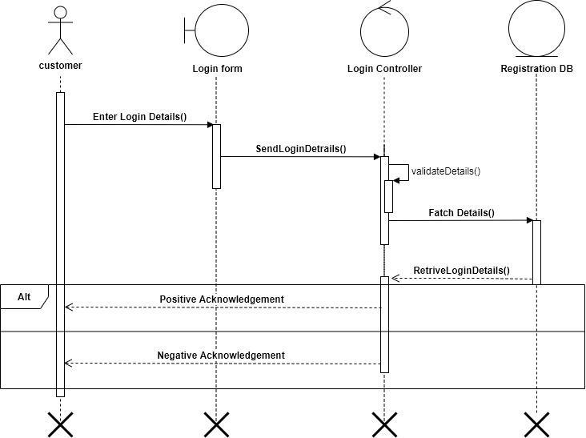

**Interaction Diagram for SignUp:-**

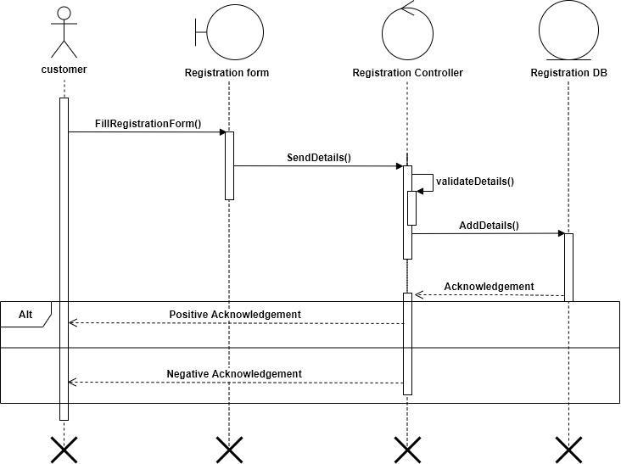

**Interaction Diagram for Product:--**

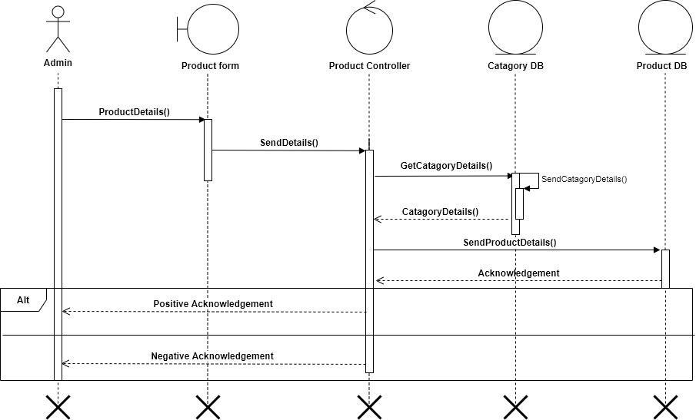

* 1. **Data Dictionary**
     + The Data Dictionary can be specifically defining as an exhaustively organized list of all data elements that are pertinent to the system with precise, rigorous understanding of inputs and outputs and the components of stores along with all the constraints and intermediate calculations.
     + In other words, a data dictionary is a catalogue – a repository of element in a system. Here in a data dictionary one can find list of all the elements composing the data flowing through a system. The major elements are data flows, data stores and process. The data dictionary stores the details and description of all these elements.

## *Importance of Data Dictionary:

* + - * To manage the details in large system.
      * To communicate a common meaning for all system elements.
      * To document the features of a system. To facilitate analyst for the details in order to evaluate system requirements
      * Following is the list of Tables which are used in my project. Consider Following Data Dictionary which denotes tables detail.

### User table - this table contains the information of the users

|  |  |  |  |
| --- | --- | --- | --- |
| **Column Name** | **Data Type** | **Constrain** | **Description** |
| Userid | Int | Primary Key | It is unique key for user |
| firstname | String(255) | Not null | It is First Name of user |
| lastname | String(255) | Not null | It is Last Name of user |  |
| username | String(255) | Not null | It is User Name of user |
| password | String(255) | Not null | It is Password of user |
| email | String(255) | Unique key | It is email of user |
| image | String(255) | Not null | It is Image of user |
| views | number | Not null | View user data |
| saved | String(255) | Not null | Save user data |
| isactive | Boolean | Not null | User active or not |
| Strip_customerid | String(255) | Not null | Payment user id |
| CreatedDate | date | Not null | Show created date |
| updatedDate | date | Not null | Show updated date |
| loginID | String(255) | Not null | Show login id |

1. SubCategory table - this table contains the information of the sub- categories

|  |  |  |  |
| --- | --- | --- | --- |
| **Column Name** | **Data Type** | **Constrain** | **Description** |
| id | String(255) | Primary Key | SubCategory id |
| Cat_id | String(255) | Foreign Key | Category id |
| Name | String(255) | Not null | Name of category |
| isActive | beelean | Not null | Isactive or not |

### Product table - this table contains the information of all the products

|  |  |  |  |
| --- | --- | --- | --- |
| **Column Name** | **Data Type** | **Constrain** | **Description** |
| id | number | Primary key | Id display |
| Categoryid | String(255) | Foreign Key | Category id |
| Sub_cat_id | String(255) | Foreign Key | Sub category id |
| Brand | String(255) | Not Null | Brand name |
| Size | String(255) | Not Null | Display size |
| description | String(255) | Not Null | Show item detail |
| price | number | Not Null | Show price |
| Discountprice | number | Not Null | SHOW Discountprice |
| Yourearning | number | Not Null | Your erning |
| condition | boolean | Not Null | Show condition |
| images | String(255) | Not Null | Show image |
| wishlist | String(255) | Not Null | Wishlist list show |
| name | String(255) | Not Null | Name of product |
| color | String(255) | Not Null | Color of product |
| Is_active | boolean | Not Null | Isactive or not |
| makeoffer | boolean | Not Null | Show make offer |
| createddate | Date | Not Null | Show create date |

|  |  |  |  |
| --- | --- | --- | --- |
| Created_id | String(255) | Foreign Key | User id |

1. PaymentCheckout table - this table contains the information of all the payments done by customers

|  |  |  |  |
| --- | --- | --- | --- |
| **Column Name** | **Data Type** | **Constrain** | **Description** |
| **id** | **number** | **Primary key** | **Show id** |
| Categoryid | String(255) | Foreign Key | Show categoryid |
| userid | String(255) | Foreign Key | Show userid |
| Amount | Number | Not null | Amount of payment |
| Bank_id | Number | Not null | Bank id show |
| Is_payment_suucees | boolean | Not null | Payment success |

### Wishlist – this table contains the information of wishlist of products

|  |  |  |  |
| --- | --- | --- | --- |
| **Column Name** | **Data Type** | **Constrain** | **Description** |
| **Id** | **number** | **Primary key** | **Show id** |
| Userid | number | Foreign Key | userid |
| Product_id | number | Foreign Key | Product id |
| createdDate | date | Not null | Created date |

### StateSchema – this table contains the information of the states

|  |  |  |  |
| --- | --- | --- | --- |
| **Column Name** | **Data Type** | **Constrain** | **Description** |
| Stateid | number | Primary Key | Stated id |
| Name | String(255) | Not null | Name of state |
| Countryid | number | Foreign Key | Country id |
| Statecode | number | Not null | State code |

1. Notification – this table contains the information of notification of the customers

|  |  |  |  |
| --- | --- | --- | --- |
| **Column Name** | **Data Type** | **Constrain** | **Description** |
| **Id** | **Number** | **Primary key** | **Ahow id** |
| Name | String(255) | Not null | Name of notification user |
| Title | String(255) | Not null | Title of notification |
| Description | String(255) | Not null | Decription of notification |
| Price | Number | Not null | Price of product |
| Type | String(255) | Not null | Type of product |
| Userid | Number | Foreign Key | User id |
| Productid | Number | Not null | Product id |
| productOwner | String(255) | Not null | Name of send notification user |

### Makeoffer – this table contains the information of offers of the products

|  |  |  |  |
| --- | --- | --- | --- |
| **Column Name** | **Data Type** | **Constrain** | **Description** |
| **Id** | **Number** | **Primary key** | **Shoe id** |
| sellerid | number | Foreign Key | Seller id |
| Notificationid | number | Not null | Notification id |
| Customerid | number | Foreign Key | User id |
| Productid | number | Foreign key | Product id |
| Is_offer_active | boolean | Not null | Active status |

1. Cities – this table contains the information of cities

|  |  |  |  |
| --- | --- | --- | --- |
| **Column Name** | **Data Type** | **Constrain** | **Description** |
| Cityid | number | Primary Key | Cityid |
| Name | String(255) | Not null | Name of city |
| Stateid | number | Foreign Key | Show State id |

### Category – this table contains the information of cities

|  |  |  |  |
| --- | --- | --- | --- |
| **Column Name** | **Data Type** | **Constrain** | **Description** |
| catid | number | Primary key | id of category |
| Isactive | boolean | Not null | Isactive or not |
| Name | String(255) | Not null | Name of category |

### BankDetails – this table contains the information of bank details of the customers

|  |  |  |  |
| --- | --- | --- | --- |
| **Column Name** | **Data Type** | **Constrain** | **Description** |
| **Id** | **Number** | **Primary key** | **Show id** |
| userid | Number | Foreign Key | User id |
| Accountholdername | String(255) | Not null | Card holder name |
| Instution_code | Number | Not null | Idec code |
| Transit_code | String(255) | Not null | Transit code |
| Account_number | Number | Not null | Account number |

1. Address – this table contains the information of address of all the users

|  |  |  |  |
| --- | --- | --- | --- |
| **Column Name** | **Data Type** | **Contrain** | **Description** |
| **Id** | **Number** | **Primary key** | **Show id** |
| Userid | Number | Foreign Key | User id |
| firstname | String(255) | Not null | Firstname of user |
| Lastname | String(255) | Not null | Lastname of user |
| Address | String(255) | Not null | Address of user |
| City | String(255) | Not null | City of user |
| State | String(255) | Not null | State of user |
| Country | String(255) | Foreign key | Country of user |
| State_code | number | Foreign key | State code |
| Country_code | Number | Foreign key | Country code |
| Phone | Number | Not null | User phone number |

### County – this table contains the information of countries

|  |  |  |  |
| --- | --- | --- | --- |
| **Column Name** | **Data Type** | **Constrain** | **Description** |
| Country_id | Number | Primary Key | Country id |
| Name | String(255) | Not null | Country name |
| Currency | String(255) | Not null | Currency |
| Region | String(255) | Not null | Region |

1. ContactUs – this table contains the information of all the orders

|  |  |  |  |
| --- | --- | --- | --- |
| **Column Name** | **Data Type** | **Constrain** | **Description** |
| id | Number | Primary Key | Id of user |
| Name | String(255) | Not null | Name of user |
| Email | String(255) | Unique key | Email of user |
| Message | String(255) | Not null | Message of user |

1. ReviewSchema – this table contains the information of customer’s review

|  |  |  |  |
| --- | --- | --- | --- |
| **Column Name** | **Data Type** | **Constrain** | **Description** |
| **Id** | **Number** | **Primary key** | **Show id** |
| productid | number | Foreign Key | Product id |
| userid | number | Foreign key | User id |
| rating | number | Not null | Ratind data |
| Comment | String(255) | Not null | message |

1. Orders – this table contains the information of all the orders

|  |  |  |  |
| --- | --- | --- | --- |
| **Column Name** | **Data Type** | **Reference** | **Description** |
| **id** | **Number** | **Primary key** | **Id show** |
| order_id | Number | Foreign Key | Order id |
| Declined_date | Date | Not null | Created date |
| Declined_by | String(255) | Not null | Created user |
| Payment_success | Boolean | Not null | Payment status |
| Shippind_id | Number | Not null | Shipping id |
| Expected_delivery_date | Date | Not null | Delivery date |
| Deleiverd_date | Date | Not null | Delivery date |
| Payment_release | String(255) | Not null | Payment release |
| Payment_released_date | date | Not null | Payment realse date |

# 4. Development

### User Sign-in

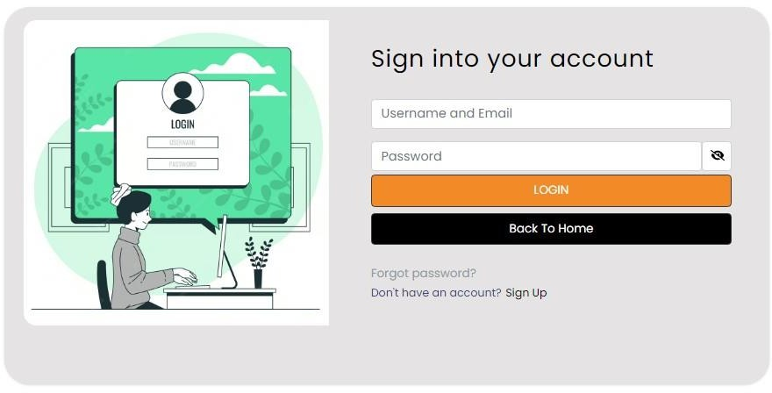

* 1. User Sign-up

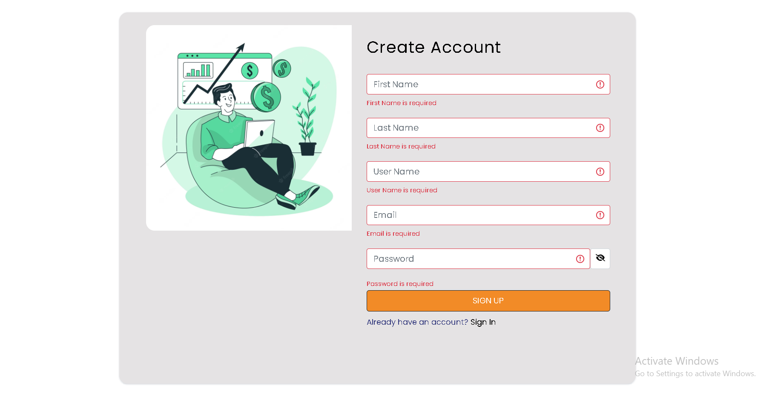

### Home



* 1. About

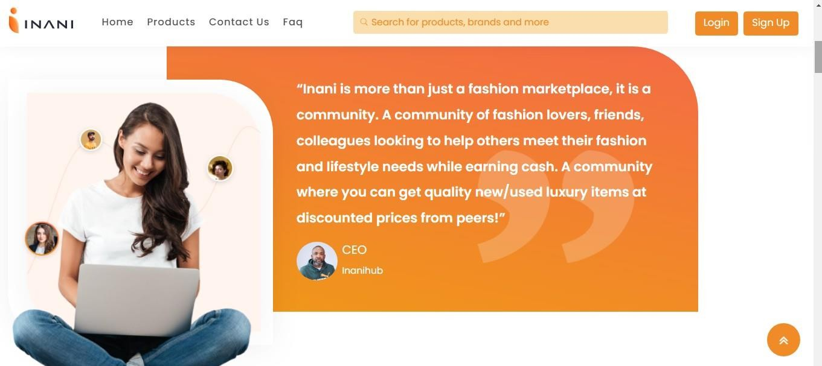

### Buyer’s information

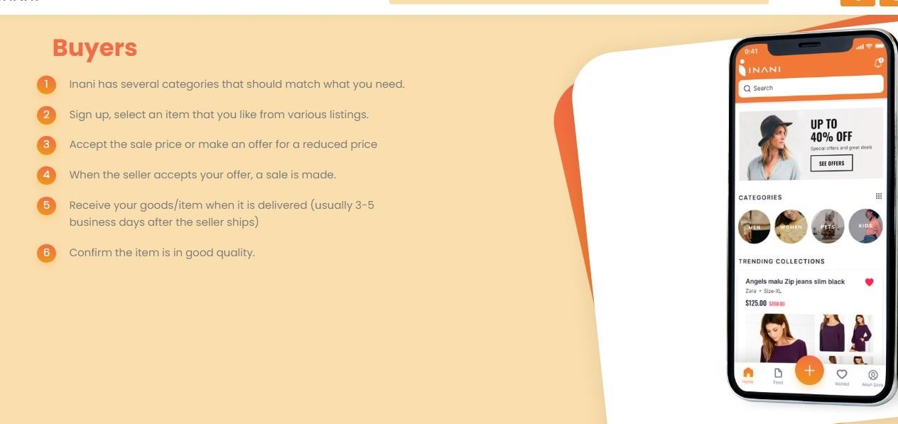

* 1. Blog’s information

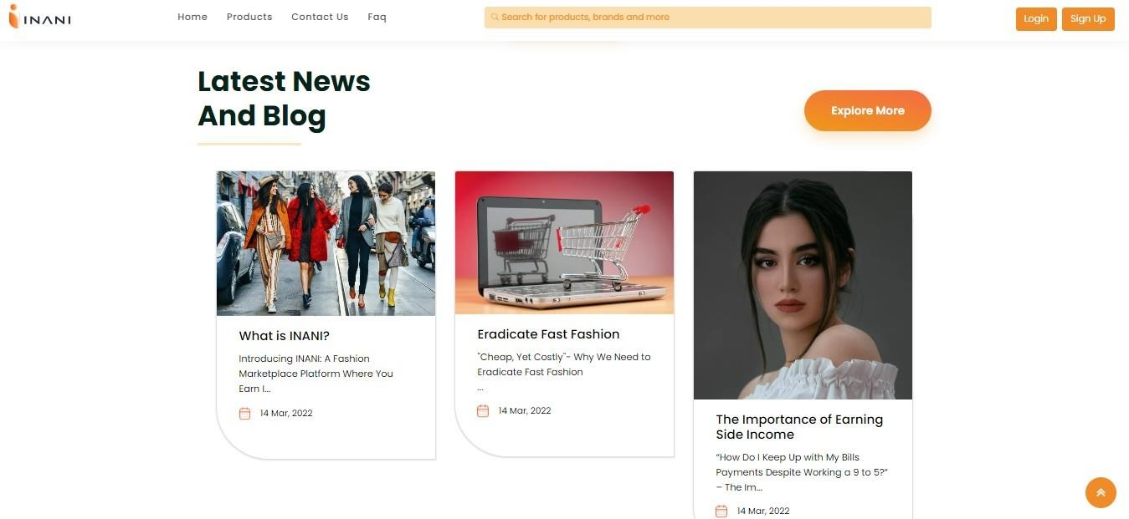

### FAQ’s information

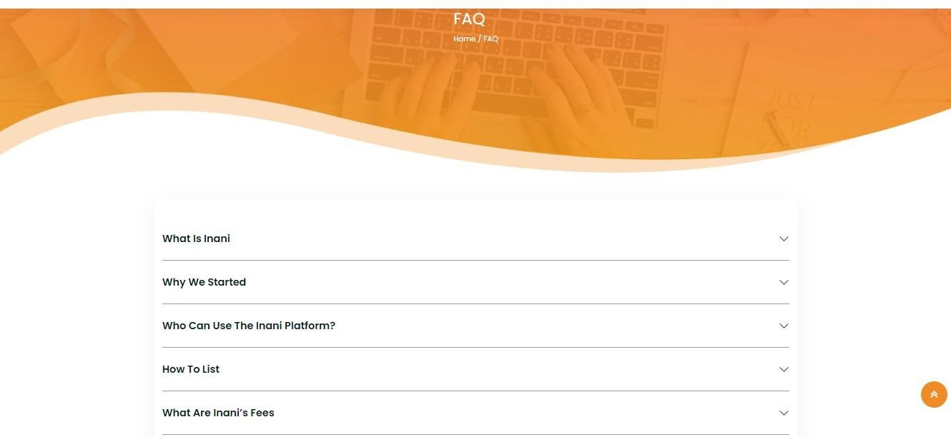

* 1. Product’s information

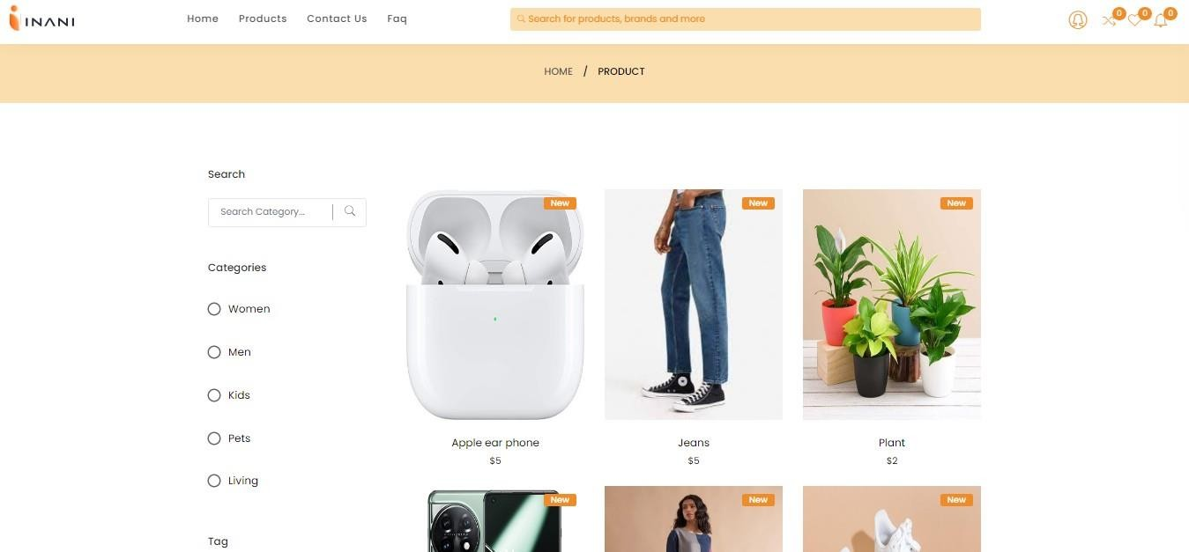

### Product’s Details

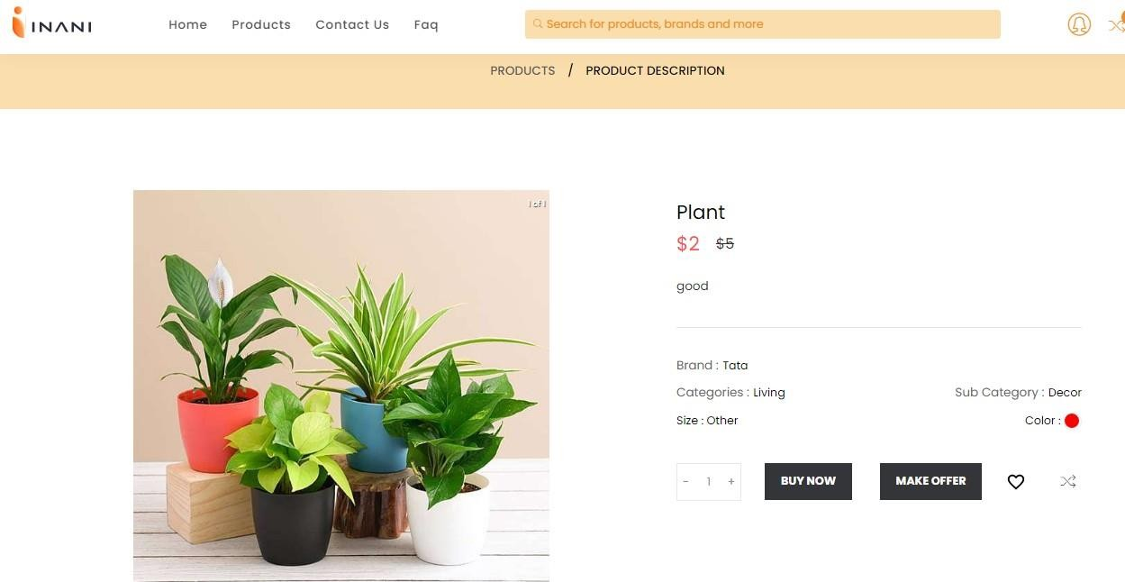

* 1. Selected Item

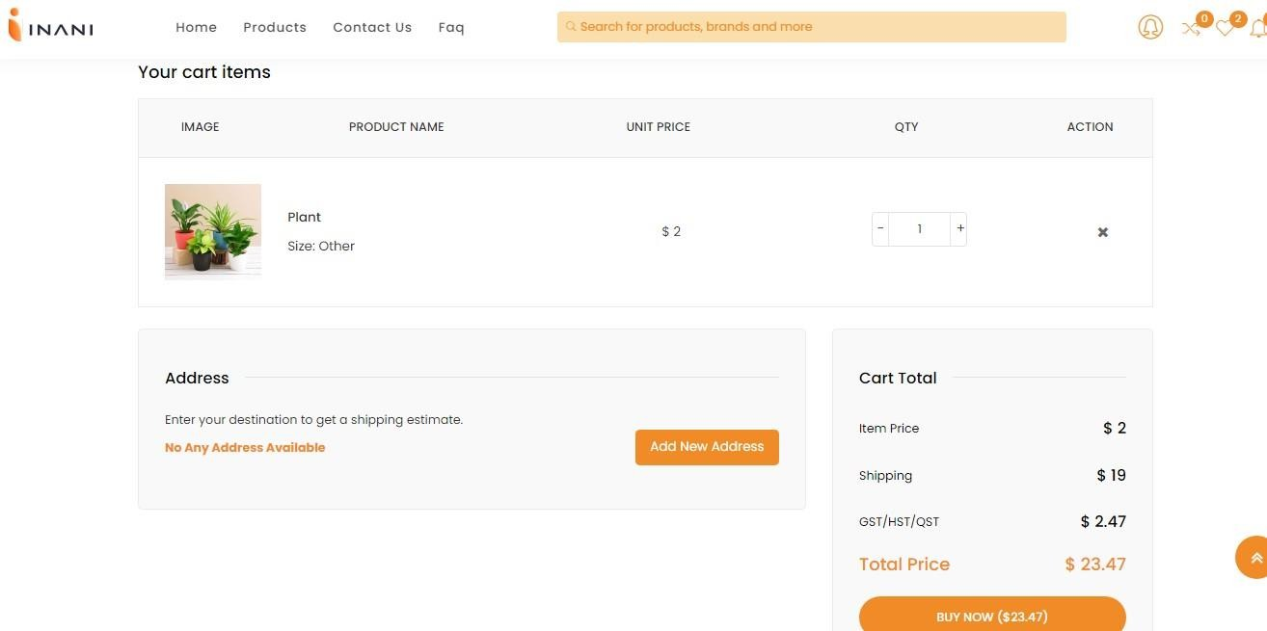

### Profile

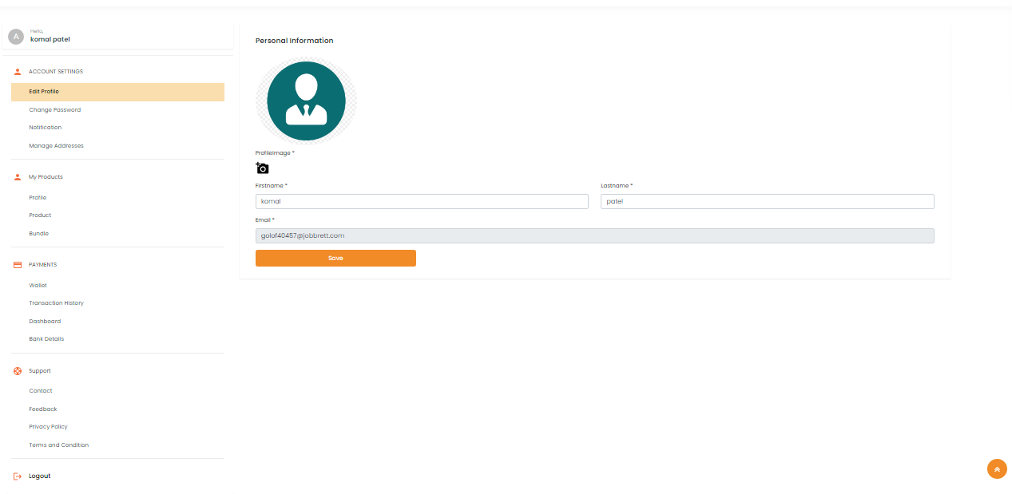

* 1. Upload Item

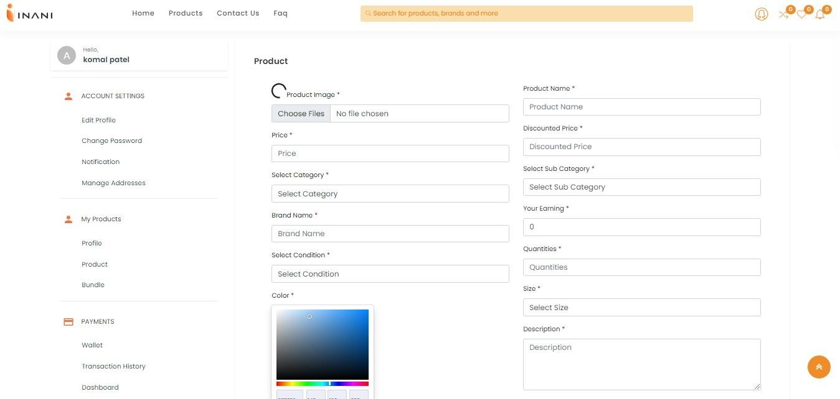

### Wishlist

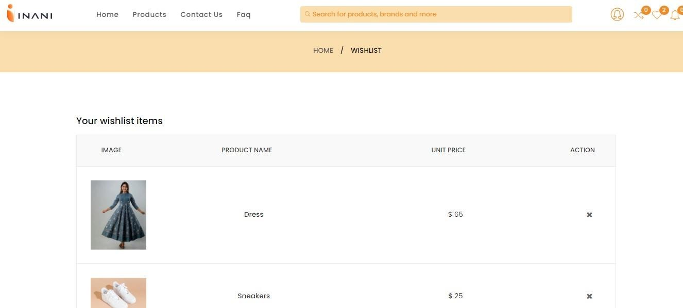

* 1. Notification

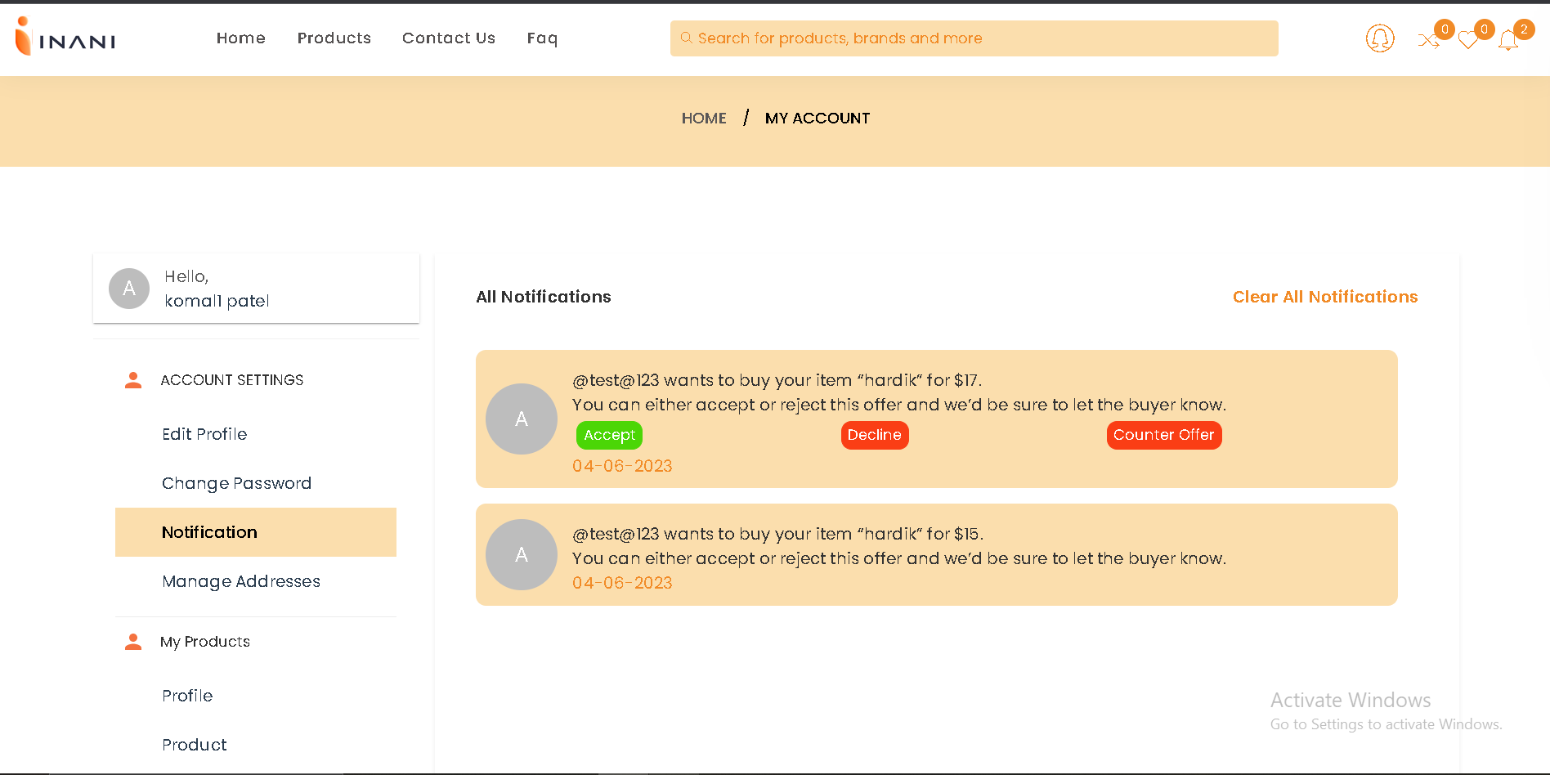

### Contact US



* 1. Categories

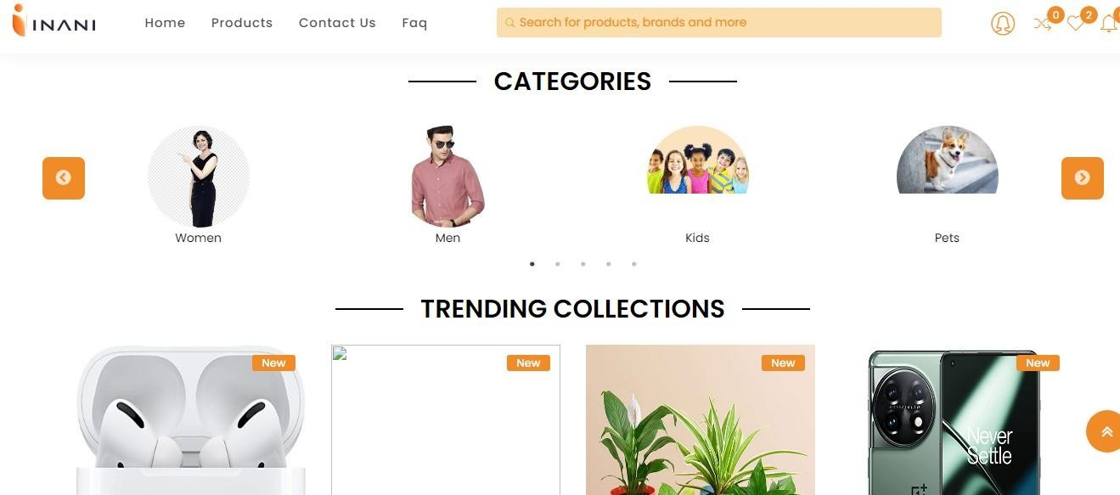

* 1. Footer

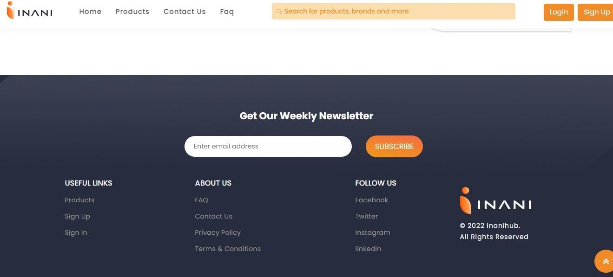

# 5. Agile Documentation

## Agile Project Charter

* + - Agile development and project management processes use a framework to adapt products quickly by shortening the release cycles of new features. In the context of retail, agile ecommerce is the rapid development of, and updates to, websites with new features or products, while reducing operational risks by improving code quality. In most cases, software development teams use either a Scrum or DevOps approach when working in agile development environments.

## Agile Roadmap

An agile roadmap using quarters would look something like this:

|  |  |  |  |  |
| --- | --- | --- | --- | --- |
| Quarter | Q1 | Q2 | Q3 | Q4 |
| Outcome | Sign-up/in Module | Customers | Sellers | Visitors |
| Features | Cerate the Sign-up and sign-in module for all the users | Create all the facility related to the customer  Create the facility for the customer’s products  Create the facility related to payment | Create all the facility related to the seller  Create the facility for the seller’s product  Create the facility related to payment | Create all the facility related to the visitors |

## Agile Project Plan

* Agile planning is a project management style with an incremental, iterative approach. Instead of using in an in-depth plan from the start of

the project which is typically product related Agile leaves room for requirement changes throughout and relies on constant feedback from end users.

* Over a defined period of time, cross-functional teams work on product iterations and achieving OKRs (objectives and key results), organizing their work into backlogs that focus on delivering value. The ultimate goal of each iteration is to produce a working project.

## Agile User Story

There are three different kinds of user stories that we typically encounter:

* Behavior-driven stories
* Granularity of a Story
* Reliability of a story

Once a Product Owner is able to recognize the type of story needed, it becomes easier for them to focus on the criteria that are important for the story acceptance.

## Behavior-Driven Stories :

These are stories where the user’s actions or decisions are the focus. These stories typically have a number of scenarios to be considered.

For example: As a customer, I need to authenticate myself so that I can see my account details and past orders.

In this example, there are multiple possible scenarios:

1. User entered the correct credentials for authentication
2. User entered incorrect credentials for authentication
3. User realizes that they forgot the credentials
4. User realizes that they do not have an account, and wants to create one now

For each scenario, we need the acceptance criteria defined. Use simple language in an active voice to state what the product needs to do. Each scenario is expected to have a “WHEN” and a “THEN” phrase. If the scenario is dependent on a specific pre-condition, then the scenario would need a “GIVEN” phrase too.

**GIVEN** <situational pre-condition>

**WHEN** <user action 1> and <user action 2> and … <user action n>

**THEN** <product action 1> and <product action 2> and … <product action n>

The earlier user story now would look as follows: As a customer, I need to authenticate myself so that I can see my account details and past orders.

Acceptance criteria:

Scenario 1: Successful authentication

When the user enters the correct email address and password and selects “sign-in” CTA

Then route the user to My Account home page and display signed-in status on header

Scenario 2: Unsuccessful authentication

When the user enters an incorrect combination of email address and password and selects “sign-in” CTA

Then reset credentials fields and display an error message “Incorrect Credentials” Scenario 2: Unsuccessful authentication

When the user enters an incorrect combination of email address and password and selects “sign-in” CTA

Then reset credentials fields and display an error message “Incorrect Credentials” Scenario 4: Register

When the user selects the “register” CTA Then route the user to the “registration” page

## Granularity of a Story:

Regardless of the type of story that is being written, there are two rules that govern the granularity of a story.

The first rule: The story needs to represent a meaningful product increment to the product user.

For example, if we are building a registration page, having two stories - one to display the form, and another to submit the form doesn’t make sense. Each individual story in this case doesn’t make any sense to the product user. We need a single story that can display the form and accept form submission. If there are any optional independent sections on the form (say a loyalty registration section), we could have a separate story to cover just that.

The second rule: The story needs to be small enough for the team to implement in one sprint.

A story may need to be split into multiple stories depending on the team’s experience and sprint duration. It’s perfectly fine to wait until refinement or planning with the team before doing this splitting.

## Reliability of a Story :

It seems obvious, but it’s worth stating: a story needs to be easily readable. Here are some tips:

* Pay attention to spelling and grammar.
* Use numbered lists wherever possible. In cases where numbering doesn’t make sense for a list, use bullets.
* Use indentation where applicable.
* When providing links to UX/UI artifacts, or other specifications as part of acceptance criteria, use plain text for the “hyperlink text” instead of the URL to avoid clutter.
* Use white space (line breaks) between sections or scenarios.

## Agile Release plan

* + - Agile release planning is an approach to product management that takes into account the intangible and flexible nature of software development—as part of this approach, teams plan iterative sprints across incremental releases.
    - This level of planning, combined with an iterative schedule to account for the dynamic nature of software, is what makes Agile product development so valuable.
    - The iterative release schedule gives teams the space to make course corrections without derailing the entire project, while the detailed roadmap and focus on the planning stage ensure everyone is on the same page.

## Agile Sprint Backlog

* + - A well-prioritized agile backlog not only makes release and iteration planning easier, it broadcasts all the things your team intends to spend time on including internal work that the customer will never notice. This helps set expectations with stakeholders and other teams, especially when they bring additional work to you, and makes engineering time a fixed asset.
    - A sprint backlog is a list of work items your team plans to complete during a project sprint. These items are usually pulled from the product backlog during the sprint planning session. A clear sprint backlog prevents scope creep by clarifying exactly what your team will be doing and not doing during each sprint

## Agile Test Plan

Types of Testing for E-commerce System :

|  |  |  |
| --- | --- | --- |
| Sr No. | Type of testing | Testing process |

|  |  |  |
| --- | --- | --- |
| 1 | Browser compatibility | * Lack of support for early browsers * Browser specific extensions * Browser testing should cover the main platforms (Linux, Windows, Mac etc.) |
| 2 | Page display | * Incorrect display of pages * Runtime error messages * Poor page download time * Dead hyperlink, plugin dependency, font sizing, etc. |
| 3 | Session Management | * Session Expiration * Session storage |
| 4 | Usability | * Non-intuitive design * Poor site navigation * Catalog navigation * Lack of help-support |
| 5 | Content Analysis | * Misleading, offensive and litigious content * Royalty free images and copyright infringement * Personalization functionality * Availability 24/7 |
| 6 | Availability | * Denial of service attacks * Unacceptable levels of unavailability |
| 7 | Back-up and Recovery | * Failure or fall over recovery * Backup failure * Fault tolerance |
| 8 | Transactions | * Transaction Integrity * Throughput |

|  |  |  |
| --- | --- | --- |
|  |  | * Auditing |
| 9 | Shopping order processing and purchasing | * Shopping cart functionality * Order processing * Payment processing * Order tracking |
| 10 | Internationalization | * Language support * Language display * Cultural sensitivity * Regional Accounting |
| 11 | Operational business procedures | * How well e-procedure copes * Observe for bottlenecks |
| 12 | System Integration | * Data Interface format * Interface frequency and activation * Updates * Interface volume capacity * Integrated performance |
| 13 | Performance | * Performance bottlenecks * Load handling * Scalability analysis |
| 14 | Login and Security | * Login capability * Penetration and access control * Insecure information transmission * Web attacks * Computer viruses * Digital signatures |

## Earned-value and burn Charts

Agile EV provides the data of **cost**, **performance** and **schedule** allowing to:

* Compare monetary expressions of value planned, earned and consumed at any given moment
* Calculate cost and schedule efficiency
* Make forecasts for the end-of-the-project time and cost

Earned value **(EV) measurement** and techniques, as methods for project **management monitoring, reporting, forecasting,** and **controlling have been developed** and **adopted over the past few decades** in software product development as well as traditional engineering projects.

# 6 . Proposed Enhancements

In Future we will add GPS system that user choose their location. In future we will add the provide the Online Payment Facility.

In future we can make all language independent so that User can Easily access it.

# 7 . Conclusion

Online shopping brings us great convenience, but it also encourages irresponsible consumption habits like exploiting the advantages of free returns and expedited shipping.

These add on to the existing pool of environmental problems that we are dealing with global warming, wastes and pollution.

# 8. Bibliography

Websites - [www.w3schools.com](http://www.w3schools.com/)

[www.javatpoint.com](http://www.javatpoint.com/)

[www.geeksforgeeks.org](http://www.geeksforgeeks.org/)

[www.tutorialspoint.com](http://www.tutorialspoint.com/)

[www.stackoverflow.com](http://www.stackoverflow.com)