# **Video Demo:**

The links to the video demo of the application are below:

1. Using VMs

<https://www.screencast.com/t/4i3bLQHbOQ>

<https://www.screencast.com/t/88Tl3iCE>

<https://www.screencast.com/t/aClvbTmaomAu>

1. Using TeamViewer

https://www.screencast.com/t/ESARUifcMAr

https://www.screencast.com/t/5ijo25AF6Ao2

<https://www.screencast.com/t/WW35cMwD>

1. Video

https://drive.google.com/file/d/1MfbrnZt7u7uNP73RdTEYys1BQ2Xmpi7p/view?usp=sharing

**Screenshots:**

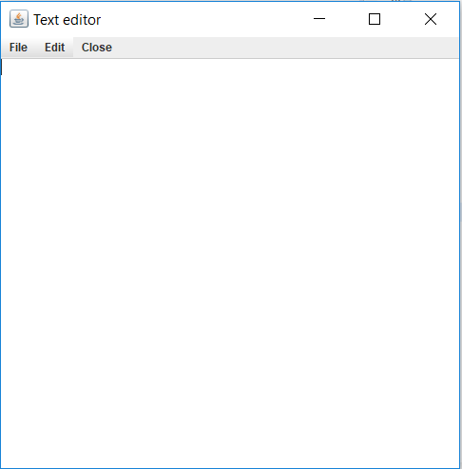

Figure 1: Text Editor

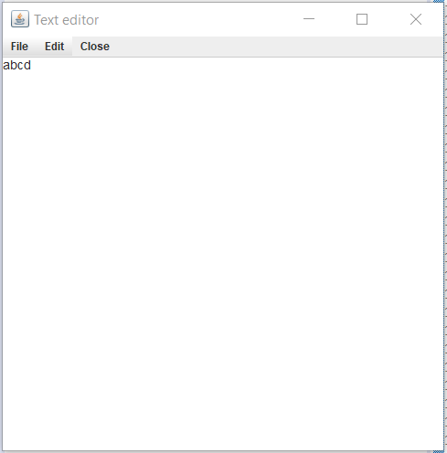 

Figure 2: Communication between peers

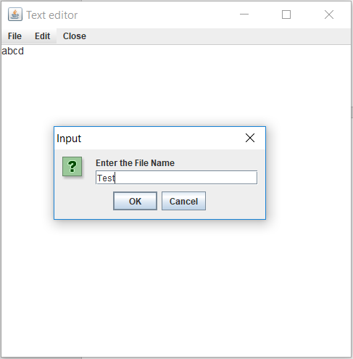

Figure 3: Saving a document to Google Drive

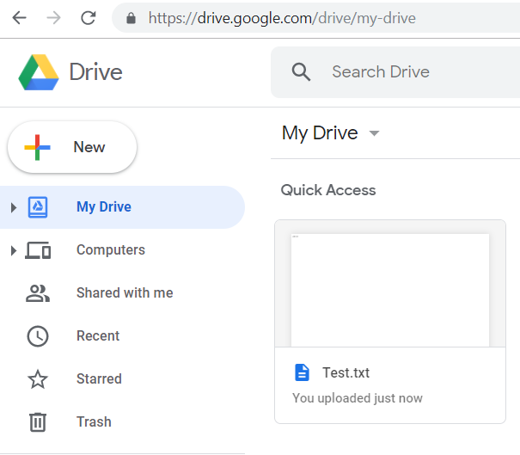

Figure 4: File saved to Google Drive

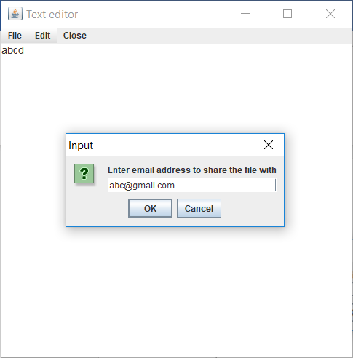

Figure 5: Sharing a document with collaborators

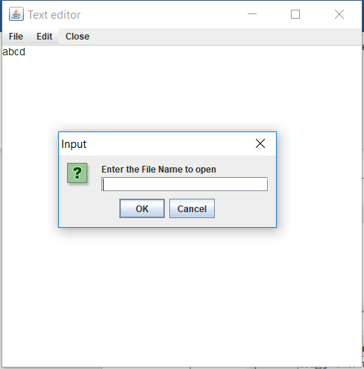

Figure 6: Opening a file from Google Drive