CLA 5 MINI PROJECT
EDUINSIGHT: An Intelligent Student Feedback Analysis and Academic Improvement System
Submitted by
Gundlakunta Madhuri
Registration Number: 231FA23103
Natural Language Processing and Deep Learning
Department of Cyber Security and Data Science
Academic Year: 2026–2027
ABSTRACT
The Student Feedback Intelligence System is a Python-based Natural Language Processing (NLP) application designed to convert free-text student comments into structured and understandable insights. Educational institutions collect feedback about teaching, assignments, infrastructure and course structure. When the volume of comments increases, manually reading and grouping every response becomes time-consuming and may cause recurring concerns to be overlooked.
The proposed system accepts feedback from a CSV file and applies a sequence of processing steps. Text preprocessing converts comments to lowercase, removes punctuation, tokenises the text and removes common stop words while preserving important negation terms. VADER is then used to calculate sentiment scores and classify each comment as Positive, Neutral or Negative. A keyword dictionary assigns comments to Teaching, Assignments, Infrastructure or Course Structure, while unmatched comments can be labelled General Feedback. CountVectorizer and TF-IDF are used to identify frequent and distinctive terms.
The results are presented through a Streamlit dashboard containing overview metrics, sentiment charts, category summaries, keyword insights, key takeaways, recommendations, a feedback explorer and CSV download options. On the documented sample of 40 comments, 22 comments (55%) were positive, 11 (27.5%) neutral and 7 (17.5%) negative. Assignments and Infrastructure were the most discussed themes, with 11 comments each.
The system is intended as a decision-support aid, not a replacement for human review. Its rule-based methods are transparent and easy to maintain, but may misinterpret context, domain-specific expressions and subtle complaints. The report discusses these limitations and proposes improvements such as domain-specific sentiment rules, trained classifiers, multilingual support and trend analysis.

TABLE OF CONTENTS
2 | Literature Review | Research on NLP, sentiment analysis and student feedback; research gap
Chapter | Title | Description
2 | Introduction | Background, motivation and project overview
3 | Problem Definition and Objectives | Problem statement, objectives, scope and outcomes
4 | Existing and Proposed System | Current manual process and proposed workflow
5 | Requirements and Technologies | Hardware, software and library requirements
6 | System Architecture and Project Structure | Pipeline architecture, modules and data flow
7 | Dataset Description | Dataset fields, sample records and validation
8 | Text Preprocessing | Cleaning, tokenisation and stop-word handling
9 | Sentiment Analysis | VADER scoring and classification thresholds
10 | Feedback Categorisation | Keyword dictionary and category assignment
11 | Keyword Extraction | CountVectorizer, TF-IDF and category reports
12 | Dashboard Design and Implementation | Streamlit layout, charts and interactions
13 | Results and Analysis | Sentiment, category and keyword findings
14 | Output Screens | Representative dashboard output images
15 | Testing and Validation | Functional test cases and expected behaviour
16 | Challenges and Limitations | Observed issues and interpretation risks
17 | Future Enhancements | Possible extensions and improvements
18 | Detailed Workflow, Algorithm and Design Considerations | End-to-end workflow, algorithm, privacy and responsible use
19 | Practical Applications and Evaluation Approach | Institutional uses, evaluation and monitoring
20 | Implementation Observations and Output Interpretation | Reading metrics, category charts and translating analysis into action
21 | Conclusion | Project summary and contribution
— | References | Research papers and technical documentation
— | Appendix | Execution steps and output file list

CHAPTER 1 – INTRODUCTION

1.1 Background
Student feedback is an important source of information for improving teaching practices, academic planning, learning resources and campus facilities. Students often express their opinions in open-ended text fields because these fields allow them to describe experiences in their own words. Such comments may contain praise, complaints, suggestions and neutral observations.
The main difficulty is that free-text feedback is unstructured. Unlike a rating scale, a sentence does not directly provide a numerical value that can be aggregated. Staff members must read each response, understand its meaning, identify the topic and determine whether it expresses satisfaction or dissatisfaction. As the number of responses grows, this manual process becomes difficult to maintain consistently.

1.2 Role of Natural Language Processing
Natural Language Processing is a field of computing concerned with enabling software to process and analyse human language. In this project, NLP techniques are used to clean student comments, identify sentiment, detect themes and extract important words. The system uses a combination of lexicon-based sentiment scoring and statistical text-feature extraction.

1.3 Project Overview
The application is organised as a pipeline. A CSV dataset is loaded, the text is cleaned, sentiment is scored, comments are categorised and keyword reports are generated. The Streamlit dashboard brings the outputs together in a browser-based interface. Users can upload a different CSV file, inspect the analysis and download the resulting reports.

1.4 Motivation
The motivation is to make feedback review faster and more systematic. A summary of the overall sentiment and the most discussed themes can help an academic team decide which comments need closer human attention. The system also makes it easier to compare categories and identify recurring terms associated with a topic.

CHAPTER 2 – LITERATURE REVIEW

2.1 Introduction
Student feedback is widely recognised as a useful source of information about the learning experience. Written comments can explain why students give a particular rating and can point to specific matters such as teaching methods, assessment workload, course organisation and campus facilities. However, these comments are usually written in everyday language and may vary in length, tone and vocabulary. Reading and organising a large collection manually can take considerable time. Researchers have therefore investigated Natural Language Processing (NLP) methods that help turn open-ended feedback into summaries that academic staff can review.

2.2 NLP for Student Feedback Analysis
NLP provides methods for preparing, representing and analysing human language. In student-feedback applications, common tasks include cleaning text, identifying sentiment, grouping comments by topic and extracting important terms. Sunar and Khalid's systematic review of research on students' feedback to instructors describes a range of NLP goals, including sentiment prediction, category prediction and analysis of students' views about courses [11]. Their review also highlights that choices about the data, language, labelling and modelling approach all influence how a feedback-analysis system should be designed.
Dalipi, Zdravkova and Ahlgren reviewed sentiment-analysis research involving feedback in Massive Open Online Courses (MOOCs). Their review discusses how student comments can be examined to understand course content, learning experiences and course design [12]. Although the present project uses a small CSV sample rather than MOOC platform data, the underlying purpose is similar: make written student opinions easier to organise and examine.

2.3 Sentiment Analysis Approaches
Sentiment analysis is commonly used to estimate whether a text expresses a positive, negative or neutral opinion. Educational-data surveys describe both lexicon-based methods and approaches based on machine learning and deep learning [13]. Lexicon-based methods use a collection of words with associated sentiment information and are often practical when a project does not have a labelled training dataset. Machine-learning and transformer-based approaches can learn more complex patterns from examples, but they generally require suitable data, evaluation and additional development effort.
Hutto and Gilbert introduced VADER as a rule-based sentiment model designed to work with short, informal text [1]. VADER combines a sentiment lexicon with rules that account for features such as capitalisation, punctuation and degree modifiers. This makes it a reasonable lightweight option for the short comments used in this project. It is not, however, designed specifically for academic feedback, so a sentence that politely requests an improvement may not always receive the sentiment label a human reviewer would expect.
Research focused on formative assessment in higher education also notes the potential of sentiment analysis to help interpret student–teacher interactions and support improvements in learning [14]. At the same time, the use of automated sentiment analysis in education requires care because language, context and the purpose of a comment can affect its interpretation.

2.4 Topic Categorisation and Keyword Extraction
Sentiment alone does not show which part of the learning experience a student is discussing. Topic or aspect categorisation adds this missing information by grouping comments under themes such as teaching, assignments, infrastructure and course structure. A keyword dictionary is easy to inspect and update, which makes it suitable for a small, explainable project. Its main weakness is that it relies on the words included in the dictionary and may not recognise synonyms or a topic expressed indirectly.
Text-feature extraction provides another way to understand a feedback collection. Count-based methods such as CountVectorizer represent documents through the number of times terms occur. TF-IDF gives greater weight to terms that are informative within a document collection and reduces the influence of terms that appear widely. These techniques are useful for highlighting recurring and distinctive words, but they do not independently determine whether a comment is a complaint or a compliment [2], [3].
Recent work has also explored deep-learning models for opinion mining and topic classification of course reviews [15]. Such methods point towards more context-aware analysis, although their performance depends on the amount and quality of labelled data and on careful testing. For a compact academic project, a transparent combination of dictionary-based categorisation and statistical keyword extraction can provide a useful starting point.

2.5 Research Gap and Relevance to the Proposed System
The literature shows that automated analysis can help educators review large collections of written feedback, but it also identifies continuing challenges. Student comments may contain negation, mixed opinions, informal expressions and context-specific language. A single comment may discuss more than one issue, while a general sentiment score may overlook the actual request being made. In addition, automated labels should be checked against the original comments rather than treated as final judgements.
The present project addresses a practical, small-scale version of this problem. It combines text preprocessing, VADER sentiment scoring, keyword-based categorisation, CountVectorizer, TF-IDF and a Streamlit dashboard in one workflow. Its contribution is not a new sentiment model; rather, it is an integrated and understandable tool that makes sample feedback easier to explore and report. The system also retains individual comments for human verification and clearly acknowledges the limitations of its rule-based methods.

2.6 Summary of the Literature Review
Overall, previous studies support the use of NLP and sentiment analysis as aids for understanding student feedback. They also show why model selection, data quality, topic identification and human validation matter. These findings inform the design of EDUINSIGHT: a lightweight decision-support application that organises feedback into sentiment, theme and keyword views while leaving final interpretation to academic staff.

CHAPTER 3 – PROBLEM DEFINITION AND OBJECTIVES

2.1 Problem Statement
Educational institutions collect large amounts of unstructured student feedback. Without an automated analysis process, it is difficult to determine whether students are generally satisfied, which academic or facility-related areas are discussed most often, and where negative comments are concentrated. Manual review requires time and may produce inconsistent grouping. The project addresses this problem by automatically processing feedback and presenting a concise analytical summary.

2.2 Objectives
- Clean raw feedback text so that it can be analysed consistently.
- Measure the sentiment of every comment as Positive, Negative or Neutral.
- Group feedback into Teaching, Assignments, Infrastructure and Course Structure, with General Feedback as a fallback.
- Identify frequent words and phrases using term-frequency analysis.
- Identify distinctive terms using TF-IDF weighting.
- Present the results in an interactive dashboard that does not require users to run Python code manually.
- Generate category-based recommendations from comments labelled Negative.

2.3 Scope
The documented system accepts English-language CSV data containing a Feedback column. A Student_ID column may also be present; if it is absent in the dashboard workflow, identifiers can be generated. Blank or missing feedback rows are removed before analysis. The implementation uses rule-based and statistical methods rather than a supervised machine-learning classifier trained on labelled institutional feedback.

2.4 Expected Outcomes
The expected outcome is a repeatable analysis workflow that produces labelled feedback, summary counts, category distributions and keyword reports. The dashboard is expected to help a user identify patterns quickly while retaining access to individual comments for verification.

CHAPTER 4 – EXISTING AND PROPOSED SYSTEM

3.1 Existing System
In a fully manual process, a staff member downloads feedback responses, reads each comment, identifies its topic and records whether it is positive or negative. The reviewer may then prepare a spreadsheet or summary report. This process is understandable and allows human interpretation, but it can become slow when the dataset contains many responses.

3.2 Drawbacks of Manual Review
- Time required to read and classify every response individually.
- Possibility of inconsistent interpretation between different reviewers.
- Difficulty identifying repeated terms across a large collection of comments.
- Limited ability to filter comments quickly by sentiment and topic.
- Additional effort required to prepare summary charts and reports.

3.3 Proposed System
The proposed system automates the repeatable parts of feedback analysis. Python scripts perform preprocessing, sentiment scoring, category assignment and keyword extraction. The Streamlit application combines these operations into one interface and displays the outputs using Plotly charts, tables and summary text.

3.4 Advantages of the Proposed System
- Processes a collection of comments in a consistent sequence.
- Provides sentiment and category labels for each usable comment.
- Shows overall counts and percentages in a visual format.
- Offers both frequent-term and distinctive-term keyword analysis.
- Allows filtering and downloading of analysed data.
- Uses transparent rules that can be inspected and modified.

3.5 Human Review
Automation does not guarantee that every label is correct. A neutral VADER score may still represent a complaint, and a word such as “improvement” may be interpreted positively even when the sentence requests a change. Therefore, the proposed system should be used to prioritise review and not to make final academic decisions without checking the original comments.

CHAPTER 5 – REQUIREMENTS AND TECHNOLOGIES

4.1 Software Requirements
Component | Purpose
Python | Main programming language
Visual Studio Code | Development environment
pandas | CSV loading, data manipulation and report generation
NumPy | Supporting numerical dependency
NLTK | English stop-word list used by preprocessing
vaderSentiment | Lexicon-based sentiment scoring
scikit-learn | CountVectorizer and TfidfVectorizer
Streamlit | Interactive web application
Plotly | Interactive charts
CSV files | Input dataset and generated reports

4.2 Hardware Requirements
The project is a lightweight Python application and can run on a standard personal computer capable of running a supported Python environment and a modern web browser. The original project documentation does not specify a minimum processor, memory or storage configuration. For this reason, exact hardware specifications are not claimed in this report.

4.3 Why Python?
Python provides readable syntax and a mature ecosystem for data processing and NLP. Its libraries support CSV handling, text vectorisation, sentiment analysis and dashboard development. Using one language across the pipeline reduces integration complexity.

4.4 Why VADER and Streamlit?
VADER is selected because it is a rule-based sentiment model designed for short, informal text and does not require a labelled training dataset. Streamlit is selected because it converts a Python script into an interactive web application with relatively little interface code. Plotly supplies charts that can be embedded in the dashboard. [1] [4]

CHAPTER 6 – SYSTEM ARCHITECTURE AND PROJECT STRUCTURE
The application follows a sequential data-processing architecture. Each processing script reads the dataset or the output generated by the previous stage, adds new information and saves a CSV file. The dashboard also contains the analysis logic so that it can process an uploaded CSV directly.
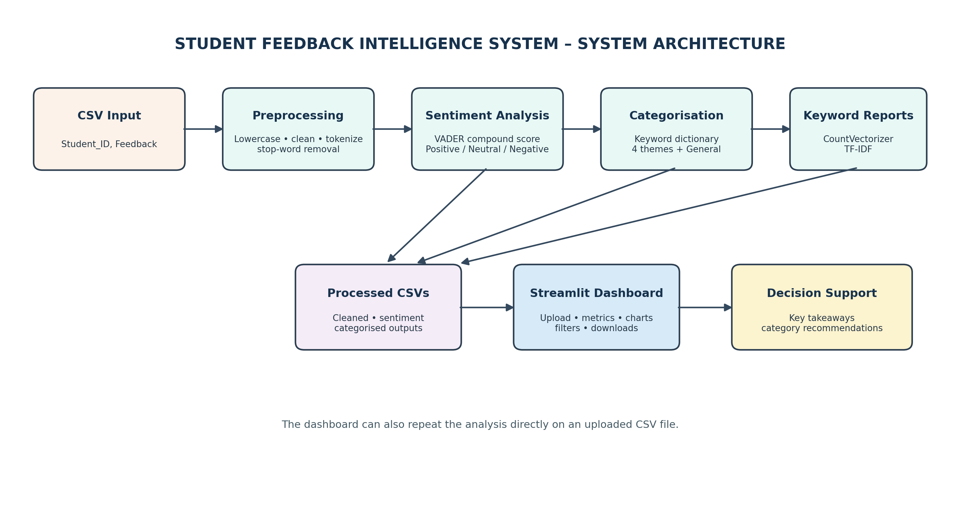
Figure 5.1: System architecture of the Student Feedback Intelligence System.

5.1 Main Modules
Module | Input | Output / Responsibility
Preprocessing | student_feedback.csv | student_feedback_cleaned.csv
Sentiment analysis | Original feedback text | VADER scores and sentiment labels
Categorisation | Cleaned feedback | Theme label for each comment
Keyword extraction | Feedback corpus and categories | Frequency, TF-IDF and category keyword reports
Dashboard | Uploaded or bundled CSV | Charts, metrics, filters, takeaways and downloads

5.2 Data Flow
The raw CSV enters the preprocessing stage. The cleaned text is stored for later keyword matching and vectorisation. Sentiment analysis uses the original feedback text because capitalisation, punctuation and intensifiers may affect VADER scoring. Categorisation uses the cleaned feedback. Keyword extraction creates overall and category-wise keyword reports. Finally, the dashboard presents the outputs in a user-friendly format.

5.3 PROJECT FILE STRUCTURE
File / Folder | Description
student_feedback.csv | Input dataset containing Student_ID and Feedback
preprocessing.py | Cleans text and creates Cleaned_Feedback
sentiment_analysis.py | Calculates VADER scores and sentiment labels
categorization.py | Assigns a category using a keyword dictionary
keyword_extraction.py | Generates frequency and TF-IDF reports
app.py | Runs the Streamlit dashboard
requirements.txt | Lists required Python packages
student_feedback_cleaned.csv | Intermediate cleaned dataset
student_feedback_sentiment.csv | Dataset with sentiment scores and labels
student_feedback_categorized.csv | Dataset with sentiment and category labels
keyword_frequency_report.csv | Overall term-frequency output
tfidf_keyword_report.csv | Distinctive-term output
category_keyword_report.csv | Category-specific keyword output

5.3 Modular Design
The scripts separate the responsibilities of the application. This makes it easier to test one stage without modifying the others. For example, a change to the category keyword dictionary can be made in the categorisation module without changing the VADER scoring logic. The dashboard provides a single point of access for users who do not need to run the individual scripts.

5.4 Generated Files
The intermediate CSV files make the workflow inspectable. A developer can open the cleaned dataset to verify preprocessing, inspect sentiment scores separately, and review category labels before relying on the dashboard summary. The keyword reports provide additional evidence for the displayed terms.

CHAPTER 7 – DATASET DESCRIPTION

6.1 Dataset Overview
The sample dataset named student_feedback.csv contains 40 short feedback comments. Student records are identified from S001 to S040. The documented dataset contains two fields: Student_ID and Feedback. Each feedback value is a short sentence describing an academic or campus-related experience.
Column | Data type | Description
Student_ID | Text | Unique identifier assigned to each sample response
Feedback | Text | Open-ended student comment to be analyzed

6.2 Themes Covered
- Teaching: clarity of explanation, teaching methods, classroom guidance and support.
- Assignments: homework, practical work, projects, difficulty and workload.
- Infrastructure: classroom conditions, laboratories, equipment, library and computers.
- Course Structure: syllabus, subject content, course pace and organisation.

6.3 Input Validation
The dashboard checks that the uploaded CSV contains a Feedback column. Empty or missing feedback rows are removed before analysis. If Student_ID is not supplied, the dashboard can generate sequential identifiers. These checks reduce avoidable failures caused by an incorrectly structured input file.

6.4 Dataset Size and Interpretation
The dataset is useful for demonstrating the processing pipeline, but it is small. With 40 comments, a single response changes a percentage by 2.5 percentage points. The results should therefore be treated as an illustration of the method and not as proof of a general trend across an entire institution.

CHAPTER 8 – TEXT PREPROCESSING

7.1 Purpose
Raw feedback often contains inconsistent capitalisation, punctuation and common words that do not add much value to keyword analysis. Preprocessing prepares the text for matching and statistical feature extraction. The script reads the input CSV, creates a Cleaned_Feedback column and writes student_feedback_cleaned.csv.

7.2 Preprocessing Steps
- Lowercasing: converts all letters to lowercase so that words such as Teacher and teacher are treated consistently.
- Punctuation removal: removes punctuation and special characters while retaining letters and spaces.
- Tokenisation: splits each sentence into individual words.
- Stop-word removal: removes common English words such as the, is and are.
- Reconstruction: joins the remaining tokens into a cleaned sentence.

7.3 Preserving Negation
The words not, no, nor and never are deliberately retained. Negation can reverse the meaning of a sentence. For example, removing “not” from “the teacher does not explain topics properly” would leave words that could appear positive when considered without context. The cleaned representation therefore retains the negation word.

7.4 Example
Original feedback | Illustrative cleaned text
The Teacher does not explain topics properly | teacher not explain topics properly
The classroom is very clean! | classroom clean
Assignments are difficult and lengthy | assignments difficult lengthy

7.5 Design Note
The preprocessing script uses NLTK stop words, while the dashboard uses the scikit-learn stop-word list to avoid requiring a separate NLTK download during dashboard execution. Both approaches preserve the specified negation terms. The two lists may not be identical, so consistency should be checked if exact reproducibility between script outputs and dashboard outputs is required. [7]

CHAPTER 9 – SENTIMENT ANALYSIS USING VADER

8.1 Overview
Sentiment analysis estimates the emotional polarity expressed in a text. This project uses VADER (Valence Aware Dictionary and sEntiment Reasoner), a lexicon- and rule-based sentiment tool. It returns positive, negative and neutral proportions along with a compound score between -1 and +1.

8.2 Compound Score and Thresholds
Compound score | Assigned label
0.05 or higher | Positive
-0.05 or lower | Negative
Between -0.05 and 0.05 | Neutral
The compound score is a normalised summary of the sentiment intensity. A score closer to +1 indicates stronger positive sentiment, while a score closer to -1 indicates stronger negative sentiment. Scores near zero are labelled neutral under the thresholds used in the project.

8.3 Why Original Text is Used
VADER is applied to the original feedback rather than the cleaned text. Capital letters, punctuation and intensifiers such as “very” and “too” can influence sentiment strength. The preprocessing stage removes some of these signals, so using the original text preserves information needed by VADER.

8.4 Examples from the Project
Feedback example | Compound score | Label
The teaching methods are excellent and easy to understand | 0.765 | Positive
The classroom is dirty and uncomfortable | -0.6705 | Negative

8.5 Saved Output
The sentiment analysis script records the positive, negative and neutral scores, the compound score and the final sentiment label. The results are saved to student_feedback_sentiment.csv for inspection and later processing.

CHAPTER 10 – FEEDBACK CATEGORISATION

9.1 Purpose
Sentiment describes the polarity of a comment, but it does not explain the subject being discussed. Categorisation adds a topic label so that users can identify whether feedback concerns teaching, assignments, infrastructure or course structure.

9.2 Keyword Dictionary
Category | Example keywords
Teaching | teacher, teaching, lecture, explain, class, guidance, supportive
Assignments | assignment, homework, practical, project, workload
Infrastructure | classroom, laboratory, equipment, library, facilities, computers, books
Course Structure | syllabus, course, subject, pace, content, structured

9.3 Assignment Logic
For each cleaned comment, the categorisation function counts how many keywords from each category appear as whole words. The category with the highest count is selected. If two categories have the same count, the category appearing first in the dictionary is selected. If no keyword matches, the comment is labelled General Feedback.

9.4 Advantages and Risks
A keyword dictionary is transparent: a reviewer can inspect the list and understand why a comment was assigned to a theme. It is also easy to extend with additional terms. However, the method is literal. It does not understand synonyms, word forms or context unless those forms are explicitly included. As a result, a comment may be assigned to a category that is not the best human interpretation.

9.5 Output
The categorisation stage creates student_feedback_categorized.csv, which combines sentiment and category information. This file is used by the dashboard's category charts, feedback explorer and recommendation logic.

CHAPTER 11 – KEYWORD EXTRACTION

10.1 Purpose
Keyword extraction helps answer the question: what do students repeatedly mention? The project uses two complementary techniques. CountVectorizer measures how often terms occur, while TF-IDF highlights terms that are distinctive within the collection of comments. [2], [3]

10.2 CountVectorizer
CountVectorizer converts a collection of text documents into a matrix of token counts. In this project, the vectoriser considers unigrams (single words) and bigrams (two-word phrases). The highest-frequency terms are retained in the overall keyword report. Frequency is useful for identifying repeated topics, but common words may dominate simply because they appear in many comments.

10.3 TF-IDF
TF-IDF stands for Term Frequency–Inverse Document Frequency. Term frequency measures how often a term appears in a document, while inverse document frequency reduces the weight of terms that appear in many documents. A higher TF-IDF value can indicate that a term is more characteristic of a subset of the corpus.
The project averages TF-IDF values across comments and reports the most distinctive terms. This complements raw frequency: a term may be frequent but not especially distinctive, while another term may occur less often yet help characterise a particular set of comments.

10.4 Category-wise Keywords
The script also calculates frequent terms separately for each feedback category. This produces a keyword profile for Teaching, Assignments, Infrastructure and Course Structure. The top terms help describe the topics that dominate each theme.

10.5 Output Files
Report file | Content
keyword_frequency_report.csv | Top overall terms ranked by occurrence
tfidf_keyword_report.csv | Top terms ranked by average TF-IDF
category_keyword_report.csv | Top terms for each feedback category

CHAPTER 12 – STREAMLIT DASHBOARD

11.1 Dashboard Overview
The app.py file combines the analysis pipeline in an interactive web page. Users can upload a CSV file through the sidebar or use the bundled sample dataset. The application validates the input, removes blank rows and executes preprocessing, sentiment analysis, categorisation and keyword extraction. [4]

11.2 Dashboard Sections
Section | Purpose
Feedback Overview | Shows total, positive, negative and neutral counts
Sentiment Analysis | Displays a donut chart and percentage indicators
Feedback Categories | Shows category counts and percentages in a bar chart
Frequently Mentioned Keywords | Displays top terms and a TF-IDF table
Key Takeaways | Summarises overall mood and key category observations
Recommendations | Suggests actions for categories receiving negative feedback
Feedback Explorer | Allows filtering by sentiment and category
Download Reports | Provides downloadable analysis and keyword CSV files

11.3 Interactive Visualisation
Plotly is used to create charts such as the sentiment donut chart and category bar chart. Streamlit places the charts, metrics and tables into a single browser interface. The dashboard is designed for users who need to explore the findings without opening each intermediate CSV file. [5], [8]

11.4 Recommendation Logic
The dashboard generates simple category-based recommendations from feedback labelled Negative. For example, negative comments associated with Assignments can lead to suggestions to review workload, clarify instructions or provide additional practical support. Infrastructure concerns can direct attention to laboratory equipment and classroom facilities. Because the recommendation panel depends on the sentiment labels, complaints mislabelled as Neutral or Positive may not trigger recommendations.

CHAPTER 13 – RESULTS AND ANALYSIS

12.1 Overall Sentiment Results
Sentiment | Number of comments | Percentage
Positive | 22 | 55.0%
Neutral | 11 | 27.5%
Negative | 7 | 17.5%
Total | 40 | 100.0%
The sample contains more positive comments than negative comments. Positive feedback accounts for 55% of the dataset. Neutral comments account for 27.5%, while 17.5% are labelled negative. This distribution provides a high-level view of the sample but should not be treated as a definitive measure of student satisfaction because the dataset contains only 40 comments and VADER has known domain limitations.

12.2 Category Results
Category | Total | Share | Positive | Neutral | Negative
Assignments | 11 | 27.5% | 4 | 4 | 3
Infrastructure | 11 | 27.5% | 6 | 3 | 2
Teaching | 10 | 25.0% | 7 | 2 | 1
Course Structure | 8 | 20.0% | 5 | 2 | 1
Total | 40 | 100% | 22 | 11 | 7

12.3 Interpretation
Assignments and Infrastructure are the most discussed themes, with 11 comments each. Assignments has the highest number of negative labels, with three. Teaching has seven positive comments out of ten and therefore appears to be the strongest area in this sample. Course Structure has eight comments, five of which are positive.

12.4 KEYWORD FINDINGS AND INTERPRETATION

12.4 Overall Frequent Keywords
Term | Frequency
assignments | 5
course | 5
practical | 5
classroom | 4
facilities | 4
laboratory | 4
teacher | 4
syllabus | 4
need | 4
excellent | 4

12.5 Most Characteristic TF-IDF Terms
Term | Average TF-IDF
teacher | 0.084
assignments | 0.082
classroom | 0.075
course | 0.072
practical | 0.072

12.6 Category Keyword Profiles
The category-specific reports are consistent with the intended themes. Teaching is led by “teacher” and “teaching”. Assignments is led by “assignments”, “practical” and “workload”. Infrastructure includes “classroom”, “facilities” and “laboratory”. Course Structure is led by “course” and “syllabus”.

12.7 Actionable Interpretation
The results suggest that a reviewer should pay particular attention to assignment workload, difficulty, clarity of instructions and practical work. Laboratory and classroom conditions are also worth reviewing because Infrastructure is one of the two most discussed themes. These findings indicate where to investigate further; they do not establish the cause of student concerns.

CHAPTER 14 – OUTPUT SCREEN IMAGES
The following figures are representative visual reconstructions prepared from the numerical findings and dashboard sections documented in the project report. They illustrate how the application outputs can be presented. They are not direct screen captures from the live Streamlit application. For a final institutional submission, replace them with screenshots captured from the actual running app if exact implementation evidence is required.

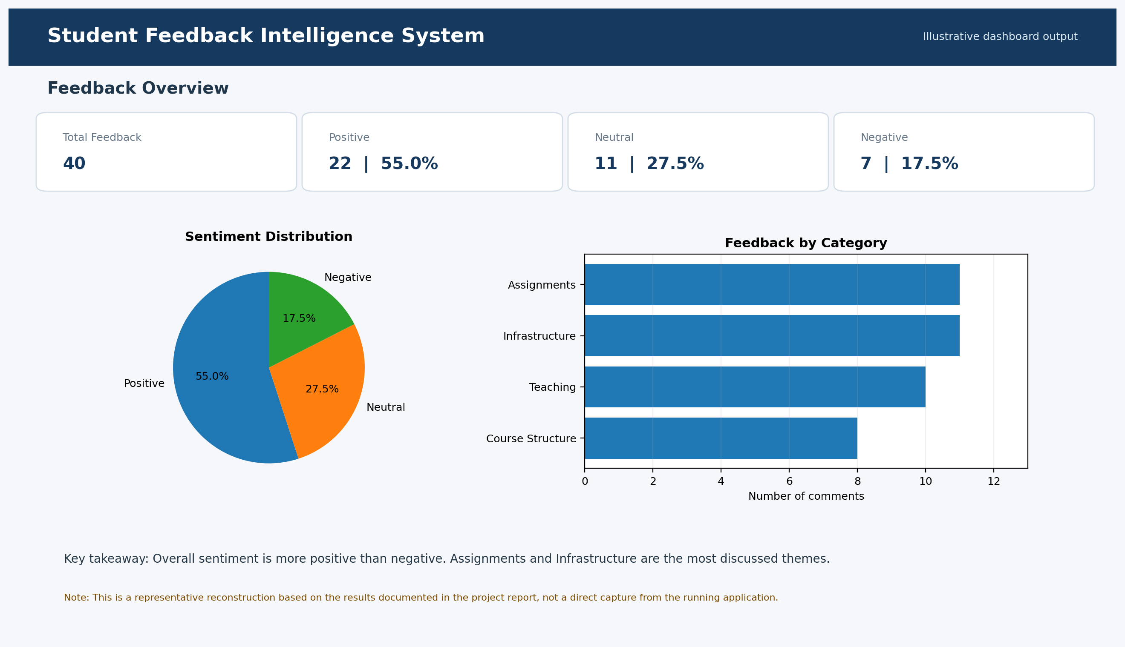
Figure 13.1: Illustrative dashboard overview showing sentiment metrics and category distribution.
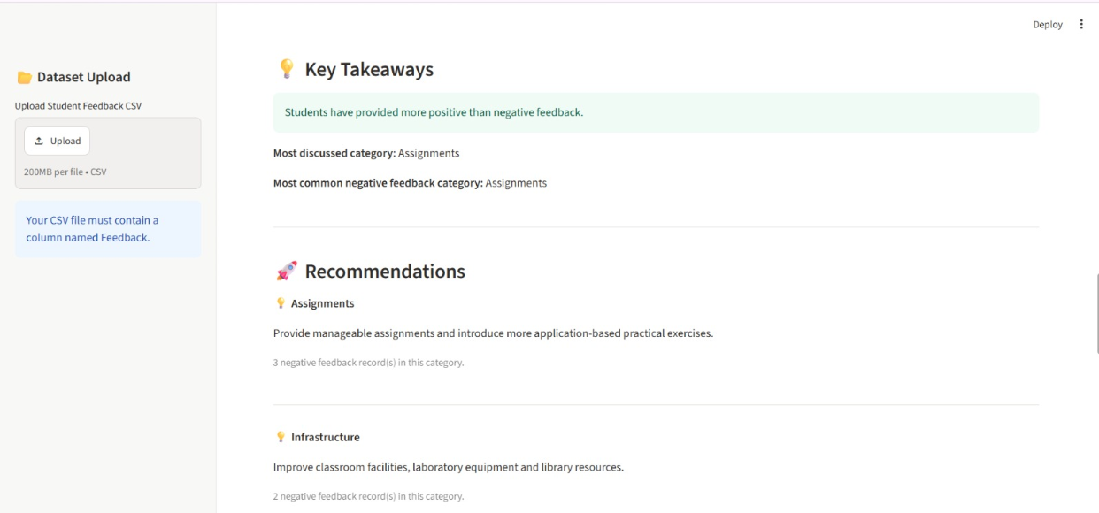
Figure 13.2: Illustrative Key Takeaways and Recommendations

CHAPTER 14 – OUTPUT SCREEN IMAGES (CONTINUED)
The second illustration represents the keyword insight and feedback explorer areas. The actual dashboard described in the project includes keyword charts, a TF-IDF table, filters for sentiment and category, and options to download the analysis reports.
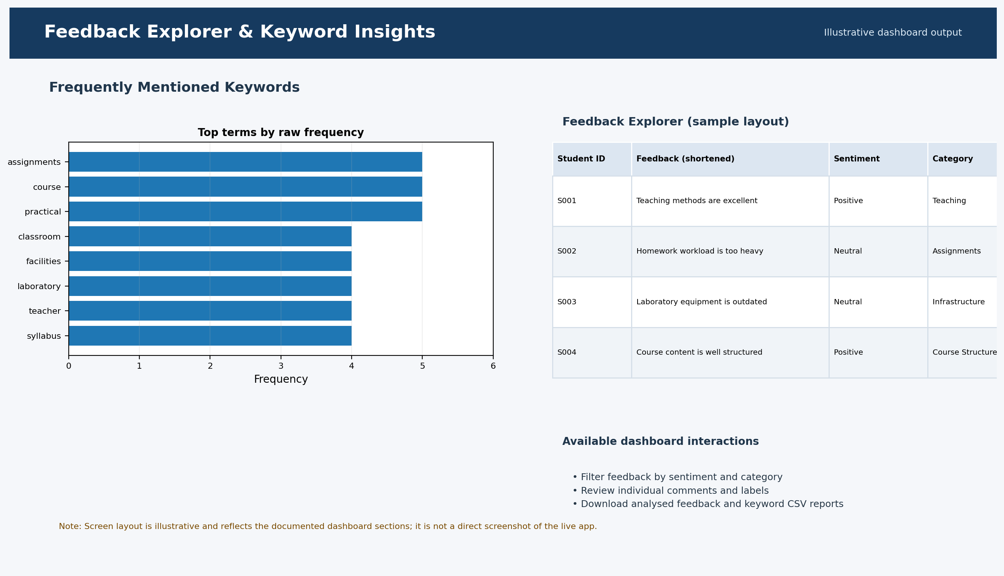
Figure 13.3: Illustrative keyword insight and feedback explorer layout.

CHAPTER 15 – TESTING AND VALIDATION
Testing checks whether each stage accepts the expected input and produces the expected output. The test cases below are derived from the documented system behaviour. They describe functional checks that should be performed when running the project.
Test ID | Test scenario | Expected behaviour
TC-01 | Load valid CSV with Feedback column | CSV is accepted and analysis begins
TC-02 | Upload CSV without Feedback column | Dashboard displays an input validation message
TC-03 | Include blank feedback rows | Blank or missing comments are removed
TC-04 | Provide no Student_ID column | Dashboard generates sequential identifiers
TC-05 | Run preprocessing | Cleaned_Feedback column is created
TC-06 | Run sentiment analysis | Scores and sentiment labels are generated
TC-07 | Run categorisation | Each comment receives a theme or General Feedback
TC-08 | Run keyword extraction | Frequency, TF-IDF and category reports are produced
TC-09 | Filter by sentiment/category | Feedback explorer displays matching rows
TC-10 | Download reports | CSV outputs can be downloaded

14.1 Validation of Reported Results
The summary values reported in this document are consistent with the original project report: 40 total comments; 22 positive, 11 neutral and 7 negative; category counts of 11, 11, 10 and 8. These values are reproduced as documented project results, not independently recomputed from the raw CSV in this report-generation step.

CHAPTER 16 – CHALLENGES AND LIMITATIONS

15.1 Sentiment Context
The original project report notes that several clear complaints received a compound score of 0.0 and were therefore labelled Neutral. Examples include comments about a teacher not explaining topics properly, excessive homework workload, outdated laboratory equipment and laboratory computers not working. These comments contain few words that VADER's general sentiment lexicon recognises as emotional.

15.2 Positive Scores for Improvement Requests
The word “improvement” can be interpreted positively by the lexicon. Consequently, comments such as “Laboratory facilities need improvement” may receive a positive compound score even though the sentence is a request for change. The report also records “We need more practical learning opportunities” as Positive.

15.3 Effect on Recommendations
The recommendation panel uses comments labelled Negative. If a complaint is classified as Neutral or Positive, it may not contribute to the recommendation summary. This is a direct consequence of the sentiment classifier's limitations.

15.4 Literal Categorisation
The category assignment uses exact whole-word matching. It does not apply stemming or semantic understanding. For example, a comment about subject workload may be assigned to Assignments because it contains “workload”, even if a human reviewer considers it a course-load issue.

15.5 Small Dataset and Text Cleaning
A 40-comment dataset is too small to support broad institutional conclusions. In addition, removing non-letter characters changes contractions such as “doesn't” to “doesnt”. The word “not” is retained intentionally and may appear among frequent keywords. These points should be considered when interpreting the reports.

CHAPTER 17 – FUTURE ENHANCEMENTS

16.1 Domain-specific sentiment vocabulary
Add education-related negative terms such as outdated, heavy and not working, or combine VADER with a custom rule set. This may help identify complaints that the general-purpose lexicon currently labels Neutral or Positive.

16.2 Transformer-based sentiment analysis
Evaluate a transformer-based model fine-tuned on labelled student feedback. Such a model may better understand context, but it would require suitable training data, validation and additional computational resources.

16.3 Improved categorisation
Use stemming, lemmatisation or a trained text classifier so that word variants and unseen expressions can be mapped more accurately.

16.4 Multi-label topic assignment
Allow one comment to belong to more than one theme when it discusses several issues, such as teaching quality and course workload in the same sentence.

16.5 Trend analysis
Store feedback across semesters and compare category and sentiment patterns over time. This would help determine whether an intervention is followed by measurable change.

16.6 Larger datasets and language support
Evaluate the system on larger collections and investigate regional-language support with appropriate language-specific preprocessing and sentiment resources.

16.7 Richer reports
Add PDF summaries, word clouds and exportable visual reports for meetings and academic review.

CHAPTER 18 – DETAILED WORKFLOW, ALGORITHM AND DESIGN CONSIDERATIONS

17.1 End-to-End Workflow
The system begins when a user selects a CSV file. The dashboard checks whether the required Feedback column is available and removes records that do not contain usable feedback. If a student identifier is not supplied, the application can create sequential identifiers so that individual comments can still be displayed in the feedback explorer. This first validation step is important because the later processing stages depend on receiving text in a predictable format.
After validation, the application prepares a cleaned representation of each comment. This representation is used for keyword matching and statistical extraction. Sentiment analysis is performed on the original sentence so that VADER can use punctuation, capitalisation and intensifying words. The category module then compares the cleaned words with the predefined theme dictionaries. Finally, the keyword module creates overall frequency and TF-IDF summaries, and the dashboard combines the results into a single view.

17.2 High-Level Algorithm
The logical sequence of the application can be expressed as the following algorithm:
- 1. Read the uploaded CSV file or load the bundled sample dataset.
- 2. Verify that the Feedback column exists; if it does not, display a validation message.
- 3. Remove empty feedback records and prepare student identifiers when required.
- 4. Convert feedback into a cleaned text form while preserving negation words.
- 5. Apply VADER to the original feedback and assign Positive, Neutral or Negative labels using the configured compound-score thresholds.
- 6. Compare cleaned tokens with the category keyword dictionary and assign the best-matching category.
- 7. Use CountVectorizer and TF-IDF to calculate frequent and distinctive terms.
- 8. Summarise the results in metrics, charts, tables, key takeaways and recommendations.
- 9. Allow users to filter the comments and download the generated CSV reports.

17.3 Important Design Decisions
One important design decision is to retain the original text for sentiment analysis while using cleaned text for keyword-based processing. The two tasks need different representations. Removing punctuation and intensifiers can simplify token matching, but those same details can help a sentiment tool interpret emphasis. Keeping both forms avoids forcing one preprocessing choice onto every stage.
Another decision is to use a transparent category dictionary rather than a trained classifier. The dictionary is easy to inspect and update, which is useful for a small academic project. However, it should be treated as a starting point. If the application is used with a much larger or more varied feedback collection, the dictionary should be reviewed with subject experts and tested against manually labelled examples.

17.4 Data Quality, Privacy and Responsible Use
Student feedback may contain personal details, names or descriptions of individual experiences. An institution using this type of application should collect only the information needed for analysis, restrict access to raw feedback and avoid publishing identifiable comments in reports. Where possible, student identifiers should be replaced with anonymous codes before analysis. The sample project uses IDs such as S001 and S002, which are suitable for demonstrating the workflow without displaying student names.
The dashboard should also communicate that its labels are automated estimates. A positive label does not prove that a student is fully satisfied, and a neutral label does not mean that a comment is unimportant. Staff members should review the original comment before deciding on an intervention. This is especially important when feedback could affect a teacher, a course or an institutional decision.

CHAPTER 19 – PRACTICAL APPLICATIONS AND EVALUATION APPROACH

18.1 Possible Institutional Uses
The system can support several routine academic review activities. A department may use it after collecting course-end feedback to identify the topics students mention most often. A programme coordinator may review the assignment category to understand whether workload, practical tasks or instructions are recurring concerns. A facilities team may use the Infrastructure category to identify comments related to laboratories, classrooms, library resources or computers. These are examples of how the categories can guide a human review; the application does not automatically assign work to departments.
The system may also help prepare a discussion summary for a faculty meeting. Instead of presenting a long list of raw comments first, the reviewer can begin with the overall sentiment split, the category distribution and the most frequent keywords. The reviewer can then open the feedback explorer and read the comments behind a particular chart. This combination of summary and traceable comments makes the dashboard more useful than a chart alone.

18.2 How the Results Should Be Evaluated
A useful next evaluation step is to prepare a manually labelled test set. Two or more reviewers could independently label a sample of comments for sentiment and category, then discuss disagreements and create a reference label set. The automated labels could be compared with this reference set. For sentiment classification, precision, recall and F1-score can be calculated for each class. For categorisation, the same measures can show whether the keyword dictionary assigns comments to the intended themes.
The evaluation should not rely only on overall accuracy. If most comments are positive, a system could appear accurate while still missing many negative comments. Class-wise precision and recall are therefore important, particularly for the negative category. Reviewers should also inspect examples where the automated result differs from the human label. Those examples can reveal missing vocabulary, ambiguous category rules or expressions that require a more context-aware model.

18.3 Monitoring the System Over Time
If the system is used repeatedly, the same input checks and analysis settings should be maintained across reporting periods. The institution should record the date or semester associated with each dataset and keep a note of any changes to the keyword dictionary or sentiment rules. Without this information, a change in category counts may reflect a change in the software rather than a real change in student feedback.
A simple monitoring process could compare the number of comments, sentiment percentages and category distributions across semesters. Such comparisons should be interpreted carefully when the number of responses differs. It is also helpful to review whether the same issues appear repeatedly and whether the comments change after an improvement has been made. The current project does not implement historical trend tracking, but its CSV outputs provide a basis for adding this capability in a future version.

18.4 Strengths of the Current Implementation
The current implementation has several practical strengths. It uses familiar Python tools, separates the processing stages into modules, produces inspectable CSV outputs and provides a dashboard that can be used without directly editing code. The methods are relatively lightweight and do not require a labelled training dataset. The category dictionary and VADER thresholds are also understandable to a student developer or project reviewer.
At the same time, these strengths are linked to trade-offs. The rule-based approach is easy to explain but does not fully understand context. The sample is useful for demonstrating the application but is not large enough to establish broad conclusions. The dashboard makes the output easier to explore, but the quality of the insight still depends on the input data and the accuracy of the automated labels. These trade-offs are part of the project's evaluation, not reasons to ignore its usefulness.

CHAPTER 20 – IMPLEMENTATION OBSERVATIONS AND OUTPUT INTERPRETATION

19.1 Understanding the Dashboard Metrics
The total feedback metric represents the number of usable comments included in the analysis after empty records are removed. The positive, neutral and negative metrics show how those comments are distributed according to the VADER compound-score thresholds. These values should always be read together with the total number of responses. For example, a category with three negative comments may deserve attention, but the reviewer should also consider how many total comments were received in that category and read the original responses before deciding on an action.

19.2 Reading Category Charts Carefully
A category chart shows how frequently students discuss a particular area. A high count does not automatically mean that the area is performing poorly. Students may mention a topic because they appreciate it, because they have a concern, or simply because it is an important part of their learning experience. The sentiment breakdown adds useful context, but it is still an automated estimate. The category count and sentiment label together provide a starting point for investigation rather than a complete evaluation of teaching or facilities.

19.3 Using Keywords as Evidence
The frequent keyword report highlights words that appear repeatedly across the feedback collection. It can help a reviewer notice topics that may not be obvious from a few individual comments. The TF-IDF report adds another perspective by identifying terms that are relatively distinctive across the corpus. Neither report should be interpreted as a list of problems by itself. A frequent word such as “course” may appear in both positive and negative comments, so the surrounding sentence must be considered before drawing a conclusion.

19.4 From Analysis to Action
A practical review process can begin with the dashboard summary, move to a category with a notable number of negative comments, and then inspect the individual feedback records. The reviewer can group similar concerns, check whether they are supported by multiple comments and decide whether further discussion is needed. For assignments, this may involve reviewing the clarity of instructions, the balance of workload and the amount of practical support. For infrastructure, it may involve checking whether equipment or facilities mentioned in comments are already scheduled for maintenance.
After an action is taken, a later feedback collection can be analysed using the same process. If the same issue continues to appear, the institution may need to investigate further. If comments become more positive, that may be a useful indication, although differences in response numbers and student groups should also be considered. The current application does not automate this follow-up comparison, but the generated CSV reports can be retained as records for future analysis.

19.5 Importance of Clear Reporting
A useful project report should distinguish between what the software calculated and what a person concludes from the results. The sentiment percentages and category counts are calculated outputs. Statements about why students feel a certain way, whether a course is effective or which improvement should be prioritised require additional context and human judgement. Keeping this distinction clear makes the system more trustworthy and prevents a simple text-analysis tool from being treated as an authority on academic quality.

CHAPTER 21 – CONCLUSION
The Student Feedback Intelligence System demonstrates how a Python-based NLP pipeline can convert unstructured student comments into organised information. The application combines text preprocessing, VADER sentiment analysis, keyword-based feedback categorisation and statistical keyword extraction. A Streamlit dashboard presents the outputs through metrics, charts, tables, filters and downloadable CSV reports.
On the documented 40-comment sample, 55% of comments were labelled Positive, 27.5% Neutral and 17.5% Negative. Assignments and Infrastructure were the most discussed categories, while Teaching had the highest positive count relative to its total comments. Assignment-related concerns deserve particular attention because this category contained the largest number of negative labels.
The project also demonstrates the importance of evaluating automated text analysis critically. VADER may miss complaints expressed without strongly negative vocabulary, and literal keyword matching may assign a comment to an imperfect category. The dashboard therefore provides a useful starting point for human review rather than a final judgement about student satisfaction.
With domain-specific sentiment handling, improved categorisation, larger datasets, multi-label analysis and trend tracking, the system can be developed into a more dependable feedback analytics tool. The current implementation provides a transparent and understandable foundation for that future work.

APPENDIX A – INSTALLATION AND EXECUTION

A.1 Create a Virtual Environment
Open a terminal in the project folder and create a virtual environment using the command:
python -m venv

A.2 Install Dependencies
pip install -r requirements.txt

A.3 Download NLTK Stop Words
python -c "import nltk; nltk.download('stopwords')"

A.4 Run Processing Scripts
Run the scripts in the documented order so that each stage can use the output generated by the previous stage:
- python preprocessing.py
- python sentiment_analysis.py
- python categorization.py
- python keyword_extraction.py

A.5 Launch the Dashboard
streamlit run app.py
The dashboard can also analyse a CSV uploaded through the application. The sample dataset is used when no file is uploaded, according to the documented project behaviour.

APPENDIX B – OUTPUT FILE CHECKLIST
- student_feedback_cleaned.csv
- student_feedback_sentiment.csv
- student_feedback_categorized.csv
- keyword_frequency_report.csv
- tfidf_keyword_report.csv
- category_keyword_report.csv
[11] A. S. Sunar and M. S. Khalid, “Natural Language Processing of Students’ Feedback to Instructors: A Systematic Review,” IEEE Transactions on Learning Technologies, vol. 17, pp. 741–753, 2024. doi: 10.1109/TLT.2023.3330531.
[12] F. Dalipi, K. Zdravkova, and F. Ahlgren, “Sentiment Analysis of Students’ Feedback in MOOCs: A Systematic Literature Review,” Frontiers in Artificial Intelligence, vol. 4, 2021. doi: 10.3389/frai.2021.728708.
[13] T. Shaik, X. Tao, C. Dann, H. Xie, Y. Li, and L. Galligan, “Sentiment Analysis and Opinion Mining on Educational Data: A Survey,” Natural Language Processing Journal, vol. 2, 2023, article 100003. doi: 10.1016/j.nlp.2022.100003.
[14] C. Grimalt-Álvaro and M. Usart, “Sentiment Analysis for Formative Assessment in Higher Education: A Systematic Literature Review,” Journal of Computing in Higher Education, vol. 36, pp. 647–682, 2024. doi: 10.1007/s12528-023-09370-5.
[15] A. Koufakou, “Deep Learning for Opinion Mining and Topic Classification of Course Reviews,” Education and Information Technologies, vol. 29, pp. 2973–2997, 2024. doi: 10.1007/s10639-023-11736-2.

REFERENCES
[1] C. Hutto and E. Gilbert, “VADER: A Parsimonious Rule-Based Model for Sentiment Analysis of Social Media Text,” Proceedings of the International AAAI Conference on Web and Social Media, vol. 8, no. 1, pp. 216–225, 2014. DOI: 10.1609/icwsm.v8i1.14550.
[2] scikit-learn Developers, “CountVectorizer,” scikit-learn API documentation. Available: https://scikit-learn.org/stable/modules/generated/sklearn.feature_extraction.text.CountVectorizer.html
[3] scikit-learn Developers, “TfidfVectorizer,” scikit-learn API documentation. Available: https://scikit-learn.org/stable/modules/generated/sklearn.feature_extraction.text.TfidfVectorizer.html
[4] Streamlit, “Basic concepts of Streamlit,” Streamlit Documentation. Available: https://docs.streamlit.io/get-started/fundamentals/main-concepts
[5] Streamlit, “st.plotly_chart,” Streamlit API Reference. Available: https://docs.streamlit.io/develop/api-reference/charts/st.plotly_chart
[6] pandas Development Team, “pandas documentation.” Available: https://pandas.pydata.org/pandas-docs/stable/
[7] NLTK Project, “Natural Language Toolkit documentation.” Available: https://www.nltk.org/
[8] Plotly Technologies Inc., “Plotly Python Graphing Library.” Available: https://plotly.com/python/
[9] Python Software Foundation, “Python Documentation.” Available: https://docs.python.org/3/
[10] Project source documentation, “Student Feedback Intelligence System: Project Report,” user-provided project report, 8 pages. Used as the primary source for implementation details and reported results.
Accessed: 9 November 2026. The library documentation URLs are provided as technical references for the tools used in the project.

