
M. V. P. Samaj’s
K. R. T. Arts, B. H. Commerce and A. M. Science College, Nashik-02
Department of Computer Science and Applications

a project report on
MATHMINDS AI
an analytical web application based on gemini-2.5-flash and sympy

submitted in partial fulfilment for the degree of
Master of Science in Computer Science

developed by,
Ms. Madhuri Ghadge
M.Sc. Comp. Sci. (SEM – IV)

under the guidance of,
Prof. Ms. R. S. Chaudhari. Mr. Navaneeth Balekumeri.
Assistant Professor Founder, Principal AI Consultant
Dept of Comp Sci and Appl. INBENNE TECHNOLOGIES

Year: 2025–2026


CERTIFICATE

This is to certify that the student Madhuri Nitin Ghadge, Roll No. 16 has successfully completed the Project work entitled, “MathMinds AI: an analytical web application” as part of their internship for the partial fulfilment of Sem IV of M.Sc. (Comp. Sci.) - II in the academic year 2025-2026,
under the guidance of,
Prof. Ms. R. S. Chaudhari,
Assistant Professor,
Department of Computer Science and Applications.

(signature)
Project Guide (signature)
Prof. Ms. R. S. Chaudhari. Prof. D. W. Aher.
Assistant Professor Head of Department,
Dept of Comp. Sci. and Appl. Dept of Comp. Sci. and Appl.

(signature) (signature)
Internal Examiner External Examiner

DECLARATION

I hereby declare that the project entitled “MATHMINDS AI” is a record of the original and bonafide work
carried out by me during the academic year 2025-26, under the guidance of Prof. Ms. R. S. Chaudhari, Assistant
Professor, Department of Computer Science and Applications, K. T. H. M. College, Nashik.
I further declare that this project has been undertaken as a part of the academic requirements for the completion
of my course. The work presented in this project report is based on my own efforts, investigations, and
implementation carried out under the supervision and valuable guidance of my project guide. The project has not
been submitted, either wholly or partially, to any other institution or university for the award of any degree,
diploma, or certificate.
I also affirm that all the sources of information, literature, data, concepts, algorithms, tools, and ideas that have
been used or referred to in this project have been properly acknowledged and cited in the bibliography section.
Wherever necessary, due credit has been given to the original authors and contributors.
I take full responsibility for the accuracy and authenticity of the information and results presented in this project
report.

Date: / /2026 (Signature)
Place: Nashik Madhuri Nitin Ghadge

ACKNOWLEDGEMENT

I would like to express my sincere gratitude to all the individuals who provided the guidance, mentorship, and
support necessary for the successful completion of this project.
First and foremost, I extend my heartfelt thanks to my project guide, Prof. Ms. R. S. Chaudhari, Assistant
Professor, Department of Computer Science and Applications, K. T. H. M. College, Nashik. Her academic
supervision, constant encouragement, valuable suggestions, and technical insights were vital to the foundation
and successful execution of this work. Her patience, motivation, and willingness to share her knowledge helped
me overcome many challenges during the development of this project. I am deeply thankful for her continuous
support and constructive feedback, which greatly contributed to improving both the quality and clarity of this
project.
I am also deeply indebted to Mr. Navaneeth Balekumeri, Founder and Principal AI Consultant at INBENNE
TECHNOLOGIES, for providing me with the valuable opportunity to work under his mentorship and for sharing
his professional expertise. His practical insights into Artificial Intelligence, industry-oriented guidance, and
thoughtful suggestions played an instrumental role in shaping the real-world implementation aspects of this
project. His encouragement and professional perspective helped me understand the practical applications of AI
concepts beyond academic learning.
I would also like to express my sincere thanks to the faculty members of the Department of Computer Science
and Applications, K. T. H. M. College, Nashik, for providing the necessary academic support, resources, and
encouragement throughout the duration of this project.
Furthermore, I am grateful to my friends and classmates who supported me with discussions, suggestions, and
motivation whenever needed. Their cooperation and encouragement made this journey more productive and
enjoyable.
I express my sincere gratitude to all those who directly or indirectly contributed to the successful completion of
this project.

Date: / /2026 (Signature)
Place: Nashik Madhuri Nitin Ghadge

INDEX

Sr. No. | TABLE OF CONTENT | Page No
1 | Introduction  - Key features  - Objectives  - Need for the system  - Drawbacks of the existing system | 8  8  8  9
2 | Proposed system and benefits | 10
3 | Analysis and Design  - Feasibility study  - Hardware and Software requirements | 12  13
4 | Entity Relationship Diagram | 14
5 | UML Diagrams  - Use Case Diagram  - Class Diagram  - Sequence Diagram  - Activity Diagram  - Component Diagram | 15  16  17  18  19
6 | Database Tables | 20
7 | Input and Output Screens | 21
8 | Result | 25
9 | Limitations | 28
10 | Future Scope | 29
11 | Conclusions | 30
12 | Bibliography | 31

MATHMINDS AI
Intelligent Problem Solving Platform
incorporating gemini-2.5-flash and sympy

Introduction

MathMinds AI is an intelligent, interactive mathematical problem-solving platform structured to assist users in understanding, solving, and formatting complex mathematical queries. The platform seamlessly bridges the gap between raw computational engines (like SymPy) and Advanced Agentic AI logic. By combining these paradigms through a agent search strategy, MathMinds AI provides accurate calculations paired with step-by-step reasoning. Designed with academia and professional use in mind, the system also features native support for turning mathematical derivations into print-ready LaTeX source code and PDF documents.

- Key Features
- Intelligent Math Solver Engine: Deep integration with the SymPy library to ensure precise, rapid mathematical computations and algebraic query resolution without AI hallucinations.
- AI-Powered Step-by-Step Reasoning: Utilizes agentic AI capabilities to break down complex problems and present understandable, logical derivation steps.
- Agent Search Strategy: Resolves complex, multi-part queries seamlessly without API conflicts by dynamically routing sub-tasks to specialized AI agent for web search.
- Advanced Academic Exports: Allows users to export AI-generated solutions and derivations directly into high-quality, print-ready LaTeX source code or formatted PDF documents.
- Cloud Data Integration: Leverages Firebase infrastructure (e.g., via firebase_utils) for secure data persistence, user management, and seamless syncing.

- Objectives
- Enhance Math Accessibility: Demystify difficult mathematical derivations by producing detailed, human-readable step-by-step explanations rather than just final numerical answers.
- Deliver High-Fidelity Outputs: Provide academic-grade document output out of the box to save researchers, educators, and students from the laborious task of manual typesetting.
- Ensure Computational Accuracy: Overcome the computational limitations of general LLMs by using SymPy as a rigid, pre-flight mathematical verification check.
- Create a Unified Workflow: Consolidate the process of exploring a concept, solving an equation, and formatting the results into a single, cohesive application.
- Maintain Scalability & Security: Use robust cloud architectures to maintain availability and seamless data management.

- Need for the System
Students, educators, and researchers continually face a frustrating bottleneck between acquiring computational answers and producing academic reporting. While computational software computes precisely, it often lacks pedagogical explanations. Conversely, natural language AI provides great explanations but frequently hallucinates when executing rigorous mathematics. Even when students navigate these platforms to find an answer, transcribing the complex formulas into a presentation-ready format like LaTeX is an arduous, highly error-prone process. MathMinds AI addresses this explicit need by unifying computational rigor, natural language reasoning, and native academic formatting in one reliable tool.

- Drawbacks of the Existing Systems
- Lack of Detailed Reasoning: Traditional symbolic solvers mostly provide a final answer lacking the intermediate steps essential for learning and verified research.
- High formatting learning curve: Transitioning from a solved problem to a publishable mathematical document requires in-depth knowledge of Markdown and LaTeX syntaxes, intimidating many users.
- AI Hallucinations in Logic: General-purpose AI models are highly prone to hallucinating steps during rigorous algebraic and calculus equations.
- Fragmented Workflows: Users are typically forced to bounce between a search engine, an AI chatbot, a specialized math tool (like Wolfram), and an editor (like Overleaf) to complete a single assignment.
- Tool Combination Conflicts: Existing implementations that stitch LLMs to math APIs generally suffer from prompt-chaining failures, API translation errors, or conflicting logic, leading to crashing application states.

Proposed System and Benefits

The proposed MathMinds AI system is a comprehensive, agentic platform designed to interactively solve and explain complex mathematical problems end-to-end. Unlike traditional AI setups, it introduces a "pre-flight" computational verification layer utilizing SymPy, which rigorously calculates the query first. The verified mathematical result is then passed to a designated Advanced Agentic AI (ADK agent), which breaks the mathematical solution down into pedagogical, step-by-step human reasoning. The entire architecture is backed by a secure, real-time cloud database (Firebase).

Key Components of the System
- Symbolic Math Engine: Powered by SymPy, handling precise algebraic and calculus computations safely before AI logic is applied.
- Agentic AI Engine: A specialized ADK-based AI system orchestrating the multi-agent search strategy to generate detailed, step-by-step derivation text.
- Real-time Cloud Database: Firebase infrastructure managing user profiles, session states, and query histories.
- Formatting Engine: An automated compilation engine responsible for translating agentic responses into print-ready LaTeX and PDF documents.

User Panel / UI
- Query Input Interface: A clean text and symbolic input dashboard where users enter their mathematical questions or upload equations.
- Interactive Solution View: A dynamic display that renders the final mathematical answer alongside expandable, step-by-step reasoning blocks.
- Session Dashboard & History: A user portal to view past queries, manage account settings, and resume previous problem-solving sessions seamlessly.
- Export Controls: One-click download buttons allowing users to instantly generate and retrieve their solutions in .tex (LaTeX source) or .pdf formats.

Modules in System

- The primary functional workflows utilized for problem-solving:
- Input Processing Module: Parses user input, extracting the mathematical intent, variables, and passing them to the solver.
- Computation Module: Executes the raw mathematical solution cleanly and mathematically validating it without relying on AI guesswork.
- Reasoning Module: Orchestrates the agent to analyse the computed solution and deduce pedagogical formatting steps for the user.

- The core technical and architectural backend services running the application:
- Authentication & Security Module: Integrates with Firebase Auth to securely handle user logins, registrations, and data protection.
- Session Management Module: Syncs real-time state across clients so users don't lose progression during multi-part math queries.
- Document Generation Module: Programmatically compiles numerical algorithms and textual data strings into compiled LaTeX/PDF formats.
- Reporting Module: Tracks project telemetry and usage data to automatically compile downloadable .doc weekly project reports.

Benefits of the Proposed System

- Elimination of AI Hallucinations: Integrating a rigid symbolic mathematical engine (SymPy) guarantees that calculations are factually correct before the AI is tasked with generating natural language explanations.
- Enhanced Pedagogical Experience: Users receive a logically structured, step-by-step breakdown rather than just a final value, drastically improving educational comprehension.
- Instant Professional Formatting: With automated, one-click export functionality to LaTeX and PDF, the system completely removes the friction of manually typesetting complex mathematical formulas for assignments or publications.
- High Scalability & Real-Time Syncing: Utilizing Firebase as a backend ensures instantaneous state syncing, secure user management, and safe access to query histories across multiple devices.
- Intelligent Routing Engine: The bespoke multi-agent search strategy routes mathematical and language tasks to the correct specialized agents. This directly prevents tool combination conflicts, API crashing, and parameter confusion, making the backend vastly more stable than a single-prompt LLM implementation.
- Radical Workflow Efficiency: Saves users countless hours typically spent context-switching between pocket calculators, generic AI chatbots, and LaTeX compilers by housing all requisite functionalities within a single, highly tuned ecosystem.

Analysis and Design

Feasibility Study

The feasibility study evaluates whether the MathMinds AI project is technically, economically, and operationally
viable.
- Technical Feasibility:
The project is highly technically feasible. It utilizes established open-source libraries (SymPy for symbolic mathematics) and reliable cloud frameworks (Firebase). The multi-agent AI architecture (ADK) can run efficiently alongside backend processing. Existing compilers for document generation (LaTeX, PDF generation via pdflatex) are mature and robust. Standard hardware and cloud architectures provide the necessary stability for these continuous integrations.
- Economic Feasibility:
Leveraging cloud-native technologies like Firebase provides a cost-effective, pay-as-you-go scaling model. Utilizing open-source mathematical libraries (SymPy) scales horizontally without requiring commercial math engine licenses. The primary operational costs revolve around agentic AI API usage, which is strictly optimized by passing only pre-verified computations to the reasoning agents—preventing expensive hallucination loops.
- Operational Feasibility:
The system is tailored to fit the actual problem-solving needs of students, educators, and researchers. By unifying query input, AI explanation, and document export into one interface, it seamlessly modernizes their daily operational workflows. The learning curve is practically non-existent on the user's end, as advanced integrations like mathematical parsing and LaTeX formatting happen completely in the background.

Hardware and Software Requirements

The system is built as an accessible digital platform, shifting heavy computational and AI generation tasks to the
Backend while keeping the user-side overhead minimal.

Backend (Server/Developer Node) Requirements

- Hardware Requirements:
  - Processor: Modern Multi-core CPU (e.g., Intel Core i5/i7 or AMD Ryzen equivalent) to execute concurrent agent evaluations efficiently.
  - RAM: Minimum 8GB (16GB recommended) due to large in-memory SymPy algebraic calculation trees and AI prompt parsing loads.
  - Storage: 20GB+ SSD for Docker containers, local Python cache, export staging directories, and log history.
  - Network: High bandwidth for incoming concurrent WebSockets, external API calls, and Firebase syncs.
- Software Requirements:
  - Operating System: Linux (Ubuntu 22.04 LTS), macOS, or Windows 10/11 with WSL2.
  - Runtime & Languages: Python 3.10+ (for API execution and multi-agent AI modeling).
  - Dependencies: Docker Engine, standard requirements.txt packages.
  - Database Infrastructure: Google Firebase (Firestore/Realtime DB) configured via firebase-admin SDK credentials (service-account.json).
  - Export Compiler: Dedicated host installation or Dockerized LaTeX distribution (e.g., TeX Live) supporting PDF creation via pdflatex.

Frontend (Client/User) Requirements

  - Processor: Standard dual-core processor (mobile or desktop).
  - RAM: Minimum 4GB (8GB recommended for smooth rendering of dynamically generated mathematical displays).
  - Network: A stable broadband internet connection required for real-time Firebase syncing, querying the agentic AI, and streaming reasoning results.

E-R Diagram

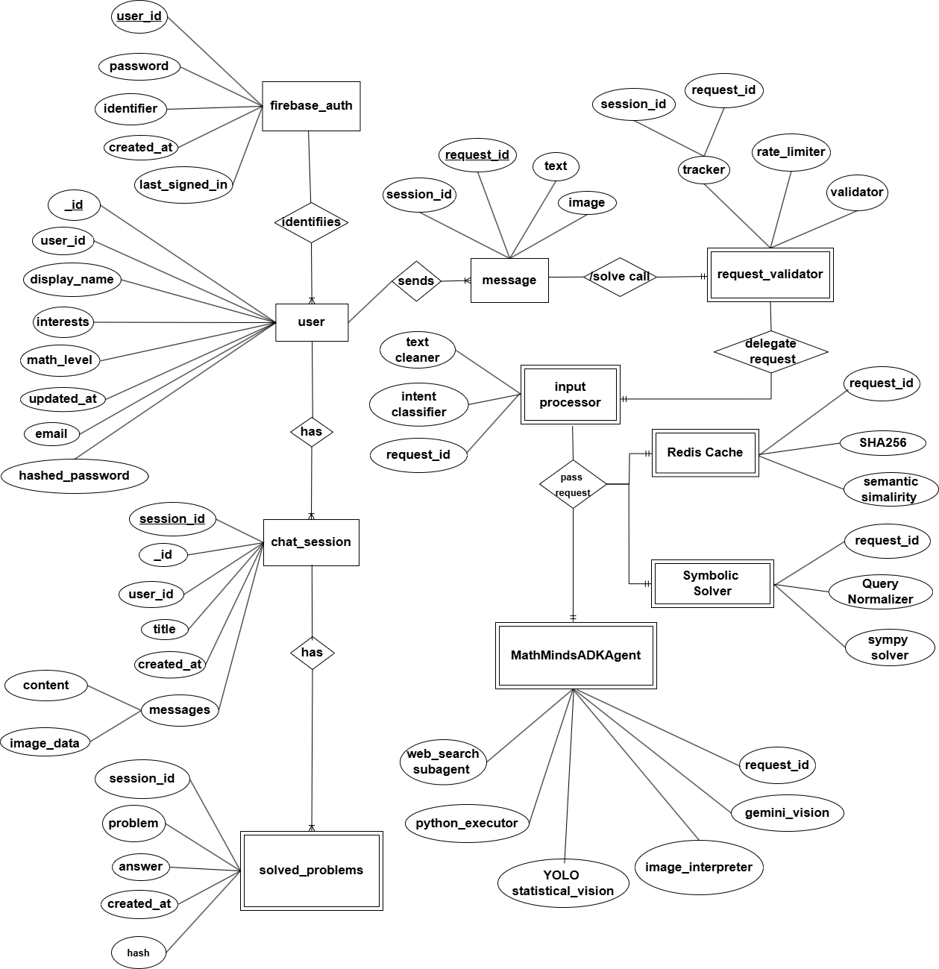

UML Diagrams

- Use Case Diagram

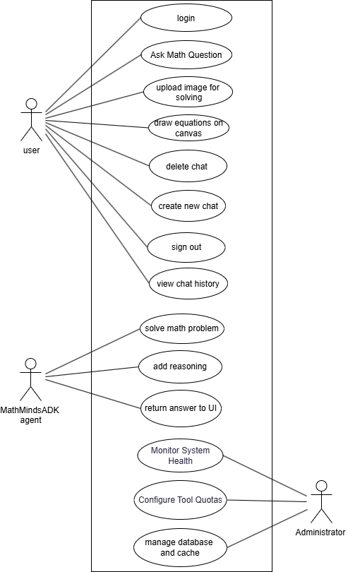

- Class Diagram

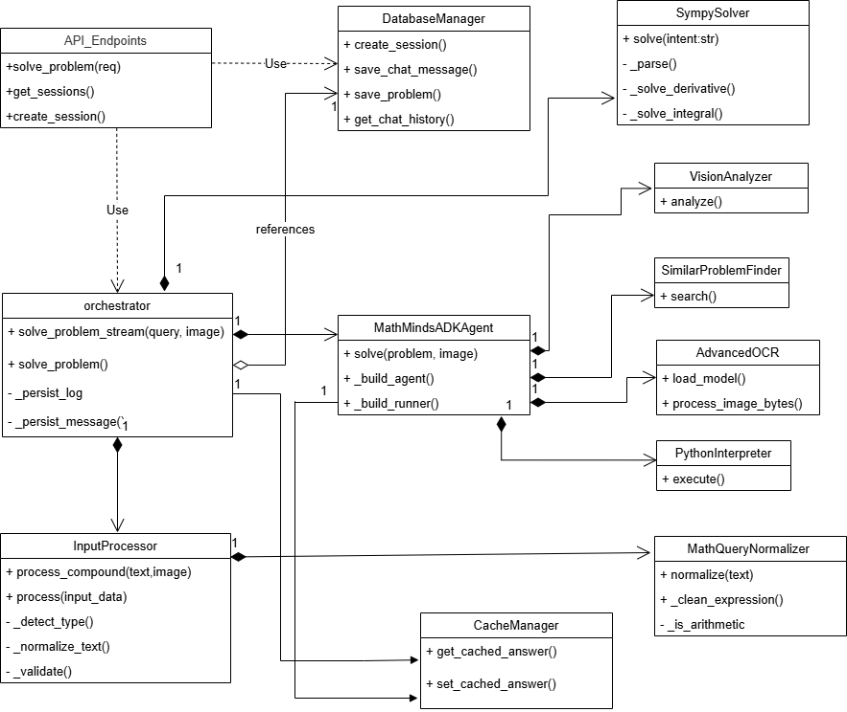

- Sequence Diagram

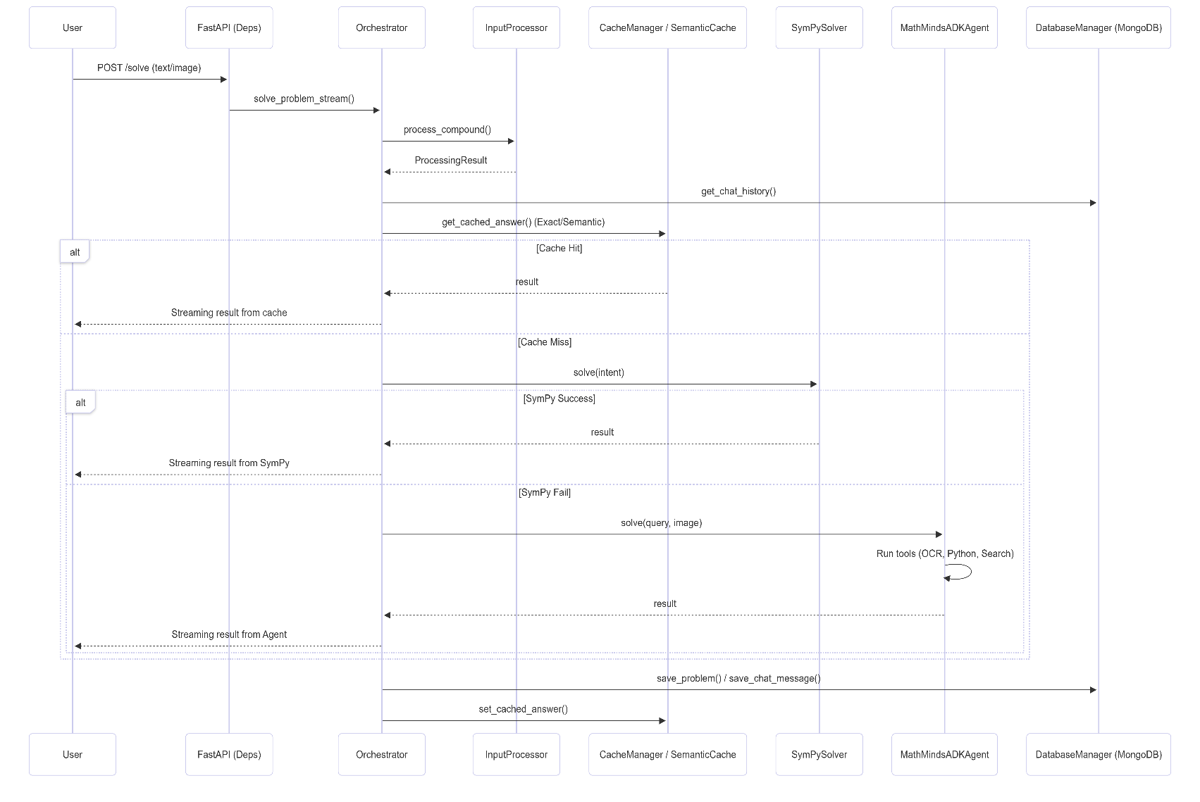

- Activity Diagram

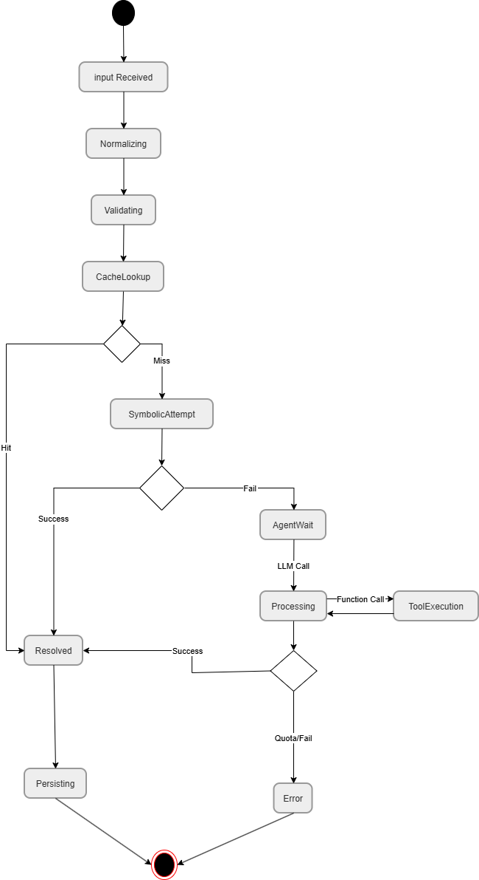

- Component Diagram

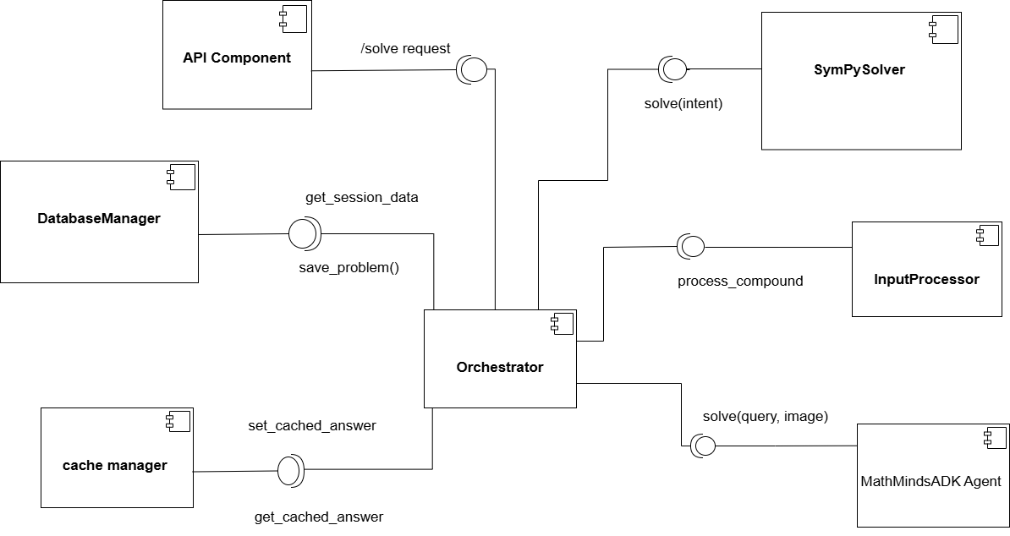

Database Tables

Table 1: User_Account
Serves as the primary identity ledger for users entering the platform.
Column Name | Data Type | Key Type | Description
user_id | VARCHAR | Primary Key | Unique identifier for the user.
email_address | VARCHAR | Unique | User's registered email address.
password_hash | VARCHAR | None | Encrypted password string.
account_created_at | TIMESTAMP | None | Timestamp of account registration.
last_login | TIMESTAMP | None | Timestamp of the user's most recent login.

Table 2: Session_History
Groups complex calculations logically under a dedicated problem-solving session.
Column Name | Data Type | Key Type | Description
session_id | VARCHAR | Primary Key | Unique identifier for the session.
user_id | VARCHAR | Foreign Key | References User_Account.user_id.
session_title | VARCHAR | None | Human-readable title of the session.
session_started_at | TIMESTAMP | None | Timestamp indicating when the session began.

Table 3: Query_Log
Records the raw mathematical requests submitted by users and the deterministic calculated answers.
Column Name | Data Type | Key Type | Description
query_id | VARCHAR | Primary key | Unique identifier for the query.
session_id | VARCHAR | Foreign Key | References Session_History.session_id.
raw_input_string | TEXT | None | The exact mathematical query submitted.
computed_sympy_answer | TEXT | None | Deterministic answer computed by SymPy engine.
query_timestamp | TIMESTAMP | None | Timestamp of the query submission.

Table 4: Agent_Reasoning
Saves the specific steps generated by the AI agent to prevent excessive LLM token usage if a user requests the same step history again.
Column Name | Data Type | Key Type | Description
reasoning_id | VARCHAR | Primary Key | Unique identifier for the reasoning step.
query_id | VARCHAR | Foreign Key | References Query_Log.query_id.
step_number | INT | None | Sequential order of the reasoning step (1, 2, 3...).
step_description | TEXT | None | AI-generated pedagogical explanation.
latex_formula | TEXT | None | Specific LaTeX mathematical formula for this step.

INPUT and OUTPUT SCREENS

    - log in page

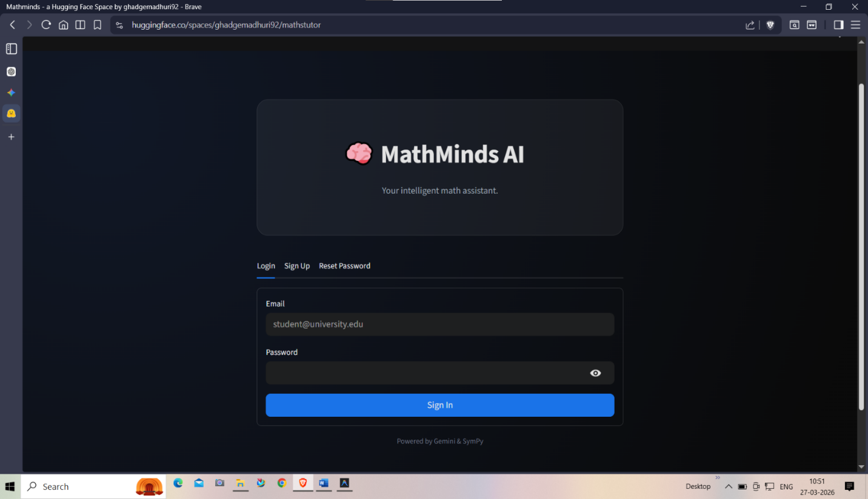

    - sign up page

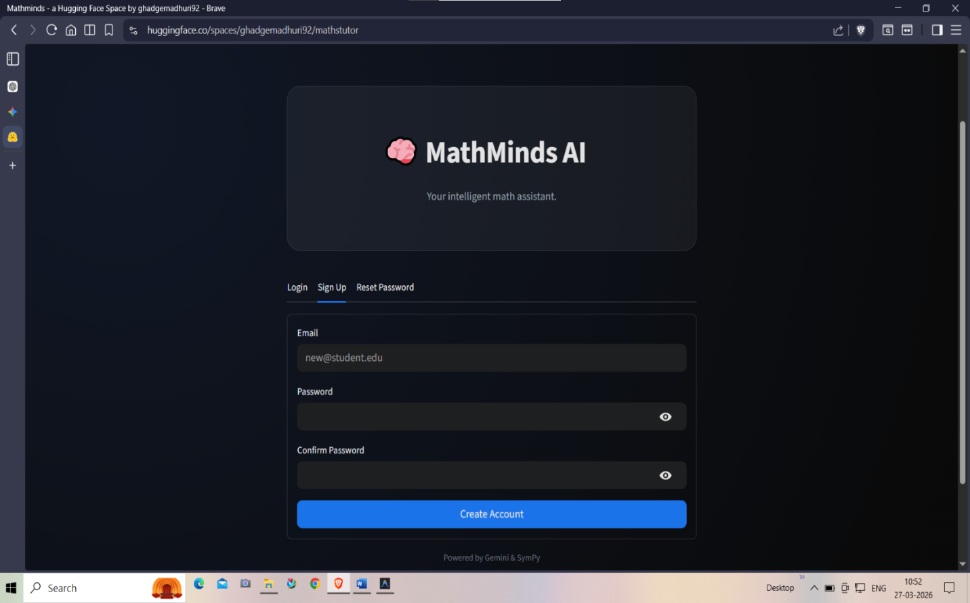

    - reset password

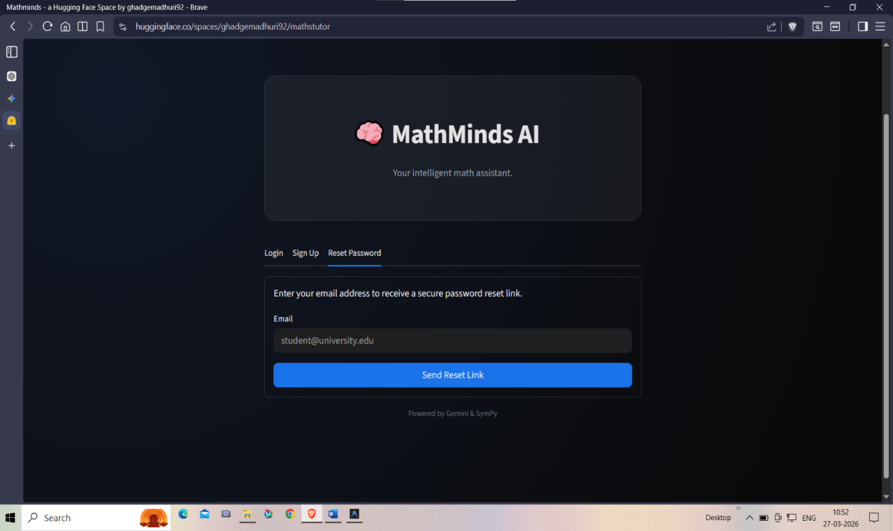

    - user profile

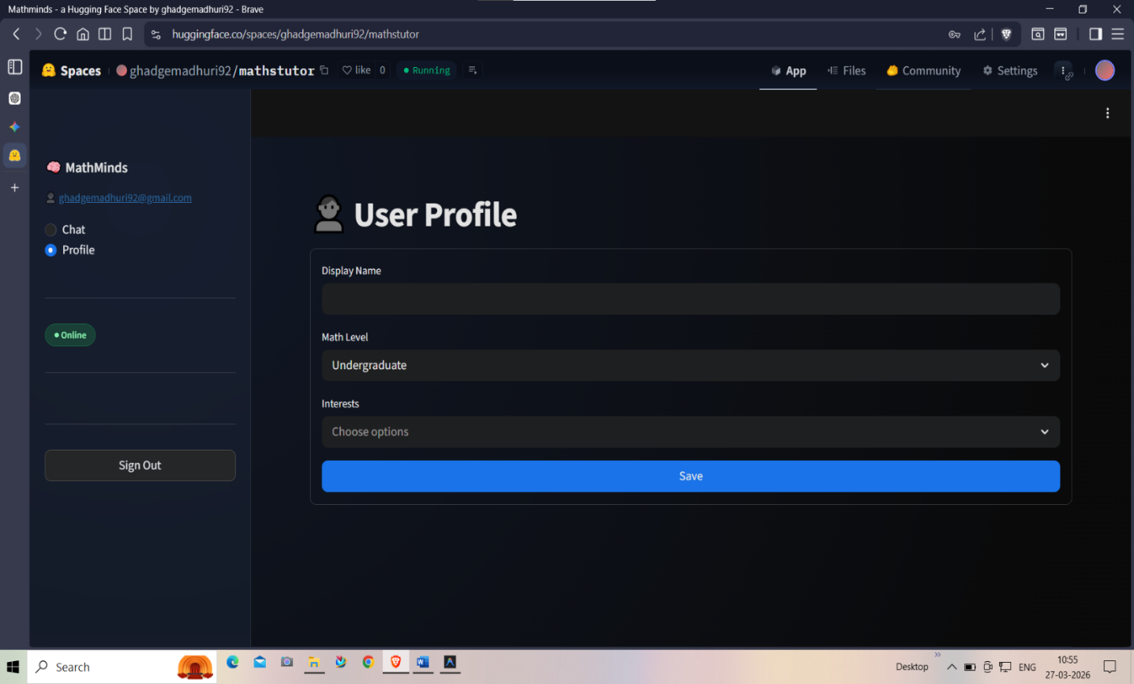

    - new chat and text input page



    - drawing canvas

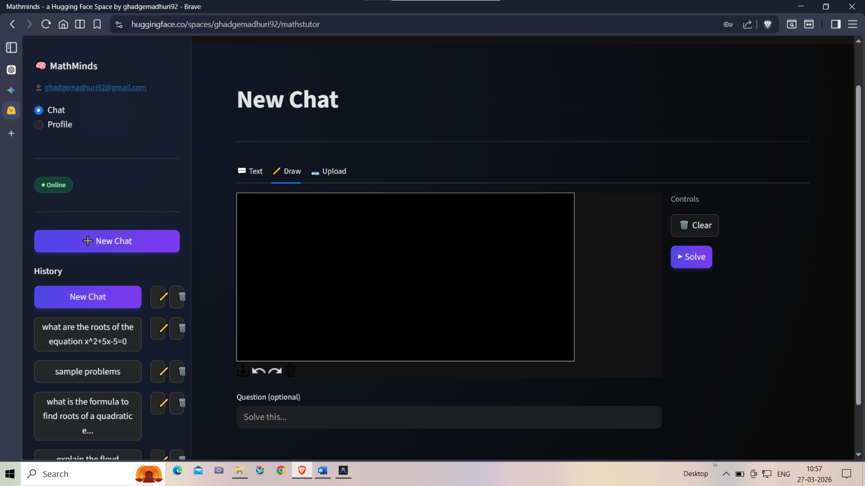

    - upload image page

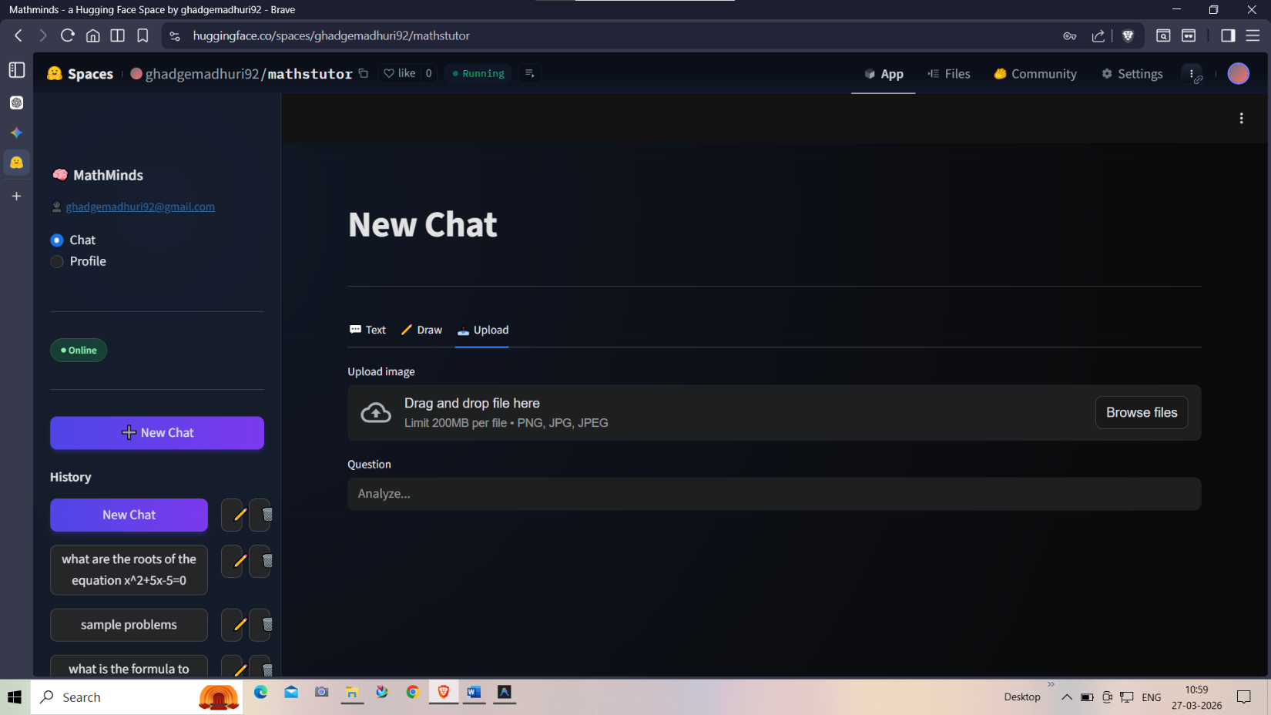

    - chat history sidebar

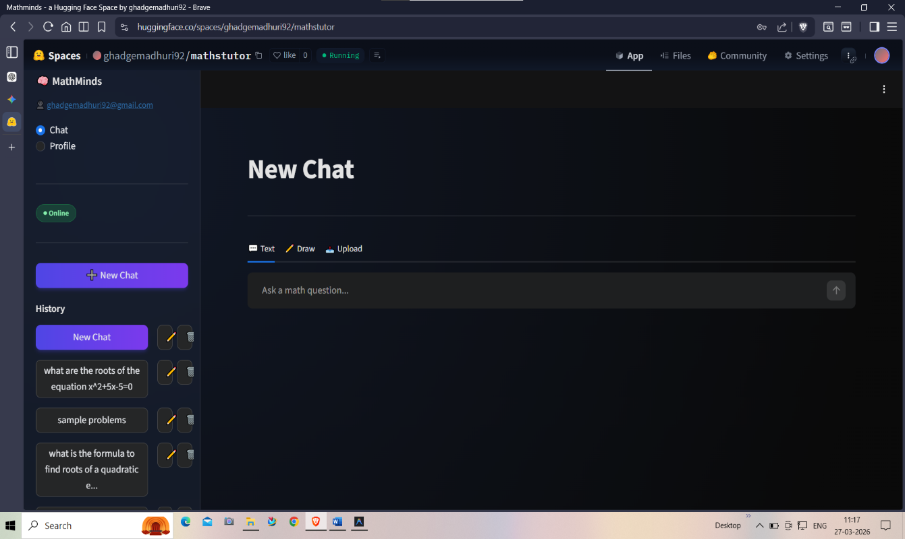

Results

Logical Input Handling

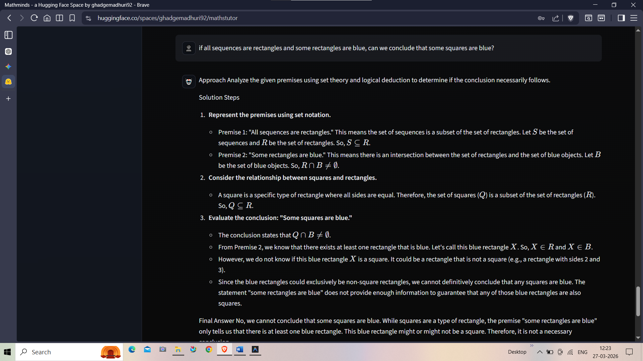

Drawable Input Handling

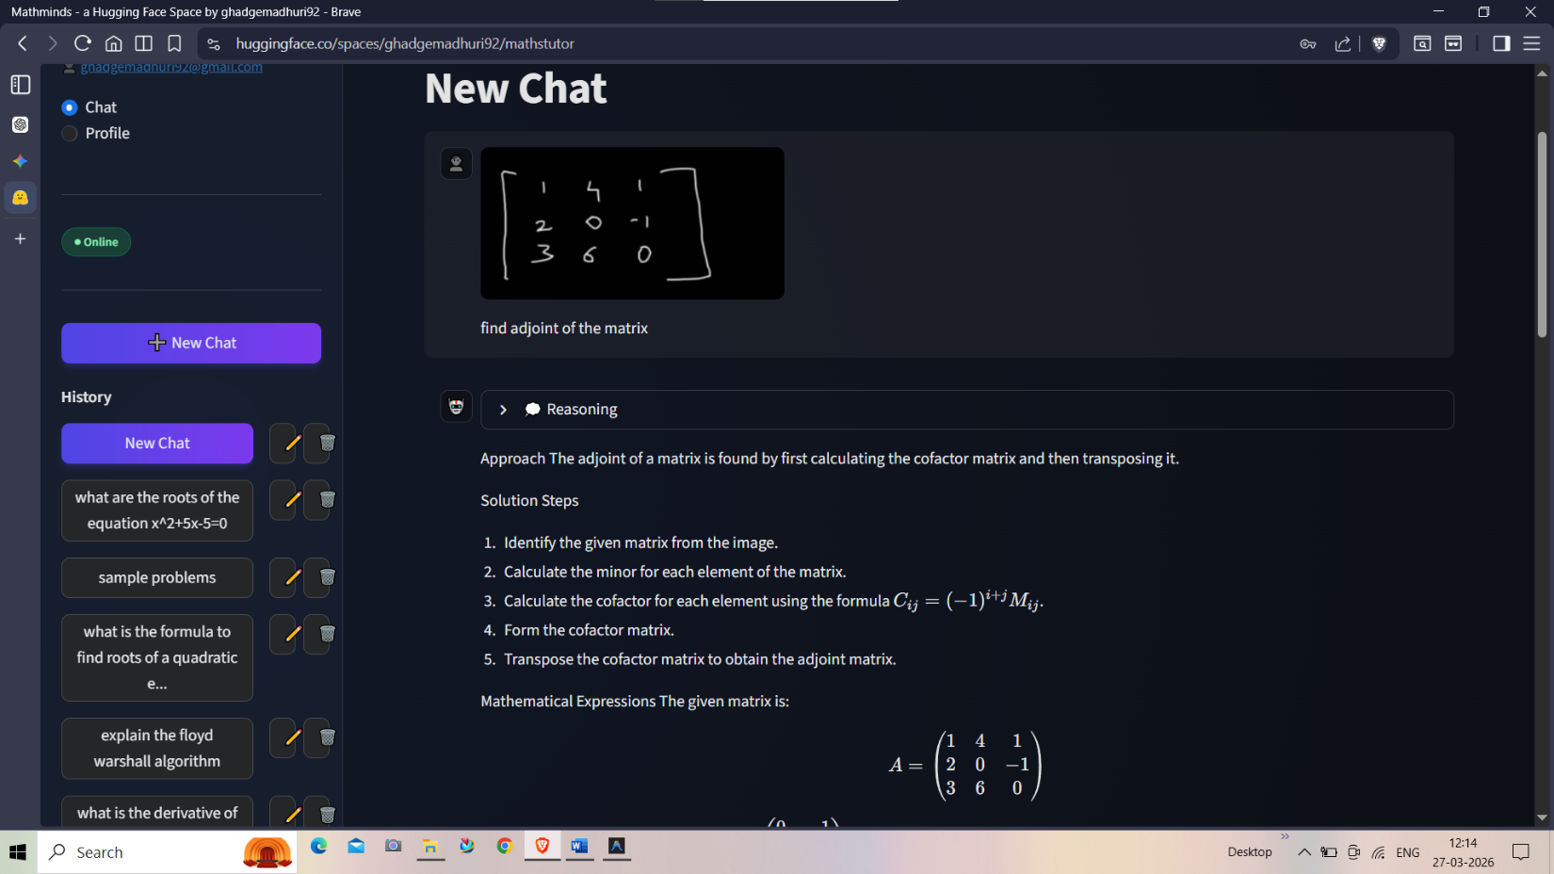

Calculus Reasoning

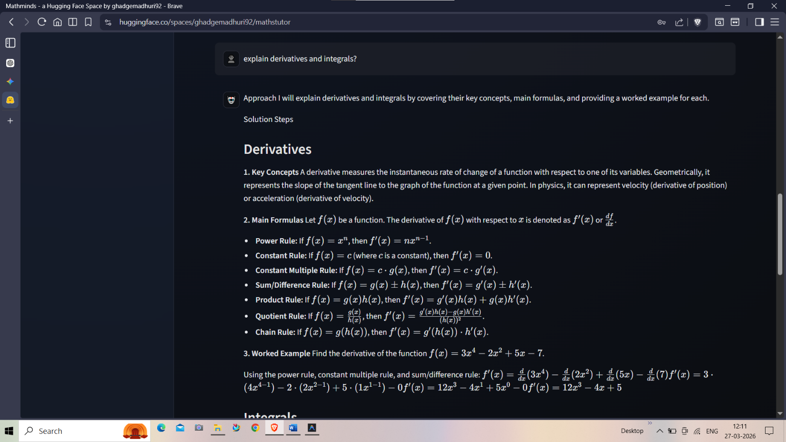

Web search and Geometry questions

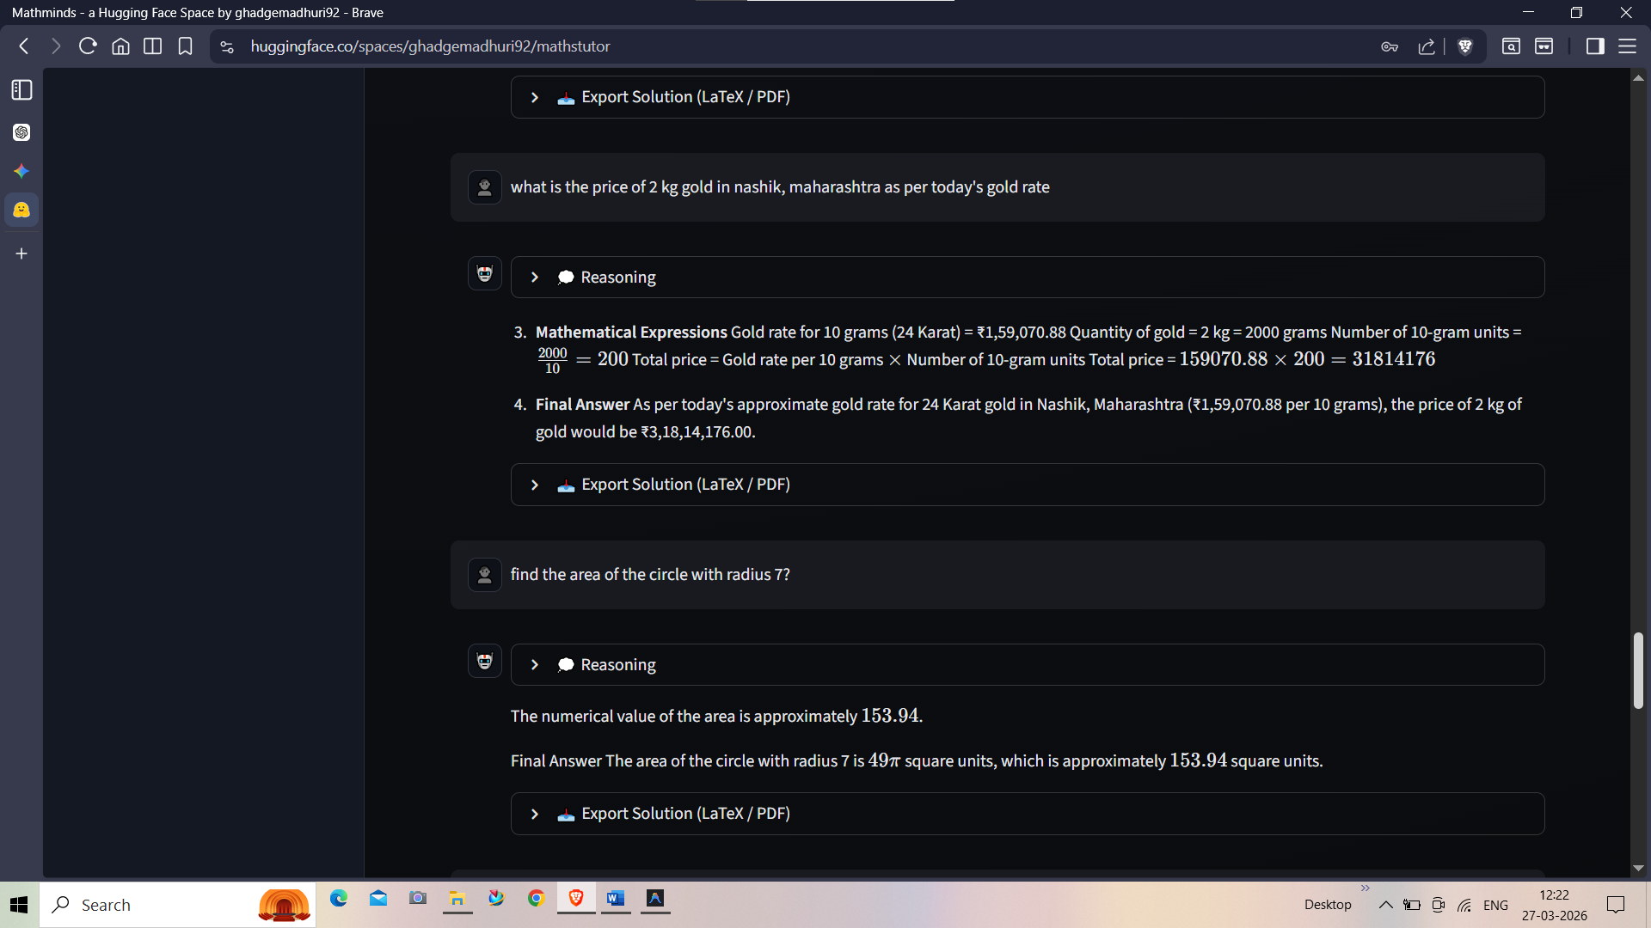

Object detection from image

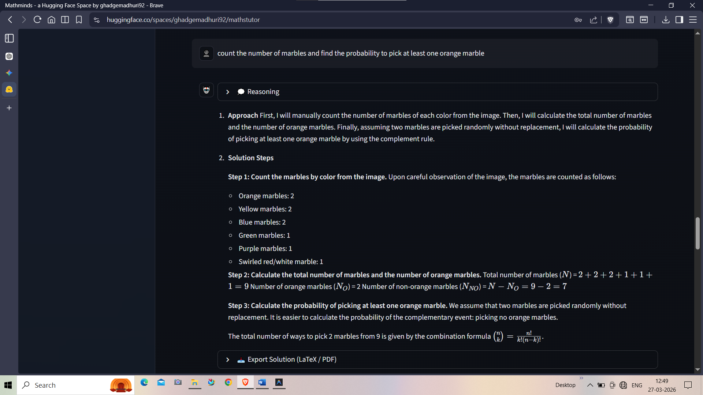

Download answer

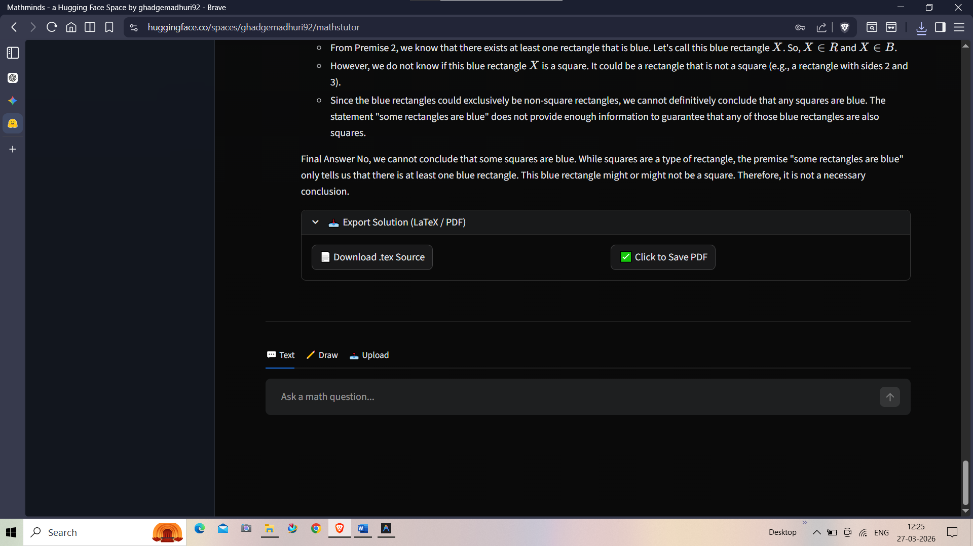

Limitations of the System

- API Latency on Complex Queries: Since the system relies on external LLMs via ADK alongside real-time formal computation through SymPy, users with slow internet connections may experience slight delays before the final derivation steps are printed.
- Symbolic Solver Strict Bounds: The precision of calculations is strictly bounded by the underlying capabilities of the SymPy logic engine. Highly abstract, graduate-level theoretical abstractions without explicitly solvable symbolic roots may fail.
- Operational Cost Scaling: If deployed in a massive multi-user production environment, the scaling token usage associated with spinning up Agentic AI repeatedly to generate complex text paths will incur higher operational server costs than traditional offline calculators.
- Visual Input Constraint: The system primarily operates via standard keyboard input syntax and equation formatting. The current iteration lacks Native Optical Character Recognition (OCR) for users to upload visual images from handwritten exams directly.
- Dynamic Visualizations/Plotting: While the system excels in delivering robust mathematical deduction and generating flat, academic PDF graphs, the implementation of dynamic, interactively pannable 3D plotting inside the exported .pdf bounds is structurally a limitation of the LaTeX compiler.

Future Scope

- 3D Graphing and Visualizations: Upgrading the export capabilities and the UI to support dynamic rendering of parameterized 3D calculus, plotted curves, and geometric structures in real-time.

- Collaborative Sessions: Enhancing the real-time syncing of the NoSQL backend to support multiplayer spaces where multiple students can edit, solve, and annotate a shared document or equation simultaneously.

- Pluggable AI Models: Expanding the ADK pipeline to allow users to select from various LLM reasoning models (e.g., GPT-4, Claude 3.5, Llama 3) based on their specific problem-solving lengths or privacy requirements.

- Multi Agent system Architecture: Evolve the current system into a robust multi-agent framework where specialized agents handle distinct logic (e.g., dedicated agents for specific math domains, search, routing, and validation) and collaborate to solve complex queries.

- Custom YOLO Model Training: Move away from pre-trained object detection/OCR models.
Train a custom YOLO model tailored specifically to the project's unique data distribution (e.g., handwritten equations, specific diagram types, or specialized math notation) for higher accuracy and faster inference.

Conclusions

MathMinds AI represents a significant leap forward in educational technology and mathematical computation.
By securely isolating strict computational execution (SymPy) from natural language generation (Agentic AI), the system successfully mitigates the hallucination risks that traditionally plague Large Language Models working with mathematics. The platform seamlessly bridges the gap between calculating an answer and comprehending the underlying logical steps. Furthermore, its built-in formatting engine dramatically reduces the friction of academic reporting by generating instant, print-ready LaTeX and PDF documents from dynamic user queries.

Bibliography

- Agent Development Kit (ADK)
An open-source, code-first Python toolkit for building, evaluating, and deploying sophisticated AI agents with flexibility and control.
https://google.github.io/adk-docs/

- Python 3.12 documentation
https://www.python.org/

- SymPy: symbolic computing in Python
Meurer A, Smith CP, Paprocki M, Čertík O, Kirpichev SB, Rocklin M, Kumar A, Ivanov S, Moore JK, Singh S, Rathnayake T, Vig S, Granger BE, Muller RP, Bonazzi F, Gupta H, Vats S, Johansson F, Pedregosa F, Curry MJ, Terrel AR, Roučka Š, Saboo A, Fernando I, Kulal S, Cimrman R, Scopatz A. (2017) SymPy: symbolic computing in Python. PeerJ Computer Science 3:e103 https://doi.org/10.7717/peerj-cs.103
https://peerj.com/articles/cs-103/

- Google AI Studio
https://aistudio.google.com/

- MongoDB Data Synchronization
https://www.mongodb.com/docs/manual/core/replica-set-sync/

- Firebase developer documentation
https://firebase.google.com/docs

- OpenAI ChatGPT
https://chatgpt.com/

- Google Gemini
https://gemini.google.com/app

- HuggingFace
https://huggingface.co/

