1. Jenkins Installation Reference URL:

<http://mirrors.jenkins-ci.org/redhat/>

1. Docker-compose file:

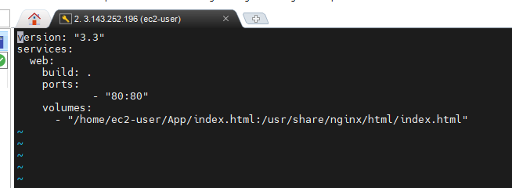

1. Shell script file for updating index.html file

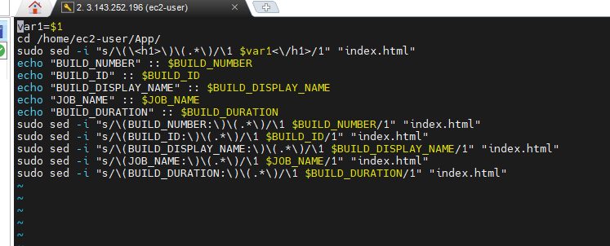

1. Jenkins accessing by using local.jenkins

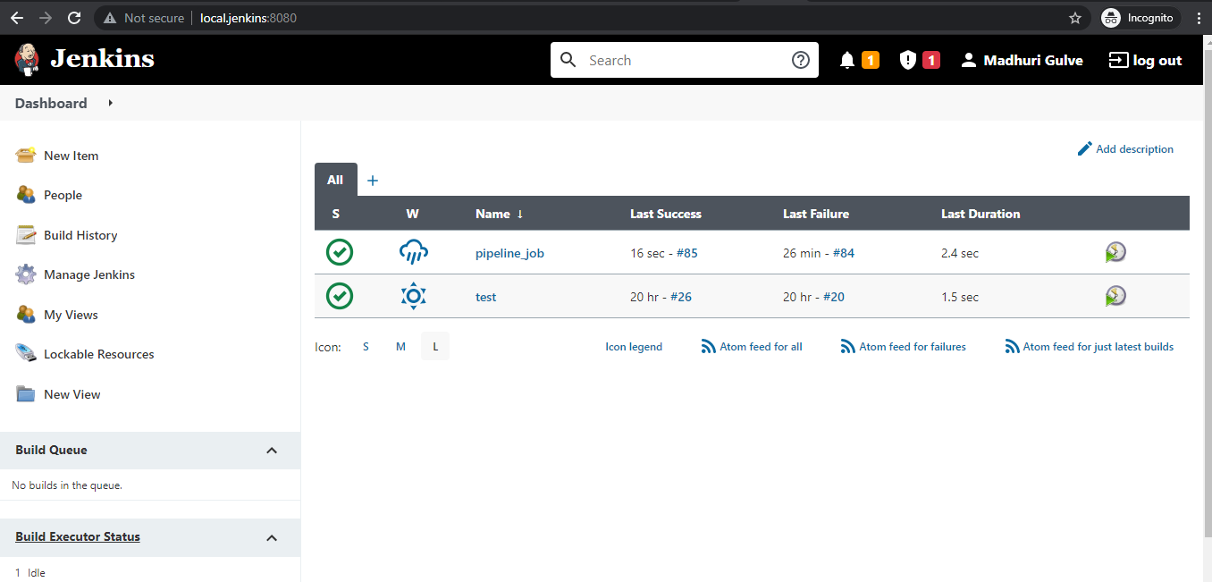

1. Webpage accessing by using local.webpage with Build information.

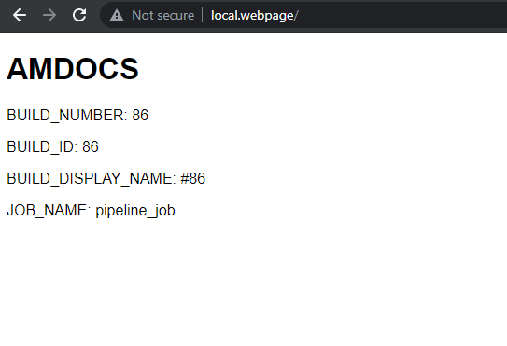

1. Pipeline Job:

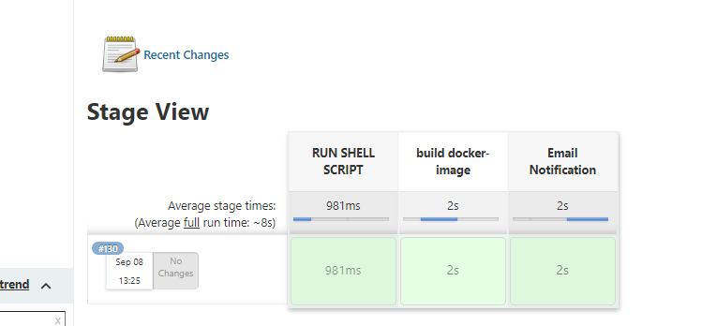

1. Pipeline Code:

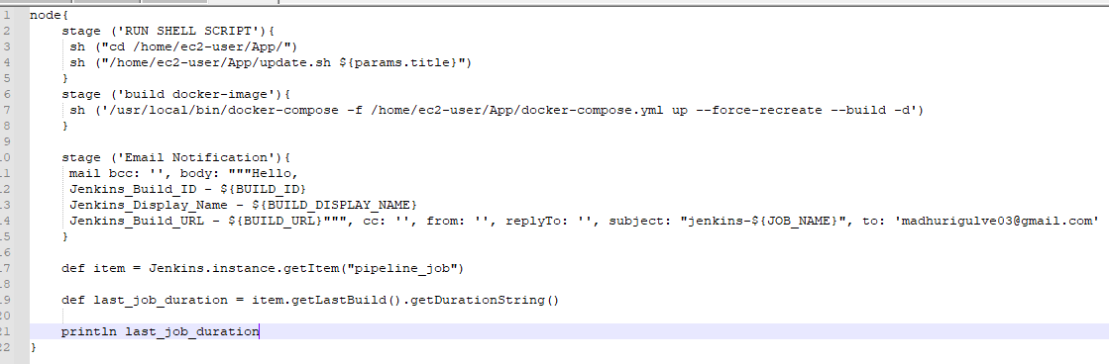

1. Pipeline to run every 5 minutes

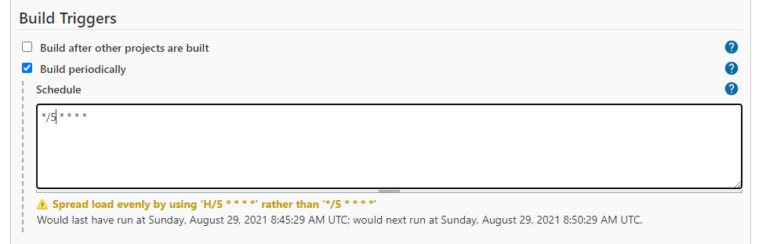

1. Email Notification:

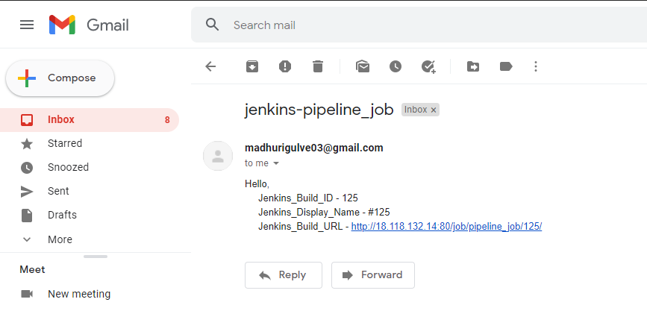

1. Console Output with Build Duration:

