VISVESVARAYA TECHNOLOGICAL UNIVERSITY

JNANA SANGAMA, BELAGAVI-590018, KARNATAKA



A Project Report
on
AGE GROUP ESTIMATION AND GENDER RECOGNITION USING FACIAL FEATURES
Submitted in partial fulfillment of the requirements for the VIII Semester of degree of Bachelor of Engineering in Information Science and Engineering of Visvesvaraya Technological University, Belagavi
Submitted by
Madhuri M G 1RN16IS047 Pareeshma P K 1RN16IS062
Mayank Kheria 1RN16IS051 Madhura J 1RN16IS046

Under the Guidance of
Mr .T S Bhagavath Singh
Associate Professor
Department of ISE
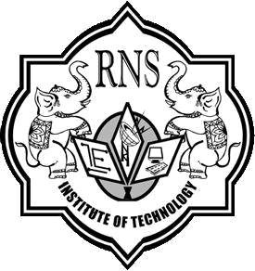

Department of Information Science and Engineering

RNS Institute of Technology
Dr. Vishnuvaradhana Road, Rajarajeshwari Nagar post, Channasandra, Bengaluru-560098

2019-2020
RNS INSTITUTE OF TECHNOLOGY
Dr. Vishnuvaradhana Road, RajarajeshwariNagar post,
Channasandra,Bengaluru - 560098

DEPARTMENT OF INFORMATION SCIENCE AND ENGINEERING

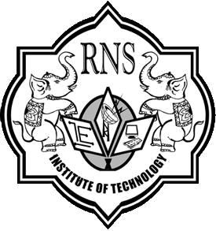

CERTIFICATE

Certified that the project work entitled Age Group Estimation And Gender Recognition Using Facial Features has been successfully completed by Madhuri M G (1RN16IS047), Mayank Kheria (1RN16IS051), Pareeshma P K (1RN16IS062) and Madhura J (1RN16IS046), bonafide students of RNS Institute of Technology, Bengaluru in partial fulfillment of the requirements for the award of degree in Bachelor of Engineering in Information Science and Engineering of Visvesvaraya Technological University, Belgaum during academic year 2019-2020. The project report has been approved as it satisfies the academic requirements in respect of project work for the said degree.

____________________ | _____________________ | _____________________
Mr. T S Bhagavath Singh | Dr. M V Sudhamani | Dr. M K Venkatesha
Project Guide | Professor and HOD | Principal
Associate Professor | Department of ISE | RNSIT
Department of ISE | RNSIT
 | External Viva
Name of the Examiners |  | Signature with Date
1. ___________________________ |  | 1. ______________________
2. ___________________________ |  | 2. ______________________

DECLARATION

We, MADHURI M G [USN: 1RN16IS047], MAYANK KHERIA [USN: 1RN16IS051], PAREESHMA P K [USN: 1RN16IS062], MADHURA J [USN: 1R16IS046] students of VIII Semester BE, in Information Science and Engineering, RNS Institute of Technology hereby declare that the Project entitled Age Group Estimation And Gender Recognition Using Facial Features has been carried out by us and submitted in partial fulfillment of the requirements for the VIII Semester of degree of Bachelor of Engineering in Information Science and Engineering of Visvesvaraya Technological University, Belgaum during academic year 2019-2020.

Place : Bengaluru

Date :

MADHURI M G (1RN16IS047)
MAYANK KHERIA (1RN16IS051)
PAREESHMA P K (1RN16IS062)
MADHURA J (1RN16IS046)

