**Chapter 3**

**ANALYSIS**

**3.1 Problem Identification**

Problem identification provides a platform for investigating a broad range of interventions and generating options. Initiatives developed in subsequent steps of the Framework should address the problems identified here. The process of problem identification involves the development of clear, straightforward problem statements that can be linked directly with the specific goals and objectives already identified.

Facial features are considered as a high-level personal trait in the field of security, law enforcement application, and attendance systems. Certain applications use facial features to unlock and to detect the right person identification. Irrespective of age and position of an individual the gender of an individual has to be detected. The main problem in detection of faces is an inappropriate dataset of training examples which may lead to less accuracy. India can provide this face detection facility with limited resources. So simple techniques enable us to implement this in many fields such as Aadhar card, PAN card, Voter Id applications, security purpose, detection of an individual face for attendance in companies and many other applications.

Age estimation for certain facial features and especially child’s and elder’s face recognition is advance level implementation. These statements should clarify how the problem might prevent the achievement of these goals and objectives. Problem statements are tested and refined through more detailed analysis undertaken as part of problem assessment and prioritization.

When identifying problems, the following should be taken into account:

* Problems prevent the goals and objectives identified in the previous step from being achieved. This should include the full range of objectives identified in the previous step – including objectives for different levels of planning and markets.
* Problem identification should consider not only ‘problems’ or ‘challenges’ but also constraints on opportunities that are preventing the goals and objectives from being achieved.

Identification should be based on empirical observations, such as data and information obtained from surveys, demand modeling, interviews and studies from a wide range of sources. Problem identification should result in problem statements that describe the nature of the problem facing the transport system and its components. Problem identification should not be confined to existing situations or issues.

Emerging and potential future problems should also be considered Problems can be different for the various planning levels. For example, achieving a goal of reducing road crashes may require a specific engineering ‘fix’ at the link level series of rest areas at the corridor level and safety education initiatives at the network level. Problems should be seen as multidimensional. It is important to ‘cast the net wide’ when identifying problems. This means considering the full range of economic, social and environmental factors and canvassing a broad spectrum of potential problems, such as accessibility, business needs, availability, prices/cost, capacity, emissions, and safety.

**3.2 Objectives**

Objectives are more specific and easier to measure than goals. Objectives are basic tools that underlie all planning and strategic activities. They serve as the basis for creating policy and evaluating performance. The main goal is to exploit the discriminative nature of sparse representation to perform classification.

The problem of face identification has received significant attention over the years. For a given probe face, the goal of face identification is to match this unknown face against a gallery of known people. Due to the availability of large amounts of data acquired in a variety of conditions, techniques that are both robust to uncontrolled acquisition conditions and scalable to large gallery sizes, which may need to be incrementally built, are challenges.

The main objectives of this project are:

* To learn face features and recognize the gender and estimate the age with the additional GUI property.
* To concentrate on overcoming certain drawbacks like noise, the improper distance between face parts and low-resolution images.
* To detect faces in the presence of facial hair and props like sunglasses.
* To provide an accurate estimation of age.
* To identify ages below 8 and above 64 as well.
* To recognize a face and determine gender irrespective of face position and distance(certain level).
* Facial aging adversely impacts the performance of face recognition and face verification and authentication using facial features.
* This stochastic personalized inevitable process poses a dynamic theoretical and practical challenge to the computer vision and pattern recognition community.
* The face recognition is one of the biometric methods to identify individuals by features of the face.
* A complete face recognition includes two patterns of face detection and faces recognition. And these can be achieved using machine learning techniques.
* A problem of personal verification and identification is an actively growing area of research and security areas.
* Support Vector Machine(SVM) classifier and Local Binary Pattern(LBP) is used for age and gender classification.
* It provides a framework for two crucial issues: feature extraction and robustness.
* Applicable for high-classification of high-dimensional data as well as for corrupted images
* This paper deals with the use of 2D-facial images for gender classification.
* An individual’s face is considered who’s image of different ages are estimated by age synthesis and age estimation.
* The image is identified as irrespective of facial expressions.
* Face detection in videos are implemented giving less accuracy comparatively which is an advanced implementation
* LDP is an extraction algorithm which improves age and gender recognition rate effectively with robustness for noise is better.
* Ear and hair are also considered as a part of face recognition.
* Used in paper advertisements.
* A quick survey of facial expressions.
* Less noise in the time of processing compared to many techniques.
* Video-based, sketch-based, near-infrared face recognition is detected and estimated.
* The proposed method is a challenging aspect in the field of image analysis and computer vision.
* It detects the unknown images and classifies them with the database images.

**3.3 Methodology**

The methodology is the systematic, theoretical analysis of the methods applied to a field of study. It comprises the theoretical analysis of the body of methods and principles associated with a branch of knowledge. Typically, it encompasses concepts such as paradigm, theoretical model, phases and quantitative or qualitative techniques.

A methodology does not set out to provide solutions it is, therefore, not the same as a method. Instead, a methodology offers the theoretical underpinning for understanding which method, set of methods, or best practices can be applied to a specific case, for example, to calculate a specific result.

It has been defined also as follows:

1. The analysis of the principles of methods, rules, and postulates employed by a discipline.
2. The systematic study of methods that are, can be or have been applied within a discipline.
3. The study or description of methods.

The methodology is the general research strategy that outlines the way in which research is to be undertaken and, among other things, identifies the methods to be used in it. These methods, described in the methodology, define the means or modes of data collection or, sometimes, how a specific result is to be calculated.The methodology does not define specific methods, even though much attention is given to the nature and kinds of processes to be followed in a particular procedure or to attain an objective.

When proper to a study of methodology, such processes constitute a constructive generic framework, and may, therefore, be broken down into sub-processes, combined, or their sequence changed. A paradigm is similar to a methodology in that it is also a constructive framework. In theoretical work, the development of paradigms satisfies most or all of the criteria for methodology. An algorithm, like a paradigm, is also a type of constructive framework, meaning that the construction is a logical, rather than a physical, array of connected elements.

Any description of a means of calculation of a specific result is always a description of a method and never a description of a methodology. It is thus important to avoid using methodology as a synonym for method or body of methods. Doing this shifts it away from its true epistemological meaning and reduces it to being the procedure itself, or the set of tools, or the instruments that should have been its outcome. A methodology is the design process for carrying out research or the development of a procedure and is not in itself an instrument, or method, or procedure for doing things.

Methodology and methods are not interchangeable. In recent years, however, there has been a tendency to use methodology as a "pretentious substitute for the word method". Using methodology as a synonym for method or set of methods leads to confusion and misinterpretation and undermines the proper analysis that should go into designing research.

The proposed system has the following steps:

1.Face detection: Initially, images are stored in the database which is the training datasets are detected.

2. Gender recognition and age group estimation: The gender recognition is done using binary classification and age group is estimated using wide residual networks.

**1. Preprocessing image:**

Image preprocessing is a desirable step in every pattern recognition system to improve its performance and used to reduce variations and produce a more consistent set of data.

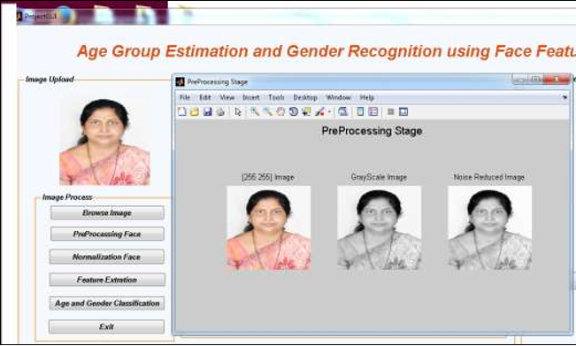

**Figure 3.1 Preprocessing stage**

The face image of a person is captured by a digital camera as shown in Figure 3.1. Pre-processing includes three steps as detecting the image, converting to grayscale & noise-reduced image. The color image is converted into a grayscale image. The Matlab code is used for conversion of RGB to Grayscale image represented in binary digits 0 and 1. There are different types of filtration methods used for noise reduction techniques. The Gaussian filtering method is used for noise reduction.

**2. Normalization:**

Detecting the features of faces and cropping the rectangular features of faces.In the normalization process, the system crop the detected rectangular face area as shown in Figure 3.2 using Matlab in-built object function. Then, detect the eye pair, mouth, nose, and chin. It gives the specific images of the left eye, right eye, left eyebrow, right eyebrow, mouth i.e. image of lips & also detects chin hairline part of face image and also gives the nose image.

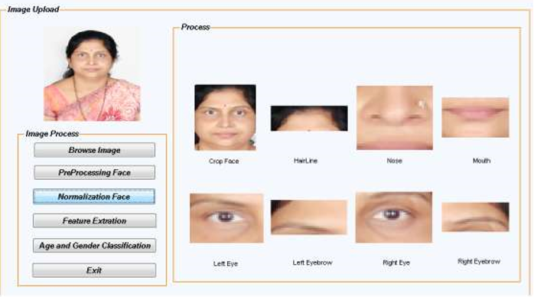

**Figure 3.2 Normalization**

**3. Feature Extraction:**

A combination of global and grid features are extracted by geometric based and appearance based extraction methods. Those features are stored in the database. The distance between them is calculated which is called Euclidian distance.

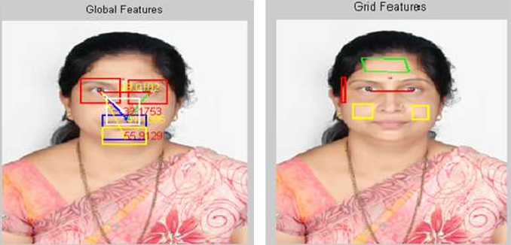

**Figure 3.3 Feature extraction**

Four features F1, F2, F3, and F4 denotes the global features and the feature F5 is calculated for grid features. The Canny edge detection technique is used for finding the grid features.The four features F1, F2, F3, and F4 are calculated as follows:

F1 = (distance from left to right eyeball) / (distance from eye to nose)

F2 = (distance from left to right eyeball) / (distance from eye to lip)

F3 = (distance from eye to nose) / (distance from eye to chin)

F4 = (distance from eye to nose) / (distance from eye to lip)

**4. Binary Classification:**

Based on the distances gender is recognized. Basically, it can be classified by the SVM(support vector machine) technique.

* SVM is a supervised learning algorithm for feature or pattern classification. Once the training dataset is learned, the test dataset is given with a number of images of detection and recognition. Later after building this model, the user interface is established to read data from the user directly using a web camera.
* In machine learning, SVMs have supervised learning models with associated learning algorithms that analyze the data used for classification and regression analysis.
* SVM training algorithms build a new model that assigns new examples to one category or the other.
* Here SVM is used for both age and gender classification.
* Based on feature classification and gender recognition, the calculated distance determines the age of an individual within a certain age range.

**3.4 System requirement specification**

A System Requirements Specification (SRS)  also known as a Software Requirements Specification is a document or set of documentation that describes the features and behavior of a system or software application. It includes a variety of elements (see below) that attempts to define the intended functionality required by the customer to satisfy their different users. In addition to specifying how the system should behave, the specification also defines at a high level the main business processes that will be supported, what simplifying assumptions have been made and what key performance parameters will need to be met by the system.

**3.4.1 Software requirement specification**

* Python 3.5
* Numpy 1.13.3+mkl
* Keras 2.0.8
* TensorFlow 1.4.0
* Opencv 1.0.1+
* Opencv-python 3.3.0+contrib
* Windows 10

**3.4.2 Hardware requirement specification**

* RAM 2GB or higher
* I3/I5 processor

**3.4.3 Functional requirement**

A Functional Requirementdefines a function of a [system](https://en.wikipedia.org/wiki/System) or its component, where a function is described as a specification of behavior between outputs and inputs. In our project the gender detection functionality implemented in [cv lib](https://github.com/arunponnusamy/cvlib) which can be accessed through a single function call detect_gender().

**3.4.4 Non Functional requirement**

The PCs used must be at least be INTEL CORE i3 machines so that they can give optimum performance of the product. In addition to these requirements, the system should also embrace the following requirements:-

* + - * Reliability: The system should have little or no downtime.
      * Ease of Use: The general and administrative views should be easy to use.