**Chapter 7**

**DISCUSSION OF RESULTS**

The output of this model is obtained by reading the input from web camera. Input is the human face which is captured from webcam of the system. The model can read one, two as well as three faces at a time. The faces in the picture can also be read based on clarity of face in the picture. Hence the output of this model is estimation of age group and recognizing the gender of the given input face(or faces).

Here are some experiment results for different input images read from the webcam. Detected face of the image is shown within blue square. Age group and gender of the image is displayed for the image as shown in Figure 7.1. Detected face gender is female represented as F and age group is in between the range 19 to 35.

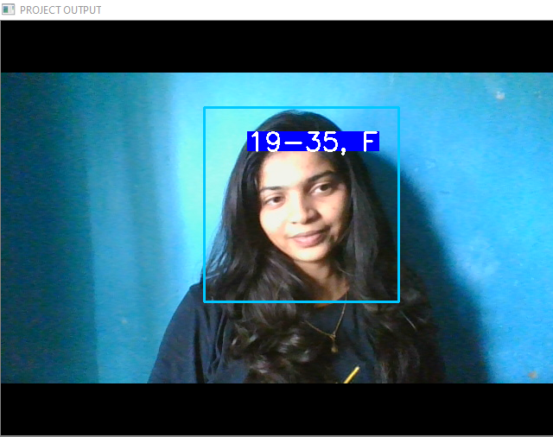

**Figure 7.1 One face detection where gender is female and age group is in between 19-35**

The model captures video using web camera and detects the face and crops the face to extract features. Different age groups in this model are :

* 01-18
* 19-35
* 36-56
* 56-75
* 76-100

Gender is recognized as :

* F for Female
* M for Male

Here is another snapshot of result with different gender as the input. Detected face gender is male represented as M and age group is in between the range 19 to 35 is shown in figure 7.2.

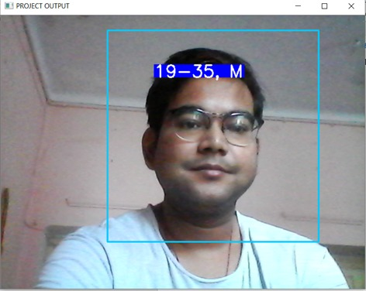

**Figure 7.2 One face detection where gender is male and age group is in between**

**19-35**

Detection of two faces at a time of different age group and different gender is shown in figure 7.3 and figure 7.4.

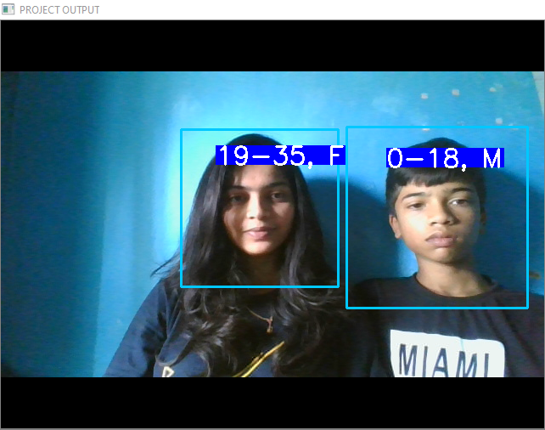

**Figure 7.3 Detection of two faces of two different age group and gender**

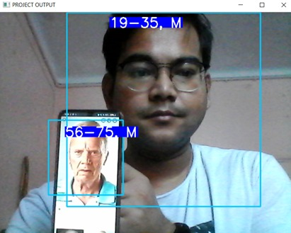

**Figure 7.4 Detection of two faces where one face is detected from the picture**

Detection of three faces at a time is shown in figure 7.5 where two faces are detected from the picture.

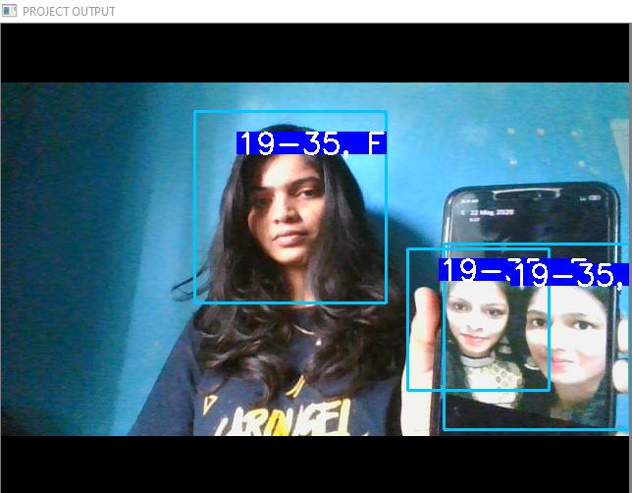

**Figure 7.5 Detection of three faces at a time**