MongoDB Queries

1. ***Retrieve all products in the "Electronics" category.***

**db.products.find({category:”Electronics”})**

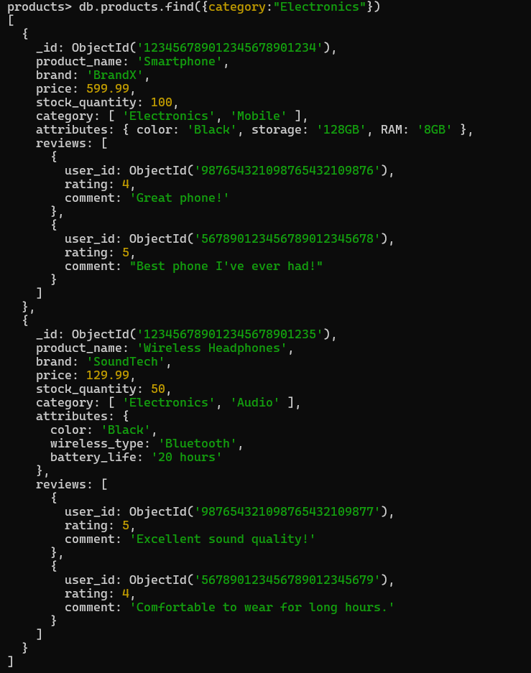

1. ***Find all products with a price less than $500.***

**db.products.find({price:{$lt:500}})**

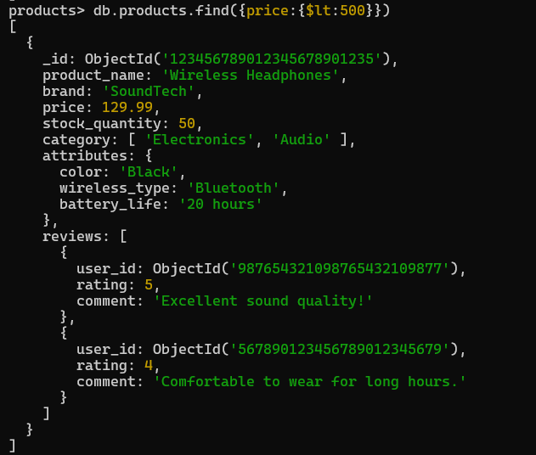

1. ***Retrieve all products with a rating greater than 4.***

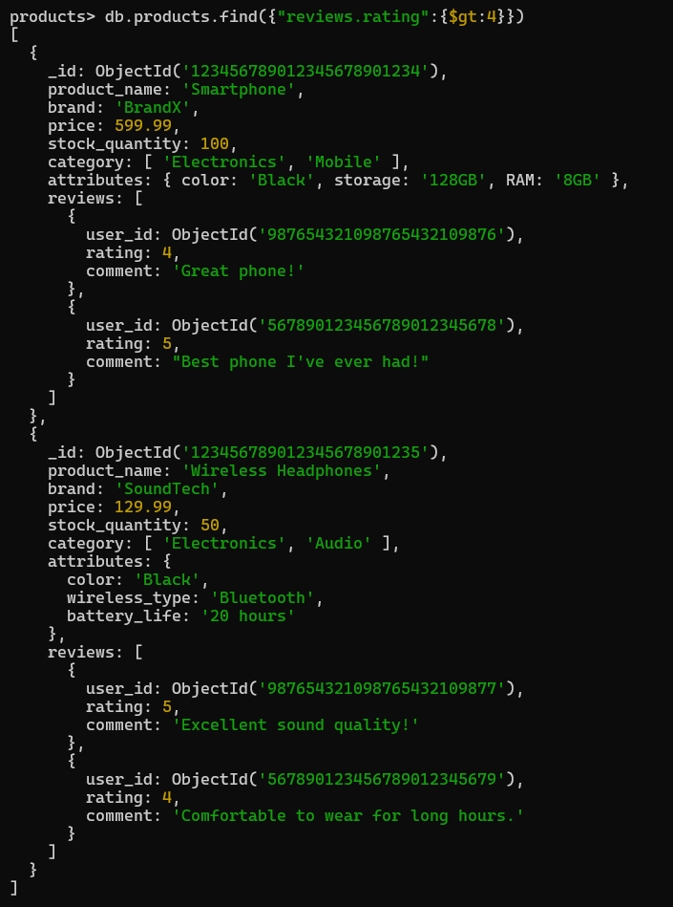**db.products.find({“reviews.rating”:{$gt:4}})**

1. ***Find all products with a specific color (e.g., Black).***

**db.products.find({“attributes.color”:”Black”})**

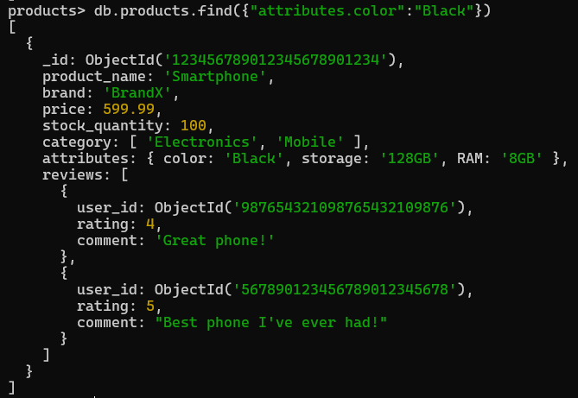

1. 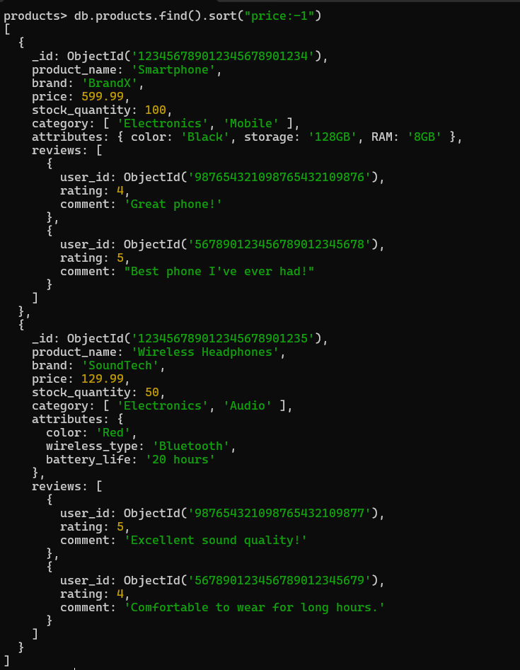 ***Retrieve all products sorted by price in descending order.***

**db.products.find().sort(“price: -1”)**

1. ***Calculate the average rating of all products.***

**Db.products.aggregate([{$unwind:”reviews”},{$group:{_id:null,**

**averageRating:{$avg:”$reviews.rating”}}}])**

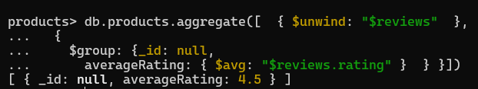

1. ***Find all products where the stock quantity is less than 10.***

**db.products.find({stock_quantity:{$lt:10}})**

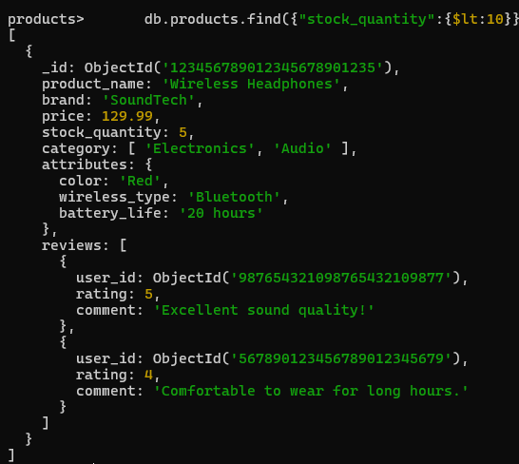

1. ***Retrieve all products with a specific brand (e.g., BrandX).***

**db.products.find({brand:”BrandX”})**

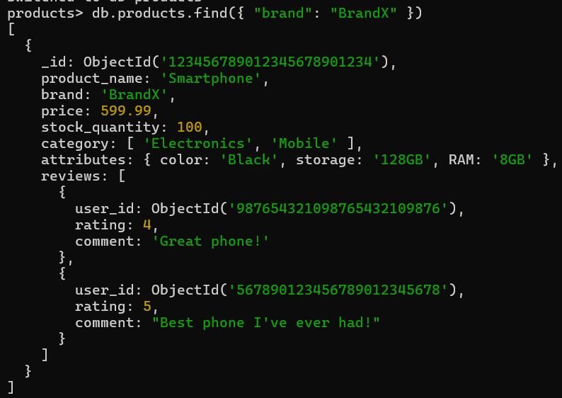

1. ***Find all products where the storage is 128GB and RAM is 8GB.***

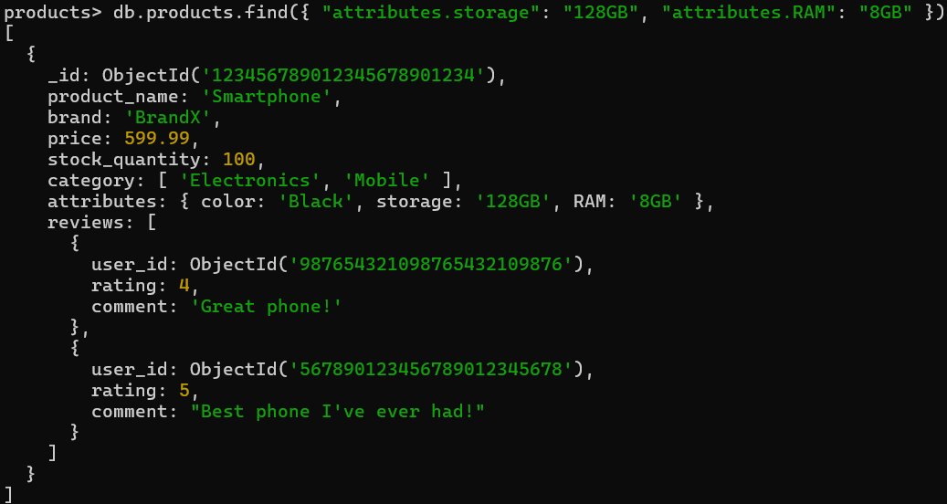 **db.products.find({ "attributes.storage": "128GB", "attributes.RAM": "8GB" })**

1. ***Retrieve all products with a specific user's review (eg,user_id:ObjectId("987654321098765432109876")).***

**db.products.find({ "reviews.user_id":**

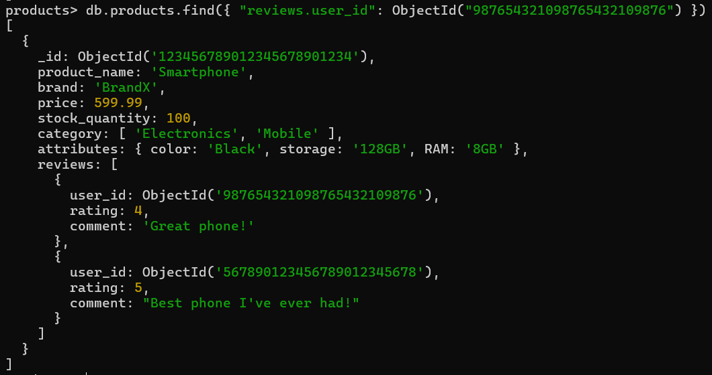**ObjectId ("987654321098765432109876") })**

1. ***Calculate the total number of reviews for each product.***

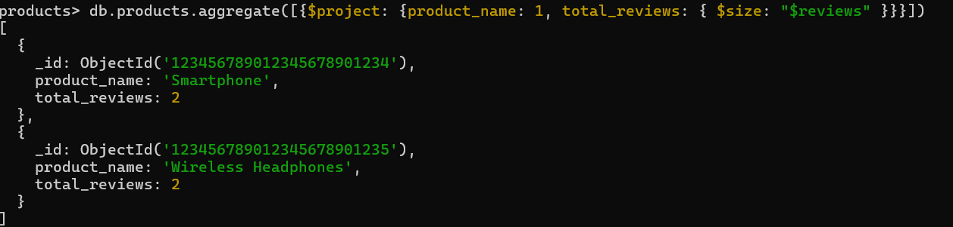**db.products.aggregate([{$project: {product_name: 1, total_reviews: { $size: "$reviews" }}}])**

1. ***Find all products with a price between $400 and $600.***

**db.products.find({price:{$gte:400,$lte:600}})**

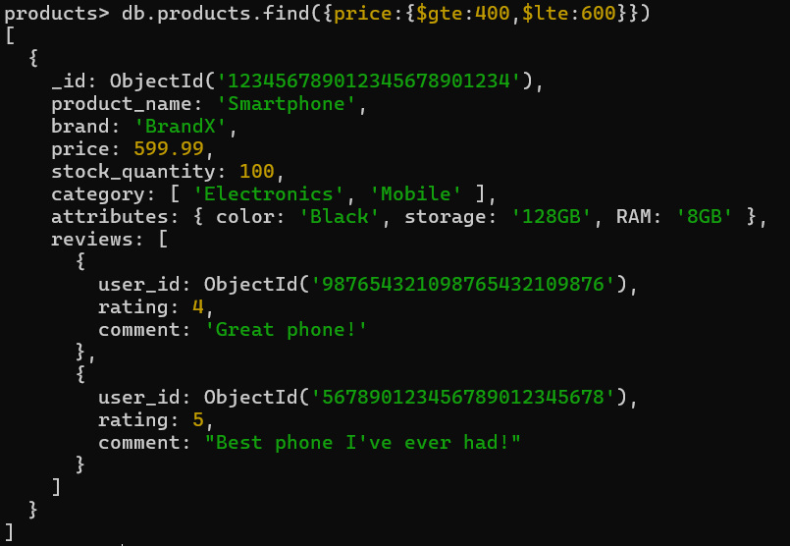

1. ***Find all products with a specific category (e.g., "Mobile") and a stock quantity greater than 500***

**db.products.find({“category”: “Mobile”, “stock_quantity”:{$gt:50}})**

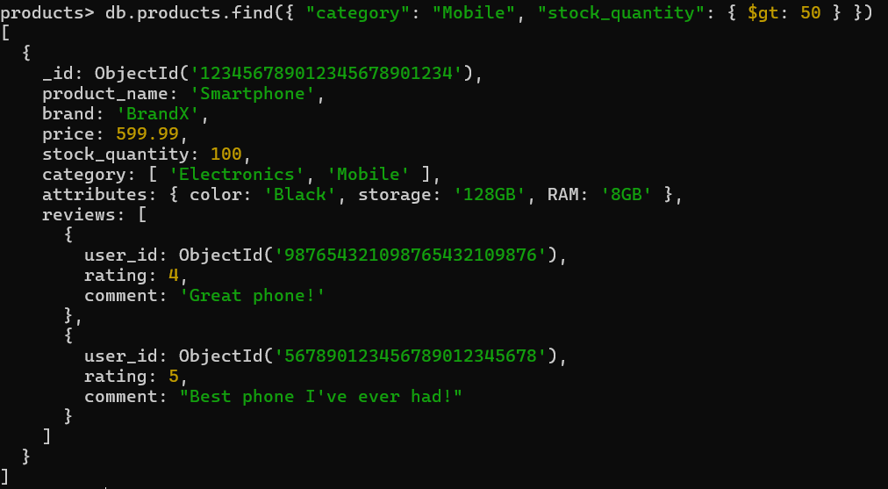

1. ***Find the highest rated product.***

**db.products.aggregate([{ $unwind: "$reviews" }, { $sort: { "reviews.rating": -1 } }, { $limit: 1 }])**

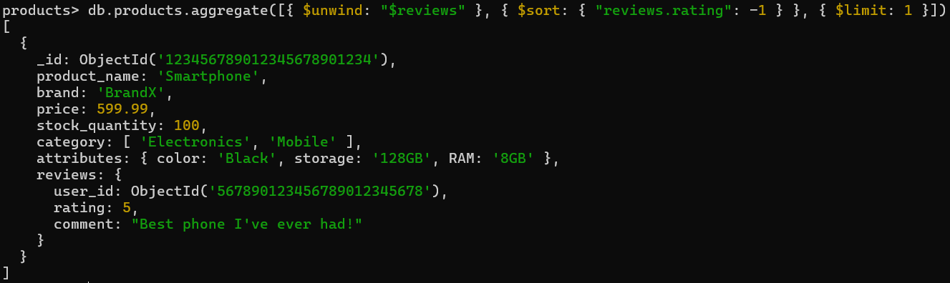

1. ***Retrieve all products sorted by brand in ascending order and then by price in descending order.***

**db.products.find().sort({ "brand": 1, "price": -1 })**

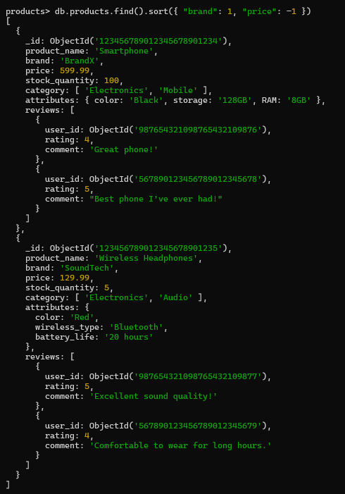

1. ***Find all products with a specific comment in their reviews (e.g., "Great phone!").***

**db.products.find({“reviews.comment”: “Great phone!”})**

