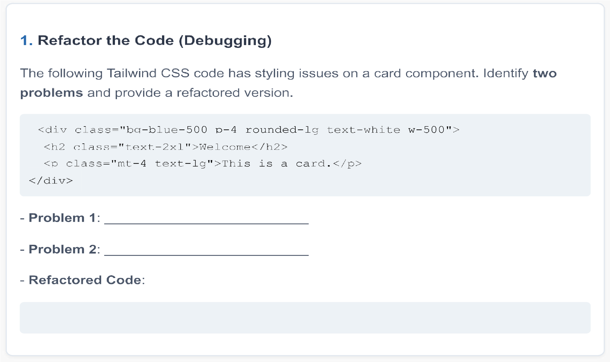

Ans: <div classname=” bg-blue-500 p-4 round-lg w-[500pxl] ”>

<h2 classname=” text-2xl ”> Welcome </h2>

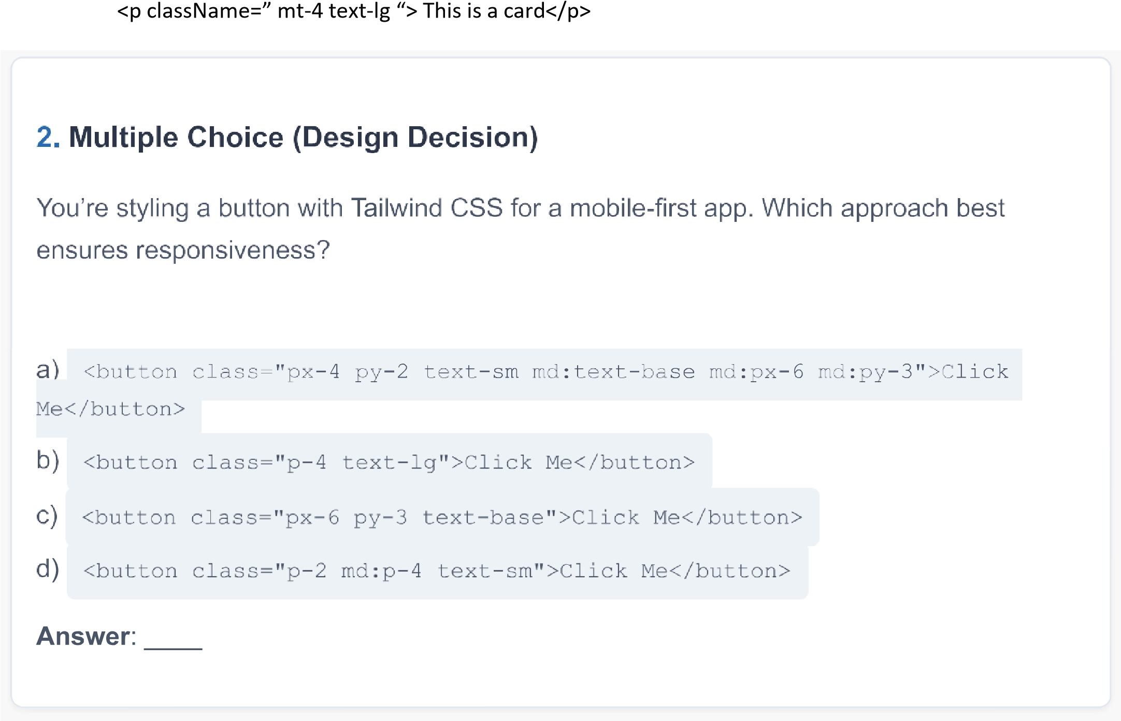

Option: A



1. True ( We are using Tailwindcss version 4 so utility class is in built.
2. True

5

.Text

white bg

-

red



1. a-2, b-1, c-3
2. Write the tailwindcss code into tages/ If there is repeated styles create a commmon css file and import ( enable the content option in tailwind.config.js)

8

9. 2,4,6 on separete line

10. True or False (Coding Standards)Using const for variables that won't be reassigned is a best practice in JavaScript.

Answer: a.True

Arrow functions ( ) are always shorter and clearer than traditional function declaratins.

Answer:b..False

11. Fill in the Blank (Performance)

To avoid memory leaks in event listeners, you should use  to remove them when they're no longer needed.

Answer: useeffect

12 . Guess the Output

What's logged by this code?

let x function test ( ) let x console. log (x) ;

test () ;

a) 10

1. 20
2. undefined
3. Error

ans.20

### Map the Items (Functionality)

Match the JavaScript method to its purpose:

1. querySe1ector  1. Executes a function after a delay
2. set Timeout 2. Selects the first matching element

C) map  3. Creates a new array from an array

1. a-2 b-1 c-3

### Short Answer (Performance)

14.Your Vanilla JS app re-renders a list of 1 ,000 items on every button click. Suggest one technique to optimize this.

Answerusestate

15 15. Multiple Choice (Debugging)

Why does this code throw an error?

const data undefined; console . log (data . name) ;

1. data is not an object
2. name is a reserved keyword
3. data is not declared
4. console. log is misused

A( Data is not an aobject)

16. Code Challenge (Coding Standards)

Write a Vanilla JS function to toggle a class active on an element with ID box 

Ensure it follows ES6+ standards and is concise

code : const Active= () => { const box = document.getElementById('box'); box.classList.toggle('active');

};

17. Refactor the Code (Debugging)

This React component causes a warning in the console. Identify the issue and refactor it.

function Counter ( ) const [count, setCount]React. useState (0) ; return (

<div>

{ count I < /

<button onCIick={ ( ) => setCount (count++) } > Increment</button>

< / div >

Issue

Answer. import { useState } from 'react';

function Counter() { const [count, setCount] = useState(0); return (

<div>

<p>Count: {count}</p>

<button onClick={() => setCount(count + 1)}>Increment</button>

</div>

);

}

export default Counter;

Answer a 19.

a. True

b. False

1. Parent
2. World

22 a-2,b-1,c-3

1. React.memo
2. a
3. import { useState, useEffect } from 'react'; function UsersList() { const [users, setUsers] = useState([]); const [isLoading, setIsLoading] = useState(true); const [error, setError] = useState(null); useEffect(() => { const fetchUsers = async () => {

try {

const response = await fetch('https://jsonplaceholder.typicode.com/users'); if (!response.ok) throw new Error('Failed to fetch users'); const data = await response.json(); setUsers(data); } catch (err) {

setError(err.message);

} finally { setIsLoading(false);

}

};

fetchUsers();

}, []);

if (isLoading) return <div className="text-center p-4">Loading...</div>; if (error) return <div className="text-red-500 text-center p-4">Error: {error}</div>;

return (

<ul className="max-w-md mx-auto p-4 space-y-2">

{users.map(user => (

<li

key={user.id}

className="bg-white p-3 rounded-lg shadow hover:bg-gray-50 transition"

>

{user.name}

</li>

))}

</ul>

);

}

export default UsersList;

